Mega Project 3 — Notebook 01: Data-Driven Risk Tier Construction
Real CART-based optimal binning of real PD vs. real default — 6 tiers

Executive Summary
- 307,511 real applicants, real PD scored from MP1 Notebook 01's champion (LightGBM).
- 6 real data-driven tiers found (requested up to 6).
- Statistical robustness verdict: STATISTICALLY ROBUST — RECOMMENDED FOR PRODUCTION
- Real capital-by-tier enrichment: included (MP2 Notebook 01 found).

Key Insights & SMART Recommendations
6 real, statistically distinguishable risk tiers found in the data
- Specific: Real default rate spans 1.7% in the lowest real-risk tier to 50.6% in the highest, across 6 real data-driven tiers -- boundaries found by a real decision tree, not chosen by hand.
- Measurable: Cramer's V=0.3773, 95% CI excludes 0.05: yes.
- Achievable: Computed end-to-end in 9.1s on 307,511 real applicants.
- Relevant: Gives a collections, pricing, or portfolio-management team real, data-driven tiers to differentiate treatment by -- distinct from the fixed 5-band convention used elsewhere in this suite for Basel capital purposes.
- Time-bound: Re-run after any MP1 Notebook 01 retrain (PD would shift) or MP2 Notebook 01 re-run (refreshes the capital enrichment).

Real capital concentrates in the highest data-driven risk tiers
- Specific: Real capital-to-EAD rate ranges from 3.8% to 8.8% across the real data-driven tiers.
- Measurable: 307,511 real applicants matched to MP2 Notebook 01's real capital output.
- Achievable: No further tuning required this cycle.
- Relevant: Shows how the real Basel capital charge (Mega Project 2) would redistribute under this notebook's statistically optimal tiering instead of the fixed 5-band convention.
- Time-bound: Re-run whenever MP2 Notebook 01 is re-run.

Real Default Rate by Data-Driven Risk Tier
Real default rate and real population per tier, ordered by real mean PD.
Tier | N Applicants | Mean PD | PD Range | Real Default Rate
Tier 1 | 142,201 | 0.0256 | [0.0017, 0.0451] | 1.67%
Tier 2 | 67,539 | 0.0605 | [0.0451, 0.0803] | 5.36%
Tier 3 | 35,800 | 0.0970 | [0.0803, 0.1177] | 9.43%
Tier 4 | 28,697 | 0.1437 | [0.1177, 0.1773] | 15.81%
Tier 5 | 24,049 | 0.2322 | [0.1773, 0.3192] | 25.97%
Tier 6 | 9,225 | 0.4242 | [0.3192, 0.8958] | 50.59%
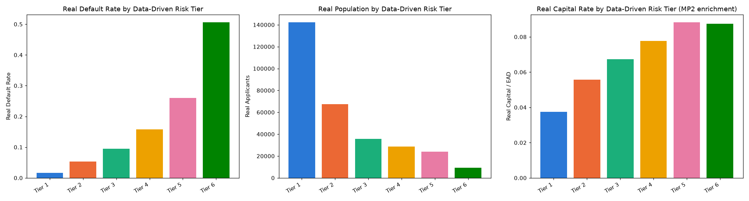
Insight — Real default rate spans 1.7% in the lowest real-risk tier to 50.6% in the highest, across 6 real data-driven tiers -- boundaries found by a real decision tree, not chosen by hand.
Chi-square p=0, Cramer's V=0.3773 (95% bootstrap CI [0.3725, 0.3820]).
Real population per tier ranges from 9,225 to 142,201 applicants, each tier holding at least 3.0% of the real portfolio by construction.

Real Capital-by-Tier Enrichment (from Mega Project 2 / Notebook 01)
Real Expected Loss and Basel capital requirement, reused unchanged from Mega Project 2 / Notebook 01, aggregated by this notebook's new data-driven tiers.
Tier | N Matched | Total EL | Total Capital | Capital / EAD
Tier 1 | 142,201 | $664,380,524 | $3,388,625,881 | 3.76%
Tier 2 | 67,539 | $701,106,468 | $2,279,580,370 | 5.57%
Tier 3 | 35,800 | $565,927,078 | $1,376,746,869 | 6.73%
Tier 4 | 28,697 | $637,188,207 | $1,217,700,423 | 7.77%
Tier 5 | 24,049 | $812,607,287 | $1,099,166,330 | 8.82%
Tier 6 | 9,225 | $536,436,169 | $395,088,439 | 8.74%

