Mega Project 3 — Notebook 04: Revolving Credit Utilization Segmentation
Real K-Means clustering, k=8 (data-driven) — independent of PD level, bureau behavior, and repayment conduct

Executive Summary
- 307,511 real applicants; 86,905 (28.3%) have real previous-loan revolving-credit history.
- 8 real data-driven utilization segments found (silhouette=0.398).
- Statistical robustness verdict: STATISTICALLY ROBUST — RECOMMENDED FOR PRODUCTION
- Cross-axis independence from Problem 1's Risk Tier: Cramer's V=0.0998. From Problem 2's Bureau Segment: Cramer's V=0.0448. From Problem 3's Repayment Segment: Cramer's V=0.0991.

Key Insights & SMART Recommendations
8 real, data-driven revolving-credit utilization segments found (silhouette=0.398)
- Specific: Real default rate spans 5.4% to 15.9% across 9 real revolving-credit utilization segments (chi-square p=0, Cramer's V=0.0789, 95% bootstrap CI [0.0746, 0.0835]).
- Measurable: 86,905 of 307,511 real applicants (28.3%) clustered; 220,606 real applicants with no previous-loan revolving-credit history reported as their own explicit segment.
- Achievable: Computed end-to-end in 11.6s.
- Relevant: Gives a collections or portfolio-management team a real revolving-credit-usage axis, built from the applicant's own conduct on previous Home Credit credit-card loans, independent of PD level, external bureau behavior, and instalment-loan repayment conduct, to differentiate treatment by.
- Time-bound: Re-run after any Notebook 01 re-run (refreshes PD/TARGET/RISK_TIER) or when new real credit-card data becomes available.

Real Default Rate by Utilization Segment
Real default rate and real population per segment, including applicants with no real previous-loan revolving-credit history as their own explicit segment.
Segment | N Applicants | Real Default Rate | Mean Utilization | % Months Any Cash Advance
Utilization Segment A | 25,896 | 5.42% | 0.3% | 0.3%
Utilization Segment B | 2,138 | 13.84% | 61.5% | 22.5%
Utilization Segment C | 18,018 | 6.12% | 31.4% | 7.8%
Utilization Segment D | 17,345 | 15.94% | 73.5% | 47.4%
Utilization Segment E | 2,927 | 6.90% | 5.6% | 3.7%
Utilization Segment F | 2,272 | 8.89% | 23.9% | 23.2%
Utilization Segment G | 1,054 | 6.83% | 36.6% | 5.0%
Utilization Segment H | 17,255 | 8.65% | 32.9% | 14.2%
No Revolving Credit History | 220,606 | 7.84% | 0.0% | 0.0%
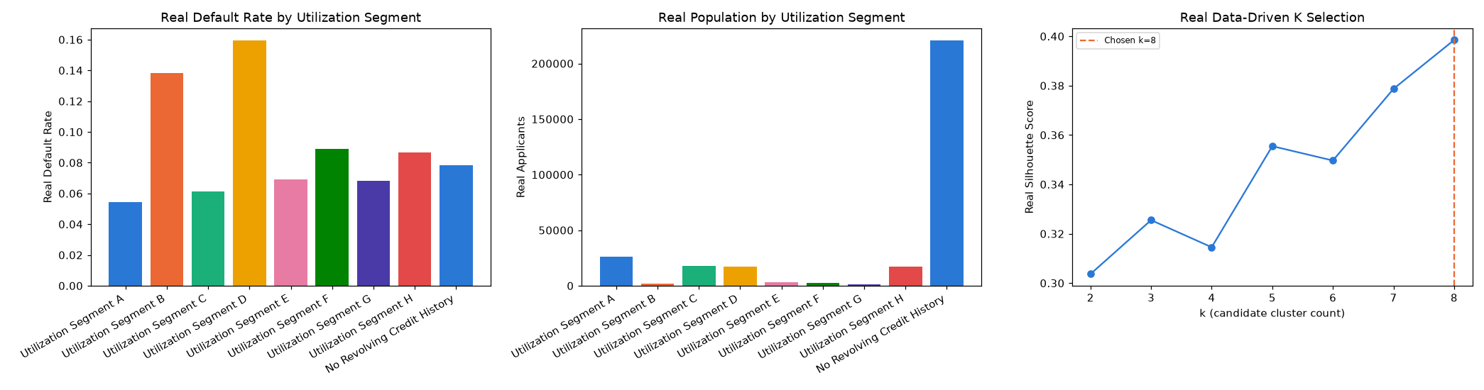
Insight — Real default rate spans 5.4% to 15.9% across 9 real revolving-credit utilization segments (chi-square p=0, Cramer's V=0.0789, 95% bootstrap CI [0.0746, 0.0835]).
Cross-check against Problem 1's Risk Tier: Cramer's V=0.0998; against Problem 2's Bureau Segment: Cramer's V=0.0448; against Problem 3's Repayment Segment: Cramer's V=0.0991.

