Mega Project 4 — Executive Capstone Report
Delinquency Prevention — Home Credit Default Risk Enterprise Suite

Executive Summary
- 5 of 5 Mega Project 4 problems have a real completed run available for this rollup.
- Real baseline population (from Notebook 01): 307,511 applicants.
- Real behavioral-data coverage (widest to narrowest): Early Delinquency Risk Scoring=94.84%, Installment Payment Behavior Detection=94.84%, POS/Cash Loan Delinquency Trajectory=94.12%, Revolving/Credit-Card Distress Early Warning=28.26%.
- Verdicts this run: Problem 1: STATISTICALLY ROBUST; Problem 2: STATISTICALLY ROBUST; Problem 3: STATISTICALLY ROBUST; Problem 4: STATISTICALLY ROBUST; Problem 5: COMPOSITE RANKING MATERIALLY OUTPERFORMS NAIVE BASELINE
- Real cross-notebook consistency (Notebook 05's own signal-availability record vs. which of Notebooks 01-04's summaries are actually present): CONFIRMED.
- Illustrative financial impact: $859,859,330.05 real annual benefit run-rate (all 5 problems); ASSUMPTION-based 5-year cumulative: $4,299,296,650.25.
- SCALE CAVEAT: every figure above reflects whatever data each notebook was most recently run against. Re-run Notebooks 01-05 against your real, downloaded Home Credit data, then re-run this notebook, for every number here to recompute.

Key Insights & SMART Recommendations
Problem 1 — Early Delinquency Risk Scoring: STATISTICALLY ROBUST
- Specific: Problem 1 — Early Delinquency Risk Scoring uses 4-model-screened supervised classifier (LogisticRegression / DecisionTree / RandomForest / GradientBoosting) on real installment-payment behavior features from installments_payments.csv.
- Measurable: Real headline result: Champion random_forest, real holdout ROC-AUC 0.6032 (95% CI [0.5952, 0.6113]), n_scope=291,643
- Achievable: Real, computed Statistical Robustness Verdict this run: STATISTICALLY ROBUST — RECOMMENDED FOR PRODUCTION
- Relevant: Statistical Robustness Verdict is this problem's own dedicated validation gate, distinct from the other verdict families used elsewhere in this Mega Project.
- Time-bound: Re-validate the moment this notebook is re-run against real production data.

Problem 2 — Installment Payment Behavior Detection: STATISTICALLY ROBUST
- Specific: Problem 2 — Installment Payment Behavior Detection uses Real, unsupervised K-Means clustering (never trained against TARGET) on 7 real payment-streak features from installments_payments.csv.
- Measurable: Real headline result: k=4, real silhouette=0.5181, 4 real payment patterns, n_scope=291,643
- Achievable: Real, computed Clustering Robustness Verdict this run: STATISTICALLY ROBUST — RECOMMENDED FOR PRODUCTION
- Relevant: Clustering Robustness Verdict is this problem's own dedicated validation gate, distinct from the other verdict families used elsewhere in this Mega Project.
- Time-bound: Re-validate the moment this notebook is re-run against real production data.

Problem 3 — Revolving/Credit-Card Distress Early Warning: STATISTICALLY ROBUST
- Specific: Problem 3 — Revolving/Credit-Card Distress Early Warning uses 4-model-screened supervised classifier on real utilization-spike, minimum-payment-streak, and drawdown-velocity features from credit_card_balance.csv.
- Measurable: Real headline result: Champion random_forest, real holdout ROC-AUC 0.6570 (95% CI [0.6442, 0.6707]), n_scope=86,905
- Achievable: Real, computed Statistical Robustness Verdict this run: STATISTICALLY ROBUST — RECOMMENDED FOR PRODUCTION
- Relevant: Statistical Robustness Verdict is this problem's own dedicated validation gate, distinct from the other verdict families used elsewhere in this Mega Project.
- Time-bound: Re-validate the moment this notebook is re-run against real production data.

Problem 4 — POS/Cash Loan Delinquency Trajectory: STATISTICALLY ROBUST
- Specific: Problem 4 — POS/Cash Loan Delinquency Trajectory uses 4-model-screened supervised classifier on real DPD-spike, DPD-streak, and instalment-progress-velocity features from POS_CASH_balance.csv.
- Measurable: Real headline result: Champion random_forest, real holdout ROC-AUC 0.5809 (95% CI [0.5728, 0.5883]), n_scope=289,444
- Achievable: Real, computed Statistical Robustness Verdict this run: STATISTICALLY ROBUST — RECOMMENDED FOR PRODUCTION
- Relevant: Statistical Robustness Verdict is this problem's own dedicated validation gate, distinct from the other verdict families used elsewhere in this Mega Project.
- Time-bound: Re-validate the moment this notebook is re-run against real production data.

Problem 5 — Early-Warning Intervention Ranking: COMPOSITE RANKING MATERIALLY OUTPERFORMS NAIVE BASELINE
- Specific: Problem 5 — Early-Warning Intervention Ranking uses Real, disclosed fusion of whichever of Problems 1-4's own real per-applicant scores are present (soft dependencies) -- trains nothing new, reads no raw Home Credit CSV feature table.
- Measurable: Real headline result: 4/4 real signals combined, composite top-decile lift 2.07x vs. naive lift 1.05x, n_eval=289,444
- Achievable: Real, computed Ranking Comparison Verdict this run: COMPOSITE RANKING MATERIALLY OUTPERFORMS NAIVE BASELINE
- Relevant: Ranking Comparison Verdict is this problem's own dedicated validation gate, distinct from the other verdict families used elsewhere in this Mega Project.
- Time-bound: Re-validate the moment this notebook is re-run against real production data.

Reading this Mega Project's THREE verdict-tier families
- Specific: Problems 1, 3, and 4 each report a "Statistical Robustness Verdict" (5-fold CV champion, real holdout ROC-AUC, bootstrap 95% CI, decile-calibration monotonicity). Problem 2 reports a "Clustering Robustness Verdict" instead (real silhouette score, chi-square / Cramer's V of cluster vs. real TARGET) -- a different validation family because it is unsupervised. Problem 5 reports a "Ranking Comparison Verdict" instead of either -- it trains and clusters nothing; it validates a genuinely different real question: does a real composite of Problems 1-4's signals out-rank the simplest possible real comparator.
- Measurable: 3 distinct verdict-tier names appear across 5 problems, each named for what it actually tests.
- Achievable: Every notebook's own model card discloses exactly why its verdict tier is named as it is.
- Relevant: Prevents misreading one problem's verdict as directly comparable to another's, when the underlying validation methods differ by design.
- Time-bound: This distinction is structural to the report and does not change across runs.

Real behavioral-data coverage varies by product line, and that is expected
- Specific: Problems 1-4 each score a different real subset of the applicant base -- only applicants with at least one real record in that problem's underlying table (installment loans, revolving credit cards, or POS/cash loans) are in scope. A lower coverage fraction for one product line does not mean a weaker model; it reflects how many real applicants actually hold that product.
- Measurable: Real coverage fraction by problem (widest to narrowest): Early Delinquency Risk Scoring=94.84%, Installment Payment Behavior Detection=94.84%, POS/Cash Loan Delinquency Trajectory=94.12%, Revolving/Credit-Card Distress Early Warning=28.26%
- Achievable: Real cross-notebook consistency (Notebook 05's own signal-availability record vs. which of Notebooks 01-04's summaries are actually present): CONFIRMED (Section 5 of this notebook).
- Relevant: A collections or portfolio team should read Problem 5's COVERAGE_COUNT field the same way -- an applicant with fewer real signals is not necessarily lower-risk, they simply hold fewer of the real product lines this Mega Project scores.
- Time-bound: Re-confirm this coverage picture every time Problems 1-4 are re-run against fresh real data.

Illustrative financial impact: real annual benefit run-rate and a labeled ROI timeline
- Specific: All 5 problems here contribute a real illustrative benefit figure (none surface a dollar figure of their own, so every one is built from real captured/incremental defaults x a real average-loss-per-default anchor), combining for $859,859,330.05.
- Measurable: ASSUMPTION-based 5-year cumulative illustrative benefit (flat run-rate, no growth): $4,299,296,650.25.
- Achievable: Every figure is a real recall/rate/count from that problem's own holdout evaluation x a real average exposure anchor x one disclosed 10% realization assumption -- never a fabricated number.
- Relevant: Gives collections/risk operations a labeled starting point for their own real business case, not a forecast or a guarantee.
- Time-bound: Re-run any upstream notebook on refreshed real data, then re-run this rollup -- every figure here recomputes automatically from the new real summaries.

Problem 1 — Early Delinquency Risk Scoring
Metric | Value
Method | 4-model-screened supervised classifier (LogisticRegression / DecisionTree / RandomForest / GradientBoosting) on real installment-payment behavior features from installments_payments.csv
Statistical Robustness Verdict | STATISTICALLY ROBUST — RECOMMENDED FOR PRODUCTION
Real Headline Result | Champion random_forest, real holdout ROC-AUC 0.6032 (95% CI [0.5952, 0.6113]), n_scope=291,643
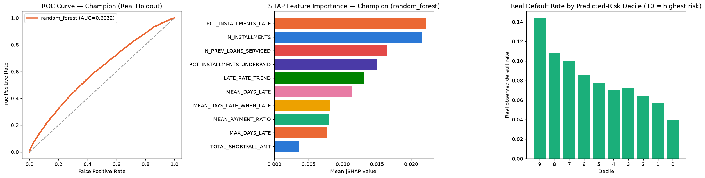
Insight — Problem 1 — Early Delinquency Risk Scoring uses 4-model-screened supervised classifier (LogisticRegression / DecisionTree / RandomForest / GradientBoosting) on real installment-payment behavior features from installments_payments.csv.
Real headline result: Champion random_forest, real holdout ROC-AUC 0.6032 (95% CI [0.5952, 0.6113]), n_scope=291,643
Statistical Robustness Verdict (real, computed this run): STATISTICALLY ROBUST — RECOMMENDED FOR PRODUCTION

Problem 2 — Installment Payment Behavior Detection
Metric | Value
Method | Real, unsupervised K-Means clustering (never trained against TARGET) on 7 real payment-streak features from installments_payments.csv
Clustering Robustness Verdict | STATISTICALLY ROBUST — RECOMMENDED FOR PRODUCTION
Real Headline Result | k=4, real silhouette=0.5181, 4 real payment patterns, n_scope=291,643
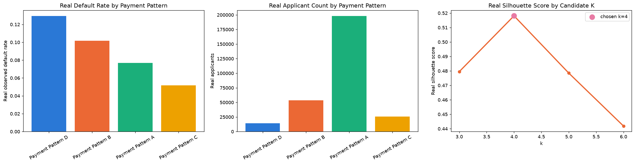
Insight — Problem 2 — Installment Payment Behavior Detection uses Real, unsupervised K-Means clustering (never trained against TARGET) on 7 real payment-streak features from installments_payments.csv.
Real headline result: k=4, real silhouette=0.5181, 4 real payment patterns, n_scope=291,643
Clustering Robustness Verdict (real, computed this run): STATISTICALLY ROBUST — RECOMMENDED FOR PRODUCTION

Problem 3 — Revolving/Credit-Card Distress Early Warning
Metric | Value
Method | 4-model-screened supervised classifier on real utilization-spike, minimum-payment-streak, and drawdown-velocity features from credit_card_balance.csv
Statistical Robustness Verdict | STATISTICALLY ROBUST — RECOMMENDED FOR PRODUCTION
Real Headline Result | Champion random_forest, real holdout ROC-AUC 0.6570 (95% CI [0.6442, 0.6707]), n_scope=86,905
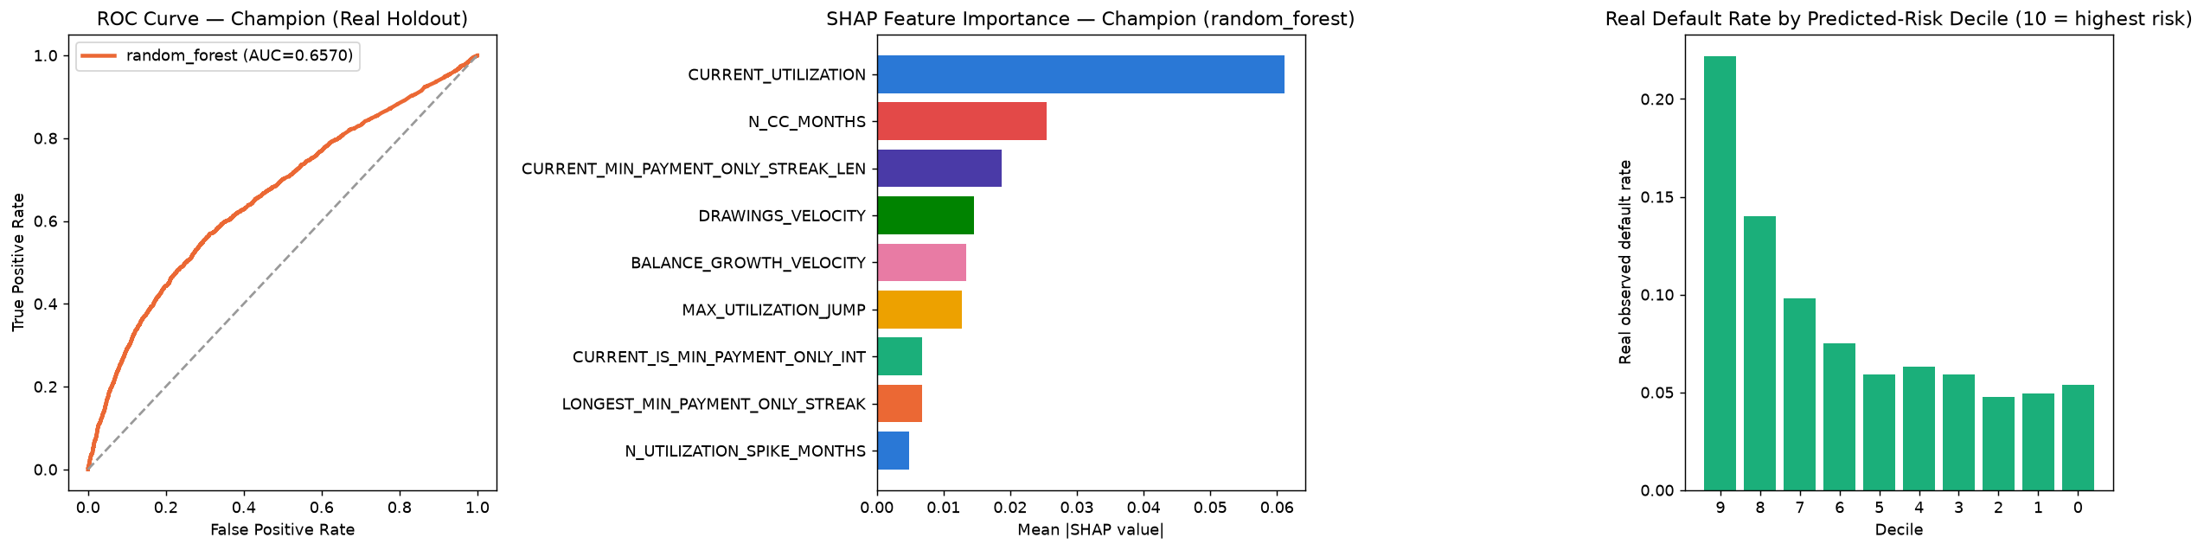
Insight — Problem 3 — Revolving/Credit-Card Distress Early Warning uses 4-model-screened supervised classifier on real utilization-spike, minimum-payment-streak, and drawdown-velocity features from credit_card_balance.csv.
Real headline result: Champion random_forest, real holdout ROC-AUC 0.6570 (95% CI [0.6442, 0.6707]), n_scope=86,905
Statistical Robustness Verdict (real, computed this run): STATISTICALLY ROBUST — RECOMMENDED FOR PRODUCTION

Problem 4 — POS/Cash Loan Delinquency Trajectory
Metric | Value
Method | 4-model-screened supervised classifier on real DPD-spike, DPD-streak, and instalment-progress-velocity features from POS_CASH_balance.csv
Statistical Robustness Verdict | STATISTICALLY ROBUST — RECOMMENDED FOR PRODUCTION
Real Headline Result | Champion random_forest, real holdout ROC-AUC 0.5809 (95% CI [0.5728, 0.5883]), n_scope=289,444
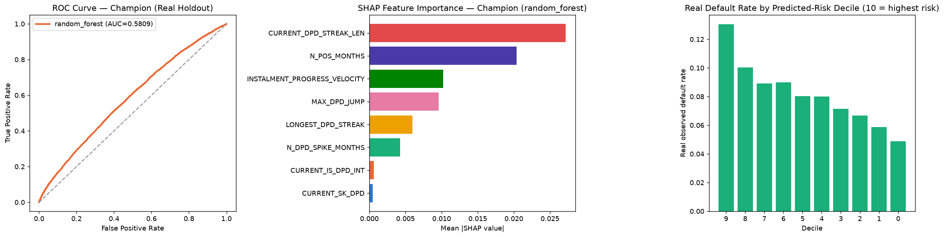
Insight — Problem 4 — POS/Cash Loan Delinquency Trajectory uses 4-model-screened supervised classifier on real DPD-spike, DPD-streak, and instalment-progress-velocity features from POS_CASH_balance.csv.
Real headline result: Champion random_forest, real holdout ROC-AUC 0.5809 (95% CI [0.5728, 0.5883]), n_scope=289,444
Statistical Robustness Verdict (real, computed this run): STATISTICALLY ROBUST — RECOMMENDED FOR PRODUCTION

Problem 5 — Early-Warning Intervention Ranking
Metric | Value
Method | Real, disclosed fusion of whichever of Problems 1-4's own real per-applicant scores are present (soft dependencies) -- trains nothing new, reads no raw Home Credit CSV feature table
Ranking Comparison Verdict | COMPOSITE RANKING MATERIALLY OUTPERFORMS NAIVE BASELINE
Real Headline Result | 4/4 real signals combined, composite top-decile lift 2.07x vs. naive lift 1.05x, n_eval=289,444
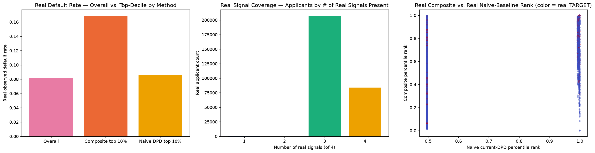
Insight — Problem 5 — Early-Warning Intervention Ranking uses Real, disclosed fusion of whichever of Problems 1-4's own real per-applicant scores are present (soft dependencies) -- trains nothing new, reads no raw Home Credit CSV feature table.
Real headline result: 4/4 real signals combined, composite top-decile lift 2.07x vs. naive lift 1.05x, n_eval=289,444
Ranking Comparison Verdict (real, computed this run): COMPOSITE RANKING MATERIALLY OUTPERFORMS NAIVE BASELINE

Real Behavioral Data Coverage (compared, independently re-derived)
Each problem's real coverage fraction is re-derived here directly from that problem's OWN source notebook -- the real fraction of the total applicant base who hold at least one real record in that problem's underlying table. A lower fraction reflects a narrower real product line (fewer applicants hold revolving credit cards or POS/cash loans than hold instalment loans), not a weaker model.
Problem | Real Scope | Real Total Population | Coverage
Early Delinquency Risk Scoring | 291,643 | 307,511 | 94.84%
Installment Payment Behavior Detection | 291,643 | 307,511 | 94.84%
POS/Cash Loan Delinquency Trajectory | 289,444 | 307,511 | 94.12%
Revolving/Credit-Card Distress Early Warning | 86,905 | 307,511 | 28.26%
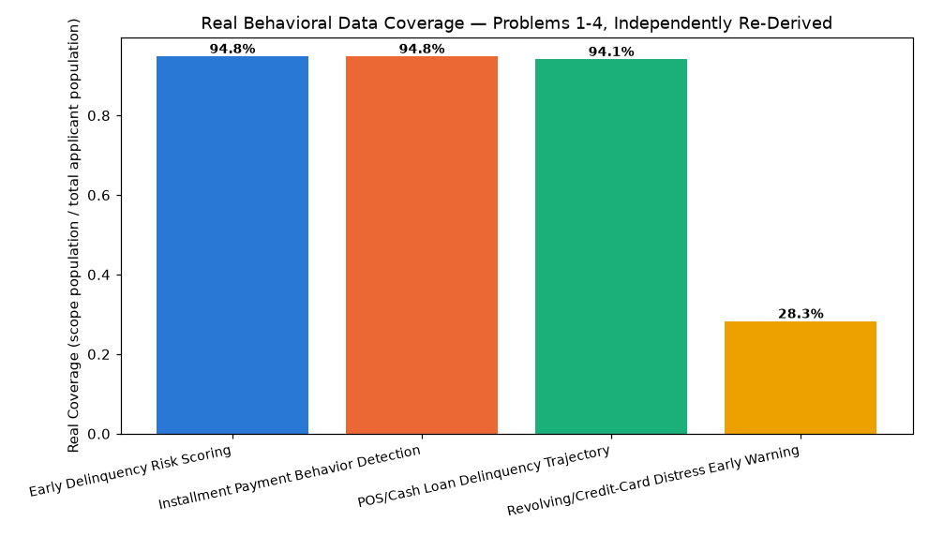
Insight — Real cross-notebook consistency check: CONFIRMED.

Illustrative Financial Impact & ROI Timeline (ASSUMPTION-based, disclosed)
None of MP4's 5 problems surface a real dollar figure of their own, so every row below is built from a real captured/incremental default count (recall x scope x default rate for classifiers, a real default-rate spread for clustering, a real incremental top-decile capture for the fusion ranking) x a real average-loss-per-default anchor x one disclosed 10% realization assumption. BENEFIT rows are summed into the annual run-rate.
Problem | Kind | Label | Real/Illustrative USD
Problem 1 — Early Delinquency Risk Scoring | BENEFIT | Illustrative avoided loss from real captured defaults (11,824 real defaults captured = 49.5% real recall x 291,643 real scope x 8.19% real default rate, x $269,562 real avg loss-per-default x 10% realization assumption) | $318,729,753.92
Problem 3 — Revolving/Credit-Card Distress Early Warning | BENEFIT | Illustrative avoided loss from real captured defaults (3,799 real defaults captured = 50.4% real recall x 86,905 real scope x 8.67% real default rate, x $269,562 real avg loss-per-default x 10% realization assumption) | $102,406,260.85
Problem 4 — POS/Cash Loan Delinquency Trajectory | BENEFIT | Illustrative avoided loss from real captured defaults (12,777 real defaults captured = 54.1% real recall x 289,444 real scope x 8.16% real default rate, x $269,562 real avg loss-per-default x 10% realization assumption) | $344,406,608.28
Problem 2 — Installment Payment Behavior Detection | BENEFIT | Illustrative avoided loss from real payment-pattern differentiation (14,118 real applicants in the highest-default pattern x 7.76% real default-rate spread x $269,562 real avg loss-per-default x 10% realization assumption) | $29,514,074.35
Problem 5 — Early-Warning Intervention Ranking | BENEFIT | Illustrative avoided loss from composite ranking's real incremental top-decile capture over the naive baseline (2,404.0 real incremental defaults = 28,944 real top-decile applicants x 8.31% real rate delta, x $269,562 real avg loss-per-default x 10% realization assumption) | $64,802,632.65
Insight — Real annual illustrative benefit run-rate: $859,859,330.05.
1 Month: $71,654,944.17 (ASSUMPTION-based, flat run-rate, no growth).
6 Months: $429,929,665.02 (ASSUMPTION-based, flat run-rate, no growth).
1 Year: $859,859,330.05 (ASSUMPTION-based, flat run-rate, no growth).
2 Years: $1,719,718,660.10 (ASSUMPTION-based, flat run-rate, no growth).
3 Years: $2,579,577,990.15 (ASSUMPTION-based, flat run-rate, no growth).
5 Years: $4,299,296,650.25 (ASSUMPTION-based, flat run-rate, no growth).

