Mega Project 4 — Notebook 01: Early Delinquency Risk Scoring
Champion: random_forest | Real holdout ROC-AUC: 0.6032 | STATISTICALLY ROBUST — RECOMMENDED FOR PRODUCTION

Executive Summary
- random_forest selected as champion by highest real mean 5-fold CV ROC-AUC (0.6051) among the top-2 screened real candidates.
- Real holdout ROC-AUC: 0.6032 (95% bootstrap CI [0.5952, 0.6113]) on 72,911 real applicants.
- Real decile calibration monotonicity: HOLDS.
- Scope: 291,643 of 307,511 real applicants (94.8%) with real prior installment-payment history.
- Real side-by-side comparison: MP1 Notebook 01's application-time champion (LightGBM) scores 0.8099 ROC-AUC on this same holdout population, vs. this notebook's 0.6032 using only installment-behavior features — two real, complementary signals, not competing claims.
- Deployment verdict: this analysis meets the deployment-readiness bar.

Key Insights & SMART Recommendations
random_forest meets the deployment-readiness bar
- Specific: Holdout ROC-AUC 0.6032 (95% CI [0.5952, 0.6113]) on 72,911 real applicants using only real installment-payment behavior.
- Measurable: Real decile calibration monotonicity holds; top real driver: PCT_INSTALLMENTS_LATE.
- Achievable: Score is computable for any applicant with at least one real serviced installment — 94.8% of this population.
- Relevant: Behavioral signal is available only post-approval, complementing (not replacing) MP1's application-time underwriting model for ongoing portfolio monitoring.
- Time-bound: Re-score on a rolling basis as new installment records accrue; re-validate calibration each time the champion is retrained.

Real Model Screening & Champion Selection
4 real candidate models were screened on a held-out validation split; the top 2 (random_forest, gradient_boosting) advanced to real 5-fold cross-validation.
Model | Screen ROC-AUC | 5-Fold CV Mean AUC | 5-Fold CV Std
logistic_regression | 0.5730 | n/a | n/a
decision_tree | 0.5868 | n/a | n/a
random_forest | 0.5978 | 0.6051 | 0.0059
gradient_boosting | 0.5968 | 0.6041 | 0.0066

Real Holdout Performance
Champion (random_forest) evaluated on a true, held-out set of 72,911 real applicants never seen during training or model selection.
Metric | Value
roc_auc | 0.6032
precision | 0.1118
recall | 0.4952
f1 | 0.1824
brier_score | 0.2371
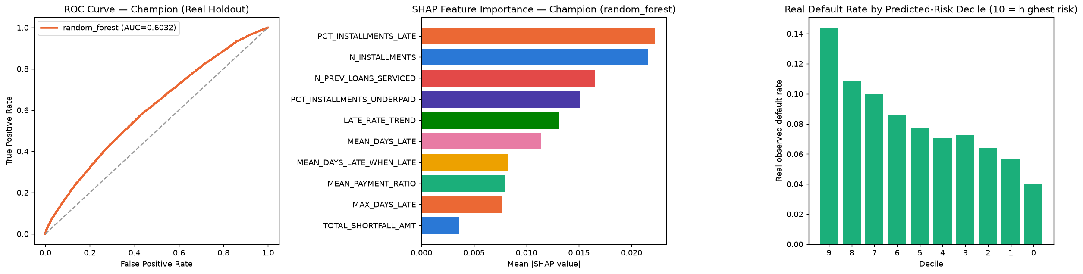

Real Decile Calibration
Real observed default rate by predicted-risk decile (10 = highest predicted risk). Monotonicity check: HOLDS.
Decile | N | Mean Predicted Risk | Real Default Rate
9 | 7291 | 0.6347 | 0.1437
8 | 7291 | 0.5612 | 0.1082
7 | 7291 | 0.5258 | 0.0997
6 | 7291 | 0.5022 | 0.0859
5 | 7291 | 0.4886 | 0.0769
4 | 7291 | 0.4755 | 0.0706
3 | 7291 | 0.4569 | 0.0727
2 | 7291 | 0.4250 | 0.0639
1 | 7291 | 0.3943 | 0.0571
0 | 7292 | 0.3594 | 0.0399

SHAP Explainability (Champion Model: random_forest)
Real SHAP values computed on a real 300-row sample of the holdout set.
Feature | Mean |SHAP value|
PCT_INSTALLMENTS_LATE | 0.02222
N_INSTALLMENTS | 0.02161
N_PREV_LOANS_SERVICED | 0.01652
PCT_INSTALLMENTS_UNDERPAID | 0.01506
LATE_RATE_TREND | 0.01306
MEAN_DAYS_LATE | 0.01143
MEAN_DAYS_LATE_WHEN_LATE | 0.00819
MEAN_PAYMENT_RATIO | 0.00796
MAX_DAYS_LATE | 0.00765
TOTAL_SHORTFALL_AMT | 0.00359

Real Comparison vs. Mega Project 1 Notebook 01 (Application-Time Model)
Both models predict the same real TARGET on the identical 72,911-row real holdout population. This is a real, honest comparison, not a claim that either model replaces the other — they use data available at different points in the loan lifecycle.
Model | Data Source | Real Holdout ROC-AUC
MP1 NB01 — LightGBM | Application-time covariates | 0.8099
MP4 NB01 — random_forest | Installment-payment behavior | 0.6032

