Mega Project 4 — Notebook 02: Installment Payment Behavior Detection
4 real payment patterns | silhouette=0.5181 | STATISTICALLY ROBUST — RECOMMENDED FOR PRODUCTION

Executive Summary
- 4 real, data-driven payment patterns found via K-Means clustering on real installment streak features (silhouette=0.5181), chosen from candidates k=3-7.
- Real chi-square test: Payment Pattern vs. real TARGET is statistically significant (p=6.368e-234), Cramer's V=0.0609 (95% CI [0.0572, 0.0645]).
- Scope: 291,643 of 307,511 real applicants (94.8%) with real prior installment-payment history.
- Real cross-check against Notebook 01's continuous risk score: ANOVA F=41562.02 (p=0), eta-squared=0.2995 — honest evidence of how related the two real, independently-derived outputs are.
- Statistical robustness verdict: STATISTICALLY ROBUST — RECOMMENDED FOR PRODUCTION.

Real K Selection (Data-Driven, Not Fixed)
K is chosen by the highest real silhouette score among candidates k=3-7 where every real resulting cluster meets the minimum stable size (8,749 applicants, 3.0% of scope).
k | Real Silhouette Score
3 | 0.4795
4 | 0.5181
5 | 0.4785
6 | 0.4419
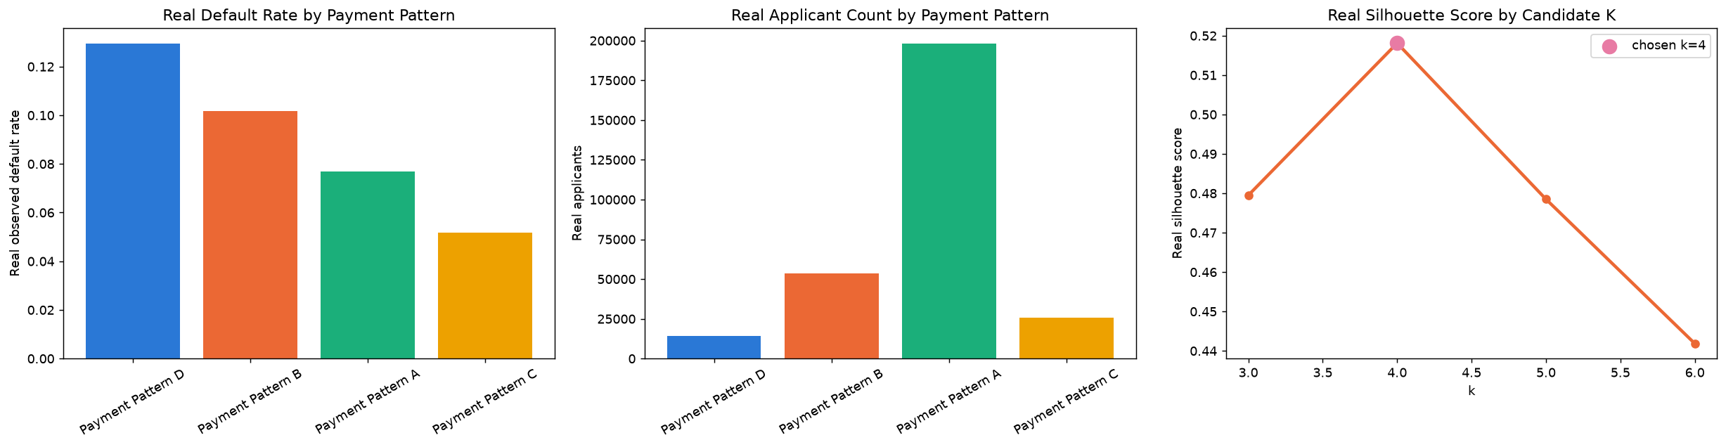

Real Payment Pattern Profiles
Ordered by real observed default rate (descriptive labeling only — clustering itself never used real TARGET).
Pattern | N Applicants | Real Default Rate | % Currently in Late Streak | Mean Current Streak Length
Payment Pattern D | 14118 | 0.1293 | 100.0% | 1.64
Payment Pattern B | 53781 | 0.1018 | 0.1% | 9.89
Payment Pattern A | 197926 | 0.0770 | 0.0% | 14.95
Payment Pattern C | 25818 | 0.0518 | 0.0% | 77.63

Real Statistical Validation
Chi-square: chi2=1080.44, dof=3, p=6.368e-234. Cramer's V=0.0609, real 500-resample bootstrap 95% CI [0.0572, 0.0645].

Real Cross-Check vs. Notebook 01's Continuous Risk Score
One-way ANOVA of Notebook 01's real, continuous early-delinquency-risk score across this notebook's 4 real payment patterns — reported honestly as evidence of relatedness, not gated pass/fail.
Statistic | Value
F-statistic | 41562.0215
p-value | 0
eta-squared | 0.2995

