Mega Project 4 — Notebook 03: Revolving/Credit-Card Distress Early Warning
Champion: random_forest | Real holdout ROC-AUC: 0.6570 | STATISTICALLY ROBUST — RECOMMENDED FOR PRODUCTION

Executive Summary
- random_forest selected as champion by highest real mean 5-fold CV ROC-AUC (0.6475) among the top-2 screened real candidates.
- Real holdout ROC-AUC: 0.6570 (95% bootstrap CI [0.6442, 0.6707]) on 21,727 real applicants.
- Real decile calibration monotonicity: HOLDS.
- Scope: 86,905 of 307,511 real applicants (28.3%) with real prior revolving/credit-card history.
- Real comparison vs. MP1 Notebook 01 (application-time, LightGBM): 0.8227 ROC-AUC on this same holdout population, vs. this notebook's 0.6570 using only revolving-credit distress-trajectory features.
- Real comparison vs. MP4 Notebook 01 (installment-payment behavior): 0.6634 ROC-AUC on the 21,671 real applicants both notebooks' scopes share.
- Deployment verdict: this analysis meets the deployment-readiness bar.

Key Insights & SMART Recommendations
random_forest meets the deployment-readiness bar
- Specific: Holdout ROC-AUC 0.6570 (95% CI [0.6442, 0.6707]) on 21,727 real applicants using only real revolving-credit distress trajectory features.
- Measurable: Real decile calibration monotonicity holds; top real driver: CURRENT_UTILIZATION.
- Achievable: Score is computable for any applicant with at least one real prior revolving/credit-card loan -- 28.3% of this population.
- Relevant: Trajectory signal (spikes/streaks/velocity) is available only post-approval, complementing MP1's application-time model and MP4 Notebook 01's installment-behavior model for ongoing portfolio monitoring.
- Time-bound: Re-score on a rolling basis as new credit_card_balance records accrue; re-validate calibration each time the champion is retrained.

Real Model Screening & Champion Selection
4 real candidate models were screened on a held-out validation split; the top 2 (random_forest, gradient_boosting) advanced to real 5-fold cross-validation.
Model | Screen ROC-AUC | 5-Fold CV Mean AUC | 5-Fold CV Std
logistic_regression | 0.5952 | n/a | n/a
decision_tree | 0.6378 | n/a | n/a
random_forest | 0.6609 | 0.6475 | 0.0124
gradient_boosting | 0.6558 | 0.6455 | 0.0116

Real Holdout Performance
Champion (random_forest) evaluated on a true, held-out set of 21,727 real applicants never seen during training or model selection.
Metric | Value
roc_auc | 0.6570
precision | 0.1572
recall | 0.5042
f1 | 0.2396
brier_score | 0.2175
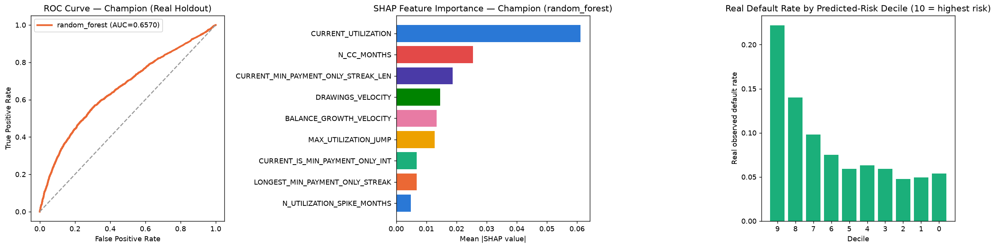

Real Decile Calibration
Real observed default rate by predicted-risk decile (10 = highest predicted risk). Monotonicity check: HOLDS.
Decile | N | Mean Predicted Risk | Real Default Rate
9 | 2173 | 0.7139 | 0.2218
8 | 2173 | 0.5955 | 0.1399
7 | 2172 | 0.5147 | 0.0981
6 | 2173 | 0.4622 | 0.0750
5 | 2172 | 0.4213 | 0.0589
4 | 2173 | 0.3994 | 0.0630
3 | 2147 | 0.3816 | 0.0592
2 | 1934 | 0.3736 | 0.0476
1 | 2407 | 0.3697 | 0.0494
0 | 2203 | 0.3386 | 0.0540

SHAP Explainability (Champion Model: random_forest)
Real SHAP values computed on a real 300-row sample of the holdout set.
Feature | Mean |SHAP value|
CURRENT_UTILIZATION | 0.06116
N_CC_MONTHS | 0.02546
CURRENT_MIN_PAYMENT_ONLY_STREAK_LEN | 0.01874
DRAWINGS_VELOCITY | 0.01455
BALANCE_GROWTH_VELOCITY | 0.01345
MAX_UTILIZATION_JUMP | 0.01276
CURRENT_IS_MIN_PAYMENT_ONLY_INT | 0.00677
LONGEST_MIN_PAYMENT_ONLY_STREAK | 0.00673
N_UTILIZATION_SPIKE_MONTHS | 0.00488

Real Comparison vs. Other Real Champion Models
Real, honest AUC comparisons on the applicable real holdout/overlap population(s) -- not a claim that any model replaces another; each uses data available at a different point in the loan lifecycle or from a different real data source.
Model | Data Source | Real ROC-AUC
MP4 NB03 — random_forest | Revolving/credit-card distress trajectory | 0.6570
MP1 NB01 — LightGBM | Application-time covariates | 0.8227
MP4 NB01 (on 21,671-row overlap) | Installment-payment behavior | 0.6634

