Mega Project 4 — Notebook 04: POS/Cash Loan Delinquency Trajectory
Champion: random_forest | Real holdout ROC-AUC: 0.5809 | STATISTICALLY ROBUST — RECOMMENDED FOR PRODUCTION

Executive Summary
- random_forest selected as champion by highest real mean 5-fold CV ROC-AUC (0.5779) among the top-2 screened real candidates.
- Real holdout ROC-AUC: 0.5809 (95% bootstrap CI [0.5728, 0.5883]) on 72,361 real applicants.
- Real decile calibration monotonicity: HOLDS.
- Scope: 289,444 of 307,511 real applicants (94.1%) with real prior POS/cash loan history.
- Real comparison vs. MP1 Notebook 01: 0.8146 ROC-AUC (application-time), vs. this notebook's 0.5809.
- Real comparison vs. MP4 Notebook 01: 0.6390 ROC-AUC on the 72,268-row real overlap.
- Real comparison vs. MP4 Notebook 03: 0.7025 ROC-AUC on the 21,181-row real overlap.
- Deployment verdict: this analysis meets the deployment-readiness bar.

Key Insights & SMART Recommendations
random_forest meets the deployment-readiness bar
- Specific: Holdout ROC-AUC 0.5809 (95% CI [0.5728, 0.5883]) on 72,361 real applicants using only real POS/cash DPD-trajectory features.
- Measurable: Real decile calibration monotonicity holds; top real driver: CURRENT_DPD_STREAK_LEN.
- Achievable: Score is computable for any applicant with at least one real prior POS/cash loan -- 94.1% of this population.
- Relevant: Trajectory signal (DPD spikes/streaks, progress velocity) is available only post-approval, complementing MP1, MP4 Notebook 01, and MP4 Notebook 03 for ongoing portfolio monitoring.
- Time-bound: Re-score on a rolling basis as new POS_CASH_balance records accrue; re-validate calibration each time the champion is retrained.

Real Model Screening & Champion Selection
4 real candidate models were screened on a held-out validation split; the top 2 (random_forest, gradient_boosting) advanced to real 5-fold cross-validation.
Model | Screen ROC-AUC | 5-Fold CV Mean AUC | 5-Fold CV Std
logistic_regression | 0.5701 | n/a | n/a
decision_tree | 0.5751 | n/a | n/a
random_forest | 0.5809 | 0.5779 | 0.0032
gradient_boosting | 0.5782 | 0.5766 | 0.0022

Real Holdout Performance
Champion (random_forest) evaluated on a true, held-out set of 72,361 real applicants never seen during training or model selection.
Metric | Value
roc_auc | 0.5809
precision | 0.1003
recall | 0.5409
f1 | 0.1692
brier_score | 0.2417
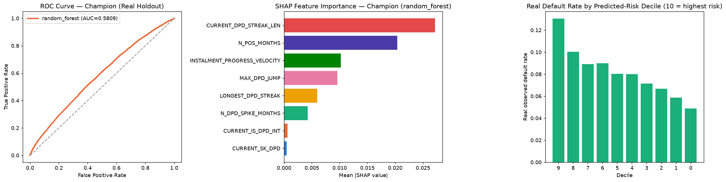

Real Decile Calibration
Real observed default rate by predicted-risk decile (10 = highest predicted risk). Monotonicity check: HOLDS.
Decile | N | Mean Predicted Risk | Real Default Rate
9 | 7236 | 0.6090 | 0.1305
8 | 7216 | 0.5442 | 0.1003
7 | 6958 | 0.5340 | 0.0891
6 | 7522 | 0.5228 | 0.0900
5 | 7208 | 0.4979 | 0.0803
4 | 7276 | 0.4741 | 0.0800
3 | 7234 | 0.4546 | 0.0715
2 | 7238 | 0.4391 | 0.0667
1 | 7236 | 0.4210 | 0.0587
0 | 7237 | 0.3888 | 0.0489

SHAP Explainability (Champion Model: random_forest)
Real SHAP values computed on a real 300-row sample of the holdout set.
Feature | Mean |SHAP value|
CURRENT_DPD_STREAK_LEN | 0.02718
N_POS_MONTHS | 0.02037
INSTALMENT_PROGRESS_VELOCITY | 0.01022
MAX_DPD_JUMP | 0.00958
LONGEST_DPD_STREAK | 0.00598
N_DPD_SPIKE_MONTHS | 0.00423
CURRENT_IS_DPD_INT | 0.00061
CURRENT_SK_DPD | 0.00049

Real Comparison vs. Other Real Champion Models
Real, honest AUC comparisons on the applicable real holdout/overlap population(s) -- not a claim that any model replaces another.
Model | Data Source | Real ROC-AUC
MP4 NB04 — random_forest | POS/cash DPD trajectory | 0.5809
MP1 NB01 — LightGBM | Application-time covariates | 0.8146
MP4 NB01 (on 72,268-row overlap) | Installment-payment behavior | 0.6390
MP4 NB03 (on 21,181-row overlap) | Revolving/credit-card distress | 0.7025

