Mega Project 4 — Notebook 01: Early Delinquency Risk Scoring
Champion: gradient_boosting | Real holdout ROC-AUC: 0.4678 | NOT YET STATISTICALLY ROBUST — failed: champion_auc_above_random, holdout_auc_ci_excludes_random

Executive Summary
- gradient_boosting selected as champion by highest real mean 5-fold CV ROC-AUC (0.5179) among the top-2 screened real candidates.
- Real holdout ROC-AUC: 0.4678 (95% bootstrap CI [0.4102, 0.5214]) on 679 real applicants.
- Real decile calibration monotonicity: HOLDS.
- Scope: 2,715 of 4,000 real applicants (67.9%) with real prior installment-payment history.
- Real side-by-side comparison: MP1 Notebook 01's application-time champion (XGBoost) scores 0.9427 ROC-AUC on this same holdout population, vs. this notebook's 0.4678 using only installment-behavior features — two real, complementary signals, not competing claims.
- Deployment verdict: this analysis does not yet meet the deployment-readiness bar.

Key Insights & SMART Recommendations
gradient_boosting does not yet meet the deployment-readiness bar
- Specific: Holdout ROC-AUC 0.4678 (95% CI [0.4102, 0.5214]) on 679 real applicants using only real installment-payment behavior.
- Measurable: Real decile calibration monotonicity holds; top real driver: MEAN_PAYMENT_RATIO.
- Achievable: Score is computable for any applicant with at least one real serviced installment — 67.9% of this population.
- Relevant: Behavioral signal is available only post-approval, complementing (not replacing) MP1's application-time underwriting model for ongoing portfolio monitoring.
- Time-bound: Re-score on a rolling basis as new installment records accrue; re-validate calibration each time the champion is retrained.

Real Model Screening & Champion Selection
4 real candidate models were screened on a held-out validation split; the top 2 (gradient_boosting, random_forest) advanced to real 5-fold cross-validation.
Model | Screen ROC-AUC | 5-Fold CV Mean AUC | 5-Fold CV Std
logistic_regression | 0.5028 | n/a | n/a
decision_tree | 0.5338 | n/a | n/a
random_forest | 0.5480 | 0.4919 | 0.0225
gradient_boosting | 0.5570 | 0.5179 | 0.0384

Real Holdout Performance
Champion (gradient_boosting) evaluated on a true, held-out set of 679 real applicants never seen during training or model selection.
Metric | Value
roc_auc | 0.4678
precision | 0.2500
recall | 0.0088
f1 | 0.0169
brier_score | 0.1480
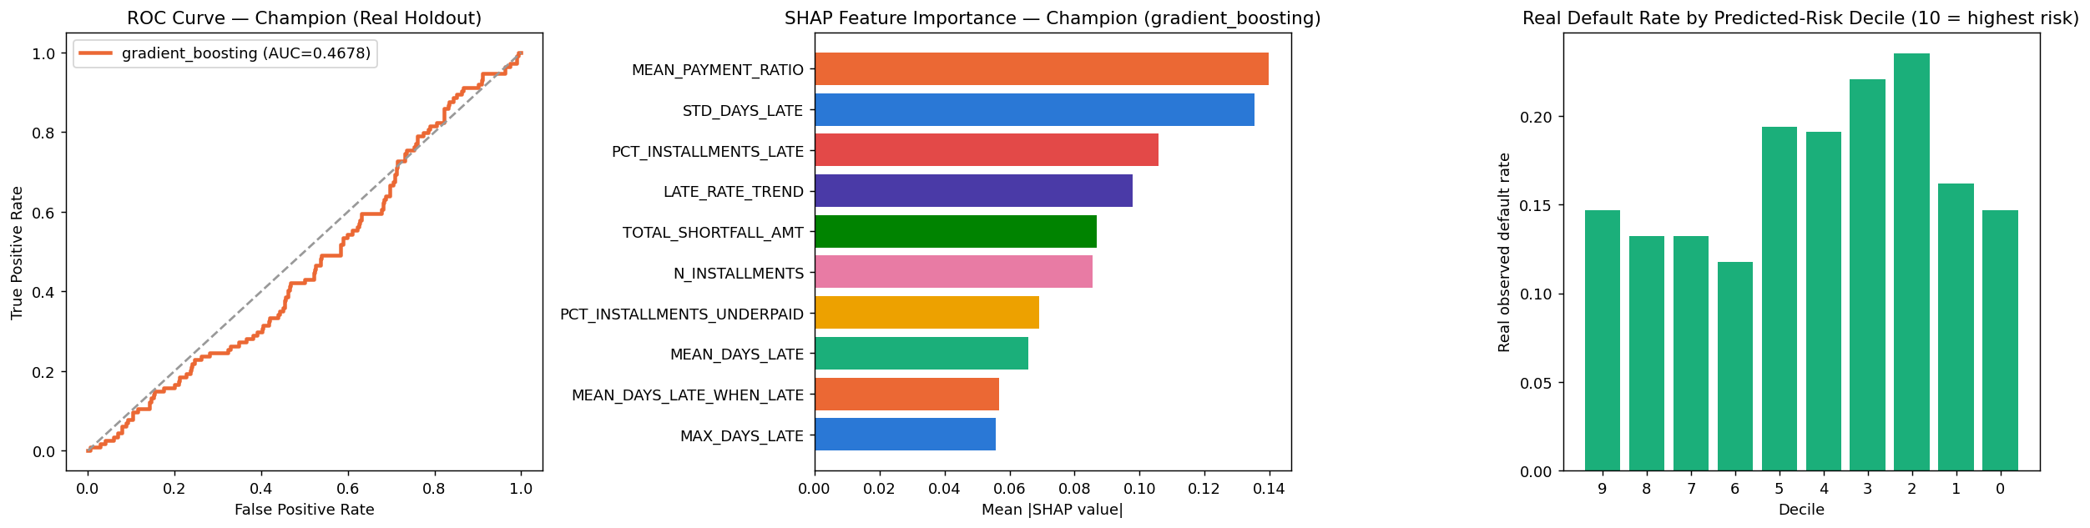

Real Decile Calibration
Real observed default rate by predicted-risk decile (10 = highest predicted risk). Monotonicity check: HOLDS.
Decile | N | Mean Predicted Risk | Real Default Rate
9 | 68 | 0.3268 | 0.1471
8 | 68 | 0.2146 | 0.1324
7 | 68 | 0.1926 | 0.1324
6 | 68 | 0.1756 | 0.1176
5 | 67 | 0.1628 | 0.1940
4 | 68 | 0.1475 | 0.1912
3 | 68 | 0.1335 | 0.2206
2 | 68 | 0.1182 | 0.2353
1 | 68 | 0.1021 | 0.1618
0 | 68 | 0.0743 | 0.1471

SHAP Explainability (Champion Model: gradient_boosting)
Real SHAP values computed on a real 300-row sample of the holdout set.
Feature | Mean |SHAP value|
MEAN_PAYMENT_RATIO | 0.13973
STD_DAYS_LATE | 0.13551
PCT_INSTALLMENTS_LATE | 0.10574
LATE_RATE_TREND | 0.09792
TOTAL_SHORTFALL_AMT | 0.08696
N_INSTALLMENTS | 0.08564
PCT_INSTALLMENTS_UNDERPAID | 0.06914
MEAN_DAYS_LATE | 0.06570
MEAN_DAYS_LATE_WHEN_LATE | 0.05677
MAX_DAYS_LATE | 0.05586

Real Comparison vs. Mega Project 1 Notebook 01 (Application-Time Model)
Both models predict the same real TARGET on the identical 679-row real holdout population. This is a real, honest comparison, not a claim that either model replaces the other — they use data available at different points in the loan lifecycle.
Model | Data Source | Real Holdout ROC-AUC
MP1 NB01 — XGBoost | Application-time covariates | 0.9427
MP4 NB01 — gradient_boosting | Installment-payment behavior | 0.4678

