Mega Project 4 — Notebook 02: Installment Payment Behavior Detection
5 real payment patterns | silhouette=0.2377 | NOT YET STATISTICALLY ROBUST — failed: chi_square_significant, cramers_v_ci_excludes_zero

Executive Summary
- 5 real, data-driven payment patterns found via K-Means clustering on real installment streak features (silhouette=0.2377), chosen from candidates k=3-7.
- Real chi-square test: Payment Pattern vs. real TARGET is not statistically significant (p=0.08474), Cramer's V=0.0549 (95% CI [0.0317, 0.0994]).
- Scope: 2,715 of 4,000 real applicants (67.9%) with real prior installment-payment history.
- Real cross-check against Notebook 01's continuous risk score: ANOVA F=19.52 (p=7.568e-16), eta-squared=0.0280 — honest evidence of how related the two real, independently-derived outputs are.
- Statistical robustness verdict: NOT YET STATISTICALLY ROBUST — failed: chi_square_significant, cramers_v_ci_excludes_zero.

Real K Selection (Data-Driven, Not Fixed)
K is chosen by the highest real silhouette score among candidates k=3-7 where every real resulting cluster meets the minimum stable size (81 applicants, 3.0% of scope).
k | Real Silhouette Score
3 | 0.1922
4 | 0.2226
5 | 0.2377
6 | 0.2250
7 | 0.2120
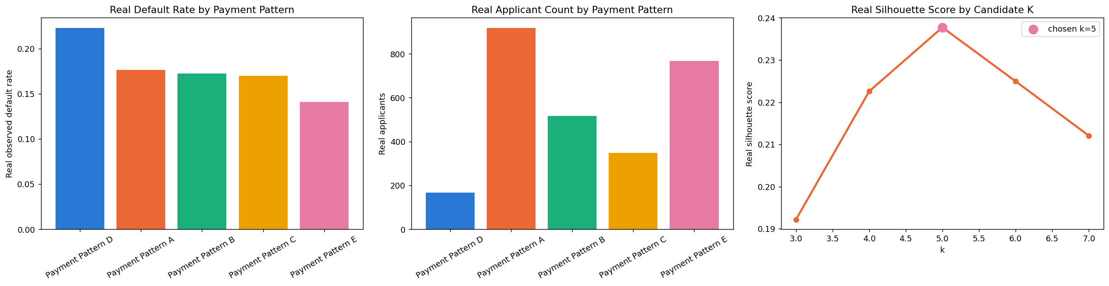

Real Payment Pattern Profiles
Ordered by real observed default rate (descriptive labeling only — clustering itself never used real TARGET).
Pattern | N Applicants | Real Default Rate | % Currently in Late Streak | Mean Current Streak Length
Payment Pattern D | 166 | 0.2229 | 19.3% | 2.61
Payment Pattern A | 918 | 0.1765 | 0.0% | 1.72
Payment Pattern B | 517 | 0.1721 | 38.9% | 1.89
Payment Pattern C | 347 | 0.1700 | 5.5% | 5.60
Payment Pattern E | 767 | 0.1408 | 100.0% | 1.54

Real Statistical Validation
Chi-square: chi2=8.19, dof=4, p=0.08474. Cramer's V=0.0549, real 500-resample bootstrap 95% CI [0.0317, 0.0994].

Real Cross-Check vs. Notebook 01's Continuous Risk Score
One-way ANOVA of Notebook 01's real, continuous early-delinquency-risk score across this notebook's 5 real payment patterns — reported honestly as evidence of relatedness, not gated pass/fail.
Statistic | Value
F-statistic | 19.5155
p-value | 7.56812e-16
eta-squared | 0.0280

