Top Level Design

PROJECT: Let’s Make a Coffee Shop COURSE: SOFTWARE ENGINEERING

NAME: R PRAGNESH REDDY NANDYALA DATE: 4/16/2016

SOFTWARE DESIGN

In designing the software following principles are followed:

1. Modularity and partitioning: software is designed such that, each system should consists

of hierarchy of modules and serve to partition into separate function.

2. Coupling: modules should have little dependence on other modules of a system.

3. Cohesion: modules should carry out in a single processing function.

4. Shared use: avoid duplication by allowing a single module be called by other that need

the function it provides.

3. System Features

Modules and functionalities:

3.1 Security and Accounts Module:

This security module plays a vital role. In this module the person Security is provided to Software Tester(Owner) through login id and password. Further, the (Software Tester)Owner can update their items whenever they want. So, this avoids access of unauthorized information.

• Login

• Logout

3.2 Admin Module:

Administrator plays a very vital role. In this module the Admin uploads the information

Login details, add items, search items, look particular items, sync New item, compute total cost .

The admin has all rights to perform manipulations on information.

• Adding/delete item

• Adding/delete new Employee Adding/delete items

3.3 Search and Help Requests module

• look for a particular in the system.

Here search for any item requests for any particular kind of item availability in

terms of product.

And then searching in the inventory for particular item

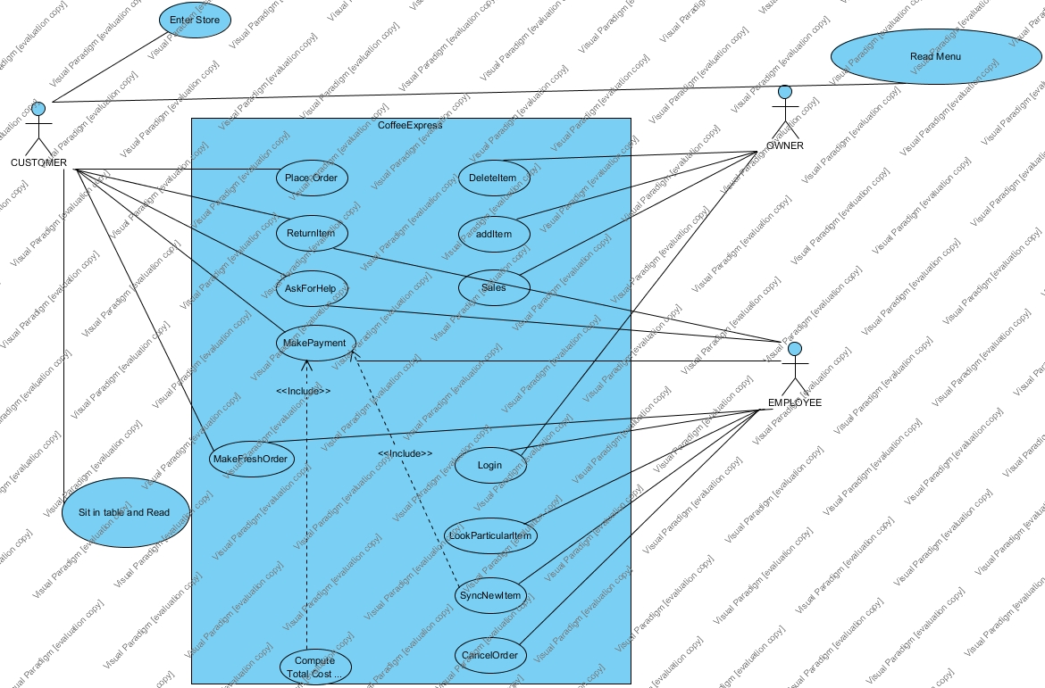

3.4 Module for Completing Transaction :

In this module, the Software Tester(Employee) can get the details of according to particular item

Through the item Id. They get the particular Id number for each item.

Through this module we can get the information of required item very easily.

By this the Software Tester can compute the transction.

• Login: Login to the Inventory.

• Look particular item ID:

After that Login Look for Particular Item in the inventory System.

Here the customer can easily contact with the (Software Tester)employee .

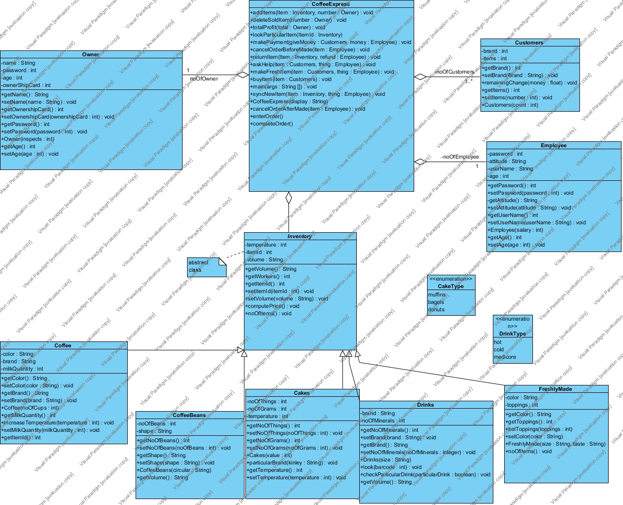

3.5 Owner , Employee and Customer

• Maintaining item Details like item Id number and status of item and color of item.

In this module we can compute the total profit through the transactions so this can help owner to have a look by owner without need to calculate the profit again.

Module provide the software tester to make a particular item by selecting the items like color, taste and size of the drink.

This module gives flexibility to cancel order before and after made.