Using Exploratory Data Analysis we are going to predict the values for the years 1965 and 1970 for food and tobbaco.

hist(Personal$F.T,main="Expenditure on Food and Tobbaco in United states",xlab="billion dollars",breaks=10,col="brown",ylim=c(0,2),border="yellow")

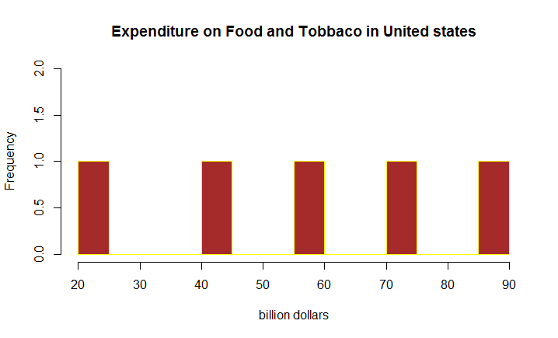

Here the target variable is food and tobbaco

Using Exploratory Data Analysis we are going to predict the values for the years 1965 and 1970 for medical and health.

hist(Personal$M.H,main="Expenditure on Medical and Health in United states",xlab="billion dollars",breaks=10,col="blue",ylim=c(0,2),xlim=c(1,25),border="green")

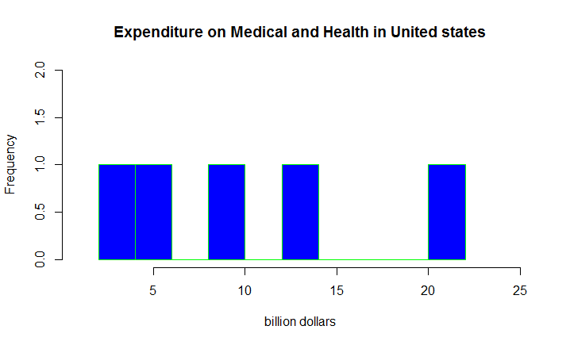

Here target variable is medical and health

Here we are going to compare the two variables in order to show the increment throughout the years.

plot(Personal[,2],type="s",Personal[,4],xlab="Food and Tobbaco in Billion$'s",ylab="Medical and health in Billion$'s",main="comparison of both variables from 5 years",col="dark red")

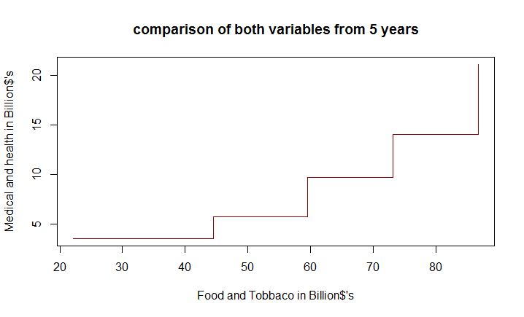

table preview: Represent the number of values

mytable<-table(Personal$F.T)

sum(mytable)

[1] 5

mytable<-table(Personal$M.H)

> sum(mytable)

[1] 5

This two codes represents the number of values present in food and tobbaco, medical and health.

|  |
| --- |
| summary(Personal$F.T)  Min. 1st Qu. Median Mean 3rd Qu. Max.  22.20 44.50 59.60 57.26 73.20 86.80  summary(Personal$M.H)  Min. 1st Qu. Median Mean 3rd Qu. Max.  3.53 5.76 9.71 10.82 14.00 21.10 |
| Problem statement:  What will be the value of food and tobbaco in the year 1975?   |  | | --- | | > sd(Personal$M.H)  [1] 6.995902  sd(Personal$F.T)  [1] 25.12067  Every where F.T and M.H represents food and tobbaco, Medical and health.  For food and tobbaco 1965=111.92  1970=137.04 | |  | | |  | | --- | |  | | |
| |  | | --- | |  | |