3.barplot(USPersonalExpenditure,legend=rownames(USPersonalExpenditure),col=c("red","orange","blue","yellow","lightblue"),main="Rise in Expenses",xlab="Years",ylab="billion$")
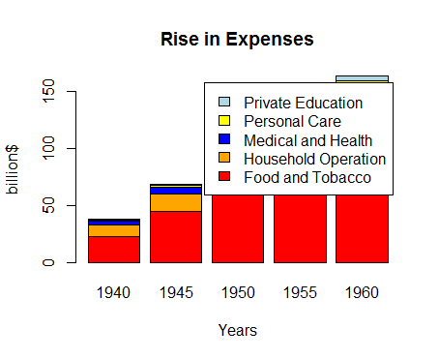
barplot(USPersonalExpenditure,col=c("red","orange","blue","yellow","lightblue"),main="Rise in Expenses",xlab="Years",ylab="billion$")