Map 10 with Eu

Map 10 with Manhattan

Map 8 with Manhattan

Map 8 with Eu

Map 2 with EU

Map 2 with Manhattan

Map 1 with EU

Map 1 with Manhattan

Map 1 DFS

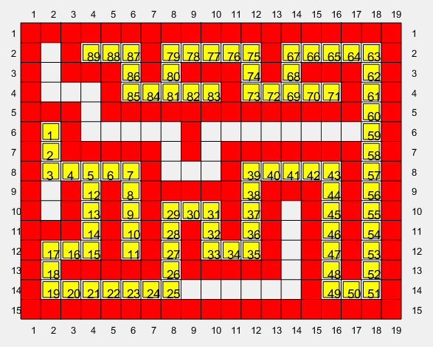

Map 8 dfs

Map 10 dfs

Map 2 dfs

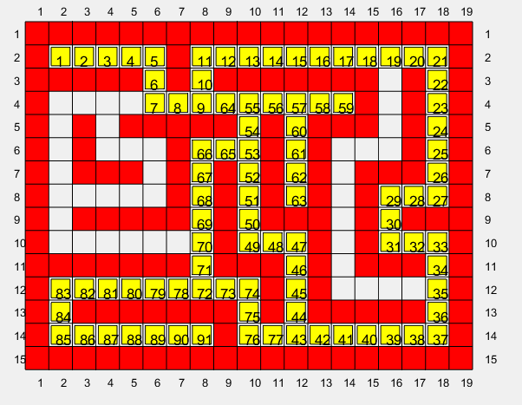

22/8/22 bug fix

Map 2 w/ Euclidean map 2 w/ Manhattan

