QUESTION 1

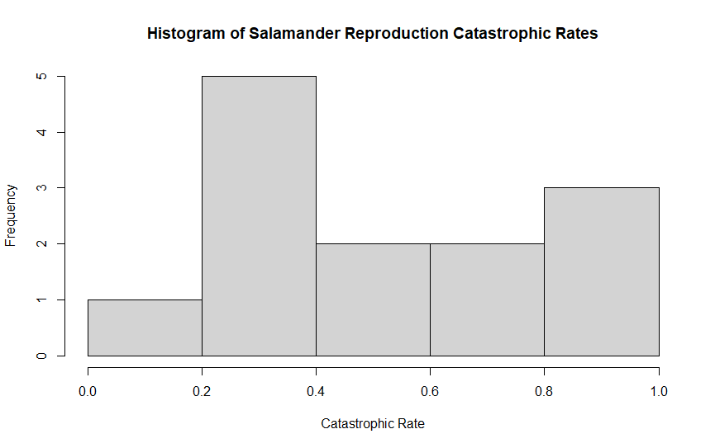

QUESTION 2

shapiro.test(catrate$cat.rate)

QUESTION 3

**Q1**

The null hypothesis for the Shapiro test is that the analyzed variable (in this case, the salamander catastrophic rates) is normally distributed.

**Q2**

The p-value obtained is 0.04097. Since the alpha value used for the Shapiro test is 0.05, and my p-value is less than the alpha value, we have enough evidence to reject the null hypothesis. Therefore, we can reject the hypothesis of our data of salamander catastrophic rates being normally distributed. So, yes, there is strong evidence that the sample came from a non-normally-distributed population.

QUESTION 4

**Q1**

The null hypothesis of the test is that the catastrophic rate is the same as the pond late-filling rate.

**Q2**

t.test(x = catrate$cat.rate, mu = 2/7)

QUESTION 5

**Q1**

p-value = 0.01193

**Q2**

The confidence interval goes from 0.3526250 to 0.7261295.

The confidence interval did not include zero since both endpoints were positive.

**Q3**

Yes, there is strong evidence to reject the null hypothesis because the p-value is less than 0.05. Also, since the null hypothesis means that the catastrophic rate is the same as the pond late-filling rate (0.2857143) and the the pond late-filling rate is not included in the confidence interval (from 0.3526250 to 0.7261295), we have good reasons to reject the null hypothesis.

QUESTION 6

wilcox.test(catrate$cat.rate, mu = 2 / 7)

QUESTION 7

**Q1**

p-value = 0.006275

**Q2**

Yes, because the p-value (0.006275) is considerably less than 0.05. So, we have good evidence to reject the null hypothesis (the catastrophic rate being the same as the pond late-filling rate).

QUESTION 8

QUESTION 9

**Q1**

shapiro.test(subset(penguin_dat, species == "Adelie")$flipper_length_mm)

shapiro.test(subset(penguin_dat, species == "Chinstrap")$flipper_length_mm)

**Q2**

We do not reject the null hypothesis, which is that the flipper lengths were normally-distributed, because the p-value for the Adelie species is 0.72 and for the Chinstrap species is 0.8106, both values considerably greater than 0.05. We should not affirm that the flipper lengths are normally-distributed, but we certainly cannot reject that the flipper lengths may be normally-distributed.

QUESTION 10

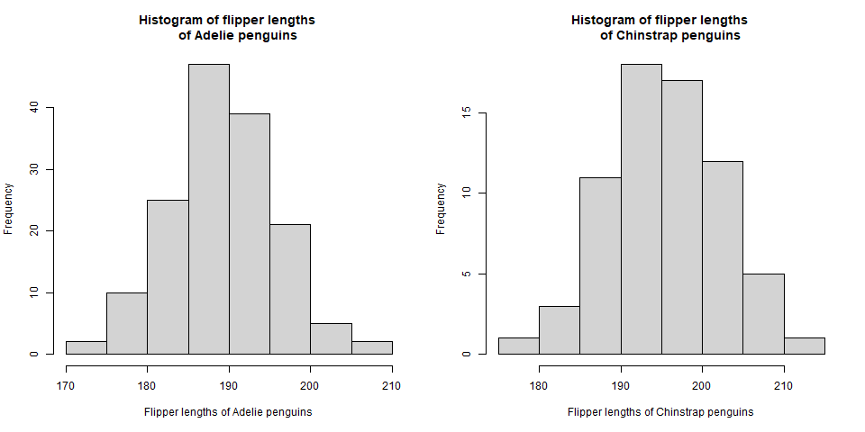

QUESTION 11

**Q1**

The alternative hypothesis is that there is is a difference between the mean of the flipper lengths of the Adelie penguins and the mean of the flipper lengths of the Chinstrap penguins. In a simple way, the alternative hypothesis says that both means are not equal.

**Q2**

t.test(flipper_length_mm ~ species, data = penguin_dat)