you are a IT professional who applied to this job About the job
We are seeking motivated, self-directed, and technically outstanding developers to join our team of Software Engineers responsible for building back office systems that support our order routing, execution, and management system. With our constantly growing client base and the ever-changing demands of markets and financial technology worldwide, these systems are in a constant state of improvement and expansion.

In this role you will
Engage in full cycle development of custom-built back office systems (billing, real-time monitoring systems, and varying APIs to name a few)
Communicate with stakeholders to identify issues and develop improvements to these systems
Gather requirements, design solutions, iterate on implementations with peers and business advisors, participate in code reviews, and deliver products in a timely manner
Troubleshoot and solve the most complex problems escalated by support staff
Provide insights on and help prioritize tasks to optimize, modernize, and simplify our system on your own initiative, as well as ways to improve usability and scalability
Document the requirements and usage of the software, along with technical specifications and test cases
Keep abreast of emerging technologies, new language features, and new APIs or tools

Minimum Qualifications
Have 3+ years of software engineering experience in an OOP language such as C# (preferred), C++, or Java
Experience with Windows, Linux, .Net, WPF, Blazor, Python, and/or SQL
Be organized, self-directed, and dependable. Be able to manage your own workload and provide reasonable estimates for completion
Have superb analytical and problem-solving skills
Have excellent verbal and written communication skills, able to convey design decisions in both technical and layman’s terms

Headquartered in Chicago, Wolverine Execution Services (WEX) is an independent broker-dealer specializing in the execution of equities, options and futures for institutional investors. WEX offers clients multiple venues for execution including a proprietary electronic trading platform, algorithms, direct floor access, and an agency brokerage desk. Leveraging expertise in trading technology and risk management, WEX provides clients with anonymity, superior execution and order management in all asset classes, delivering exceptional solutions for both technical and institutional trading styles. For more information visit www.tradewex.com.

We may use artificial intelligence (AI) tools to support parts of the hiring process, such as reviewing applications, analyzing resumes, or assessing responses. These tools assist our recruitment team but do not replace human judgment. Final hiring decisions are ultimately made by humans. If you would like more information about how your data is processed, please contact us.

The base compensation range for this role is approximately $80,000-$110,000 contingent on experience. WEX's total compensation model includes base salary and an annual discretionary bonus. with this experience Navyaprabha Rajappa
navyaprabha.rajappa@gmail.com | 260-410-6908 | https://github.com/rnavyaprabha | linkedin.com/in/navyaprabha/
PROFESSIONAL SUMMARY
Full Stack Software Engineer with expertise in building scalable .NET and web applications across the full software development lifecycle.
Skilled in frontend (React.js, Vue.js, HTML/CSS, Tailwind) and backend (.NET, C#, microservices, REST APIs) development, with hands-on
experience in CI/CD, Docker, Kubernetes, and cloud platforms (AWS, Azure). Strong collaborator with cross-functional teams, experienced
in mentoring, troubleshooting, and delivering secure, high-performance solutions.
WORK EXPERIENCE
Software Development Engineer, Medical Informatics Engineering Feb 2025 - Present
• Designed, developed, debugged, tested, and supported .NET and web applications, delivering end-to-end solutions across the full
software development lifecycle.
• Developed dynamic dashboards and responsive frontends using HTML5, TailwindCSS, and React.js, ensuring accessibility
(WCAG/ADA) and usability compliance.
• Implemented CRUD operations and data modeling using MongoDB, building scalable and efficient NoSQL solutions for application
data management.
• Refactored Python code, adding error handling and logging, and developed microservices with OAuth 2.0 authentication, email, and
push notifications to improve scalability and maintainability.
• Implemented CI/CD pipelines using GitHub Actions, configuring YAML files and Docker containers to automate build, testing, and
deployment workflows.
• Documented development progress, architecture decisions, and feature updates, creating guides and videos to help peers and
future developers quickly understand the system.
• Participated in code reviews, debugging, and PR reviews, collaborating cross-functionally through Scrum calls and GitHub issue
resolution to deliver high-quality solutions.
IT Operation Engineer II, Hewlett Packard Enterprise May 2021 - Dec 2022
• Owned and maintained C#/.NET applications, troubleshooting and resolving code issues, implementing enhancements,
and managing version control using GitHub to ensure stable and maintainable enterprise solutions.
• Automated application testing, developing and executing reusable test cases that reduced testing time by 40%.
• Worked closely with cross-functional teams(QA, design, product managers, and engineers) to track issue resolution,
remove blockers, and ensure smooth delivery of features and deployments.
• Deployed containerized .NET applications on AWS ECS and implemented AWS Lambda–based serverless workflows,
integrating services such as S3, DynamoDB, and API Gateway for backend automation.
• Optimized slow SQL queries by developing efficient stored procedures, functions, views, and indexes, improving system
performance and eliminating bottlenecks.
• Mentored junior developers, providing guidance on .NET 8, microservices, and service-oriented architecture to ensure
best practices and high-quality code.
Software Engineer, Positive Edge Dec 2020 - May 2021
• Developed responsive, enterprise-grade front-end applications using HTML, CSS, React.js, and Vue.js, building dashboards,
data visualizations, and interactive features.
• Designed and implemented scalable microservices and RESTful APIs using .NET, C#, and modern JavaScript to improve system
modularity and performance.
• Containerized services using Docker and Kubernetes, enabling scalable and highly available deployments across Azure cloud
environments.
• Collaborated within Agile teams, actively participating in sprint planning, backlog refinement, daily stand-ups, and code
reviews, delivering enhancements and resolving issues tracked in Jira
Software Engineer, L&T Infotech Jan 2018 - Dec 2020
• Led the migration of 216 legacy applications across ASP.NET, MVC, Web Forms, WCF, Windows Forms, WPF, Console, to
the latest .NET Framework, driving a 25% performance improvement through modernized architecture.
• Optimized and secured relational databases (MySQL, SQL Server) by refactoring queries, implementing indexing and SSISbased data processing, and remediating SQL injection and insecure database access to support enterprise .NET applications.
• Developed and enhanced full-stack applications using C#, VB.NET, ASP.NET, RESTful APIs, and AngularJS to deliver secure,
scalable enterprise web solutions.
• Built Azure DevOps CI/CD pipelines automating build, testing, and multi-environment deployments, reducing deployment
time by 30% and minimizing manual release errors.
• Conducted unit testing and functional verification to ensure post-migration stability, leveraging tools such as Visual Studio
Test Explorer and NUnit.

PROJECTS

Full-Stack Cloud-Native Web Application
• Tech Stack: React.js, .NET, C#, REST APIs, MongoDB, SQL, OAuth 2.0, Docker, GitHub Actions, AWS/Azure
• Designed and developed a full-stack web application using React.js, HTML, CSS, and TailwindCSS with a backend built on
.NET, C#, and RESTful APIs.
• Implemented CRUD operations and data modeling using MongoDB and relational databases to support scalable data
management.
• Integrated OAuth 2.0 authentication and authorization, enabling secure user access and API communication.
• Containerized services using Docker and automated build and deployment workflows through GitHub Actions–based CI/CD
pipelines on AWS/Azure.
Secure Microservices Platform with DevOps Automation
• Tech Stack: .NET, C#, Python, Microservices, REST APIs, AWS ECS, Lambda, Docker, CI/CD, YAML, SQL, MongoDB
• Designed and implemented a microservices-based architecture using .NET, C#, Python, and modern JavaScript to improve
system modularity and scalability.
• Built RESTful APIs with logging, error handling, and secure service-to-service communication, ensuring reliability and
maintainability.
• Deployed containerized services using Docker and cloud platforms such as AWS ECS and AWS Lambda for scalable backend
processing.
• Automated application builds, testing, and multi-environment deployments using YAML-based CI/CD pipelines, improving
release consistency and system stability.
SKILLS
Languages & Frameworks: C#, VB.NET, JavaScript (Node.js), Python, HTML5, CSS3, React.js, Vue.js, AngularJS, Tailwind,
ASP.NET, WinForms, WCF
Backend & APIs: RESTful APIs, CRUD operations, Microservices, OAuth 2.0, JSON, HTTP/HTTPS.
Databases: MySQL, SQL Server, PostgreSQL, MongoDB, Data Modeling, Query Optimization, SSIS
Cloud & DevOps: AWS (ECS, Lambda, S3, DynamoDB, API Gateway), Azure (App Services, Pipelines, DevOps), Docker,
Kubernetes (basic), CI/CD (GitHub Actions, Azure DevOps, YAML)
Testing & Quality: Unit Testing, Integration Testing, TOSCA, Debugging, Code Reviews, Clean Code Practices
Collaboration & Agile: Agile/Scrum, Jira, ServiceNow, Git/GitHub, Cross-functional Team Collaboration, Documentation
EDUCATION
Master of Science, Computer Science | Purdue University | Jan 2023 – Dec 2024|GPA: 4.00
Bachelor of Engineering, Computer Science| PESIT, Bangalore | Jul 2013 – May 2017|GPA: 3.56
AWARDS
Inclusive Excellence Award –Disability Access Center, PurdueUniversity
Recognized for leading the development of an AI-driven Learning Assistant that advanced inclusivity by providing realtime transcription, summarization, translation, and note structuring for students with disabilities, non-native English
speakers, and those with ADHD.
Diversity Award – 28th Annual Student Research & Creative Endeavors Symposium
Honored for research that promoted diversity, equity, and inclusion through innovative deep learning solutions,
showcasing how technology can break down barriers in education and accessibility.
Top 50 Student Award – Purdue University Fort Wayne
Selected from 1,500+ eligible students for excellence in scholastic achievement (4.0 GPA), impactful research, community
service, and leadership, demonstrating the ability to balance technical rigor with meaningful contributions to society............now company as send you online Assement
andidate guide to taking an Assessment
Guide for candidates to have a positive experience taking an Assessment on Coderbyte
You may receive an invite to an Assessment as an email or link distributed via another source. In either case, it's important to carefully read the instructions before clicking the link, and not to distribute the link to others. Often, the invite link can only be clicked once and is associated with your email address.

Starting the assessment
Once you click the link for your Assessment, you'll be asked to input your name and/or email address. Make sure any ad-blocker extensions are disabled so this page can work properly.
Once you are ready, check the box and click Begin Assessment.
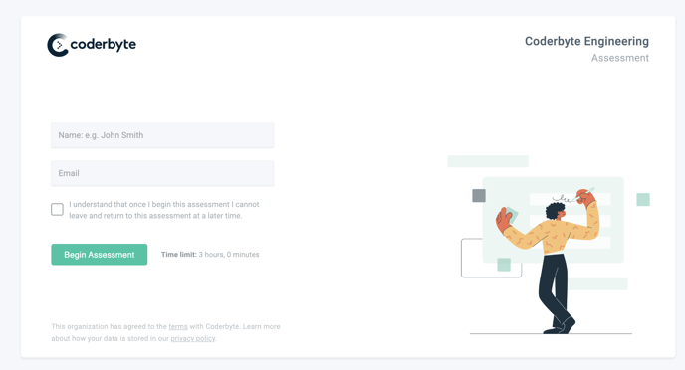
You will then see a Welcome screen similar to the one below. This is where your organization can provide some instructions on what to expect from the assessment. You can also see how much time you'll have to complete the entire assessment on the left-hand side.
Once you click Begin Assessment on this Welcome screen, you will be shown all the questions and challenges you need to solve, and the timer will begin. You cannot pause the Assessment, so make sure if there is a time limit set that you allocate some time to complete the entire Assessment.
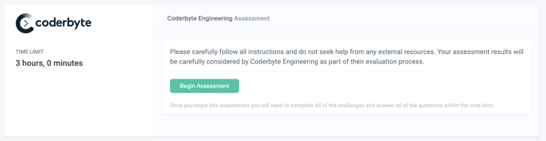
Taking the assessment
Next you will see a screen similar to the one below. This is your entire assessment and it is where you'll be presented with the following questions and challenges depending on how your organization created the assessment:
- Coding and/or spreadsheet challenges
- Free-form questions
- Multiple choice and/or short answer questions
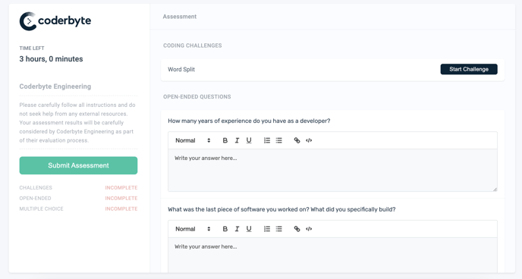
Coding challenges
To solve your coding challenges, click Begin challenge and you will be presented with an information page regarding the specific challenge, and the following page will load your editor.
The editor will have a challenge description on the left-hand side along with some sample test cases (if any exist for the challenge). Your goal is to modify the code so that it outputs the correct answers. Do not copy and paste code from outside the editor as this will be detected as a potential form of cheating.
When you are done writing your solution, make sure you click Submit to submit your solution for grading.
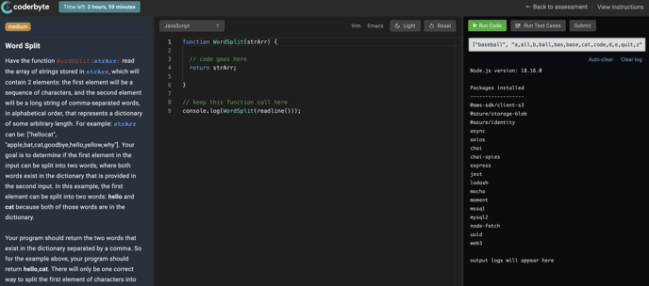
Note: For algorithm challenges, do not modify the function call at the bottom of the editor. This is required to run your code against a set of test cases. For example: console.log(Challenge(readline()) shouldn't be modified in a JavaScript challenge.

Google search
It's important not to leave the tab while coding, as this will be detected as a potential form of cheating. However, using Google Search is common while programming to search for syntax or other resources.
If the organization that invited you to the Assessment has it enabled, you will see a Google Search box below the instructions on the left-hand panel. You can use this to help you solve the challenge and look things up without ever needing to leave the editor.
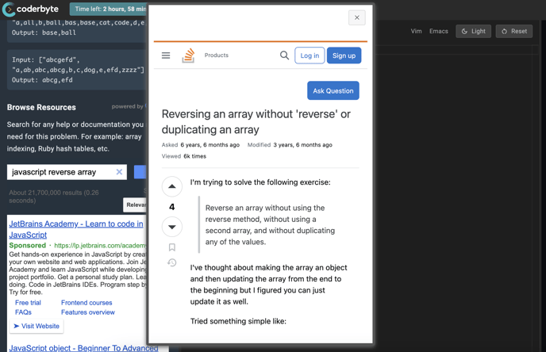
Completing the Assessment
When you've finally answered all the questions and solved all the coding challenges, you can go ahead and click the big green button titled Submit Assessment. You will then see the screen below.
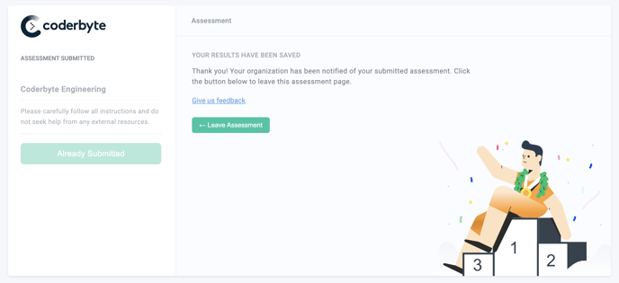
Post-assessment
After you submit your assessment, you don't have to do anything else and the organization that invited you will review your results. If you have any questions about the platform, email us at support@coderbyte.com.

