**Voice Bot with Alexa**

**Health Insurance Provider Support Bot**

**Plan**

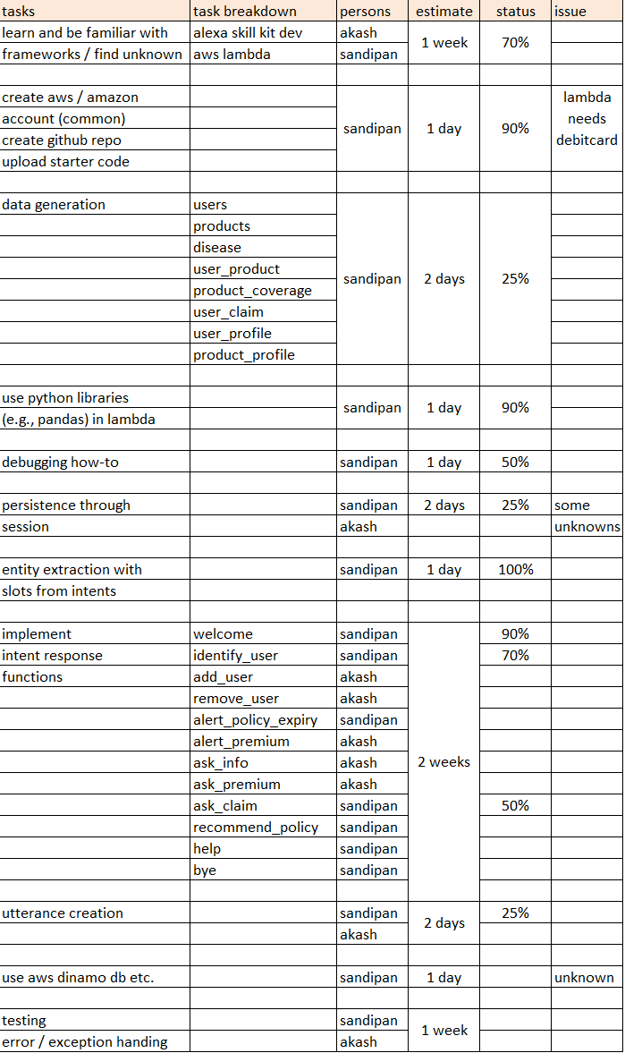

**Architecture**

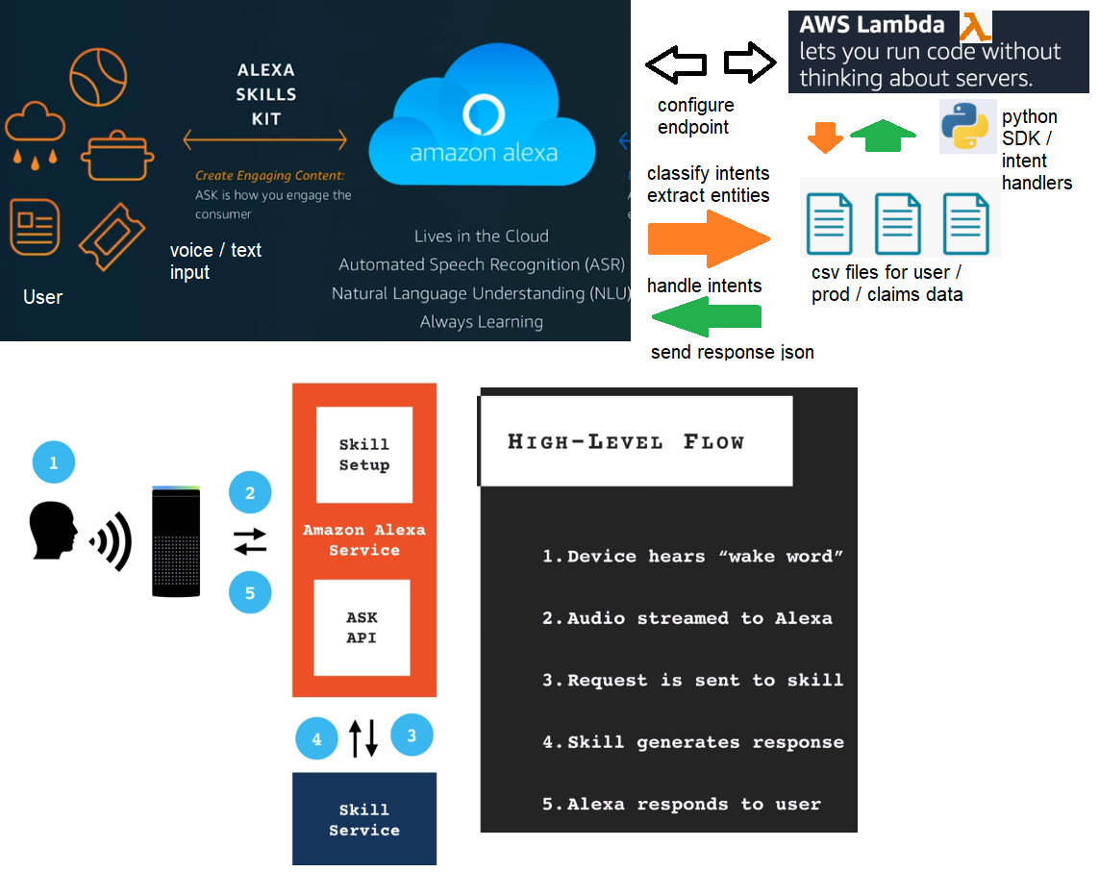

**Story**

* We shall implement a health insurance voicebot with Alexa, with a few features.
* Alexa greets the user and ask questions to identify the user (from the database).
* If an existing user, the user can ask queries to know information about him / her.
* A user can ask about his benefits / claim information, Alexa responds to the user’s query by providing information about his already claimed amount and max amount he / she can claim for a particular disease.
* If the user is not covered for the particular disease by the plan, Alexa will inform that too.
* A user can ask about his premium information, when it’s due, how many premiums he already paid etc.
* Alexa will proactively generate an alert if a premium is due for a user for a policy and also if a plan is about to expire.
* If a user is new, Alexa then asks the user if he wants to register with the system and asks for demographic information.
* For a new user, Alexa will recommend products based on his demographic information (proactively).
* For an existing user, Alexa will recommend products he / she may be interested in(with content-based recommendation).

**Data Model**

User (id,name,age,gender,married,children,bmi,smoker)

Prod (id,pronce,pramt,interest,term_yrs)

ProdCov (pid,did,maxamt)

UserProd(uid,pid,date,nprpaid)

UserClaim(uid,pid,did,amt)

