**Alexa Voice Service (AVS) for integration with Alexa**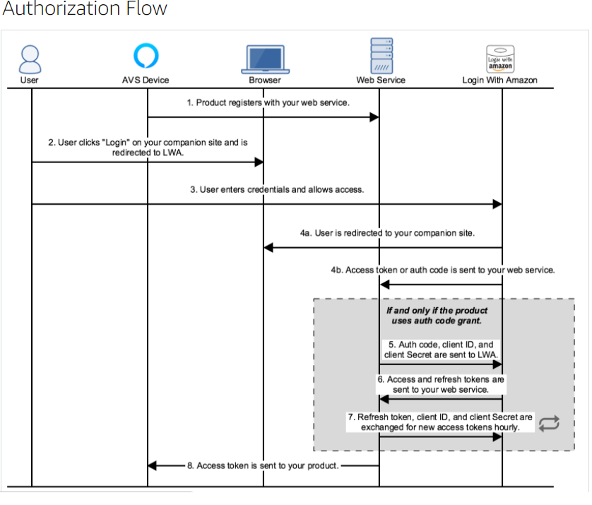  
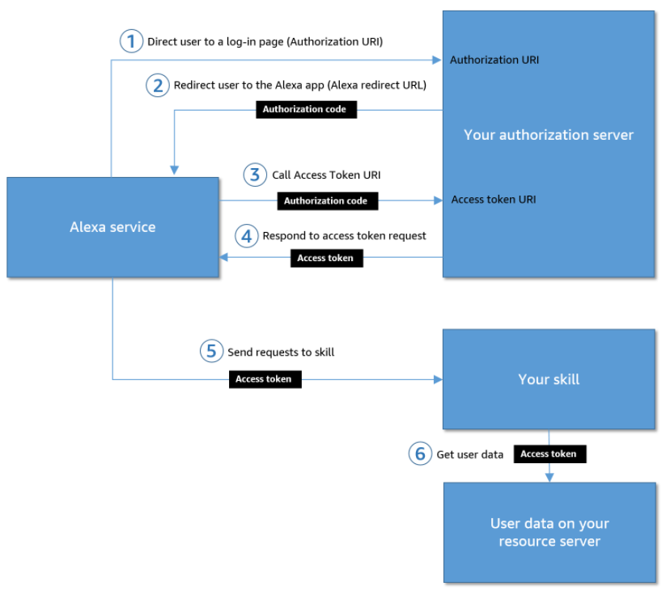

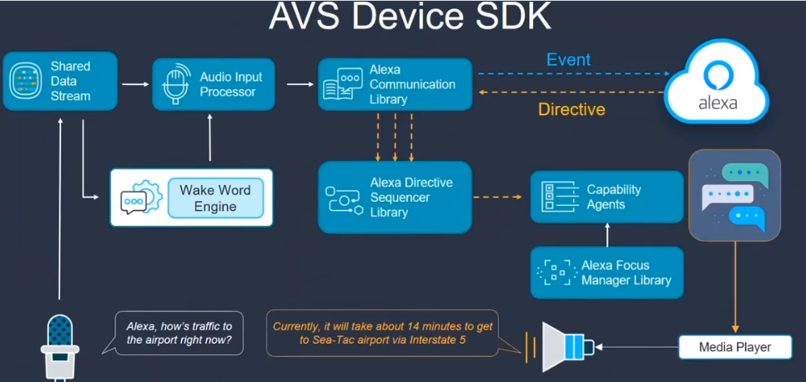

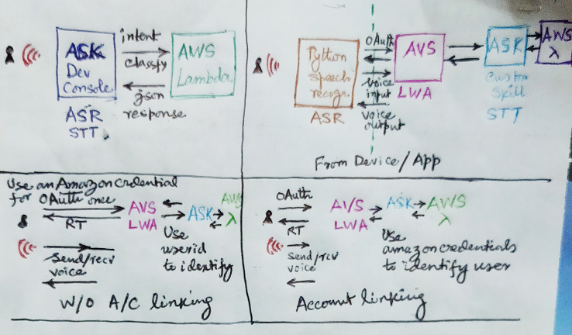

**References**

<https://developer.amazon.com/en-US/docs/alexa/alexa-voice-service/authorize-companion-site.html>

<http://ewenchou.github.io/blog/2016/03/20/alexa-voice-service/>

<https://forums.developer.amazon.com/questions/52384/linking-avs-to-custom-skill-kit.html>

<https://stackoverflow.com/questions/54022897/how-to-make-alexa-sample-app-voice-service-to-call-invoke-custom-skills>

<https://forums.developer.amazon.com/questions/233421/the-target-lambda-application-returned-a-failure-r.html>

<https://console.aws.amazon.com/lambda/home?region=us-east-1#/functions/SampleVoiceBot?tab=monitoring>

<https://forums.developer.amazon.com/questions/33674/how-to-invoke-custom-ask-from-avs.html>

<https://console.aws.amazon.com/cloudwatch/home?region=us-east-1#logsV2:log-groups/log-group/$252Faws$252Flambda$252FSampleVoiceBot/log-events/2021$252F03$252F04$252F$255B$2524LATEST$255Dd1fa94751e574bf195fa6b2ca69d81d1>

<https://developer.amazon.com/en-US/docs/alexa/avs-device-sdk/windows-64.html#run-and-authorize-the-sample-app>

<https://developer.amazon.com/en-US/docs/alexa/avs-device-sdk/use-the-sample-app.html#interact-with-alexa-by-using-tap-to-talk>

<https://forums.developer.amazon.com/questions/219396/sampleappexe-the-procedure-entry-point-ssl-ctx-set.html>

<https://core.ac.uk/download/pdf/226765486.pdf>

<https://developer.amazon.com/en-US/docs/alexa/account-linking/account-linking-for-custom-skills.html>

<https://developer.amazon.com/en-US/blogs/alexa/alexa-skills-kit/2020/07/you-can-now-seamlessly-connect-alexa-skills-to-mobile-apps>

<https://developer.amazon.com/en-US/docs/alexa/account-linking/app-to-app-account-linking-starting-from-your-app.html>

<https://developer.amazon.com/en-US/docs/alexa/account-linking/understand-account-linking.html>

<https://developer.amazon.com/en-US/docs/alexa/alexa-voice-service/authorize-on-product.html>

<https://github.com/richtier/alexa-browser-client>