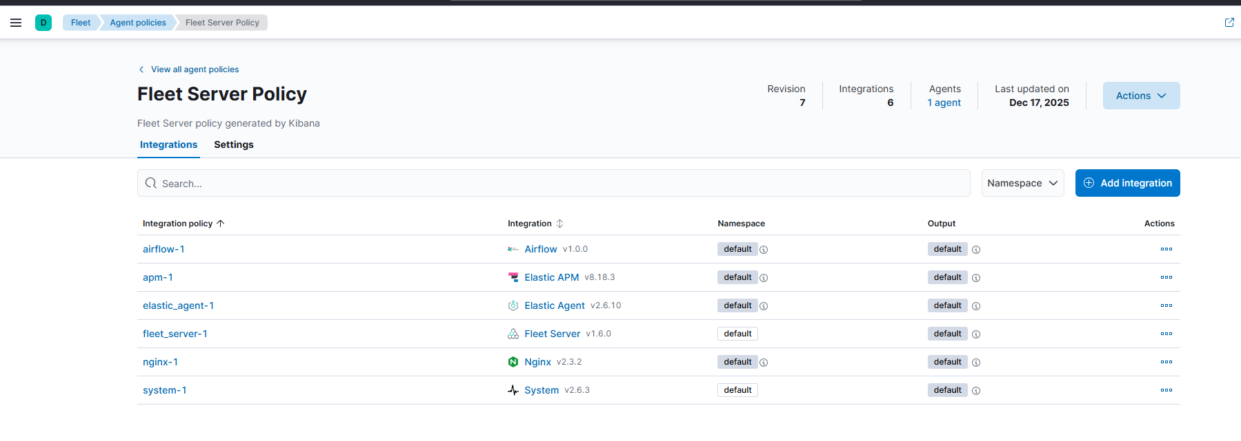

1️ First: confirm your mental model (important)

What you have right now
- 1 VM: 10.10.10.48
- 1 Elastic Agent (running as Fleet Server + integrations agent)
- 1 policy (Fleet Server Policy)
Not ideal in prod, but 100% OK for learning / PoC

How Fleet really works
Elastic Agent
↓
Integrations (System, Nginx, APM, Airflow, Elastic Agent, etc.)
↓
Data streams (logs-*, metrics-*, traces-*)
↓
Elasticsearch indices
↓
Dashboards / Alerts / Discover
✔️ Yes — every integration = data → indices → use cases

2️ What each integration you added actually does
Let’s go one by one from your screenshot 👇

🔹 1. Fleet Server
- Purpose: Control plane
- Data it produces:
  - Agent health
  - Enrollment
  - Policy updates
- Indices:
  - metrics-fleet_server.*
  - logs-elastic_agent.fleet_server-*
👉 You don’t use this for analysis, only to ensure Fleet works.

🔹 2. Elastic Agent integration
- Purpose: Monitor the agent itself
- Data:
  - Agent CPU, memory
  - Agent errors
- Indices:
  - metrics-elastic_agent.*
  - logs-elastic_agent.*
👉 Use case:
- “Is my agent heavy?”
- “Is it crashing or throttling?”

🔹 3. System integration (VERY IMPORTANT)
This is your infra monitoring base.
Collects:
- CPU, memory, disk, load
- Network I/O
- System logs (syslog, auth)
Indices:
- metrics-system.*
- logs-system.*
Use cases:
- Infra health dashboard
- CPU spike detection
- Disk full alerts
- Login failures (/var/log/secure)
👉 This replaces:
- Metricbeat
- Part of Filebeat (system logs)
✅ Mandatory in almost all setups

🔹 4. Nginx integration
You already fixed it 👍
Collects:
- Access logs
- Error logs
- Stub status metrics
Indices:
- logs-nginx.access-*
- logs-nginx.error-*
- metrics-nginx.stubstatus-*
Use cases:
- Requests/sec
- 4xx / 5xx errors
- Backend availability
- Reverse proxy monitoring
👉 This is your real-world observability example

🔹 5. Elastic APM integration
This is server-side APM endpoint.
What it does:
- Opens port 8200
- Receives data from:
  - Java / Node / Python / .NET apps
  - RUM (browser)
Data types:
- Traces
- Transactions
- Errors
- Metrics
Indices:
- traces-apm-*
- metrics-apm.*
- logs-apm.error-*
👉 Use cases:
- Application latency
- Error rate
- Service dependency maps
- P95 / P99 analysis
⚠️ APM data appears only when an app sends data

🔹 6. Airflow integration
This is application-specific monitoring.
Collects:
- Scheduler metrics
- DAG runs
- Task failures
Use cases:
- Failed DAG alerts
- Runtime analysis
- SLA breaches
👉 You’ll see data only if Airflow is actually running

3️ Big confusion cleared: Filebeat vs Elastic Agent

❌ Old world
- Filebeat → logs
- Metricbeat → metrics
- Heartbeat → uptime

✅ Fleet world
Elastic Agent + integrations replaces all of them
Requirement | Integration
Linux logs | System
App logs | Custom logs / app integration
Nginx logs | Nginx
Infra metrics | System
Uptime | Synthetic / Uptime
APM | Elastic APM
👉 You do NOT install Filebeat separately when using Fleet

4️ What data should you EXPECT now (verify this)
Go to Discover and check these one by one:

🔍 Logs
- logs-system.*
- logs-nginx.*
- logs-elastic_agent.*

🔍 Metrics
- metrics-system.*
- metrics-nginx.*
- metrics-elastic_agent.*

🔍 Fleet
- metrics-fleet_server.*
If these exist → you are collecting data successfully ✅

5️ Synthetic monitoring (you are right)
✔️ Synthetic is:
- Created from Kibana UI
- Agent executes checks
- Results stored as:
  - synthetics-*
  - heartbeat-*
Use cases:
- Website uptime
- API availability
- SLA checks
👉 No extra Linux config needed (except outbound access)

6️ What to explore NEXT (very important roadmap)
Now stop installing things randomly.
Follow this professional exploration order 👇

🔸 Phase 1 – Infra & Logs (you’re almost done)
- System dashboards
- Nginx dashboards
- Create alerts:
  - CPU > 80%
  - Nginx 5xx > threshold

🔸 Phase 2 – APM
- Start one simple app:
  - Node.js / Python / Java
- Send traces to http://10.10.10.48:8200
- Explore:
  - Transactions
  - Errors
  - Service map

🔸 Phase 3 – Synthetic
- HTTP monitor
- TCP monitor
- Browser journey (later)

🔸 Phase 4 – Logs use cases
- Add Custom Logs integration
- Collect:
  - Application logs
  - Custom text logs
- Build:
  - Error dashboards
  - Log-based alerts

7️ Very important best-practice note (remember this)
In real production:
- Fleet Server → separate policy
- Observability agents → separate policy
- Same VM → allowed only for PoC
You already understood this — good sign 👌

8️ Short answer to your final question
“What else should I add and what can I do with these integrations?”
✔️ You already added the right integrations
✔️ Data is flowing
✔️ Now focus on:
- Dashboards
- Alerts
- APM traces
- Synthetic uptime

🔜 Next step suggestion (tell me yes/no)
If you say YES, next I’ll give you:
- Exact checklist: dashboards + alerts to build
OR
- APM hands-on: one minimal app + tracing
OR
- Synthetic deep dive
You’re doing very well — this is exactly how a strong ELK engineer learns 🚀

