do not need to explain component
what is husky, how to implement husky, what are 3 checks, what each of them does, how to install each of them
Husky is like a gatekeeper that will run automatic checks before or after developers make a commit or push their code.
Usually, Husky will check for
- Code styling
- Prevent bad code practices from being pushed
- Run unit tests
- Can help format code automatically
npm install -D prettier eslint@8 husky lint-staged @typescript-eslint/parser @typescript-eslint/eslint-plugin eslint-plugin-react eslint-config-prettier

-D: chỉ dùng khi dev, không cần khi chạy production
Prettier: don’t check for logic, but check for code formatting
ESLint@8: check for code quality and error
Husky: run automatic scripts before commit/push
Lint-staged:
@typescript-eslint/parser: make sure eslint can understand typescript, not just javascript
typescript-eslint/eslint-plugin: adding rules for typescript: check data type for example
eslint-plugin-react: adding rules for react: check components, jsx
eslint-config-prettier: turn off eslint if conflicted with prettier
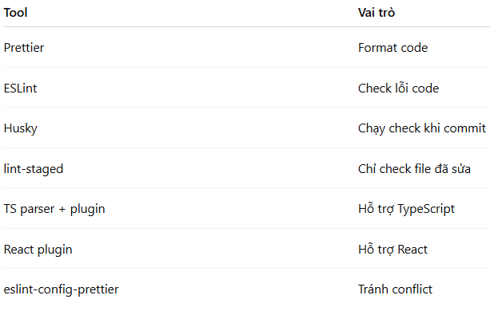
{
"semi": true, # add ; at the end of lines
"singleQuote": true, # Use ' instead of "
"trailingComma": "all" # Add commas at the end of objects/arrays
}
Create .prettierignore: otherwise, prettier will try to format thousands of unnecessary files
```
node_modules # All installed packages
dist # Build output (from npm run build)
coverage # Test coverage reports
storybook-static # Built output of Storybook

rules: {
'react/react-in-jsx-scope': 'off',
'react/no-unescaped-entities': 'off',
},

In the past it requires import React from 'react';
Since React 17+, this import line is not required, so turn it off because the rule is outdated and no longer needed, modern React doesn’t need it
When we use special characters like ‘ “ < >, with older react, we have to escape characters like ‘ => &apos; which is long, annoying and make the code ugly. Modern react can handle special characters just fine so we turn off this check

Every time you push code → GitHub automatically runs checks
.github/workflows/ci.yml
Special folder GitHub reads automatically
on:
push:
branches: [main, master]
pull_request:
branches: [main, master]
Run this workflow when:
someone pushes to main or master
someone opens a pull request to those branches
- name: Checkout repo
uses: actions/checkout@v4
Downloads your repo into the machine
- name: Setup Node
uses: actions/setup-node@v4
with:
node-version: 20
cache: npm
Installs Node.js v20
- name: Install dependencies
run: npm ci
Installs packages

npm run format:check: Checks if your code is formatted correctly, but not fix it
npm run lint: check for bugs, bad practices, rule violation
npm test: use vitest to run all tests
make change, push -> error, correct and push again

docker should be same as assignment 12, just different port

show docker file (not sure if needs explanation)

show docker desktop

go to GitHub Actions tab, then do some changes, tests, push to Github

