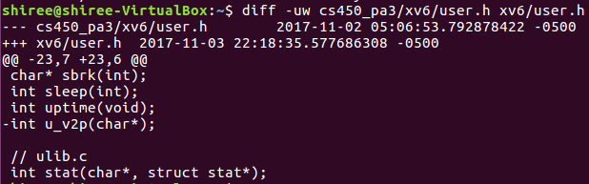

Figure 1: user.h u_v2p def diff

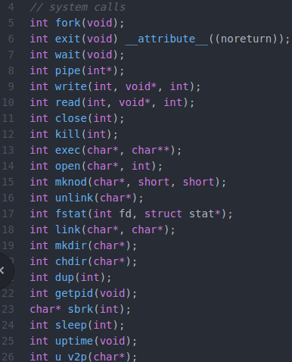



Figure 2: user.h u_v2p def

Defining u_v2p as a system call, callable by user.

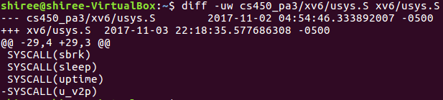

Figure 3: usys.S u_v2p SYSCALL diff

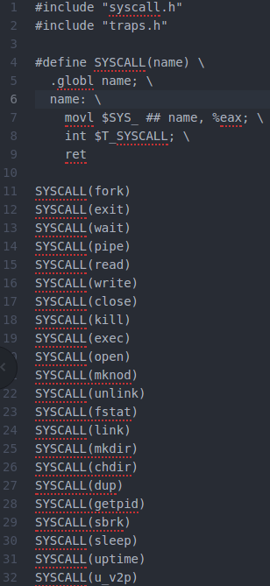



Figure 4: usys.S u_v2p SYSCALL

Adding u_v2p as a system call.

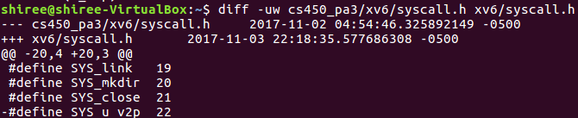

Figure 5: syscall.h SYS_u_v2p diff

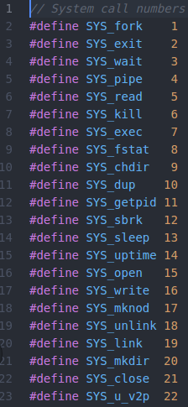



Figure 6: syscall.h SYS_u_v2p

Defining the system call number.

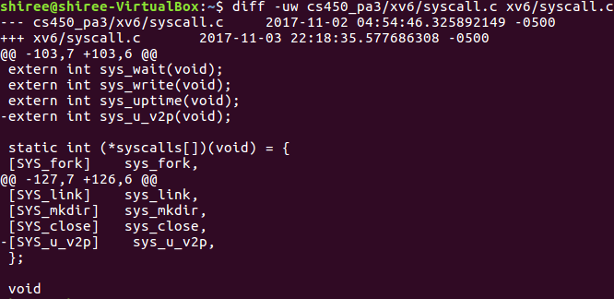

Figure 7: syscall.c sys_u_v2p diff

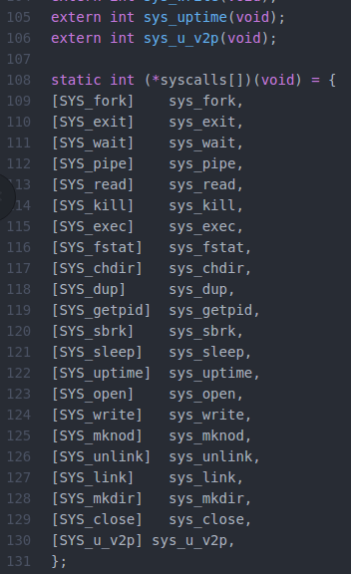



Figure 8: syscall.c sys_u_v2p

Adding the system call to the list and the associated function.

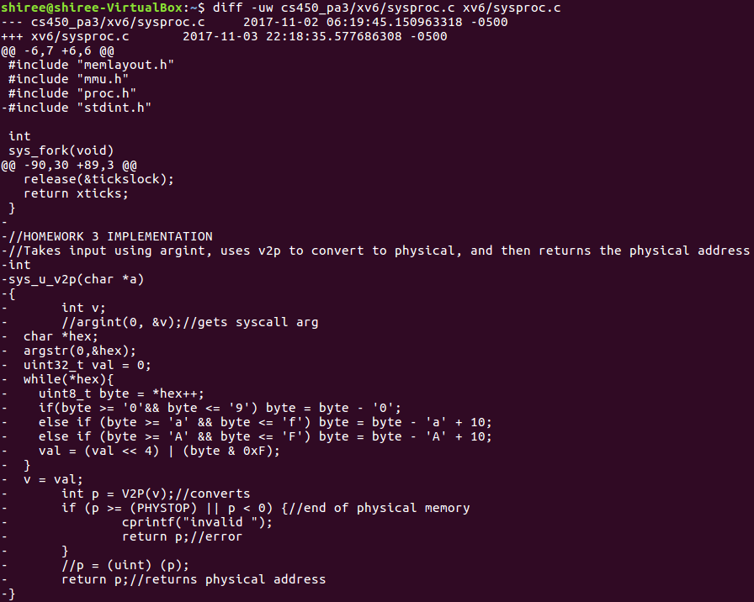

Figure 9: sysproc.c sys_u_v2p diff

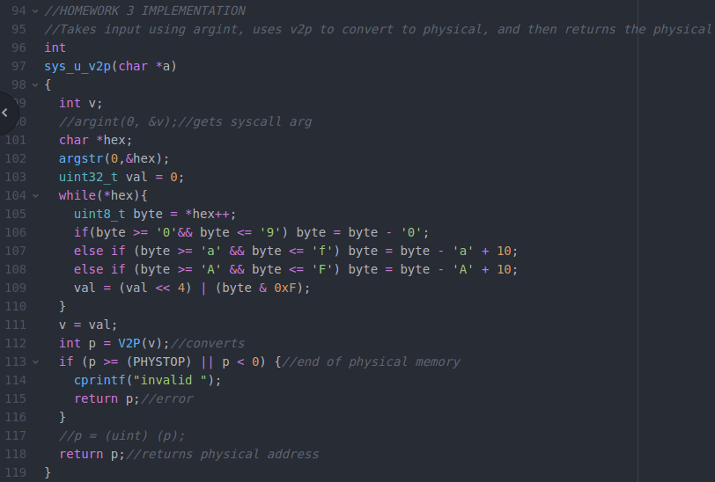

Figure 5: sysproc.c sys_u_v2p

Implementation of u_v2p. Takes the syscall argument as a hex encoded string, converts into an integer and passes it as an argument to V2P. The returned value is checked between the bounds of 0 to PHYSTOP, in which if true states invalid. The returned value is the integer of the address.

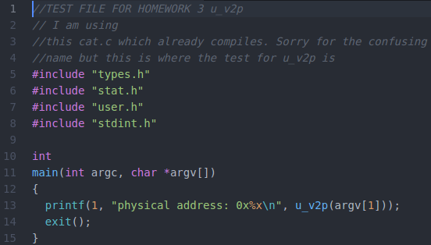

Figure 11: uv2p.c

Execution of u_v2p, in which takes the argument and returns the hex translated address.