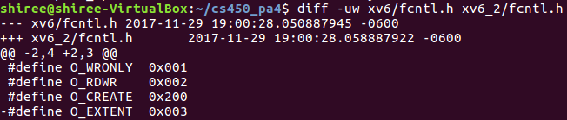

fnctl.h

Added O_EXTENT to define opening.

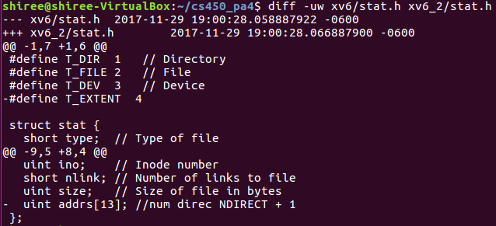

stat.h

Added T_EXTENT to define type and stat addrs[] for testing/print purposes.

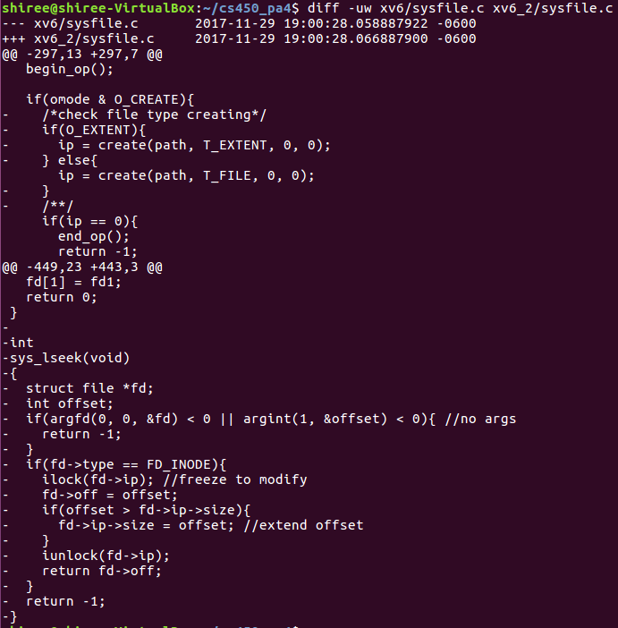

sysfile.c

Modified sys_open for conditional check if extent or normal.

Added sys_lseek implementation, which validates arguments before freezing inode and for offset.

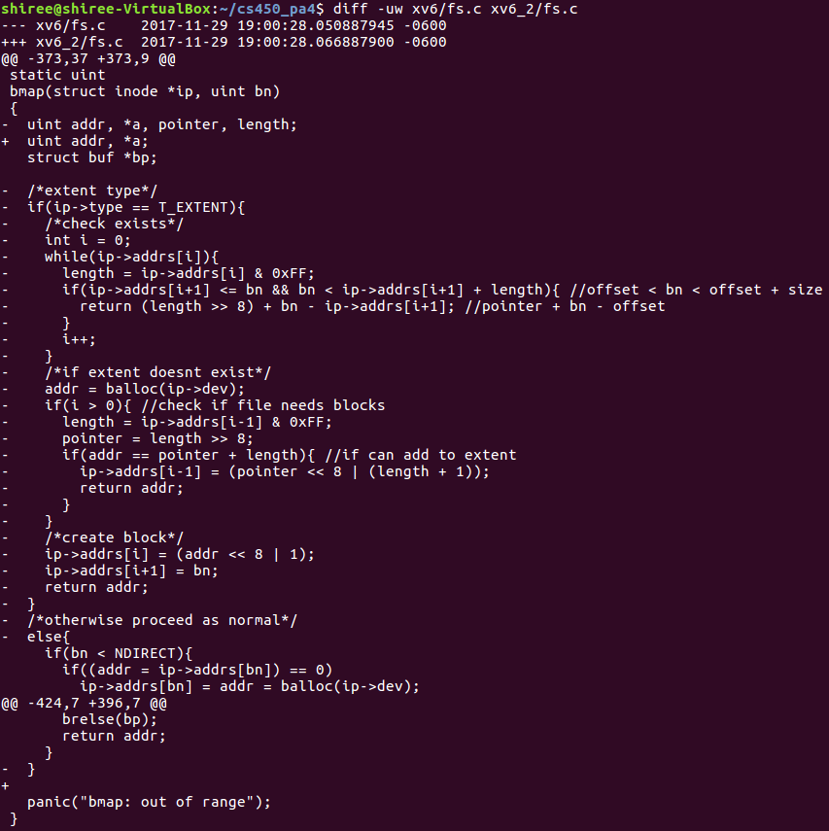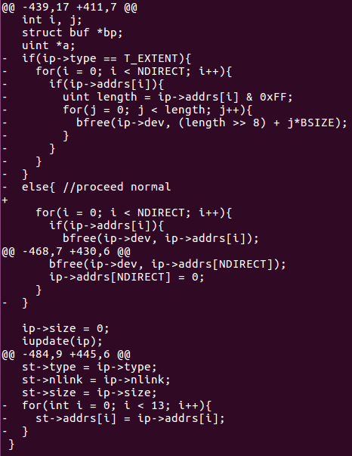

fs.c

Modified bmap to perform implementation of mapping. Idea was to check if within bounds and return next pointer, or balloc a pointer to a new data block and return accordingly. Otherwise perform normal file operations.

Modified itrunc for freeing purposes, both was not confirmed if working due to non-working bmap.

Modified istat to print addresses for statistics.

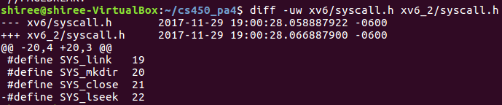

syscall.h

Added SYS_lseek number

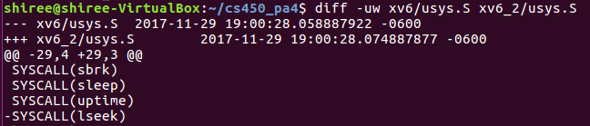

usys.S

Added syscall lseek

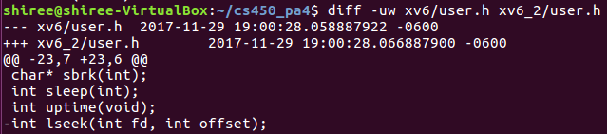

user.h

Added syscall function

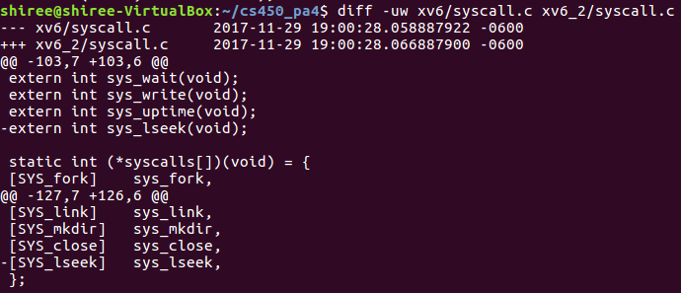syscall.c

Added sys_lseek to list