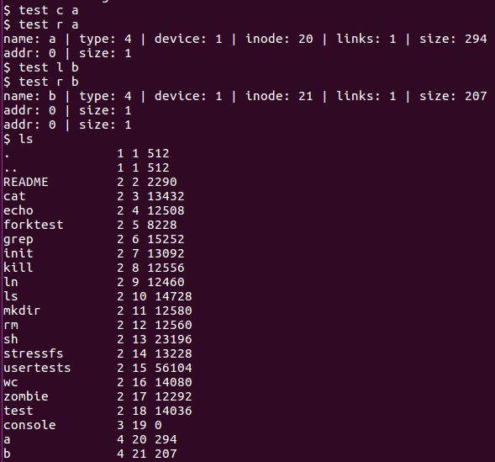

As code does not work, no proper test case can be done.

Depicted image demonstrates that when creating with preset strings, an extent type is made. However, allocation is improper, noted by the invalid addresses and size.