**Instructions**

1. **Downloading the data**

Raw climate or hydrological data can be downloaded from here:

<https://gdo-dcp.ucllnl.org/downscaled_cmip_projections/#Projections:%20Subset%20Request>

The first section is temporal & Spatial Extent

Previously we have worked with:

Time period: Jan 1950 to Dec 2099

Basin Specific Rio Grande

Rectangular area : make sure you cover the whole area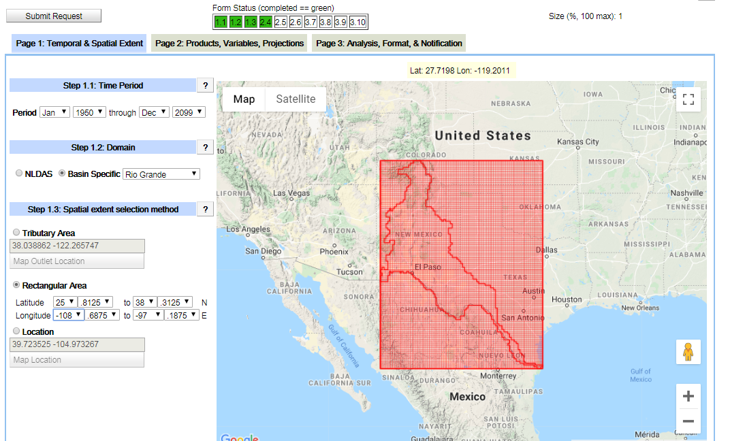

Section 2, Product, variables and Projections:

We have been working with monthly CMIP5 so far including both climate and hydrology data.

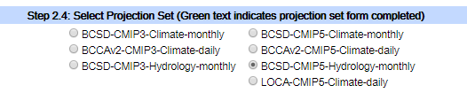

Next step is the products:

We have worked with 1/8 degree projections

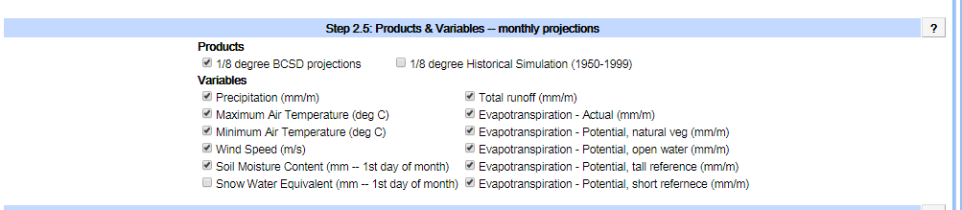

Step 3 is the Emission Scenarios, Climate Models and Runs

You have to pick **only ONE** projections each time.

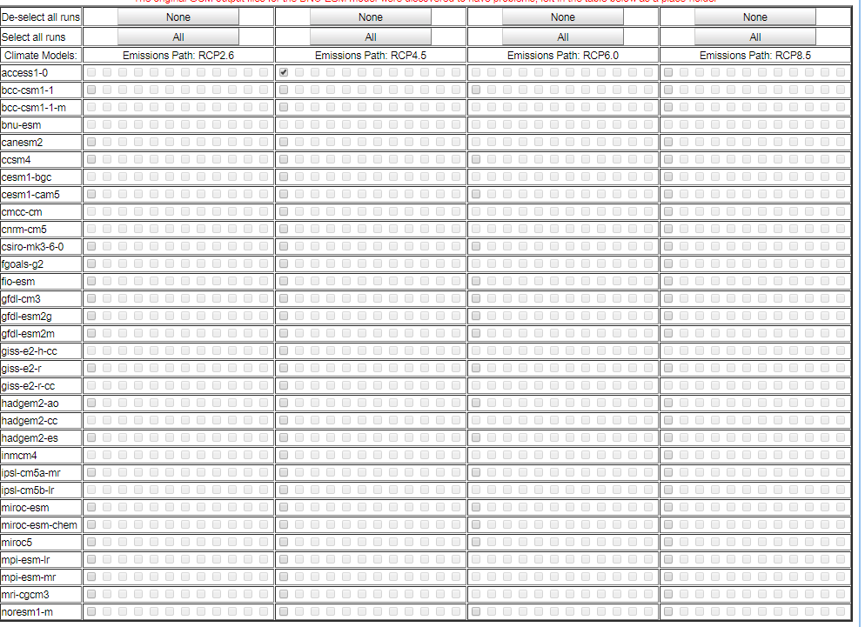

Section 3:

We have worked with “No Analysis”, “NETCDF” files so far.

Finally, submit the request.

You should get an email that has a link to your requested data.

It can take several hours depending on the number of requests on the server.

1. **Extracting the NetCDF files using the PYTHON code**

First you need to have the Python file:



You need to have three folders (I recommend using simple names, I named mine 1, 2 and 3)

Folder 1: you should place the netcdf files in this folder.

Note: **the NetCDF should belong to one projection.**

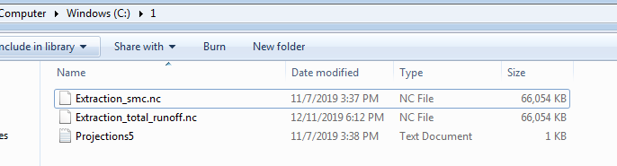

Folder 2: empty folder for processing and final excel file.

Folder 3: a shapefile for the Rio Grande sub watersheds. (Use simple names, I named it Clip)

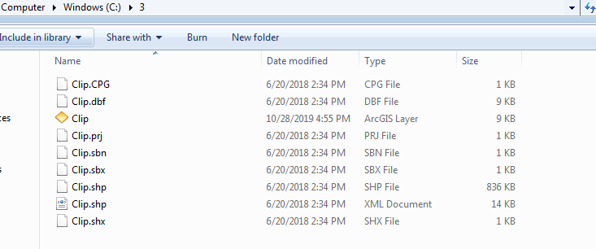

Time to Run the code

You need to provide the address in your computer for the mentioned folders respectively

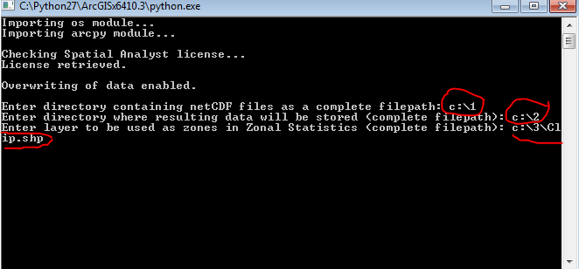

Depending on the number of the NETCDF files this will take several hours.

The final product is monthly excel file in the second folder that has the extracted parameters (monthly averages).

I used Pivot table in excel to make average annuals based on monthly average data.