**EE457 Homework-1 Ronahi Haykır**

**2023205195**

**Intro**

Define the real-valued function

f(x) = x2 − 9x + esin(x) +ln(x)

then using the matlabFunction(.) we convert the symbolic expression f(.) to function to calculate values numerically.

Define the interval_lenght matrix to store the interval lengths that is 4x15 matrix, method versus the iteration.

**Plot**

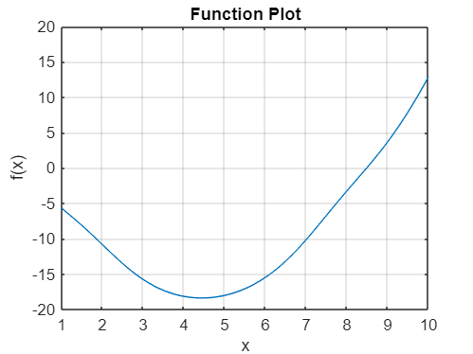

Figure 1. Plot of f(x) = x2 − 9x + esin(x) +ln(x) versus x over the interval [1, 10].

Figure 1 shows that f(x) is unimodal over [1, 10] as it contains only one local minimizer that is between the points 4.0 and 5.0. We will be using this unimodal function over the same interval.

**Golden Section Search**

We assign the value of the golden ratio to γ, interval reduction factor. That is,

γ = (3 - √5) / 2

Then we choose the first intermediate points a1 and b1,

a1 = a0 + γ(b0 – a0) and b1 = b0 - γ(b0 – a0)

where a0 and b0 are the first and last point of the initial interval, respectively.

Now we observe the corresponding function values of these points to determine the new interval,

Case 1: If f(b1) > f(a1), then the minimizer lies in the interval [a0, b1] and to continue the iteration correctly, we assign the new ending point of the interval to the previous b value. This is done by the line b0 = b1 in the code.

Case 2: Otherwise, if f(a1) ≥ f(b1), then the minimizer lies in the interval [a1, b0] and to continue the iteration correctly, we assign the new starting point of the interval to the previous a value. This is done by the line a0 = a1 in the code.

Lastly, using the new a0 and b0 values we calculate the following a1 and b1 values and proceed with the same logic 15 times.

We store the interval lengths in the first row of the interval_length matrix through the iteration.

Last uncertainity interval is [4.416910, 4.457563].

**Fibonacci Method**

This is the same algorithm as the Golden Section Search. We start with using the golden ratio as the reduction factor. Only difference is that after the first step, we use fibonacci numbers in reduction factor. We use F(n-k+1) / F(n-k+2) where F(n) is the nth fibonacci number, n is the total iteration number, and k is the kth iteration, we obtain

γ = 1 – (F(16-i) / F(17-i))

We store the interval lengths in the second row of the interval_length matrix through the iteration.

Last uncertainity interval is [4.418803, 4.456303].

**Bisection Method**

First, we assign the midpoint of the given interval to x0. In this method we use the first derivative of f(x).

Case 1: If f’(x) > 0, then the minimizer lies in the interval [a0, x0].

Case 2: If f’(x) < 0, then the minimizer lies in the interval [x0, b0].

Case 3: If f’(x) = 0, then the minimizer is the midpoint.

Then we assign the starting point, midpoint, end point of the new interval to a0, b0, x0, respectively,and continue with the same process.

We store the interval lengths in the third row of the interval_length matrix through the iteration.

Last uncertainity interval is [4.438721, 4.438995].

**Newton’s Method**

We use the quadratic Taylor approximation of f(x) so we will be using first and second derivative of f(x). Starting with x = 7 as the given initial point, our new x value is

x = xk – (f’(xk) / f’’(xk))

where xk is the previous x value that is stored in the line just above in the code.

The iteration stops if f’(x) = 0, where the minimizer is equal to that x value.

We store the absolute value of the successive x values in the fourth row of the interval_length matrix through the iteration.

Last two x values are 4.438918213100447 and 4.438918213100448.

**Interval Lengths**

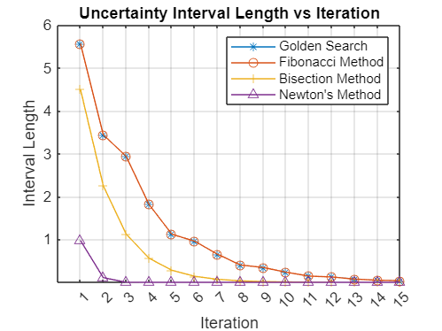

Figure 2. Plot of interval lengths of the Golden Section Search, Fibonacci, Bisection Methods and absolute values of the successive x values of Newton’s Method versus the iteration. Plots of Golden Search and Fibonacci coincide.

Differences of the all methods converge to zero as expected.

**Table**

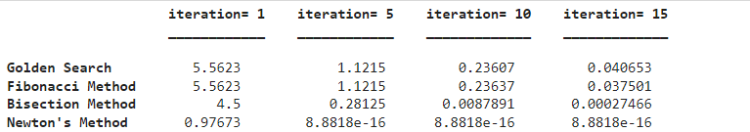

Table 1. Table of the interval lengths of Golden Search, Fibonacci, Bisection Methods and absolute values of the successive x values of Newton’s Method at iterations 1, 5, 10 and 15th.

**Secant Method**

Define real-valued function g(x) = xtan(3x) + 2x3 + 1. To find the roots of g(x) using the secant method we assign the given first two inital points to x0 and x1. Then using

x = xk – (xk - xk-1)g(xk) / g(xk) - g(xk-1)

where xk and xk-1 are the last two x values. We continue with the same process until absolute value of the xk and xk-1 are smaller than the given ε>0 value that is 10-5.

Root of g(x) is 6.559373e-01 and the value of g(6.559373e-01) is 7.639287e-10.