Ronahi Haykır - 2023205195

CMPE480 - Generic CSP Solver

1/11/2024

Generic Constraint Problem Solver aims to solve three problems: n-queens, map coloring and cryptoarithmethic. It uses backtracking search, starting with an empty assignment set, it recursively runs the algorithm.

Recursive backtracking search controls whether the assignment is complete or not, by checking if all the variables in the beginning is in the assignment set. If not, continues by selecting an unassigned variable. It uses Minimum Remaining Variables function and chooses the variable with the least number of possible values. If the number is the same as another variable, then it uses Degree Heuristic as tie-breaker and chooses the variable that id involved in the most number of constraints of other unassigned variables. In order to select a value for the chosen variable, the value domain is ordered by using Least Constrained Value so that it chooses the value that causes the least number of constraints to other variables. If the value is consistent regarding the constraints, then the variable is assigned to that value.

Lastly, assignment is also checked by Constraint Propagation. In order to reduce the values that causes conflicts as much as possible it creates a list with variables and their neighbours. Connected variables are checked until the list is empty. For each pair, values that are inconsistent with the second variable are removed from the first variable’s domain and if it is empty in the end then it indicates that a conflict exists. At last if the second variable is not a neighbour or the neighbour is not assigned, neighbour and the first variable is added to list to satisfy the consistency.

If it is valid, then continues to search values for other variables until all of them are assigned, if not, it backtracks and tries other values for the same variable.

Example runs:

1. n-queens, n=3: Place the queens where no other queen capture the other.

>python general_csp.py 3 P1 problem.txt

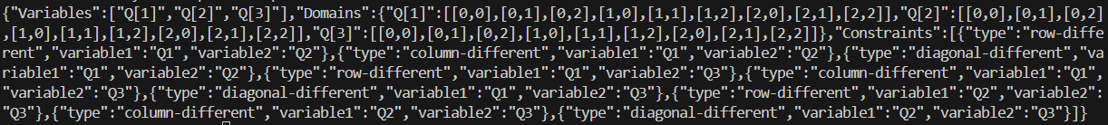

>python general_csp.py MRV DH LCV CP problem.txt

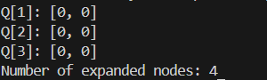

1. map-coloring, n=2: No adjacent city is the same color.

> python general_csp.py 3 P2 problem.txt

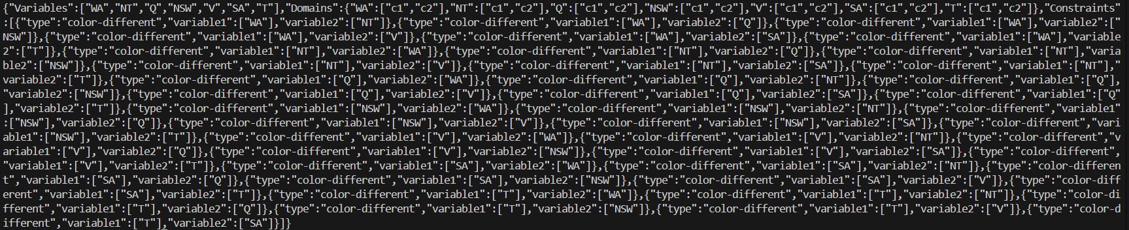

> python general_csp.py MRV DH LCV CP problem.txt

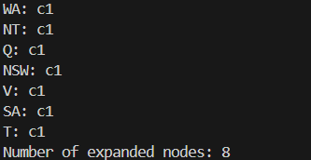

1. cryptoarithmethic, n=2: TXWO + TXWO = FOWXR

>python general_csp.py 2 P3 problem.txt



> python general_csp.py MRV DH LCV CP problem.txt

Search continues forever.

The outputs are the opposite of the expected output.