“The impact of internal control systems on organizational commitment: Employee participation as a moderator”

AUTHORS | Emad Waladali 
ARTICLE INFO | Emad Waladali (2022). The impact of internal control systems on organizational commitment: Employee participation as a moderator. Problems and Perspectives in Management, 20(1), 514-531. doi:10.21511/ppm.20(1).2022.41
DOI | http://dx.doi.org/10.21511/ppm.20(1).2022.41
RELEASED ON | Tuesday, 05 April 2022
RECEIVED ON | Thursday, 13 January 2022
ACCEPTED ON | Friday, 25 March 2022
LICENSE |   This work is licensed under a Creative Commons Attribution 4.0 International License
JOURNAL | "Problems and Perspectives in Management"
ISSN PRINT | 1727-7051
ISSN ONLINE | 1810-5467
PUBLISHER | LLC “Consulting Publishing Company “Business Perspectives”
FOUNDER | LLC “Consulting Publishing Company “Business Perspectives”

  NUMBER OF REFERENCES  88 |   NUMBER OF FIGURES  5 |   NUMBER OF TABLES  5
© The author(s) 2022. This publication is an open access article.
 |   LLC “СPС “Business Perspectives”  Hryhorii Skovoroda lane, 10,  Sumy, 40022, Ukraine  www.businessperspectives.org | Emad Waladali (Palestine)  The impact of internal  control systems  on organizational  commitment:  Employee participation  as a moderator
 | Received on: 13th of January, 2022  Accepted on: 25th of March, 2022  Published on: 5th of April, 2022  © Emad Waladali, 2022  Emad Waladali, Ph.D., Department of  Business Administration, Faculty of  Administrative and Financial Sciences,  Arab American University, Palestine. | Abstract  Palestinian companies nowadays realize the importance of performance management systems. This study examines the moderating effect of employee participation in the relationship between internal control systems and organizational commitment of employees in Palestinian service companies. A questionnaire was designed using Google Docs and distributed randomly via e-mail among 174 employees working in Palestinian service companies. A structural equation modeling, using AMOS V26, was used to test the hypotheses. The findings showed that internal control systems has a significant positive impact on organizational commitment (β = 0.77; p-value = 0.000). While the justice dimension of internal control systems has a significant positive impact on organizational commitment (β = 0.52; p-value = 0.007), the accuracy dimension was found insignificant (β = 0.26; p-value = 0.178).  Regarding the moderating effect, neither the interaction between the internal control systems and employee participation (β = –0.031; p-value = 0.465) nor the justice dimension was significant (β = 0.103; p-value = 0.203). Nevertheless, the interaction between the accuracy dimension and employee participation was negative (β = –0.14; p-value = 0.034). This study yielded support for the importance of internal control systems. Employees who perceived the internal control systems to be effective have higher organizational commitment. Therefore, managers, especially HR managers, in service companies should pay more attention to the internal control systems, especially its justice dimension, to gain the benefits of committed employees.
 |  | Keywords | perceived accuracy, perceived fairness, internal control systems, organizational commitment, Palestinian service companies, structural model
 |  | JEL Classification | O15, M12
   | This is an Open Access article,  distributed under the terms of the  Creative Commons Attribution 4.0  International license, which permits  unrestricted re-use, distribution, and  reproduction in any medium, provided  the original work is properly cited.  Conflict of interest statement:  Author(s) reported no conflict of interest | INTRODUCTION  Nowadays many organizations face challenges due to high competition, dynamic and complex environments, and increased customer demands. Therefore, organizations need to consider all factors that help to survive in such an environment. It was proved that organizational commitment positively influences many employee attitudes such as job performance, absenteeism, and turnover (Breitsohl & Ruhle, 2013), performance (Meyer et al., 1989; Meyer et al., 2002; Chen & Francesco, 2003; Bizri et al., 2021), organizational citizenship behavior (Meyer et al., 2002), work engagement (Gelderen & Bik, 2016), and job involvement (Singh & Gupta, 2015). Since employees may have different levels of commitment types (Meyer et al., 1993), and different types of
commitment have different impacts on employee willingness to achieve organizational goals (Allen & Meyer, 1990), the coronavirus pandemic may generate different types of commitment. Thus, organizations must look for factors that create and increase employee organizational commitment because it is the most beneficial type of commitment.
How employees perceive the effectiveness of a performance management system is critical to its success. Sharma et al. (2016) found that internal control systems (ICS) has two ingredients: perceived accuracy and perceived justice. Therefore, there is a need to examine the extent to which the two-factor construct exists in the Palestinian environment and examine the influence of internal control systems (accuracy and fairness) on employee outcomes such as organizational commitment.
Although the importance of organizational commitment is highlighted in previous research, it is important to investigate Palestinian organizations for several reasons: the cultural factor of the Palestinian environment, the high unemployment rate, and the coronavirus pandemic.
There is scarce research that addresses the relationship between perceived accuracy and organizational commitment. Although Scheller and Harrison (2018), Lee and Wei (2017), Simons and Roberson (2003), and Ohana et al. (2013) addressed the relationship between different types of perceived justice and organizational commitment, none of them investigated the effect of both dimensions on organizational commitment nor the moderating role of employee participation.

1. LITERATURE REVIEW AND HYPOTHESES DEVELOPMENT
Many scholars defined employee performance management. In general, it is an ongoing process to ensure that employee activities contribute to achieving organizational goals (Glendinning, 2002; Biron et al., 2011; Dessler, 2013, p. 286). Performance management has revolutionized from performance appraisal, which denotes estimating employee performance against predefined performance standards (Dessler, 2013, p. 284). While performance appraising is a single activity (Decramer et al., 2013), performance management is a multiactivity process, e.g., planning, acting, monitoring, and reviewing (Armstrong, 2006, p. 337). Moreover, performance management reflects the strategic fit between HRM and organizational strategy (Decramer et al., 2013). Therefore, PMS should be distinguished from performance appraisal or performance measurements (Aguinis et al., 2011; Amaratunga & Baldry, 2002; Waeyenberg et al., 2017; Sharma et al., 2016).
Effectiveness denotes performing activities that lead to goals achievement (Robbins & Coulter,
2018, p. 8). Therefore, effective PMS can refer to a performance management system that produces desired outcomes associated with the performance management process. According to Sharma et al. (2016), it is the degree to which PMS meets its objectives (i.e., rewarding good performers; managing bad performers (Lawler, 2003); decisions and activities aligned with organization strategic objectives (Bento & Bento, 2006); increasing employee retention and performance (Haines & St-Onge, 2012; Lawler, 2003); enhancing integration between HRM components (Bevan & Thompson, 1991).
The question here is why PMS may not be effective. Many researchers proposed different answers to this question. The reason for ineffective PMS can be divided into technical, related to PMS itself, and non-technical. Technical reasons include the content of PMS (i.e., what are the elements included in the PMS) (Rademan & Vos, 2001; Furnham, 2004). In addition, there could be an improper implementation of the system (Glendinning, 2002; Hazard, 2004). According to Grensing-Pophal (2001), PMS is a complex process; it is not connected to rewards and is not under control. Non-technical reasons include employees’ doubt of the credibility of PMS (Sharma et al., 2016),
organizations focusing on appraising performance rather than managing it (Aguinis et al., 2011), lack of understanding of the factors that enhance PMS (Biron et al., 2011), managers not providing feedback (Mello, 2014, p. 452), and organizations not improving performance (Grensing-Pophal, 2001).
Scholars proposed different measures of effective PMS. Yu et al. (2018) measured it by achieving process outcomes and organizational performance. Lawler (2003) distinguished between two types of effectiveness: effective PMS, measured through the results of the PMS (i.e., developing individual skills and knowledge), and differentiation effectiveness, differentiating between employees in terms of performance. Moreover, Baird et al. (2012) divide the Lawler’s effective PMS scale into staff-related and performance-related outcomes. According to Sharma et al. (2016), employee acceptance of PMS is critical to being effective. Moreover, PMS if considered effective when employees perceive it as fair in respect of distribution, procedures, and interaction (DeNisi & Pritchard, 2006). Sharma et al. (2016) measured internal control systems through perceived accuracy and perceived fairness.
Factors affecting ICS include rater training, clear communication of performance expectations, and involvement of senior management (Biron et al., 2011; Lawler, 2003); connecting PMS outcomes with a reward system (Lawler, 2003; Baird et al., 2012); and the existence of ongoing feedback and behavior-based measurement (Lawler, 2003). Literature shows that some factors enhance the effectiveness of PMS, such as supervisor training (Haines & St-Onge, 2012) and good academic backgrounds (Rao, 2007).
Organizational justice (OJ) is about how employees perceive equality among employees (Imamoglu et al., 2019). Therefore, in the context of ICS, OJ can refer to the perceived equality of PMS. It has been widely researched since 1990 due to its importance (Cohen-Charash & Spector, 2001). In the context of performance appraisal, justice has a critical role. According to Leung et al. (2001) and Flint (1999), employees respond favorably when the appraising system is fair. Moreover, employee performance may decrease in specific fields if they perceive its rating as unfair (Flint, 1999).
Distributional justice (DIJ) is how employees perceive the fairness of the distribution of organizational outcomes (Ghumman, 2021). Employees usually perceive DIJ through the ratio of the outputs (i.e., rewards, recognition) to input (i.e., educational level, performance). Although DIJ does not have a substantial impact on performance (Konovsky & Cropanzano, 1991), it predicts citizenship behavior in the organizations (Cohen-Charash & Spector, 2001; Zhang & Agarwal, 2009), as well as OC (Scheller & Harrison, 2018). Antecedents of DIJ include empowerment and psychological contract (Zhang & Agarwal, 2009).
Procedural justice (PRJ) is related to the fairness of organizational procedures used to distribute organizational outcomes (Cohen-Charash & Spector, 2001; Imamoglu et al., 2019). Despite the unfair distribution of corporate products, the employee’s perception of justice is more significant if he thinks that the procedures used to distribute organizational outcomes are fair. In ICS, PRJ refers to the fairness of methods used in the PMS. PRJ is related to many employee’s attitudes in the organization. For example, job performance and unproductive work behavior (Cohen-Charash & Spector, 2001), organizational citizenship behavior (Cohen-Charash & Spector, 2001; Zhang & Agarwal, 2009; Moorman, 1991), and OC (Ohana et al., 2013). According to Erdogan (2002), due process, satisfactory notice, rightful hearing, and evidence-based judgment predict PRJ.
Interactional justice is the perceived fairness of interaction between managers and employees during the PMS process (Erdogan, 2002). Since a supervisor is responsible for implementing organizational procedures, according to Moorman (1991) and Masterson et al. (2000), he/she is the source of interactional fairness, and the organization is the source of PRJ. Colquitt (2001) splits interactional justice into two different constructs: interpersonal justice (INJ) and informational justice (IFJ). INJ is concerned with how a supervisor treats an employee. In IFJ, employees perceive justice when decisions made regarding the employee are explained. INJ has a positive impact on several employee attitudes. For example, INJ positively affects OC (Lee & Wei, 2017; Simons & Roberson, 2003) and organizational citizenship behavior (Zhang & Agarwal, 2009). IFJ also has an impact
on employee attitudes. Leung et al. (2001) show that even criticism, when associated with high INJ, will result in a favorable disposition toward a supervisor and more acceptance of feedback.
Organizational commitment (OC) is the degree to which an employee wishes to stay a member of the organization (Colqitt et al., 2015, p. 64). OC was significantly researched during the 1990s (Meyer et al., 2002). In addition, practitioners tried to use OC to attract, retain, and develop employees and improve their performance (Mercurio, 2015).
The most popular form to study OC is Mayer and Allen’s model, composed of three components (Jaros, 2007). This model suggests that the employees feel connection with their organization because they want to (affective), they ought to (normative), and they need to (continuance) (Jayasingam et al., 2016), or as described by Jaros (2017), they feel emotional connection, obligation-based connection, and cost-based connection respectively. Normative commitment (NC) can be divided into two dimensions: “moral duty” – a high level of OC, and “indebted obligation” – a high level of CC (Meyer & Parfyonova, 2010).
Meyer and Allen (1984) first introduced the concept of organizational commitment (OC). OC “is about emotional attachment to, identification with, and involvement in the organization” (Meyer et al., 2002; Meyer et al., 1989). It is the core of OC (Mercurio, 2015). However, it should be distinguished from attachment to a supervisor or workgroup (Vandenberghe et al., 2021).
OC is considered vital because it has a favorable impact on employee-relevant and organization-relevant outcomes. Regarding organizational-relevant results, OC positively affects employee performance (Meyer et al., 1989; Meyer et al., 2002; Chen & Francesco, 2003; Bizri et al., 2021); attendance, and organizational citizenship behavior (Meyer et al., 2002); work engagement (Gelderen & Bik, 2016); job involvement, and team commitment (Singh & Gupta, 2015); and talent and leadership development practices (Chami-Malaeb & Garavan, 2013). Regarding employee-relevant outcomes, OC positively affects stress and work-family conflict outcomes (Meyer et al., 2002).
Many organizational factors can enhance employees’ OC. For example, they include PRJ (Cheng, 2014), human resource (HR) system strength meta‐features (Bos‐Nehles et al., 2021), transformational leadership (Ribeiro et al., 2018; Allen et al., 2017), congruence between espoused and enacted organizational values (Howell et al., 2012), and perceived corporate social responsibility (Papacharalampous & Papadimitriou, 2021). Moreover, organizational culture, which is based on mutual trust (Curado & Vieira, 2019), performance management (Asamany & Shaorong, 2018), interactional justice (Lee & Wei, 2017), internal consistency of PMS (Waeyenberg et al., 2017; Casimir et al., 2014), and managers’ coaching skills (Ribeiro et al., 2021), can influence employees’ OC. Furthermore, base pay level among knowledge workers (Kuvaas, 2006), effective enactment of HR practices and the effective relations-oriented leadership behavior of line managers (Gilbert et al., 2011), and networking, trying to create and keep relationships with others for mutual benefits in their career, within one’s organization (Forret & Dougherty, 2001) are of great importance.
On the other hand, some factors undermine employees’ OC. For example, they are task-oriented leadership (Hong et al., 2016), leader surface acting (Moin, 2018), and content plateauing (Tremblay, 2021).
Organizational culture construct has been widely used in the literature (Ghosh & Srivastava, 2014). According to Robbins and Judge (2017, p. 565), organizational culture is “a system of shared meanings held by members that distinguish the organization from other organizations.” There are no agreements on the dimensions of corporate culture (Ghosh & Srivastava, 2014). Ghosh and Srivastava (2014) identified seven dimensions of corporate culture: trust, openness, freedom to experience, individualism and attitude toward constructive dissent, result orientation, and employee participation. Employee participation is when employees’ views are considered, and they can express their ideas freely (Ghosh & Srivastava, 2014). In previous studies, employee participation was found to impact OC (Abdulkadir et al., 2012; Bhatti et al., 2011) and OC (Grund & Titz, 2021).
Few studies examine the moderating role of employee participation in the relationship between
internal control systems and organizational commitment. Therefore, the aim of this paper is to examine the effect of ICS on organizational commitment and the moderating role of employee participation in the relationship between internal control systems and its sub-dimensions on organizational commitment in Palestinian service companies. Namely, this study set out to answer the following questions:
1. Does the two-factor construct of ICS valid in the Palestinian context?
2. Does the internal control systems influence organizational commitment?
3. Does employee participation affect organizational commitment?
4. Does employee participation affect the relationship between internal control systems and organizational commitment?
5. Which dimension of the internal control systems has more effect on organizational commitment?
Following the review of the literature, this paper investigates the moderating role of employee participation on the relationship between internal control systems and organizational commitment in the context of Palestinian service companies. Thus, the following hypotheses were formulated:
H1: ICS is positively related to organizational commitment.
H1.1: The accuracy dimension of ICS is positively related to organizational commitment.
H1.2: Justice dimension of ICS is positively related to organizational commitment.
H2: Employee participation (EPA) moderates the relationship between ICS and organizational commitment (higher EPA strengthens the positive relationship between ICS and organizational commitment).
H2.1: Employee participation (EPA) moderates the relationship between the accuracy dimension of ICS and organizational commitment (higher EPA strengthens the positive relationship between the accuracy dimension and organizational commitment).
H2.2: Employee participation (EPA) moderates the relationship between the justice dimension of ICS and organizational commitment (higher EPA would strengthen the positive relationship between the justice dimension and organizational commitment).
2. METHODOLOGY
The data were collected using an online questionnaire through Google Docs distributed via e-mail. Therefore, all responses were valid, and there were no missing data. The target population includes employees from different service companies operating in Palestine during November and December 2021. Aa a result, 175 questionnaires were retrieved. The demographics of the respondents are illustrated in Table 1. The questionnaire was designed in English. Qualified experts translated it into Arabic to guarantee its consistency. Next, university professors in human resource management, accounting, finance, and business administration were asked to review the questionnaire’s items to ensure their quality. The questionnaire covered all measures in the study (personal data, independent variables, and dependent variable) using a 5-point Likert scale.
The survey consists of four parts. The first part includes items regarding OC. The second part contains items regarding ICS. The third part contains items regarding employee participation, and the fourth part includes questions regarding the users’ demographic data.
Jaros’ (2007) scale used the commitment scale, which modified Allen and Meyer’s (1990) scale. In organizational commitment, the first statement in Allen and Meyer’s (1990) scale was replaced by “I am very happy being a member of this organization.” Internal control systems has two factors. First, employee perception of PMS accuracy is
Table 1. Descriptive statistics of demographics
Item | Frequency | Percentage (%)
Gender
Male | 135 | 77.1
Female | 40 | 22.9
Education level
High school or below | 4 | 2.3
Diploma (2 years) | 15 | 8.6
1st university degree (4 years) | 86 | 49.1
Post-graduate studies | 70 | 40
Age
Under 25 | 7 | 4
25 and less than 35 | 47 | 26.9
35 and less than 45 | 68 | 38.9
45 and over | 53 | 30.2
Experience
Less than 5 years | 21 | 12
5 years and less than 10 | 40 | 22.9
10 years and less than 15 | 33 | 18.9
15 years and over | 81 | 46.2

adopted from Sharma et al. (2016). Although Sharma et al. (2016) used a 7-points Likert scale, this paper used a 5-points Likert scale. Second, employee perception of PMS fairness was adopted from Colquitt (2001). According to Sharma et al. (2016), the items of organizational justice generated by Colquitt (2001) can be tailored to specific contents. Therefore, perceived corporate justice items are tailored to reflect the employee perception of PMS fairness. Finally, the employee participation scale was adopted from Ghosh and Srivastava (2014) as shown in Appendix A.
3. RESULTS
The reliability was measured through Cronbach’s α indicator. According to Sekaran and Bougie (2010, p. 290), values of 0.7 and above are considered acceptable. All the variables in the study obtained excellent bargains, as illustrated in Table 2. Next, the paper employed confirmatory factor analysis to examine convergent and divergent validity. This analysis tested convergent validity through standardized factor loading. Items with factor loading less than 0.5 were removed. Therefore, items OC4R, OC5R, OC5R, and EPA3 were deleted from the dataset, as their loadings were 0.037, 0.409, 0.492, and 0.403, respectively. The coefficients of the remaining items were significantly different from zero, and the loadings between latent and observed variables were above the cut-off
point in all cases. Therefore, according to Bollen (1989), the latent variable explains the observed variables adequately.
To examine discriminant validity, analysis results show that the variances differed from zero and significant. In addition, the correlation between each pair of scales was not above 0.8. Since there is a weak relationship among the constructs, it is confirmed that there are three constructs in the model. Moreover, the reliability and validity of the scale were tested using different methods drawn from the confirmatory factor analysis. The average variance extracted (AVE), with 0.5 as a reference point, and composite reliability (CR), with 0.7 as a reference point, were used. The values obtained exceeds the threshold (Bollen, 1989; Hair et al., 1995) except for performance review accuracy (PRA) (AVE = 0.474 and CR = 0.728), as illustrated in Table 2.
After collecting the data, common method bias (CMB) was detected. Harman’s single factor was tested to evaluate the impact of CMB through component factor analysis (Podsakoff et al., 2003). The findings showed ten significant factors with eigenvalues of more than 1; the first factor explains 37.66% of the variance, which is below the cut-off point (0.5) according to Hulland et al. (2018). Therefore, it is concluded that data is free of CMB.
This study also tests for multivariate outliers in structural model data using AMOS v.26 through
Table 2. Convergent validity and internal consistency reliability
Variable | Item | β | Cronbach’s Alpha | CR | AVE
Performance planning accuracy (PPA) | PPA1 | 0.878 | 0.785 | 0.825 | 0.616
Performance planning accuracy (PPA) | PPA2 | 0.828 | 0.785 | 0.825 | 0.616
Performance planning accuracy (PPA) | PPA3 | 0.626 | 0.785 | 0.825 | 0.616
Feedback and coaching accuracy (FCA) | FCA1 | 0.639 | 0.767 | 0.780 | 0.544
Feedback and coaching accuracy (FCA) | FCA2 | 0.796 | 0.767 | 0.780 | 0.544
Feedback and coaching accuracy (FCA) | FCA3 | 0.768 | 0.767 | 0.780 | 0.544
Performance review accuracy (PRA) | PRA1 | 0.523 | 0.702 | 0.716 | 0.463
Performance review accuracy (PRA) | PRA 2 | 0.716 | 0.702 | 0.716 | 0.463
Performance review accuracy (PRA) | PRA 3 | 0.776 | 0.702 | 0.716 | 0.463
Outcomes accuracy (OUA) | OUA1 | 0.581 | 0.817 | 0.842 | 0.648
Outcomes accuracy (OUA) | AOU 2 | 0.909 | 0.817 | 0.842 | 0.648
Outcomes accuracy (OUA) | OUA 3 | 0.883 | 0.817 | 0.842 | 0.648
Procedural justice (PRJ) | PRJ1 | 0.742 | 0.900 | 0.899 | 0.598
Procedural justice (PRJ) | PRJ 2 | 0.811 | 0.900 | 0.899 | 0.598
Procedural justice (PRJ) | PRJ 3 | 0.843 | 0.900 | 0.899 | 0.598
Procedural justice (PRJ) | PRJ 4 | 0.794 | 0.900 | 0.899 | 0.598
Procedural justice (PRJ) | PRJ 5 | 0.701 | 0.900 | 0.899 | 0.598
Procedural justice (PRJ) | PRJ 6 | 0.74 | 0.900 | 0.899 | 0.598
Distributive justice (DIJ) | DIJ1 | 0.823 | 0.917 | 0.909 | 0.715
Distributive justice (DIJ) | DIJ 2 | 0.834 | 0.917 | 0.909 | 0.715
Distributive justice (DIJ) | DIJ 3 | 0.828 | 0.917 | 0.909 | 0.715
Distributive justice (DIJ) | DIJ 4 | 0.895 | 0.917 | 0.909 | 0.715
Interpersonal justice (INJ) | INJ 1 | 0.849 | 0.910 | 0.916 | 0.733
Interpersonal justice (INJ) | INJ 2 | 0.953 | 0.910 | 0.916 | 0.733
Interpersonal justice (INJ) | INJ 3 | 0.913 | 0.910 | 0.916 | 0.733
Interpersonal justice (INJ) | INJ 4 | 0.686 | 0.910 | 0.916 | 0.733
Informational justice (IFJ) | IFJ 1 | 0.787 | 0.937 | 0.938 | 0.751
Informational justice (IFJ) | IFJ 2 | 0.896 | 0.937 | 0.938 | 0.751
Informational justice (IFJ) | IFJ 3 | 0.912 | 0.937 | 0.938 | 0.751
Informational justice (IFJ) | IFJ 4 | 0.903 | 0.937 | 0.938 | 0.751
Informational justice (IFJ) | IFJ 5 | 0.828 | 0.937 | 0.938 | 0.751
Organizational commitment (OC) | OC 1 | 0.933 | 0.857 | 0.867 | 0.574
Organizational commitment (OC) | OC 2 | 0.832 | 0.857 | 0.867 | 0.574
Organizational commitment (OC) | OC 3 | 0.719 | 0.857 | 0.867 | 0.574
Organizational commitment (OC) | OC 7 | 0.734 | 0.857 | 0.867 | 0.574
Organizational commitment (OC) | OC8R | 0.501 | 0.857 | 0.867 | 0.574
Employee participation (EPA) | EPA1 | 0.832 | 0.841 | 0.898 | 0.747
Employee participation (EPA) | EPA2 | 0.938 | 0.841 | 0.898 | 0.747
Employee participation (EPA) | EPA4 | 0.818 | 0.841 | 0.898 | 0.747
Note: β – standardized regression weight, AVE – average variance extracted, α – Cronbach’s alpha, CR – composite reliability.

the Mahalanobis distance test. The P1 value of Mahalanobis distance for each item was used to detect multivariate outliers with 0.001 as a cut-off point. Therefore, all entries with P1 values less than the cut-off point are considered an outlier (Pollet & Meij, 2017). The result revealed that there are seven outliers. Therefore, they were removed from the dataset, leaving 168 valid questionnaires for further analysis.
Table 3 shows that the measurement model has a good fit. The value of CMIN/DF is (1.627), and the standardized root mean square residuals
(SRMR) are 6.5%, which is in the accepted range. Moreover, the root mean square error of approximation (RMSEA) = 6.1%, which is below the cut-off point (8%), according to Hu and Bentler (1999). Comparative fit model (CFI) = 91.5%, and Trucker-Lewis Index (TLI) = 90.8%. The values implied a goodness fit model, according to Hair et al. (2013). Thus, the study concludes that the minimum values of the goodness of fit model were obtained.
The hypotheses are tested using structural equation modeling (SEM). The study opted for the
Table 3. Goodness-of-fit indicators in the measurement model
Fit indices | Recommended value | Value in the model
CMIN/DF | 2 < CMIN/DF < 5 | 1.627
CFI | > 0.90 | 0.915
TLI | > 0.90 | 0.908
IFI | > 0.90 | 0.916
SRMR | < 0.08 | 0.065
RMSEA | < 0.08 | 0.061
Note: CMIN/DF – normal chi-square/degrees of freedom; CFI – comparative goodness of fit; TLI – Tucker-Lewis Index; IFI – incremental fit index; SRMR – standardized root mean square residual; RMSEA – root mean square error of approximation.

maximum likelihood estimation method since the multivariate normality was violated (CR for kurtosis was 25.182). Moreover, the maximum likelihood is preferable when there is a small sample size (West et al., 1995). The values of the proposed model (Table 4) indicate a good model fit (Hu & Bentler, 1999): RMSEA = 6.7%, CFI = 90.5%.
Table 4. Goodness-of-fit indicators in the structural model
Fit indices | Recommended value | Value in the model
CMIN/DF | 2 < CMIN/DF < 5 | 1.756
CFI | > 0.90 | 0.905
TLI | > 0.90 | 0.896
IFI | > 0.90 | 0.906
SRMR | < 0.08 | 0.073
RMSEA | < 0.08 | 0.067
Note: CMIN/DF – normal chi-square/degrees of freedom; CFI – comparative goodness of fit; TLI – Tucker-Lewis Index; IFI – incremental fit index; SRMR – standardized root mean square residual; RMSEA – root mean square error of approximation.
Table 5 and Figures 1-5 shows the results of the SEM analysis for the main hypotheses and the sub hypotheses results. It is revealed that the main hypothesis (Figure 1) result is significant. H1, which proposed a positive relationship between ICS and organizational commitment, was confirmed (β = 0.77; p-value = 0.000), which indicates that ICS stimulates strong employee commitment in Palestinian service companies.
H1.1, which stated a positive impact of accuracy dimension of ICS on organizational commitment, was not confirmed (β = 0.26; p-value = 0.178), showing that the accuracy dimension of ICS does not stimulate employee commitment in Palestinian service companies. On the other hand, H1.2, which proposed a positive impact of justice dimension of ICS on organizational commitment, was confirmed (β = 0.52; p-value = 0.007), showing that the fairness dimension of ICS stimulates strong employee commitment in Palestinian service companies (Figure 2).
H2, which proposed that employee participation strengthens the relationship between ICS and organizational commitment, was insignificant. Employee participation does not affect the relationship between ICS and organizational commitment. In the interaction model, the impact of ICS (β = 0.37; p-value = 0.000) and the impact of EPA (β = 0.42; p-value = 0.000). Nevertheless, results show that the interaction between the two constructs is insignificant (β = –0.031; p-value = 0.465), as illustrated in Figure 3.
H2.1, which stated that employee participation moderates the relationship between the accuracy dimension of ICS and organizational commitment, was significant (Figure 4). In the interaction model, the impact of accuracy dimension on
Table 5. Hypotheses testing
Hypothesis | Effect | Standardized Regression Weight | S.E. | Sig. | Support
H1 | ICS → OC | 0.77 | 0.219 | *** | Yes
H1.1 | ACC → OC | 0.26 | 0.351 | 0.178 | No
H1.2 | JUS → OC | 0.52 | 0.251 | 0.007 | Yes
H2 | ICS_x_EPA → OC | –0.06 | 0.044 | 0.27 | No
H2.1 | ACC_X_EPA → OC | –0.17 | 0.065 | 0.034 | Yes
H2.2 | JUS_X_EPA → OC | 0.10 | 0.067 | 0.203 | No

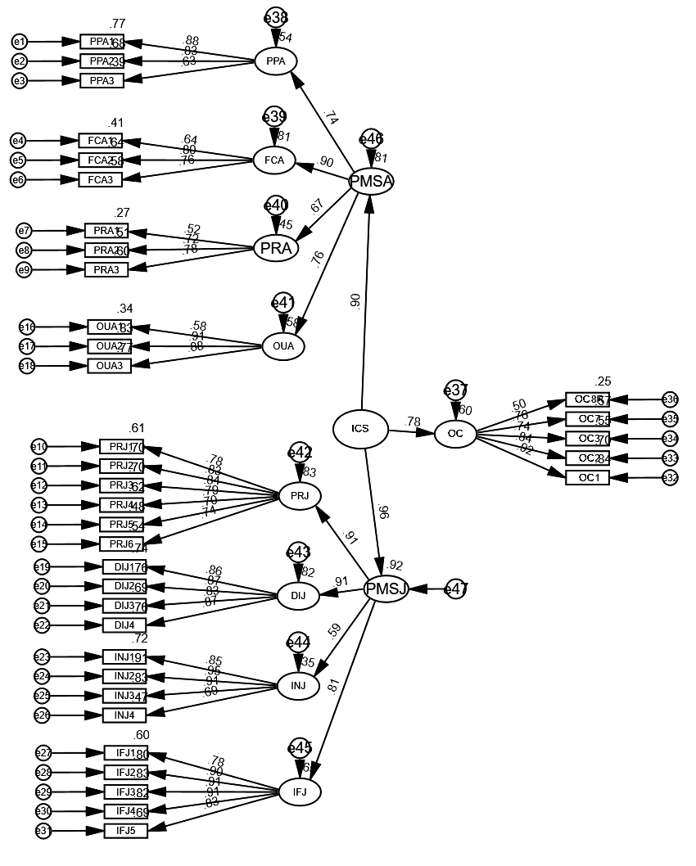
Figure 1. Structural model 1

organizational commitment was found insignificant (β = 0.037; p-value = 0.639), the influence of employee participation on organizational commitment was found significant (β = 0.457; p-value = 0.000), and the impact of interaction on organizational commitment was significant (β = –0.14; p-value = 0.034). However, Figure 5 showed that a higher level of employee participation diminishes the effect of the ICS accuracy on organizational commitment.
H2.2, which proposed that employee participation strengthens the relationship between
the justice dimension of ICS and organizational commitment, was insignificant. In the interaction model, the impact of justice on organizational commitment was found significant (β = 0.305; p-value = 0.000), the effect of employee participation on organizational commitment was found significant (β = 0.457; p-value = 0.000), and the impact of interaction on organizational commitment was seen insignificant (β = 0.103; p-value = 0.203). Therefore, employee participation does not moderate the relationship between justice dimension and organizational commitment.
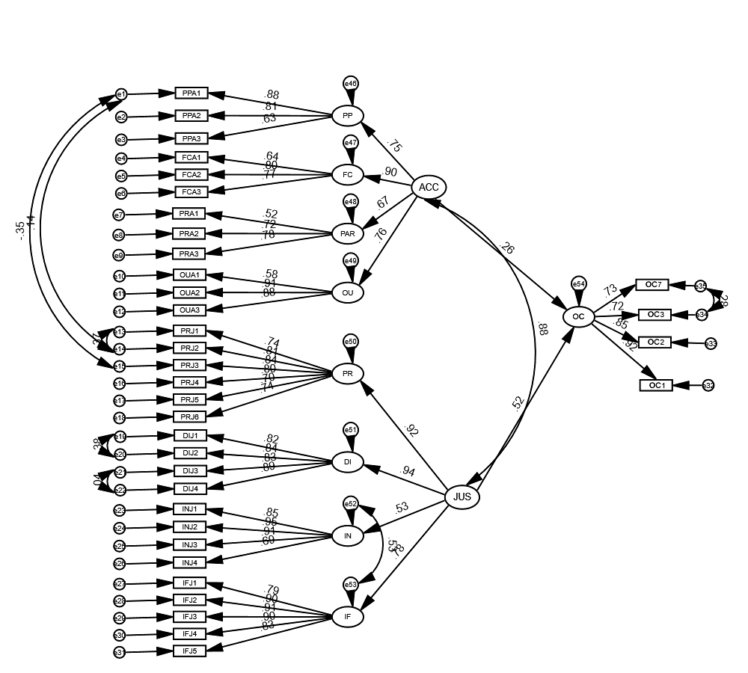
Figure 2. Structural model 2
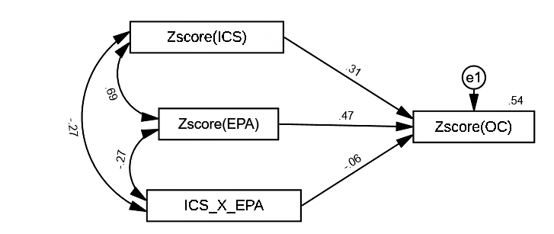
Figure 3. Interaction model 1
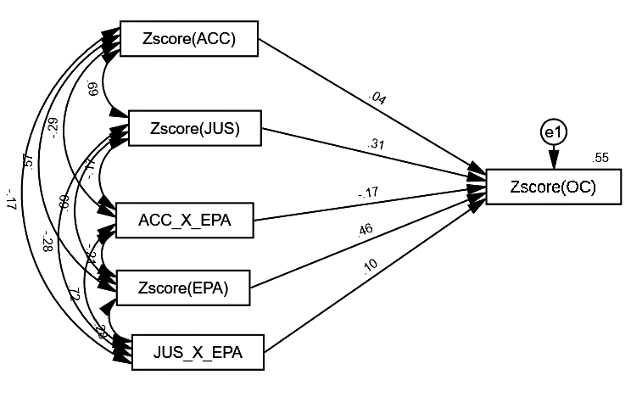
Figure 4. Interactional model 2
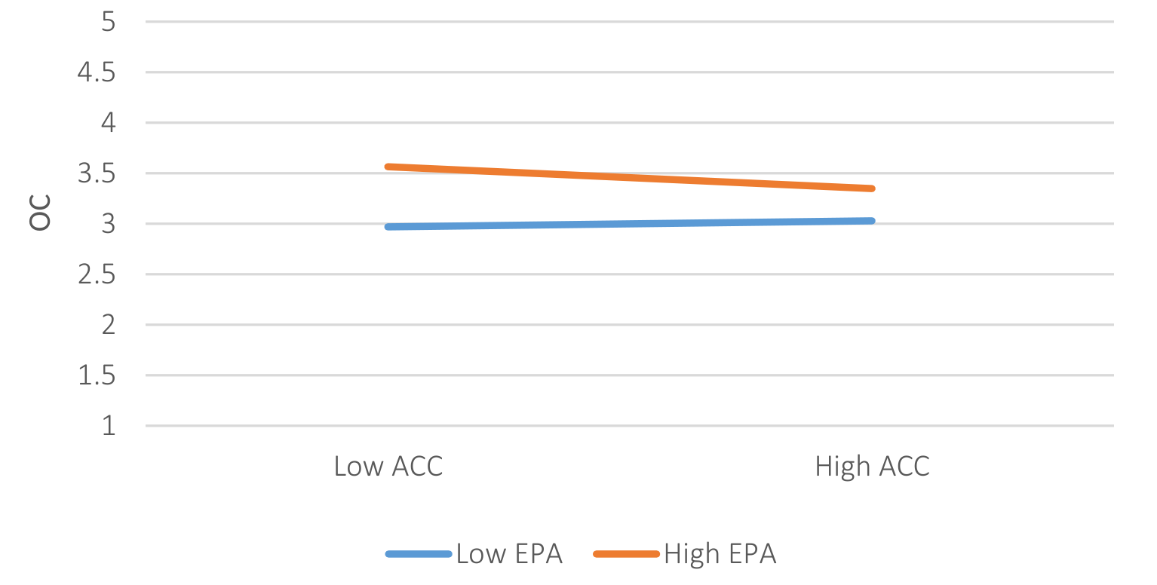
Figure 5. Interaction graph

4. DISCUSSION
Organizational commitment has received great attention from scholars. However, internal control systems is a new construct. Therefore, few studies analyzed the impact of ICS on other employees’ outcomes. Hence, this paper helps understand the impact of ICS on organizational commitment in Palestinian service companies and the moderating role of employee participation in this relationship.
The paper enlarges the existing body of knowledge by testing the composite construct of ICS and its sub-dimensions on organizational commitment. Moreover, it highlights the role of the justice
dimension of ICS in enhancing the level of organizational commitment in the organization. Finally, it highlights the role of employee participation in this relationship. From a theoretical point of view, this study extends the existing explanation of ICS and its impact on organizational commitment. This study also examines the perceived justice in the context of the performance management system. Thus, it can be considered a critical step forwarding in directing theories regarding ICS effects and its sub-dimensions, mainly the accuracy, that have received minimal attention in the Palestinian environment till today. The elaborated framework proposes that ICS positively influences organizational commitment, and employee participation strengthens such impact.
The results confirmed the two-factor construct of ICS as found in Sharma et al. (2016). Moreover, the results also confirm that accuracy is explained by four observed variables (performance planning accuracy, feedback and coaching accuracy, outcome accuracy, and performance review accuracy). The findings also indicate that ICS has a significant positive impact on organizational commitment. This result supports Sharma et al. (2016), who found that ICS positively impacts organizational commitment. It is also shown that the fairness dimension has a positive impact on organizational commitment. This result aligns with several studies that discussed the effect of organizational justice and its dimensions on organizational commitment (Ha & Ha, 2015; Lee & Wei, 2017; Simons & Roberson, 2003; Ohana et al., 2013; Scheller & Harrison, 2018). The impact of accuracy dimension on organizational commitment was found to be insignificant. This contradicts Berdicchia et al. (2021), who found that the accuracy dimension affects intrinsic and extrinsic motivation.
The paper also revealed that employee participation has a positive impact on OC. This result aligns with Bhatti et al. (2011) and Abdulkadir et
al. (2012), who found that employee participation improves commitment and productivity.
Surprisingly, results reveal that employee participation does not moderate the relationship between ICS and organizational commitment. In addition, employee participation does not moderate the relationship between the justice dimension and organizational commitment. Moreover, a high level of employee participation reduces the impact of perceived accuracy of PMS on organizational commitment. In other words, the more positive employee participation is, the more negative the effect of perceived accuracy of PMS on organizational commitment becomes. These results contradict other studies, such as Tremblay and Roger (2004), who found that employee participation reduces the negative consequences of career plateauing on job satisfaction. When employee participation is high, employees are encouraged to participate in meetings, speak out their opinions, and challenge the group. In the performance management context and Palestinian culture, employees may have disagreements, confront, and conflicts with their supervisors during the performance management phases. Therefore, this will lead to reducing organizational commitment.

CONCLUSION
This study aimed to test the moderating effect of employee participation in the relationship between ICS and organizational commitment. Results of the study indicate that ICS influences organizational commitment. While the justice dimension of ICS positively influences organizational commitment, the impact of accuracy dimension was insignificant. Moreover, employee participation reduces the impact of the accuracy dimension on organizational commitment.
Results prove the impact of ICS on organizational commitment. Thus, conclusions suggest that organizations should consider the performance management system. Thus, these systems must be developed carefully to illustrate effectiveness, as this will promote organizational commitment.
Managers should invest much effort to ensure the effectiveness of the performance management system. Although the accuracy dimension was found to be insignificant, when combined with the fairness dimension, the impact will be higher than the impact of the fairness dimension alone. Therefore, managers should guarantee the accuracy and the fairness of the performance management. For example, managers should integrate the phases of the performance management system. This may increase the consistency of the process and, therefore, increase its accuracy. Justice dimension has more influence on organizational commitment; therefore, it should receive more attention. Clear and precise procedures may be perceived as fair. Moreover, transparency and information available regarding the performance management process may increase its perceived fairness.
To ensure the internal control systems, employee involvement and acceptance of performance management systems is highly suggested. By doing so, employees’ organizational commitment will increase. This will enable companies to grasp the outcomes of committed employees, such as enhanced performance (Meyer et al., 1989; Meyer et al., 2002; Chen & Francesco, 2003; Bizri et al., 2021); higher organizational citizenship behavior (Meyer et al., 2002); higher work engagement (Gelderen & Bik, 2016); and higher job involvement (Singh & Gupta, 2015).
Since employee participation, in the context of the performance management system, has a negative moderating effect on organizational commitment, employee participation should be carefully managed.
Finally, this study may encounter several limitations. First, data were gathered from employees in service companies in Palestine. Second, the sample size was 175, which may seem a small sample. Therefore, the model should be tested in other geographic areas using a paper-based questionnaire. Since this study was conducted in a service company, further research is required in more specific areas, i.e., financial companies, or different contexts, i.e., industrial companies. Moreover, the unexpected results of the moderating role of employee participation require more investigation.
AUTHOR CONTRIBUTIONS
Conceptualization: Emad Waladali.
Data curation: Emad Waladali.
Formal analysis: Emad Waladali.
Funding acquisition: Emad Waladali.
Investigation: Emad Waladali.
Methodology: Emad Waladali.
Project administration: Emad Waladali.
Resources: Emad Waladali.
Software: Emad Waladali.
Supervision: Emad Waladali.
Validation: Emad Waladali.
Visualization: Emad Waladali.
Writing – original draft: Emad Waladali.
Writing – review & editing: Emad Waladali.
REFERENCES

1. Abdulkadir, D. S., Isiaka, S. B., &
Adedoyin, S. I. (2012). Effects of
strategic performance appraisal,
career planning and employee
participation on organizational
commitment: An Empirical
Study. International Business
Research, 5(4), 124-133. https://
doi.org/10.5539/ibr.v5n4p124
2. Aguinis, H., Joo, H., &
Gottfredson, R. K. (2011). Why
we hate performance management
– And why we should love it.
Business Horizons, 54(6), 503-507.
https://doi.org/10.1016/j.bush-
or.2011.06.001
3. Allen, G. W., Attoh, P. A., & Gong,
T. (2017). Transformational
leadership and affective
organizational commitment:
mediating roles of perceived social
responsibility and organizational
identification. Social Responsibility
Journal, 13(3), 585-600. https://doi.
org/10.1108/SRJ-11-2016-0193
4. Allen, N. J., & Meyer, J. P.
(1990). The measurement
and antecedents of affective,
continuance and normative
commitment to the organization.
Journal of Occupational
Psychology, 63(1), 1-18. https://
doi.org/10.1111/j.2044-8325.1990.
tb00506.x
5. Amaratunga, D., & Baldry, D.
(2002). Moving from performance
measurement to performance
management. Facilities,
20(5/6), 217-223. https://doi.
org/10.1108/02632770210426701
6. Armstrong, M. (2006). A
handbook of human resource
management practice (10th ed.).
London, United Kingdom: Kogan
Page Limited.
7. Asamany, A., & Shaorong, S.
(2018). The ripple effects of
performance management on
employees’ perceptions and
affective commitment among
small and medium scale
enterprises (SMEs). International
Journal of Business Administration,
9(1), 55-63. https://doi.
org/10.5430/ijba.v9n1p55
8. Baird, K., Schoch, H., &
Chen, Q. (2012). Performance
management system effectiveness
in Australian local government.
Paciﬁc Accounting Review,
24(2), 161-185. https://doi.
org/10.1108/01140581211258461
9. Bento, A., & Bento, B. (2006).
Factors affecting the outcomes
of performance management
systems. Journal of Information
Technology Management, 17(2),
23-32.
10. Berdicchia, D., Bracci, E., &
Masino, G. (2021). Disentangling
the effect of perceived
performance management system
accuracy on intrinsic and extrinsic
motivation. Meditari Accountancy
Research. https://doi.org/10.1108/
MEDAR-08-2020-0972
11. Bevan, S., & Thompson, M. (1991).
Performance management at the
crossroads. Personnel Management,
23(11), 9-36.
12. Bhatti, K. K., Nawab, S., &
Akbar, A. (2011). Effect of direct
participation on organizational
commitment. International
Journal of Business and Social
Science, 2(9), 15-23.
13. Biron, M., Farndale, E., &
Paauwe, J. (2011). Performance
management effectiveness: lessons
from world-leading ﬁrms. The
International Journal of Human
Resource Management, 22(6),
1294-1311. https://doi.org/10.1080
/09585192.2011.559100
14. Bizri, R., Wahbi, M., & Al
Jardali, H. (2021). The impact
of CSR best practices on job
performance: The mediating
roles of affective commitment
and work engagement. Journal
of Organizational Effectiveness:
People and Performance, 8(1),
129-148. https://doi.org/10.1108/
JOEPP-01-2020-0015
15. Bollen, K. A. (1989). A new
incremental fit index for general
structural equation models.
Sociological Methods & Research,
17(3), 303-316.
16. Bos‐Nehles, A., Conway, E., &
Fox, G. (2021). Optimising human
resource system strength in
nurturing affective commitment:
Do all meta‐features matter?
Human Resource Management
Journal, 31(2), 493-513. https://doi.
org/10.1111/1748-8583.12320
17. Breitsohl, H., & Ruhle, S. (2013).
Residual affective commitment
to organizations: Concept, causes
and consequences. Human
Resource Management Review,
23(3), 161-173.
18. Casimir, Ngee Keith Ng, Y., Yuan
Wang, K., & Ooi, G. (2014). The
relationships amongst leader-
member exchange, perceived
organizational support, affective
commitment, and in-role
performance: A social-exchange
perspective. Leadership &
Organization Development
Journal, 35(5), 366-385. https://doi.
org/10.1108/LODJ-04-2012-0054
19. Chami-Malaeb, R., & Garavan,
T. (2013). Talent and leadership
development practices as drivers
of intention to stay in Lebanese
organisations: The mediating role
of affective commitment. The
International Journal of Human
Resource Management, 24(21),
4046-4062. https://doi.org/10.1080
/09585192.2013.789445
20. Chen, Z. X., & Francesco, A.
M. (2003). The relationship
between the three components
of commitment and employee
performance in China. Journal
of Vocational Behavior, 62(3),
490-510. https://doi.org/10.1016/
S0001-8791(02)00064-7
21. Cheng, S. Y. (2014). The mediating
role of organizational justice
on the relationship between
administrative performance
appraisal practices and
organizational commitment. The
International Journal of Human
Resource Management, 25(8),
1131-1148. https://doi.org/10.1080
/09585192.2013.816864
22. Cohen-Charash, Y., & Spector, P.
E. (2001). The role of justice in
organizations: A Meta-Analysis.
Organizational Behavior and
Human Decision Processes, 86(2),
278-321. https://doi.org/10.1006/
obhd.2001.2958
23. Colqitt, J. A., Lepine, J. A.,
& Wesson, M. J. (2015).
Organizational behavior:
Improving performance and
commitment in the workplace (4th
ed.). New York, NY: McGraw-Hill.
24. Colquitt, J. A. (2001). On the
dimensionality of organizational
justice: A construct validation
of a measure. Journal of Applied
Psychology, 86(3), 386-400.
https://doi.org/10.1037//0021-
9010.86.3.386
25. Curado, C., & Vieira, S. (2019).
Trust, knowledge sharing and
organizational commitment
in SMEs. Personnel Review,
48(6), 1449-1468. https://doi.
org/10.1108/PR-03-2018-0094
26. Decramer, A., Smolders, C.,
& Vanderstraeten, A. (2013).
Employee performance
management culture and system
features in higher education:
relationship with employee
performance management
satisfaction. The International
Journal of Human Resource
Management, 24(2), 352-371.
https://doi.org/10.1080/09585192.
2012.680602
27. DeNisi, A. S., & Pritchard, R. D.
(2006). Performance appraisal,
performance management
and improving individual
performance: A motivational
framework. Management and
Organization Review, 2(2), 253-
277.
28. Dessler, G. (2013). Human
resource management (13th ed.).
Upper Saddle River, New Jersey,
USA: Pearson Education Inc.
29. Erdogan, B. (2002). Antecedents
and consequences of justice
perceptions in performance
appraisals. Human Resource
Management Review, 12(4), 555-
578. https://doi.org/10.1016/
S1053-4822(02)00070-0
30. Flint, D. H. (1999). The role of
organizational justice in multi-
source performance appraisal:
Theory-based applications and
directions for research. Human
Resource Management Review,
9(1), 1-20. https://doi.org/10.1016/
s1053-4822(99)00009-1
31. Forret, M. L., & Dougherty, T. W.
(2001). Correlates of networking
behavior for managerial and
professional employees. Group &
Organization Management, 26(3),
283-311. Retrieved from http://
homepages.se.edu/cvonbergen/
files/2013/01/Correlates-of-
Networking-for-Managerial-and-
Professional-Employees.pdf
32. Furnham, A. (2004). Performance
management systems. European
Business Journal, 16, 83-94.
33. Gelderen, B. R., & Bik, L. W.
(2016). Affective organizational
commitment, work engagement
and service performance among
police officers. Policing: An
International Journal of Police
Strategies & Management, 39(1),
206-221. https://doi.org/10.1108/
PIJPSM-10-2015-0123
34. Ghosh, S., & Srivastava, B.
K. (2014). Construction of
a reliable and valid scale for
measuring organizational
culture. Global Business Review,
15(3), 583-596. https://doi.
org/10.1177/0972150914535145
35. Ghumman, A.-M. (2021).
Organizational justice and
employees’ knowledge sharing
Behavior in Pakistan: Moderating
effect of perceived organizational
support. Academy of Strategic
Management Journal, 20(5), 1-20.
36. Gilbert, C., De Winne, S., & Sels,
L. (2011). The influence of line
managers and HR department on
employees’ affective commitment.
The International Journal of
Human Resource Management,
22(8), 1618-1637. https://doi.org/1
0.1080/09585192.2011.565646
37. Glendinning, P. M. (2002).
Performance Management: Pariah
or Messiah. Public Personnel
Management, 31(2), 161-178.
38. Grensing-Pophal, L. (2001).
Motivate managers to review
performance. HR Magazine, 46(3),
45-48. Retrieved from https://
www.shrm.org/hr-today/news/hr-
magazine/pages/0301pophal.aspx
39. Grund, C., & Titz, K. (2021).
Afective commitment
through further training:
The roles of firm provision
and employee participation.
Review of Managerial Science, 1-32.
https://doi.org/10.1007/s11846-
021-00460-1
40. Ha, J.-P., & Ha, J. (2015).
Organizational justice–affective
commitment relationship
in a team sport setting: The
moderating effect of group
cohesion – ERRATUM. Journal
of Management & Organization,
21(1), 107-124. https://doi.
org/10.1017/jmo.2014.67
41. Haines, V. Y., & St-Onge, S.
(2012). Performance management
effectiveness: practices or context?
The International Journal of
Human Resource Management,
23(6), 1158-1175. http://dx.doi.org
/10.1080/09585192.2011.561230
42. Hair, J. F., Anderson, R. E.,
Tatham, R. L., & Black, W. C.
(1995). Multivariate Data Analysis
(3rd ed.). New York: Macmillan
Publishing Company.
43. Hair, J. F., Ringle, C. M., &
Sarstedt, M. (2013). Partial
least squares structural
equation modeling: Rigorous
applications, better results and
higher acceptance. Long Range
Planning, 46(1-2), 1-12. Retrieved
from https://ssrn.com/ab-
stract=2233795
44. Hazard, P. (2004). Tackling
performance management
barriers. Strategic HR Review, 3,
3-7.
45. Hong, G., Cho, Y., Froese,
F. J., & Shin, M. (2016). The
effect of leadership styles, rank,
and seniority on affective
organizational commitment: A
comparative study of US and
Korean employees. Cross Cultural
& Strategic Management, 23(2),
40-362. https://doi.org/10.1108/
CCSM-03-2014-0034
46. Howell, A., Kirk-Brown, A., &
Cooper, B. K. (2012). Does
congruence between espoused
and enacted organizational values
predict affective commitment
in Australian organizations? The
International Journal of Human
Resource Management, 23(4), 731-
747. http://dx.doi.org/10.1080/095
85192.2011.561251
47. Hu, L.‐t., & Bentler, P. M. (1999).
Cutoff criteria for fit indexes in
covariance structure analysis:
Conventional criteria versus new
alternatives. Structural Equation
Modeling: A Multidisciplinary
Journal, 6(1), 1-55. https://doi.
org/10.1080/10705519909540118
48. Hulland, J., Baumgartner, H., &
Smith, K. M. (2018). Marketing
survey research best practices:
evidence and recommendations
from a review of JAMS articles.
Journal of the Academy of
Marketing Science, 46(1), 92-108.
49. Imamoglu, S. Z., Ince, H., Turkcan,
H., & Atakay, B. (2019). The
effect of organizational justice
and organizational commitment
on knowledge sharing and
firm performanc. Procedia
Computer Science, 158(2), 899-
906. https://doi.org/10.1016/j.
procs.2019.09.129
50. Jaros, S. (2007). Meyer and
Allen model of organizational
commitment: Measurement
issues. The Icfai 8 Journal of
Organizational Behavior, 6(10),
7-24.
51. Jayasingam, S., Govindasamy, M.,
& Singh, S. K. (2016). Instilling
affective commitment: Insights
on what makes knowledge
workers want to stay. Management
Research Review, 39(3), 266-288.
https://doi.org/10.1108/MRR-03-
2014-0060
52. Konovsky, M. A., & Cropanzano,
R. (1991). Perceived fairness
of employee drug testing as a
predictor of employee attitudes
and job performance. Journal of
Applied Psychology, 76(5), 698-707.
https://doi.org/10.1037/0021-
9010.76.5.698
53. Kuvaas, B. (2006). Work
performance, affective
commitment, and work
motivation: the roles of pay
administration and pay level.
Journal of Organizational Behavior,
27(3), 365-385. https://doi.
org/10.1002/job.377
54. Lawler, E. E. (2003). Reward
practices and performance
management system effectiveness.
Organizational Dynamics, 32(4),
396-404. https://doi.org/10.1016/j.
orgdyn.2003.08.007
55. Lee, J., & Wei, F. (2017). The
moderating effect of leadership on
perceived organizational justice
and affective commitment: a
study in China. The International
Journal of Human Resource
Management, 28(5), 679-702.
https://doi.org/10.1080/09585192.
2015.1109533
56. Leung, K., Su, S., & Morris, M.
W. (2001). When is criticism not
constructive? The roles of fairness
perceptions and dispositional
attributions in employee
acceptance of critical supervisory
feedback. Human Relations, 54(9),
1155-1187.
57. Masterson, S. S., Lewis, K.,
Goldman, B. M., & Taylor, M. S.
(2000). Integrating justice and
social exchange: The differing
effects of fair procedures and
treatment on work relationships.
Academy of Management Journal,
43(4), 738-748. https://doi.
org/10.5465/1556364
58. Mello, J. A. (2014). Strategic
human resource (4th ed.). Stamford,
USA: Cengage Learning.
59. Mercurio, Z. A. (2015). Affective
commitment as a core essence
of organizational commitment:
An integrative literature review.
Human Resource Development
Review, 14(4), 389-414. https://doi.
org/10.1177/1534484315603612
60. Meyer, J. P., & Allen, N. J. (1984).
Testing the “side-bet theory” of
organizational commitment: Some
methodological considerations.
Journal of Applied Psychology,
69(3), 372-378. https://doi.
org/10.1037/0021-9010.69.3.372
61. Meyer, J. P., & Parfyonova, N. M.
(2010). Normative commitment
in the workplace: A theoretical
analysis and re-conceptualization.
Human Resource Management
Review, 20(4), 283-294. https://doi.
org/10.1016/j.hrmr.2009.09.001
62. Meyer, J. P., Allen, N. J.,
& Catherine, A. (1993).
Commitment to organizations
and occupations: Extension
and test of a three-component
conceptualization. Journal of
Applied Psychology, 78(4), 538-551.
https://doi.org/10.1037/0021-
9010.78.4.538
63. Meyer, J. P., Paunonen, S.
V., Gellatly, I. R., Goffin, R.
D., & Jackson, D. N. (1989).
Organizational commitment and
job performance: It’s the nature
of the commitment that counts.
Journal of Applied Psychology,
74(1), 152-156. https://doi.
org/10.1037/0021-9010.74.1.152
64. Meyer, J. P., Stanley, D. J.,
Herscovitch, L., & Topolnytsky,
L. (2002). Affective, continuance,
and normative commitment
to the organization: A meta-
analysis of antecedents, correlates,
and consequences. Journal
of Vocational Behavior, 61(1),
20-52. https://doi.org/10.1006/
jvbe.2001.1842
65. Moin, M. F. (2018). The link
between perceptions of leader
emotion regulation and followers’
organizational commitment.
Journal of Management
Development, 37(2), 178-187.
https://doi.org/10.1108/JMD-01-
2017-0014
66. Moorman, R. H. (1991).
Relationship between
organizational justice and
organizational citizenship
behaviors: Do fairness perceptions
influence employee citizenship?
Journal of Applied Psychology,
76(6), 845-855. https://doi.
org/10.1037/0021-9010.76.6.845
67. Ohana, M., Meyer, M., & Swaton,
S. (2013). Decision-Making in
social enterprises: Exploring
the link between employee
participation and organizational
commitment. Nonprofit and
Voluntary Sector Quarterly,
42(6), 1092-1110. https://doi.
org/10.1177/0899764012451368
68. Papacharalampous, N., &
Papadimitriou, D. (2021).
Perceived corporate social
responsibility and affective
commitment: The mediating role
of psychological capital and the
impact of employee participation.
Human Resource Development
Quarterly, 32(3), 251-272. https://
doi.org/10.1002/hrdq.21426
69. Podsakoff, M., MacKenzie, B.,
Lee, Y., & Podsakoff, P. (2003).
Common method biases in
behavioral research: A critical
review of the literature and
recommended remedies. Journal
of Applied Psychology, 88(5), 879-
903. https://doi.org/10.1037/0021-
9010.88.5.879
70. Pollet, V., & Meij, L. (2017). To
remove or not to remove: the
impact of outlier handling on
significance testing in testosterone
data. Adaptive Human Behavior
and Physiology, 3(1), 43-60.
71. Rademan, D. J., & Vos, H. D.
(2001). Performance appraisals
in the public sector: Are they
accurate and fair? Journal of
Industrial Psychology, 27(1), 54-
60. https://doi.org/10.4102/sajip.
v27i1.776
72. Rao, S. (2007). Effectiveness
of performance management
systems: An empirical study
in Indian companies. The
International Journal of
Human Resource Management,
18(10), 1812-1840. https://doi.
org/10.1080/09585190701570973
73. Ribeiro, N., Nguyen, T., Duarte,
A. P., Torres de Oliveira, R.,
& Faustino, C. (2021). How
managerial coaching promotes
employees’ affective commitment
and individual performance.
International Journal of
Productivity and Performance
Management, 70(8), 2163-
2181. https://doi.org/10.1108/
IJPPM-10-2018-0373
74. Ribeiro, N., Yücel, İ., & Gomes,
D. (2018). How transformational
leadership predicts employees’
affective commitment and
performance. International
Journal of Productivity and
Performance Management,
67(9), 1901-1917. https://doi.
org/10.1108/IJPPM-09-2017-0229
75. Robbins, S. P., & Coulter, M.
(2018). Management (14th ed.).
New York, NY, USA: Pearson
Education, Inc.
76. Robbins, S. P., & Judge, T. A.
(2017). Organizational behavior
(17th ed.). Boston, USA: Pearson
Education Limited.
77. Scheller, E. M., & Harrison,
W. (2018). Ignorance Is Bliss,
or Is It? The Effects of Pay
Transparency, Informational
Justice and Distributive
Justice on Pay Satisfaction
and Affective Commitment.
Compensation & Benefits
Review, 50(2), 65-81. https://doi.
org/10.1177/0886368719833215
78. Sekaran, U., & Bougie, R. (2010).
Research Methods for Business A
Skill-Building Approach (5th ed.).
New York: John Wiley & Sons.
79. Sharma, N. P., Sharma, T., &
Agarwal, M. N. (2016). Measuring
employee perception of
performance management system
effectiveness. Employee Relations,
38(2), 224-247. https://doi.
org/10.1108/ER-01-2015-0006
80. Simons, T., & Roberson, Q.
(2003). Why managers should
care about fairness: The effects of
aggregate justice perceptions on
organizational outcomes. Journal
of Applied Psychology, 88(3), 432-
443. https://doi.org/10.1037/0021-
9010.88.3.432
81. Singh, A., & Gupta, B.
(2015). Job involvement,
organizational commitment,
professional commitment, and
team commitment: A study
of generational diversity.
Benchmarking: An International
Journal, 22(6), 1192-1211.
82. Tremblay, M. (2021).
Understanding the dynamic
relationship between career
plateauing, organizational
affective commitment and
citizenship behavior. Journal
of Vocational Behavior, 129,
103611. https://doi.org/10.1016/j.
jvb.2021.103611
83. Tremblay, M., & Roger, A. (2004).
Career plateauing reactions: the
moderating role of job scope,
role ambiguity and participation
among Canadian managers. The
International Journal of Human
Resource Management, 15(6), 996-
1017. https://doi.org/10.1080/0958
5190410001677287
84. Vandenberghe, C., Landry,
G., Bentein, K., Anseel, F.,
Mignonac, K., & Roussel, P.
(2021). A Dynamic Model of
the Effects of feedback-seeking
behavior and organizational
commitment on newcomer
turnover. Journal of Management,
47(2), 519-544. https://doi.
org/10.1177/0149206319850621
85. Waeyenberg, T. V., Decramer,
A., Desmidt, S., & Audenaert,
M. (2017). The relationship
between employee performance
management and civil servants’
turnover intentions: A test of
the mediating roles of system
satisfaction and affective
commitment. Public Management
Review, 19(6), 747-764. https://
doi.org/10.1080/14719037.2016.1
209230
86. West, S. G., Finch, J. F., & Curran,
P. J. (1995). Structural equation
models with nonnormal variables:
Problems and remedies. In R. H.
Hoyle (Ed.), Structural equation
modeling: Concepts, issues, and
applications (pp. 56-75). Sage.
87. Yu, Y., Baird, K. M., & Tung,
A. (2018). Human resource
management in Australian
hospitals: the role of controls
in influencing the effectiveness
of performance management
systems. The International Journal
of Human Resource Management,
32(4), 920-947. https://doi.org/10.
1080/09585192.2018.1511618
88. Zhang, H., & Agarwal, N. C.
(2009). The mediating roles
of organizational justice on
the relationships between
HR practices and workplace
outcomes: an investigation in
China. The International Journal
of Human Resource Management,
20(3), 676-693. https://doi.
org/10.1080/09585190802707482
APPENDIX A. List of the questionnaire items
Construct | Item | Reference
Performance planning accuracy (PPA) | The performance plan based on PMS gives a clear idea of what is expected to  meet organizational goals (PPA1) | Sharma et al. (2016)
Performance planning accuracy (PPA) | The performance plan helps me focus my efforts through identification of goals  (and/or behaviors/skills) relevant to meet organizational goals (PPA2) | Sharma et al. (2016)
Performance planning accuracy (PPA) | My manager and I update my goals as business goals change (PPA3) | Sharma et al. (2016)
Feedback and coaching accuracy (FCA) | The ongoing feedback during the performance cycle gives an accurate evaluation  of how I am performing against planned performance (FCA1) | Sharma et al. (2016)
Feedback and coaching accuracy (FCA) | During the year my areas for improvement are clearly pointed out (FCA2) | Sharma et al. (2016)
Feedback and coaching accuracy (FCA) | I get the coaching I need during the year to achieve my goals (and/or improve my  behaviors/skills) and planned performance (FCA3) | Sharma et al. (2016)
Performance review accuracy (PRA) | Annual feedback during performance review is an accurate representation of the  ongoing feedback during the performance cycle (PRA1) | Sharma et al. (2016)
Performance review accuracy (PRA) | My goals (behaviors/ skills) are accurately rated as part of the view process (PRA2) | Sharma et al. (2016)
Performance review accuracy (PRA) | My annual performance review is very objective in assessment of my annual  performance against planned performance (PRA3) | Sharma et al. (2016)
Outcomes accuracy (OUA) | Performance review results in an accurate performance rating (OUA 1) | Sharma et al. (2016)
Outcomes accuracy (OUA) | My PMS outcomes (compensation, reward and/or recognition) are linked to my  performance rating (OUA 2) | Sharma et al. (2016)
Outcomes accuracy (OUA) | My annual performance review is directly related to my PMS outcomes  (compensation, reward and/or recognition) (OUA 3) | Sharma et al. (2016)
Procedural justice (PRJ) | Have you been able to express your views and feelings during those procedures?  (PRJ1) | Colquitt (2001)
Procedural justice (PRJ) | Have those procedures been applied consistently? (PRJ2) | Colquitt (2001)
Procedural justice (PRJ) | Have those procedures been free of bias? (PRJ3) | Colquitt (2001)
Procedural justice (PRJ) | Have those procedures been based on accurate information? (PRJ4) | Colquitt (2001)
Procedural justice (PRJ) | Have you been able to appeal the (outcome) arrived at by those procedures?  (PRJ5) | Colquitt (2001)
Procedural justice (PRJ) | Have those procedures upheld ethical and moral standards? (PRJ6) | Colquitt (2001)
Distributive justice (DIJ) | Does your (outcome) reflect the effort you have put into your work? (DIJ 1) | Colquitt (2001)
Distributive justice (DIJ) | Is your (outcome) appropriate for the work you have completed? (DIJ 2) | Colquitt (2001)
Distributive justice (DIJ) | Does your (outcome) reflect what you have contributed to the organization? (DIJ3) | Colquitt (2001)
Distributive justice (DIJ) | Is your (outcome) justified, given your performance? (DIJ 4) | Colquitt (2001)
Interpersonal justice (INJ) | Has (he/she) treated you in a polite manner? (INJ1) | Colquitt (2001)
Interpersonal justice (INJ) | Has (he/she) treated you with dignity? (INJ2) | Colquitt (2001)
Interpersonal justice (INJ) | Has (he/she) treated you with respect? (INJ3) | Colquitt (2001)
Interpersonal justice (INJ) | Has (he/she) refrained from improper remarks or comments? (INJ4) | Colquitt (2001)
Informational justice (IFJ) | Has (he/she) been candid in (his/her) communications with you? (IFJ1) | Colquitt (2001)
Informational justice (IFJ) | Has (he/she) explained the procedures thoroughly? (IFJ2) | Colquitt (2001)
Informational justice (IFJ) | Were (his/her) explanations regarding the procedures reasonable? (IFJ3) | Colquitt (2001)
Informational justice (IFJ) | Has (he/she) communicated details in a timely manner? (IFJ4) | Colquitt (2001)
Informational justice (IFJ) | Has (he/she) seemed to tailor (his/her) communications to individuals’ specific  needs? (IFJ5) | Colquitt (2001)
Organizational commitment (OC) | I am very happy being a member of this organization (OC1) | Jaros (2007)
Organizational commitment (OC) | I enjoy discussing about my organization with people outside it (OC2) | Jaros (2007)
Organizational commitment (OC) | I really feel as if this organization’s problems are my own (OC3) | Jaros (2007)
Organizational commitment (OC) | I think that I could easily become as attached to another organization as | Jaros (2007)
Organizational commitment (OC) | I am to this one (OC4) | Jaros (2007)
Organizational commitment (OC) | I do not feel like ‘part of the family’ at my organization (OC5) | Jaros (2007)
Organizational commitment (OC) | I do not feel ‘emotionally attached’ to this organization (OC6) | Jaros (2007)
Organizational commitment (OC) | This organization has a great deal of personal meaning for me (OC7) | Jaros (2007)
Organizational commitment (OC) | I do not feel a ‘strong’ sense of belonging to my organization (OC8) | Jaros (2007)
Employee participation (EPA) | Everybody is encouraged to participate in meetings (EPA1) | Ghosh and Srivastava  (2014)
Employee participation (EPA) | In meetings we seek to understand everyone’s viewpoint (EPA2) | Ghosh and Srivastava  (2014)
Employee participation (EPA) | Members are prepared to challenge assumptions of the group (EPA3) | Ghosh and Srivastava  (2014)
Employee participation (EPA) | Speaking out the truth, even if it is bitter, is encouraged (EPA4) | Ghosh and Srivastava  (2014)

