Final Project:
Predicting Total Bike Rental Sales

Rachel Nichols

Belhaven University

Dr. Andrews

MDS-620-1AO75

Making Data Decisions

Problem Statement:
This study aims to develop a predictive model for forecasting total bicycle sales seven days in advance. The objective is to enable data-driven adjustments to inventory levels and pricing strategies, thereby optimizing operational efficiency and market responsiveness.

Overall Observations

To address the challenge of forecasting total bicycle sales and informing inventory and pricing decisions, I evaluated multiple predictive approaches. After standardizing the dataset to ensure compatibility with regression and time series techniques, I selected Multiple Linear Regression and Time Series Analysis as the primary modeling frameworks, given their suitability to the problem scope and data structure.
For the Multiple Linear Regression model, I chose temperature, humidity, windspeed, and working day as predictors based on their strong correlations with total bike count. The Time Series model incorporated season, year, month, holiday, weekday, working day, weather conditions, temperature, perceived temperature (atemp), humidity, and windspeed, with total bike count as the target variable.
Among the regression methods tested, Ridge Regression yielded the lowest Root Mean Squared Error (RMSE), demonstrating robust predictive accuracy for short-term forecasts. This model offers a reliable foundation for operational decisions up to one week in advance.
In parallel, Time Series Analysis also produced accurate forecasts within the same short-term window. By integrating insights from both Ridge Regression and Time Series models, we can anticipate sales trends with confidence and adjust inventory and pricing strategies accordingly.
However, model performance declined when extending the forecast horizon to one month or beyond. Therefore, I recommend applying these models to guide weekly decision-making, enabling agile and precise responses in supply chain and pricing operations.
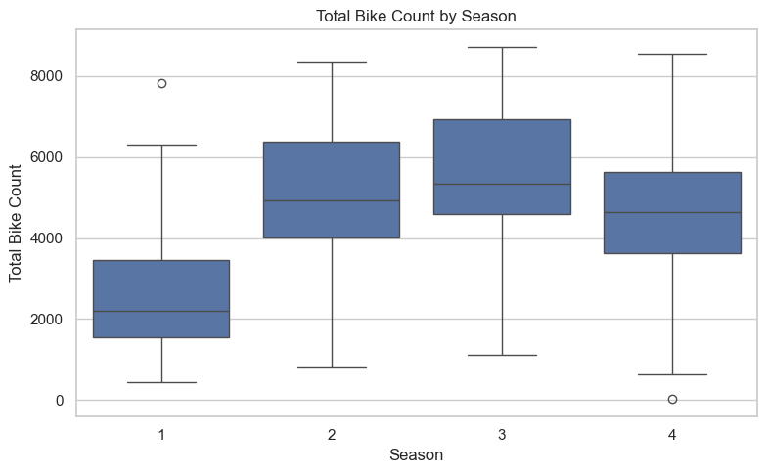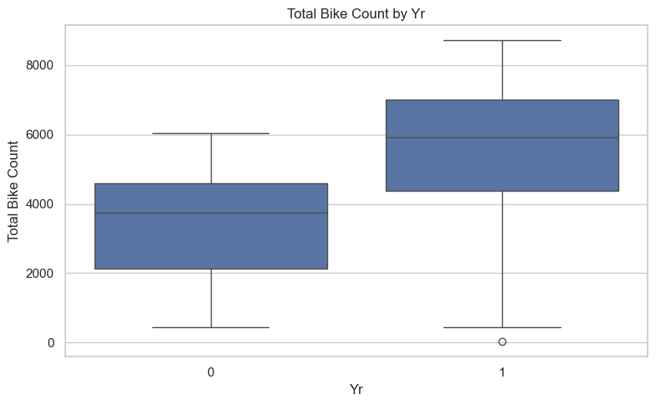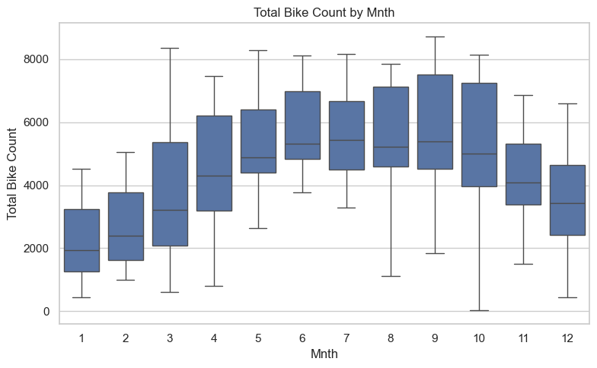
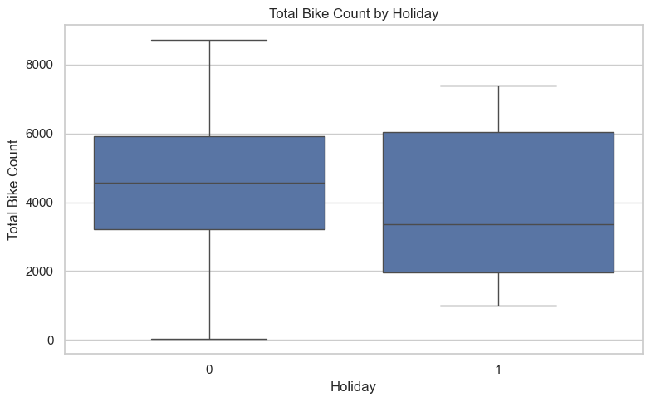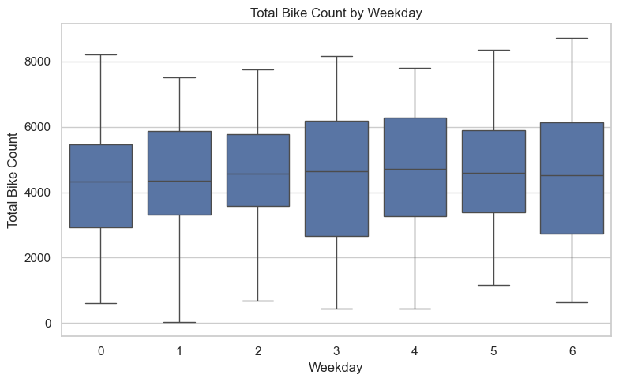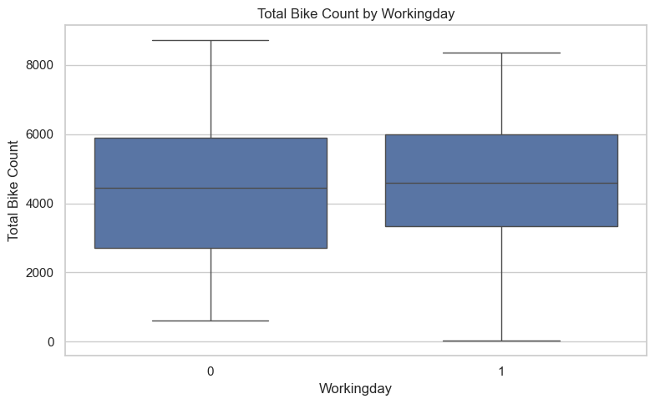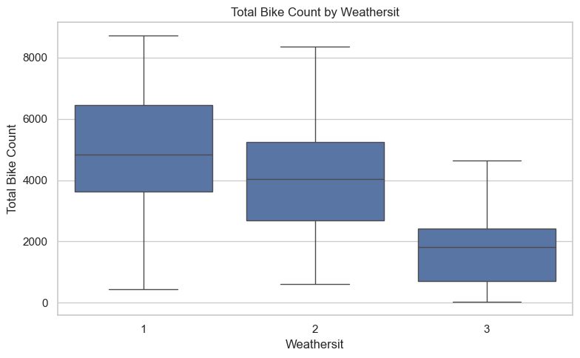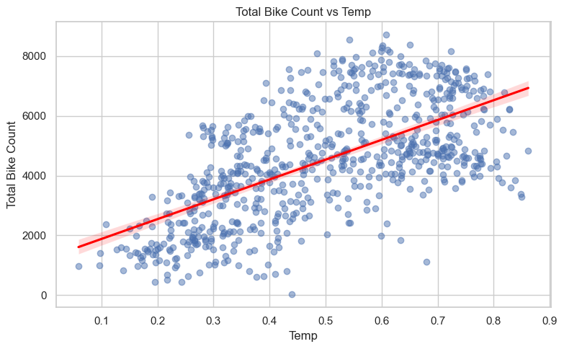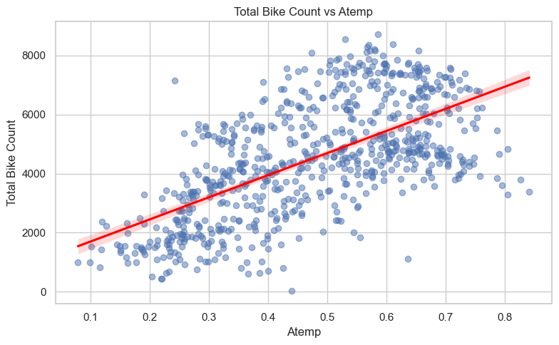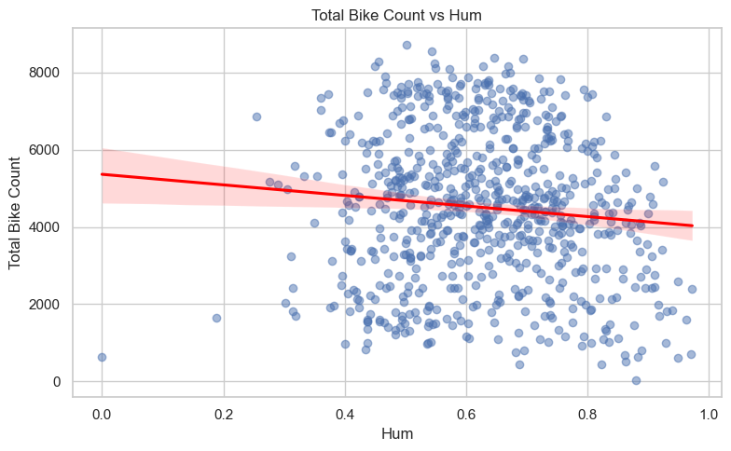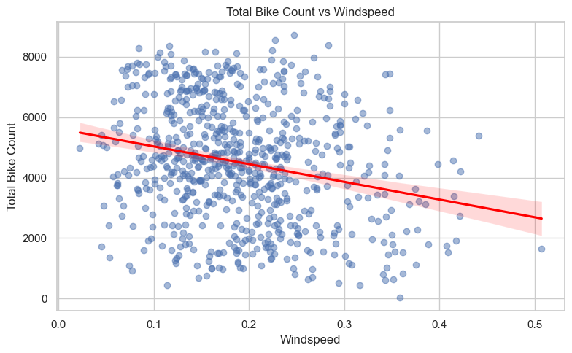

Multiple Linear Regression

To initiate the Multiple Linear Regression analysis, the dataset was partitioned into training and validation subsets, with 40% allocated to training. The model’s performance on the validation set was evaluated using standard regression metrics:

Regression statistics

Mean Error (ME) : 0.0000
Root Mean Squared Error (RMSE) : 0.7560
Mean Absolute Error (MAE) : 0.6252
Mean Percentage Error (MPE) : 61.9570
Mean Absolute Percentage Error (MAPE) : 231.0998

The RMSE of 0.7560 indicates a relatively low prediction error, suggesting that the model captures the underlying patterns in the data effectively. To further refine predictive accuracy, I compared three regularized regression techniques: Lasso, Ridge, and Bayesian Ridge. Ridge Regression demonstrated superior performance across five-fold cross-validation, with the following RMSE scores:

Regression statistics

Mean Error (ME) : -0.0435
Root Mean Squared Error (RMSE) : 0.7044
Mean Absolute Error (MAE) : 0.5743
Mean Percentage Error (MPE) : -129.6866
Mean Absolute Percentage Error (MAPE) : 363.5149

The consistency of Ridge Regression across folds, coupled with its lowest average RMSE, supports its selection as the most reliable model for short-term forecasting. Consequently, Ridge Regression is recommended for predicting bicycle sales over a seven-day horizon, enabling informed adjustments to inventory and pricing strategies.
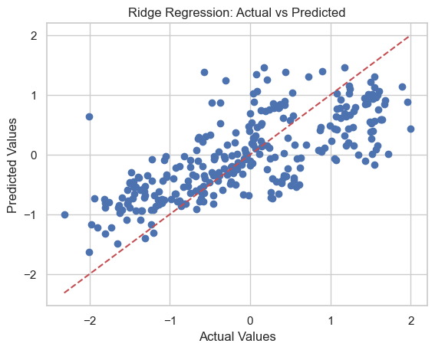

Therefore, when predicting the next seven days, Ridge Regression can be trusted when adjusting inventory and pricing.

Time Series Analysis

To initiate the Time Series Analysis, I first applied a seven-day moving average to smooth short-term fluctuations and reveal underlying sales trends (results in chart below). I then extended the analysis to include a 30-day moving average, a seven-day weighted moving average, exponential smoothing (α = 0.2), and linear regression for comparative evaluation.
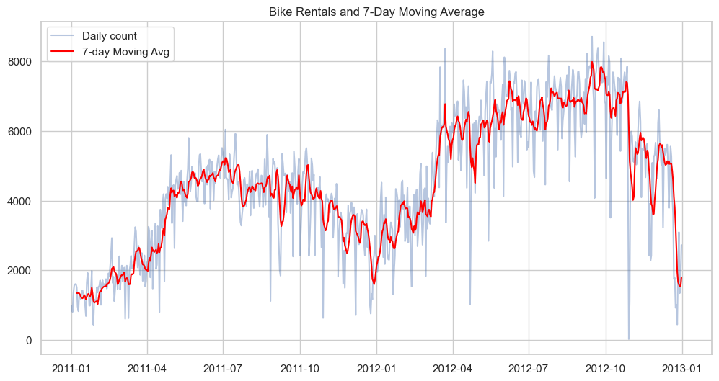

Each method was assessed using four standard error metrics: Mean Absolute Percentage Error (MAPE), Mean Absolute Error (MAE), Mean Squared Error (MSE), and Root Mean Squared Error (RMSE). The results are summarized below:

 | 7-Day Moving Average | 30-Day Moving Average | 7-Day Weighted Moving Average | Exponential Smoothing 0.2 | Linear Regression
MAPE | 58.353356 | 6.740802e+01 | 96.982251 | 65.703146 | 8.287322e+01 | MAPE
MAE | 625.580296 | 7.403320e+02 | 842.885884 | 682.427738 | 1.229867e+03 | MAE
MSE | 754703.192287 | 1.065746e+06 | 960090.116156 | 938431.489528 | 2.265729e+06 | MSE
RMSE | 868.736549 | 1.032350e+03 | 979.841883 | 968.726736 | 1.505234e+03 | RMSE
Among the methods tested, the simple 7-day moving average consistently produced the lowest error across all metrics, indicating superior performance for short-term forecasting. In contrast, the 7-day weighted moving average and linear regression exhibited higher error rates, suggesting reduced reliability for weekly predictions.
These findings support the use of a simple 7-day moving average for forecasting bicycle sales on a weekly basis. This approach offers a balance of interpretability and predictive accuracy, making it well-suited for guiding inventory and pricing decisions in dynamic retail environments.

