|  |
| --- |
| Toyon Research Corporation |
| Lab 8: Processor Integration |
| Chilipepper Tutorial Projects |

|  |
| --- |
| Version 1.0  1/27/2014 |

Table of Contents

Introduction 4

Procedure 4

Objectives 4

Generate HDL code 5

1.1 Supplemental PCores 5

1.2 QPSK_RX 5

1.3 RX_FIFO 6

1.4 MATLAB Test Bench 6

1.5 HDL Coder Project 7

Configure Cores and Export Design 13

2.1 Needed IP Cores 13

2.2 Configuring the ADC Driver Port 14

2.3 Configuring the MCU Driver Port 14

2.4 Configuring the MCU UART 14

2.5 Configuring the DC Offset 14

2.6 Configuring the QPSK RX 15

2.7 Configuring the RX FIFO 15

2.8 Configuring the TX Clock Generator IP Core 15

2.9 Configuring the RX Clock Generator IP Core 16

2.10 Pin Assignments 17

2.11 Adding ChipScope Peripheral (optional) 19

Create software project 21

3.1 Creating a new C Project 21

3.2 Programming the Board 22

3.3 Debugging with SDK 24

Testing and Design Verification 25

4.1 Verification with Terminal 25

4.2 Debugging with ChipScope Pro 26

Appendix A MATLAB RX Correlator 28

Appendix B MATLAB RX FIFO 32

Appendix C MATLAB QPSK RX Test Bench Script 34

Appendix D main.c 38

Lab 8: Processor Integration

# Introduction

This lab will extend the previous labs and allow you to interface your receive core to the Xilinx MicroBlaze Processor. To accomplish this, it is necessary to create a FIFO Core to allow bytes received from the previously created QPSK Correlator to be sent to the software running on the MicroBlaze. Once sent to this software the message will be relayed to a UART and received by a terminal program running on the PC. The lab will assume the message was received using a second Chilipepper board however if you do not have two boards, you can use the concepts of this lab to extend lab 3 by allowing a user to input a message to the TX core via terminal, export the transmitted QPSK waveform using ChipScope, and use MATLAB to analyze the transmitted message. This lab assumes prior knowledge of the workings of HDL Coder as well as the Xilinx EDK environment. It is recommended that you complete the previous labs before completing this lab.

This lab is created using:

* MATLAB 2014a
* Xilinx ISE Design Suite 14.7
* Windows 7, 64-bit

## Procedure

This lab is organized into a series of steps, each including general instructions and supplementary steps, allowing you to take advantage of the lab according to your experience level.

This lab consists of the following basic steps:

* Generate HDL code from MATLAB functions
* Generate an IP core using MATLAB HDL Coder
* Configure your created PCores and export the design into SDK
* Create software to run your design
* Test and verify your results

## Objectives

After completing this lab, you will be able to:

* Create an RX FIFO core to receive decoded QPSK symbols
* Send output to the MicroBlaze Processor Serial Port
* Create a software application to test your design
* Verify your results using a standard terminal and ChipScope

Generate HDL code Step 1

This section will show you how to create your MATLAB function and test bench files which are required to export your design into EDK.

## 1.1 Supplemental PCores

As in the previous receiver tutorials, this lab will make use of the MCU, ADC and DC Offset PCores designed in earlier labs. Since these cores have already been created, we can copy the core design into our EDK project without having to recreate the HDL Coder project.

## 1.2 QPSK_RX

The QPSK RX design in this lab uses the updated qpsk_rx_foc and qpsk_rx_toc cores created previously in Lab 7. However we will modify the qpsk_rx_correlator slightly to allow for input from the MicroBlaze processor as well as an output to the RX_FIFO core to receive new byte data. There will be no additional sub functions added to the qpsk_rx.m function, however to account for additional inputs and outputs, you should modify the design to resemble Figure 1-1 below.



Figure -1: MATLAB function to analyze received signal.

1. Create a directory for the project under C:\QPSK_Projects\Lab_8.
2. Create a MATLAB directory within the main project directory.
3. Create a new **MATLAB function** with the contents of Figure 1-1.
4. Save this function as qpsk_rx.m inside the MATLAB directory.

As you can see from Figure 1-1 above, there have been some slight modifications to the previously created qpsk_rx_correlator function. The extra output ports store_byte and clear_fifo_out are intended to give the correlator the ability to pass payload bytes to the FIFO core. The num_bytes_ready is an output intended for the software running on the MicroBlaze, while the mcu_rx_ready_in is an input which can be used to enable or disable the correlator. Neither of these signals is required, but can assist in debugging the core if bytes are not received properly. The new qpsk_rx_correlator function is shown in Appendix A. Be sure to include the qpsk_rx_foc, qpsk_rx_toc and supporting functions from the previous labs in your MATLAB directory as well.

1. Create a new **MATLAB function** with the contents of Figure A.
2. Save this function as qpsk_rx_correlator.m inside the MATLAB directory.

## 1.3 RX_FIFO

Similar to the FIFO created for the qpsk_tx core, there is another FIFO used in this Lab for the qpsk_rx core. The purpose of this FIFO is to assist with the handshaking required when sending data from the HDL PCore to the SDK project. The code for this FIFO is shown in Appendix B.

1. Create a new **MATLAB function** with the contents of Appendix B.
2. **Save** this function as rx_fifo.m inside the MATLAB directory.

## 1.4 MATLAB Test Bench

Now that you have added functionality to the receiver core, we also need to modify the test bench script a bit to accommodate the new output. For this lab, the primary output is the payload bytes sent from the FIFO core rather than the qpsk_rx core directly. In addition these bytes will be sent directory out of a UART to a terminal, which eliminates the need for MATLAB analysis of the output. Therefore, the test bench script should be modified to receive and output these received bytes and verify the message was transmitted and received correctly. Just as in the previous labs, a simulated transmit waveform is required to fully test the design. Therefore, this script will require several of the MATLAB functions used in Lab 3 to transmit the QPSK waveform. A quick list of the needed files to create the simulated waveform is shown below. The code for the test bench script can be found in Appendix C.

Required files for creating Simulated QPSK waveform

* make_srrc_lut.m and make_trig_lut.m
* CreateAppend16BitCRC.m
* tx_fifo.m
* qpsk_tx.m
* qpsk_tx_byte2sym.m
* qpsk_srrc.m
* mybitget.m
* TB_i.m and TB_q.m

1. Create a new **MATLAB script** with the contents of Appendix C.
2. Save this function as qpsk_tb.m inside the MATLAB project directory.

Running the test bench script and observing the MATLAB console should display the message “Received message correctly ans = hello world!” if the functions were created properly.

## 

## 1.5 HDL Coder Project

Now that the MATLAB files have been created, we can turn them into PCores. As mentioned earlier, we will reuse the previously created DC Offset, MCU and ADC Driver PCores, thus the only cores we need to create for this lab are the qpsk_rx and rx_fifo PCores. Using the same steps outlined in the previous labs, create a new HDL coder project called qpsk_rx. Add both your qpsk_rx.m file and your qpsk_rx_tb.m files to the **MATLAB Function** and **MATLAB Test Bench** categories respectively.

1. Once inside the workflow advisor screen, click on **HDL Code Generation** on the left hand side, and be sure to set the clock to be driven at the **DUT base rate** as in the previous labs.
2. Right-click **Fixed-Point Conversion,** and select **Run to Selected Task.**
3. The qpsk_rx.m and qpsk_rx_correlator.m, functions both require modifications to their variable’s proposed types. Modify your HDL Coder design to match the following Fixed-Point conversions for each function.

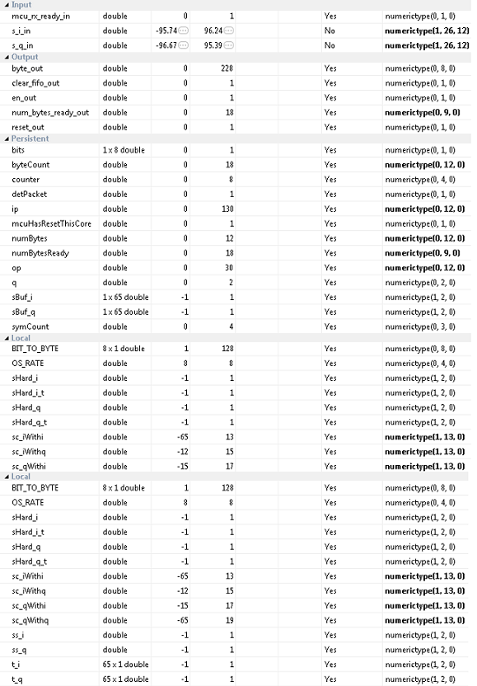

Figure 1-: Proposed variable types for qpsk_rx_correlator function

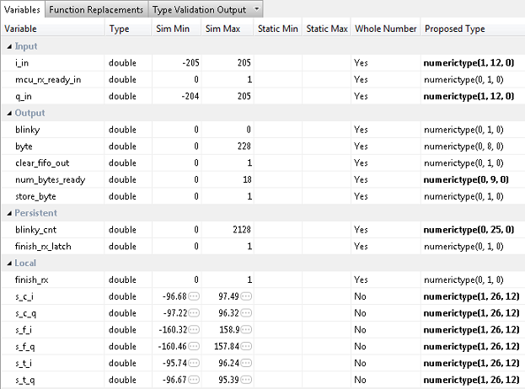

Figure 1‑3: Proposed variable types for qpsk_rx function

The Proposed variable types for qpsk_rx_foc.m, qpsk_rx_toc.m, and qpsk_rx_srrc.m should be set to the same types used in the previous labs. Refer to Lab 6 for help configuring these functions.

1. Once you have corrected the **Type** setting for all your variables, click **Select** **Code Generation Target**. Here you can select the FPGA you will use for your design. For this Lab, we will not be using any of the built-in Zynq board functionality within our MATLAB PCores. Therefore you can leave the default settings. Ensure your Workflow settings resemble figure 1-4 below

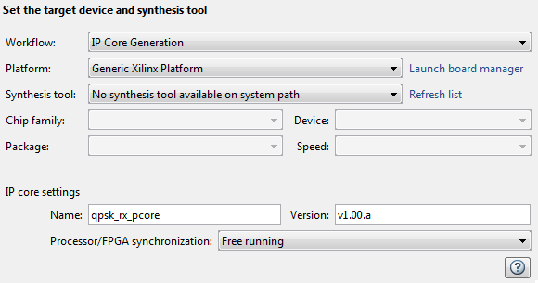

1‑4: Settings for Xilinx Zed Board HDL Coder Design

1. Just below the synthesis tool settings, **rename your PCore** to qpsk_rx_pcore or something similar. This is optional as MATLAB will give its default name for each of your cores, as well as a default version, however it is helpful to rename your core for easier netlist configuration later in the lab.
2. Once the platform and synthesis tool are set, you can click **Set Target Interface** to configure the input and output ports of the design. For this Lab, follow the settings shown in Figure 1-5 below.

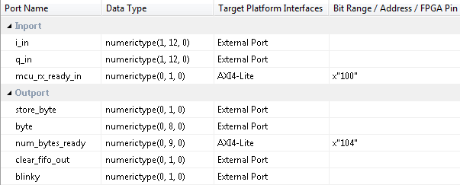

Figure 1-5: Port Interface settings for the qpsk_rx HDL Coder project

1. Once the ports are set, right-click **HDL Code Generation** and select Run This Task. This will create a PCore for your design that can be used directly within Xilinx EDK. By default, the PCore is created in <Project Directory/MATLAB folder/codegen/ipcore>.
2. Repeat this process for the rx_fifo function. Use the qpsk_tb function as the projects test bench script. **Name the PCore** rx_fifo_pcoreand verify your **Fixed-Point variable** conversions and your **Target interface port** settings using the Figures below. Also don’t forget to set both projects to use the **DUT base** clock rate.

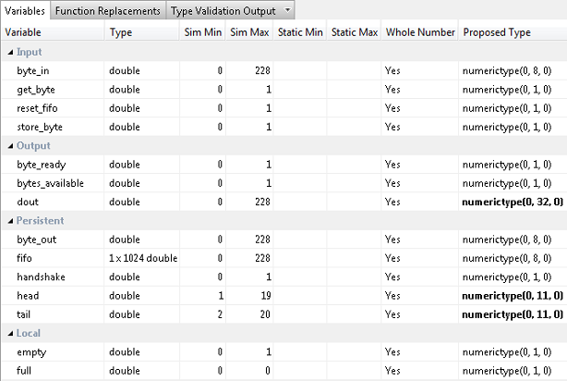

Figure 1-6: Proposed variable types for rx_fifo function

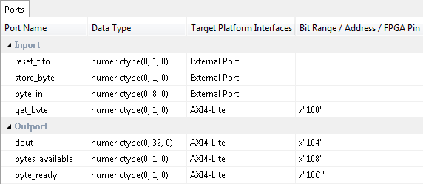

Figure 1-7: Settings for Xilinx Zed Board rx_fifo HDL Coder Design

1. Once the PCores have been created, make a **new EDK project** using the same method used in the previous lab. Be sure that you **import** the correct system configuration file.
2. Once the project is created, **copy each of the PCore folders** from the MATLAB directory into the PCores folder of your **EDK Project**. Don’t forget to also copy any previously created cores you may be reusing as well. Then simply select project -> **rescan user repositories** to show your newly added user PCores within your EDK project.

Configure Cores and Export Design Step 2

This section will show you how to integrate your PCores into your FPGA design using EDK. There are several components that must be configured for the design of this project. A quick list of the cores needed is given below. Refer to lab 0 sections 4.3 and 5.1 for information on how to add cores to the design.



## 2.1 Needed IP Cores

* ADC Driver
* MCU Driver
* MCU UART
* DC Offset
* QPSK RX
* RX FIFO
* Clock Generator (one for RX and one for TX)
* Processing System
* AXI Interconnect

In addition, several of these cores will require external ports. Be sure that you have access to modifying the external port settings. Refer to Figure 2-1 Below.

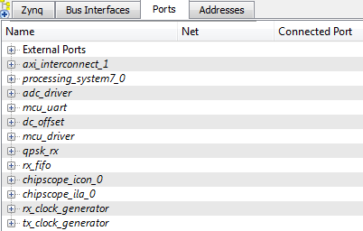

Figure 2‑1: EDK project ports list

## 2.2 Configuring the ADC Driver Port

Expand the **ADC Driver** port. There are 6 individual I/O pins which need to be routed on this port.

1. First we will configure the rx_iq_sel, the rxd and the blinky pins. Each of these pins can be assigned as **External ports**.
2. Next are the rx_i and the rx_q output pins. Connect these pins to the i_in and q_in pins of the dc_offset PCore.
3. Connect the IPCORE_RESETN port to the processing_system7 FCLK_RESET0_N port.
4. The IPCORE_CLK pin can be skipped for now and will be connected later in **section 2.5**

## 2.3 Configuring the MCU Driver Port

**Expand** the **MCU Driver** core. There are 9 individual I/O pins which need to be routed on this core.

1. Configuring this core is very simple as **all of the pins** with the exception of the IPCORE_CLK and the IPCORE_RESETN are simply **assigned** as **external ports**.
2. Connect the IPCORE_RESETN port to the processing_system7 FCLK_RESET0_N Port and skip the IPCORE_CLK for now.

## 2.4 Configuring the MCU UART

1. Under the Communications Low-Speed section, add the AXI UART (Lite) to your design
2. Name the core mcu_uart as shown in Figure 2-1. Keep all configuration settings as default.
3. This core requires no other customization; just verify the RX and TX pins are set as External ports.

## 2.5 Configuring the DC Offset

**Expand** the **DC Offset** core. There are 7 individual I/O pins which need to be routed on this core.

1. If the ADC driver was previously configured correctly, the i_in and q_in pins of the dc_offset core should already be set.
2. The i_out and q_out pins should be connected to the qpsk_rx i_in and q_in pins respectively.
3. Set the blinky pin as an External port.
4. Connect the IPCORE_RESETN port to the processing_system7 FCLK_RESET0_N Port and skip the IPCORE_CLK for now.

## Configuring the QPSK RX

**Expand** the **QPSK RX** core. There are 8 individual I/O pins which need to be routed on this core.

1. If the DC Offset core was previously configured correctly, the i_in and q_in pins of the qpsk_rx core should already be set.
2. Set the blinky pin as an External port.
3. The store_byte, clear_fifo_out and byte pins all need to be connected to the RX FIFO core. Connect the store_byte output of the qpsk_rx core to the store_byte input of the rx_fifo. Next connect the clear_fifo_out port to the reset_fifo input. Lastly, the byte output should connect to the byte_in input.
4. Connect the IPCORE_RESETN port to the processing_system7 FCLK_RESET0_N Port and skip the IPCORE_CLK for now.

## Configuring the RX FIFO

1. If the qpsk_rx core was configured correctly, 3 of the 5 rx_fifo ports should be set already. The only changes required are to connect the IPCORE_RESETN port to the processing_system7 FCLK_RESET0_N Port. Skip the IPCORE_CLK for now.

## 2.8 Configuring the TX Clock Generator IP Core

The TX Clock Generator is used in this project to distribute the appropriate clock signals to each of the PCores required for Chilipepper initialization, as well as any external hardware which may require a clock signal. For this project, the TX Clock Generator is sourced from the 40 MHz pll_clk_out on the Chilipepper radio board (as described in the **Chilipepper user’s guide**). This signal is then distributed to 3 other devices; 1 PCore (MCU Driver) and the TX_CLK and RX_CLK signals. The TX and RX clock signals are used to latch data from the TXD and RXD lines to the DAC and ADC respectively on the radio board. Although no DAC is used within the design, the clock is required for proper initialization of the Chilipepper FMC. For this lab, the Clock Generator has been named tx_clock_generator.

1. **Double click** the Clock Generator PCore and **configure** the settings as follows

* Input Clock Frequency of **40Mhz**
* CLKOUT0 Required Frequency of **20MHz**, 0 Phase, **PLLE0** group and **Buffered True**
* CLKOUT1 Required Frequency of **40MHz**, 180 Phase, **PLLE0** group and **Buffered True**
* CLKOUT2 Required Frequency of **40Mhz**, 0 Phase, **PLLE0** group and **Buffered True**

Now that the settings are configured you should have several clocks in your clock generator list.

1. **Connect** the pins according to the following.

* CLKIN External Ports
* CLKOUT0 mcu:: IPCORE_CLK
* CLKOUT1 External Ports
* CLKOUT2 External Ports
* RST net_gnd
* LOCKED External Port

## 2.9 Configuring the RX Clock Generator IP Core

In addition to the TX Clock Generator, another clock generator is required for this design. As mentioned in Lab 2 and the Chilipepper User’s Guide, the receiver chain is to be clocked using the RX return clock on the Chilipepper board to ensure data is latched properly from the ADC. In this design, there are four cores which must be clocked using the RX return clock; therefore a new clock generator called rx_clock_generator is used to distribute the clock signal.

1. **Double click** the Clock Generator PCore and **configure** the settings as follows

* Input Clock Frequency of **40Mhz**
* CLKOUT0 Required Frequency of **40MHz**, 180 Phase, **PLLE0** group and **Buffered True**
* CLKOUT1 Required Frequency of **20MHz**, 180 Phase, **PLLE0** group and **Buffered True**

Now that the settings are configured you should have several clocks in your clock generator list.

1. **Connect** the pins according to the following.

* CLKIN External Ports
* CLKOUT0 adc_driver::IPCORE_CLK
* CLKOUT1 dc_offset:: IPCORE_CLK, qpsk_rx::IPCORE_CLK and rx_fifo::IPCORE_CLK
* RST net_gnd
* LOCKED External Port

Your Clock Generator ports should look similar to Figure 2-2 below.

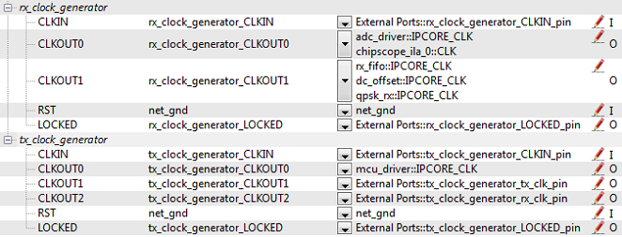

Figure 2‑2: Clock Generator port configurations

Be sure your External Port pins, as well as your PCores match the names shown in the figures above.

## 2.10 Pin Assignments

Once the clock generator is configured correctly, the IPCORE_CLK for the other cores should be set as well. The next step is to setup the **pin assignments** for the external ports.

1. Open the **Project** tab.
2. Double-click on the **UCF File: data\system.ucf** from this panel, to open the constraints file.
3. Fill in the pin out information for your design using Figure 2-3 below as a reference.



Figure 2‑3: EDK project pin assignments

## 2.11 Adding ChipScope Peripheral (optional)

Given that the output of this design will be sent directly out to a UART port, there is no need for verification using ChipScope. However, the ChipScope output may provide valuable debugging information if the design is not functioning properly. It is therefore recommended that several key steps along the receiver chain such as the dc_offset, qpsk_rx, and rx_fifo be sent to ChipScope for debugging purposes.

1. Select Debug -> **Debug Configuration** from the top menu.
2. Click the **Add ChipScope Peripheral** button on the bottom left hand side of the screen.
3. Select To **monitor arbitrary system level signals** (middle option) from the list.
4. Add some of the outputs along the rx chain to the ChipScope ports. If you add too many ports, your design may not pass timing, so only add the ones which will be most useful for debugging. Additionally, you should set the clock to the same clock used for the core, which for this design is rx_clock_generator_clockout_1.
5. Click ok to finish configuration of your ChipScope peripheral. Your new port list should look similar to Figure 2-4 below. Be sure your Clock and qpsk_rx ports have the ChipScope peripherals in the correct locations.

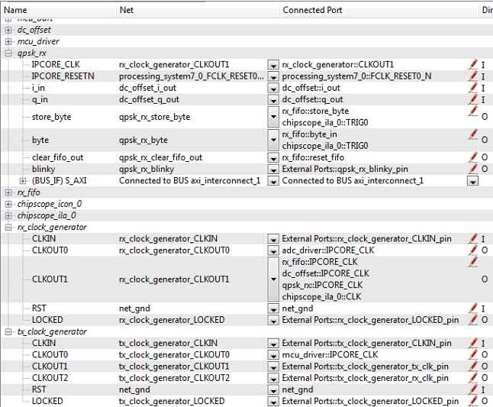

Figure 2‑4: Ports list after adding ChipScope peripheral to monitor qpsk_rx signals

Once completed, you’re ready to generate your bitstream file! Select the Export Design button from the navigator window on the left. Click the Export and Launch SDK button. This process may take awhile.

Create software project Step 3

Once the design is compiled and exported, you’ll be greeted with a screen asking you where you would like to store your software project. It is very helpful to create the SDK folder in the same directory as your MATLAB and EDK folders. Doing this will keep all relevant files in the same location.



## 3.1 Creating a new C Project

This section will show you how to create a C program to test your QPSK RX project.

1. Select **File 🡪 New** 🡪 **Application Project**.
2. Name the project “qpsk_rx” or something similar and leave the other settings at their defaults. Click next.
3. On the next screen, be sure to select **Hello World** from the list of Available Templates.
4. Click **Finish**. You should now see your qpsk_rx project folder, as well as a **board support package** (bsp) folder.
5. If you navigate into the qpsk_rx project folder, and into the src folder, you should see a helloworld.c file. Feel free to rename this file to main.c or something more appropriate.
6. **Double click** the file to open it and **replace** all of its contents with the code in Appendix D.
7. **Download** the **Chilipepper.c** and **Chilipepper.h** files from the GitHub repository[1] if you don’t already have them. Copy them into the source directory with your main.c file.
8. Open the Chilipepper.c file and modify it for this lab. The PCores that should be defined at the top of the file are MCU_DRIVER, DC_OFFSET, RX_PCORE, RX_FIFO and MCU_UART.

You may be required to add the Math Library to the project to define the pow function used in the Chilipepper.c Library file. If so, follow the optional step 9 listed below.

**Note**

1. (Optional) Click on **Project** 🡪**Properties.** Open the **C/C++ Build** arrow and click the settings option. Under **ARM gcc linker**, click the Libraries folder. Click the button, type the letter **m** into the prompt and select ok. **Apply** and hit ok.



## 3.2 Programming the Board

Once your program is written and compiled you are ready to test the design! This is done by programming the FPGA with your hardware descriptions defined in the bit file generated in EDK, and running your software on top of this design.

1. Connect the Chilipepper to the FPGA board and verify all cables are connected properly and the jumper settings are correct. Verify this by using the *Chilipepper Getting Started Guide[2]* as a reference. Also See Lab 0 for details on Jumper Configuration.
2. Once the FPGA and radio board are connected correctly, turn on the board.
3. Open iMPACT in the ISE Design tools.
4. Select no if Impact asks you to load the last saved project.
5. Select yes to allow iMPACT to automatically create a new project for you. If you receive any connection errors, verify your USB or JTAG programmer cables are connected properly.
6. Select the Automatic option for the JTAG boundary scan setting and click ok.
7. Hit yes to assign configuration files. Bypass the first file selection, but for the second selection, browse to the location of your system.bit file. It should be inside the “Implementation” folder of your EDK project folder.
8. Select ok on the next screen verifying that the board displayed is your Zynq xc7z020 board. It should look similar to Figure 3-1 below.

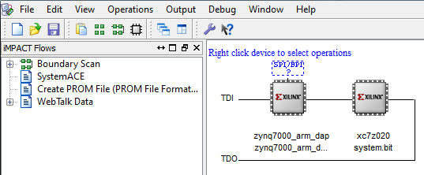

3‑1: configuration for Zed Board System.bit file

1. Right click on the xc7z020 board icon (should be on the right), select program and hit ok.

If you are running lab 3 from a second PC, you will need to repeat this process for the second board using the Lab 3 system.bit file. Alternatively, you can run Lab 3 directly from the SD card by loading a standard SD card with the Boot.bin file for lab 3, which can be found on the GitHub repo.

**Note**

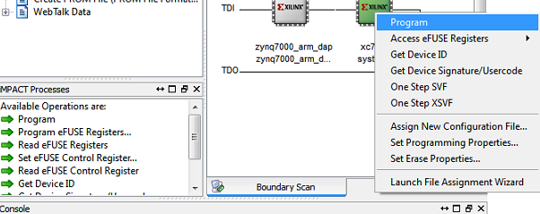

Figure 3‑2: iMPACT configuration screen

To load Lab 3 via SD card:

1. Place the file on the SD card, and place the card inside the SD slot of the FPGA.
2. Configure the jumpers on the FPGA as shown in Figure 3-3.
3. Turn on the board, and the program should load after about 30 seconds. Check for the blue light, indicated the load was successful.

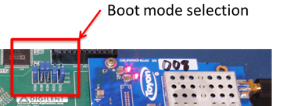

Figure 3‑3: Jumper configuration needed to load a project via SD card

## 3.3 Debugging with SDK

If the hardware design is correct, you should see a blue light on the ZED Board indicating the program was successful. You can now return to the SDK project screen to test your software.

1. Test it by **right clicking** the qpsk_rx project folder and selecting **Debug As** 🡪 **Launch on Hardware (GDB)**.
2. You should now be taken to a screen which shows the init_platform() function as highlighted. You can now start the software program by clicking the **play** button in the top menu.

If the software initialization worked, you should see a green light on the Chilipepper, as well as the Blinking LEDs on the FPGA from the PCore blinky pins.

Testing and Design Verification Step 4

## 4.1 Verification with Terminal

Once you have both labs running successfully, the next step is to verify functionality by connecting the FPGA which is running your Lab 8 design to a terminal to view the received QPSK packet.

1. Connect your FPGA to the PC using a micro USB cable. The cable should be plugged into the UART port on the FPGA, shown in Figure 4-1 below.

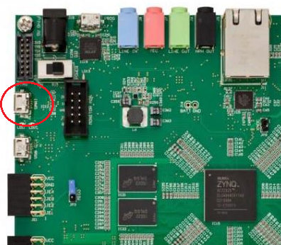

Figure 4‑: Circled in this figure is the UART port of the Xilinx Zed Board FPGA.

1. With the board powered on, open up a hyper terminal window such as Tera Term, and configure it with the following settings

**Baud: 115200; Data: 8 bit; No Parity;1 Stop bit; No Flow Control.**

Notice that the baud rate used is configured in the SetupPeripherals function in our main.c function created earlier. The other settings are all defaults for the XUartPs port.

1. Once the terminal is configured, you should be able to view your hello world packets by clicking the button on the Lab 3 Demo. In addition, if you flip the switch for continuous packet transmission, you should see several hello world packets on your terminal output as shown in Figure 4-2 below.

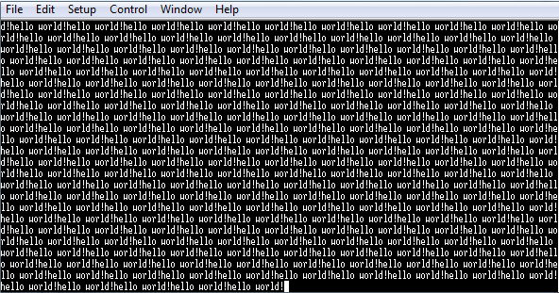

Figure -2: Output of QPSK RX received signal to Terminal

## 4.2 Debugging with ChipScope Pro

There are several methods available for verifying the MATLAB functions. For verification of the qpsk_rx_correlator design, ChipScope is recommended as it provides the most useful view of the signal correlation magnitude and an output of the resulting bytes.

1. To verify the qpsk_rx signals, you will need to open **ChipScope Pro Analyzer**. Be sure that the JTAG cable is connected to the FPGA board properly.
2. Once the program opens, click the  (open cable) button to open your JTAG connection to the board. If your jumpers are configured correctly, you should see the following devices on the cable.

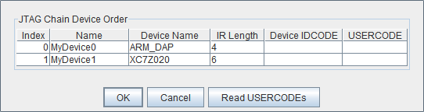

If you receive an error from ChipScope stating that you either cannot detect or cannot open the cable, try using the optional Step 3 to configure your cable setup correctly.

**Note**

1. (**Optional**)Click JTAG Chain in the top menu selection. Select the option for **Open Plug-in**... You will be greeted with a Plug-in Parameters screen. Enter the following in the box, and hit ok. “**xilinx_tcf URL=tcp::3121**”. Then click the open cable button and proceed as usual.
2. Select ok to get to the Analyzer main screen. Open the **file menu** and select **Import**.
3. Click **Select New File**, and browse to the location of your ChipScope **CDC file**, which is located in the <EDK/implementation/chipscope_ila_0_wrapper> folder of your project directory. This file was created for you when you generated your bit file in EDK, assuming you added the ChipScope peripheral appropriately. It tells the ChipScope program how to interpret the data it is receiving from the JTAG port.
4. On the Bus Plot screen, you can view any output signals that you connected to your ChipScope peripheral previously. Right click on a signal to change its features such as bus radix, name or color.
5. Click the **play button** in the top menu bar to display the signal. Additionally you can set up triggering options for periodic or continuous playback of the received signal.
6. MATLAB RX Correlator

MATLAB function qpsk_rx_correlator.m









1. MATLAB RX FIFO

MATLAB function rx_fifo.m





1. MATLAB QPSK RX Test Bench Script

MATLAB script qpsk_tb.m





1. main.c

SDK function main.c





1. Can be found at <https://github.com/Toyon/Chilipepper/tree/QPSK_pcore/ChilipepperSupport/Library%20Files>
2. Can be found at <https://github.com/Toyon/Chilipepper/tree/master/QPSK_Radio/DemoFilesAndDocumentation>