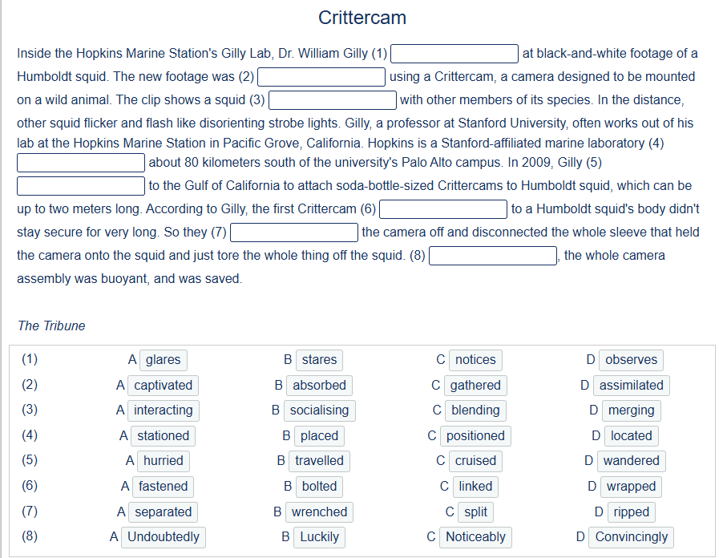

1B 2C 3A 4D 5B 6A 7D 8B

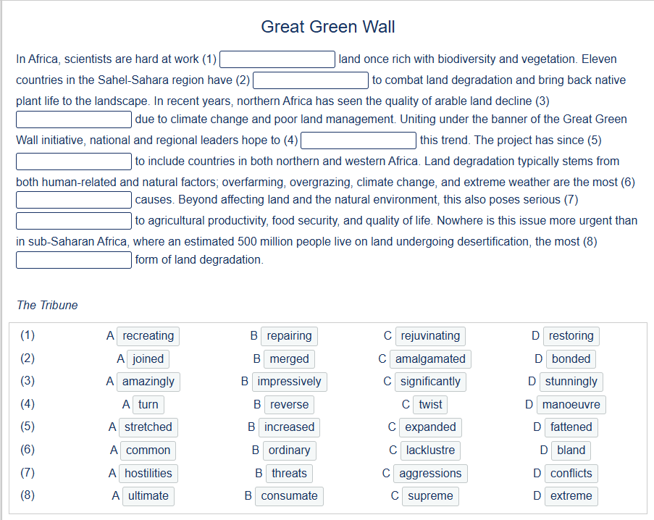

1D 2A 3C 4B 5C 6A 7B 8D

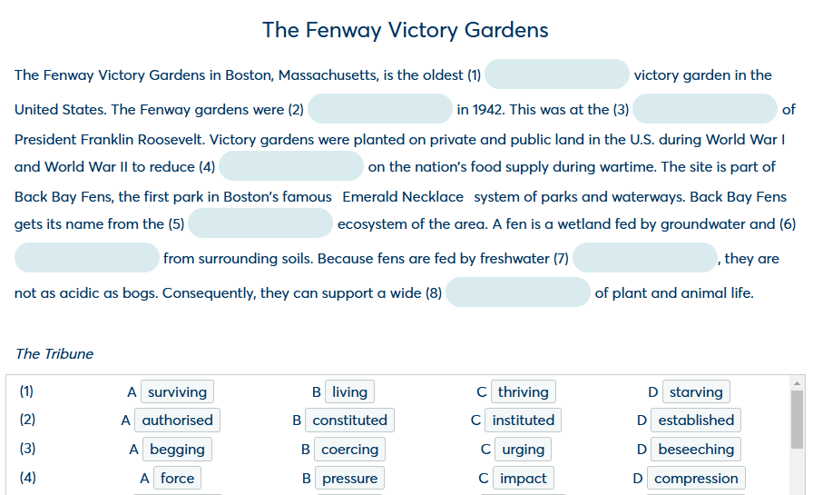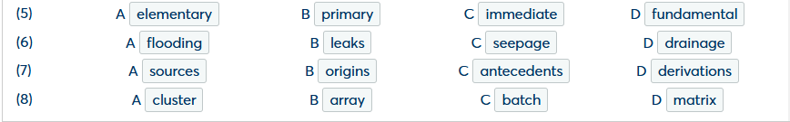

1A 2D 3C 4B 5B 6D 7A 8B

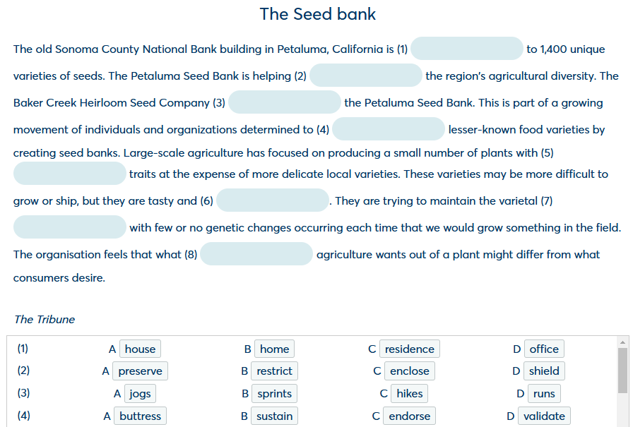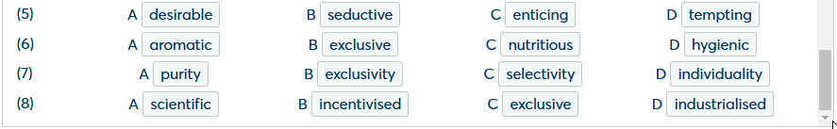

1B 2A 3D 4B 5A 6C 7A 8D

