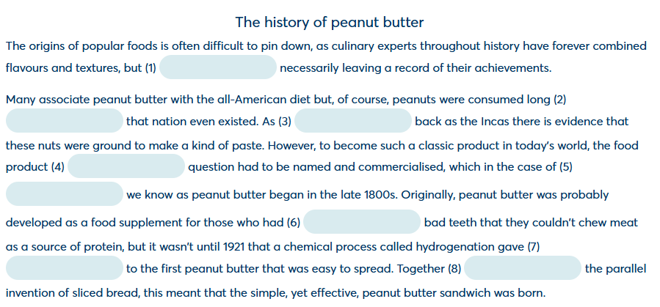

WITHOUT
BEFORE
FAR – as far back as
IN
WHAT
SUCH
RISE – give rise to (dar lugar a)
WITH

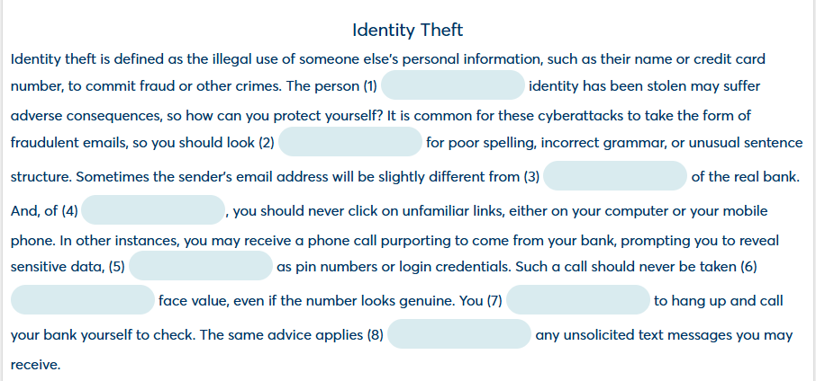

WHOSE
OUT
THAT
COURSE
SUCH
AT
NEED
TO

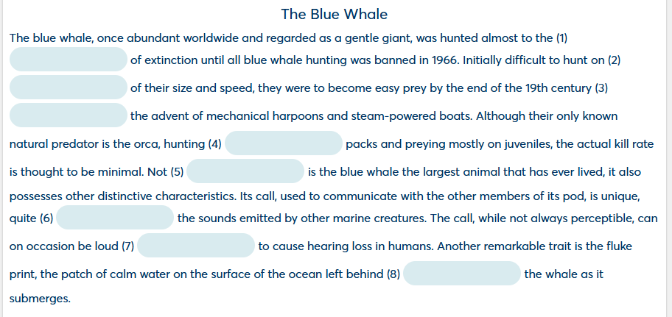

POINT
ACCOUNT
WITH
IN
ONLY – NOT ONLY
UNLIKE
ENOUGH
BY

