To All,

Almost all of our files related to the Los Padres Alternatives Studies are stored in dropbox. I am hoping to mirror the names of these models on GitHub to avoid any confusion. It currently is set up like this on dropbox. Once sorted out from Mike and Jon’s work will be pushed to GitHub.

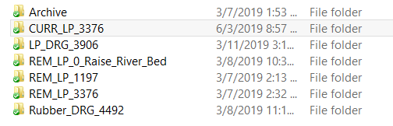

I would like to keep these names because they describe exactly what is going on in the file name.

**REM_LP_3376** – reflects scenario **1** in the Technical Assistance Agreement please keep same on GIT

Model configured to simulate removal of Los Padres Dam, with a water right of 3,376 acre-feet per year (afy), which reflects the Cease and Desist Order. Priority Run

**REM_LP_1197** – reflects scenario **2** in the Technical Assistance Agreement please keep same on GIT Model configured to simulate removal of Los Padres Dam, a water right of 1,197 afy, which reflects the loss of Cal-Am’s Los Padres Reservoir water right of 2,179 acre-feet. At this point running this model is not a high priority.

**Rubber_DRG_4492-** reflects scenario **3** in the Technical Assistance Agreement please keep same on GIT  Model configured to simulate installation of a rubber dam and dredging to Los Padres Reservoir, with a water right of 4,492 afy, which reflects additional storage capacity at Los Padres Reservoir (3,295 acre –feet) and Pre-1914 and Riparian Rights (1,197 acre-feet). Priority Run

**LP_DRG_3906** - reflects scenario **4** in the Technical Assistance Agreement please keep same on GIT Model configured to simulate a dredged Los Padres Reservoir (excluding the rubber dam), with a water right of 3,906 afy, which reflects the dredged Los Padres Reservoir capacity (2,709 acre-feet) and Pre-1914 and Riparian Rights (1,197 acre-feet). At this point running this model is not a high priority.

**CURR_LP_3376** - reflects scenario **5** in the Technical Assistance Agreement please keep same on GIT

Model configured to simulate the current state of Los Padres Reservoir with a water right of 3,376 afy, which reflects the Cease and Desist Order. Priority Run

**REM_LP_0_Raise_River_Bed** – not reflected in TAA agreement. Model configured to simulate removal of Los Padres Dam, with no pumping, and raising the river bed 10’ from Lagoon area to narrows and raising river bed 7’ from narrows to base of old San Clemente Dam. Priority Run