**Background**

What is PEST?

Basics:

* Model independent optimization software
* Requirements are text input/output

Where:

* <pesthomepage.org>

History:

* PEST; UCODE; [PEST++](https://github.com/dwelter/pestpp); or [PEST++](https://github.com/jtwhite79/pestpp)

Today’s examples will provide a very basic introduction to what PEST can do

**Exercise #1: Get familiar with Freyberg model, a synthetic model for the class**

We have recreated a MODFLOW model that was originally created by David Freyberg at Stanford University in the late 1980s. The model is a 2-dimensional MODFLOW model with 1 layer, 40 rows, and 20 columns. The model has 2 stress periods: an initial steady-state stress period used for calibration, and a 5-year transient stress period. The calibration period uses the recharge and well flux of Freyberg(1988); the forecast stress period uses 25% less recharge and 25% more pumping to represent future drought conditions for a forecast period.

Freyberg, David L. "AN EXERCISE IN GROUND‐WATER MODEL CALIBRATION AND PREDICTION." Groundwater 26.3 (1988): 350-360.

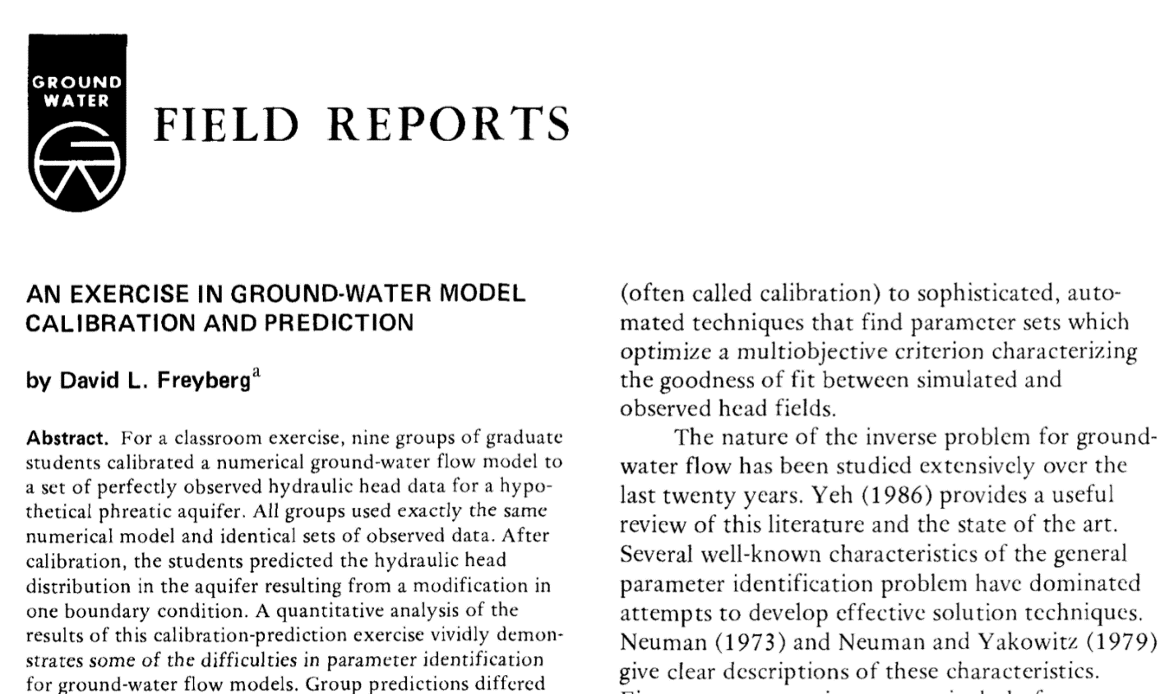

Model specifics

* 1 layer x 40 rows x 20 columns
* 2 stress periods (ignore the last stress period)
* RCH, WEL, SFR packages

Don’t forget to mention:

Official PEST class

* Make a calendar entry to check back on sspa.com/news in a few months or sign-up for the update news letter.
* Or contact Jeremy White ([jtwhite@usgs.gov](mailto:jtwhite@usgs.gov)), Mike Fienen ([mfienen@usgs.gov](mailto:mfienen@usgs.gov)), or Randy Hunt ([rjhunt@usgs.gov](mailto:rjhunt@usgs.gov)) and let them know you are interested PEST++ class.

Introduction example:

* Walk through PEST input
  + Template files
  + Instruction files
* Plot well fits
* Look through .rec file (this is PEST’s standard ‘listing’ file)
  + Look at how values of phi changed
  + Look at changes in parameter values
  + Look at contribution to phi from both observation groups

Piecewise-zone example:

* Look at how the template file changed
* Compare monitoring well fits

In Pilot Point example:

* MODFLOW’s OPEN/CLOSE statement
* Have a look at the _RunModel.bat file, trace it through
* Call folks’ attention to the variogram
* After running PEST on pilot points, look at K array in excel with color
* **PEST in parallel example**
* **PEST on NV WSC cluster example (see image below)**

Time permitting:

* Add a new template file
* Add a new instruction file

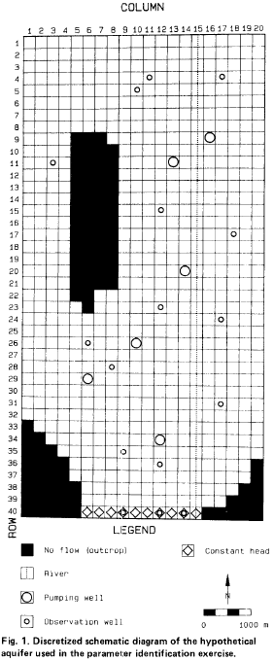

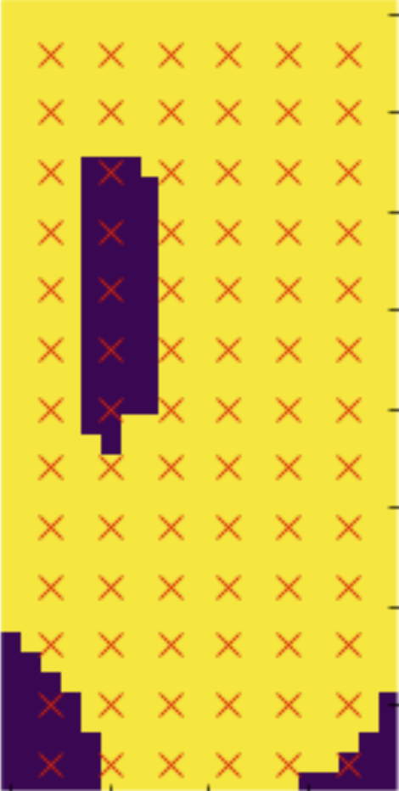

**Location of pilot points**

**This is the model we will be running on the NV WSC cluster**

