Ansible Server

Docker server

Build – stage1 (Docker file transferred to ansible server)

Image build on docker server

Docker server (Container created)

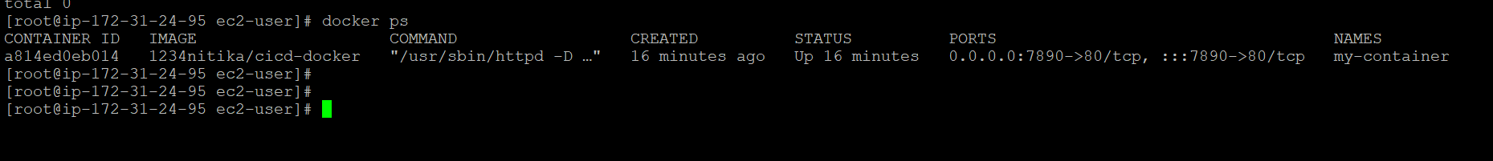

Final output:

