Report

1. Download Open Source from curl

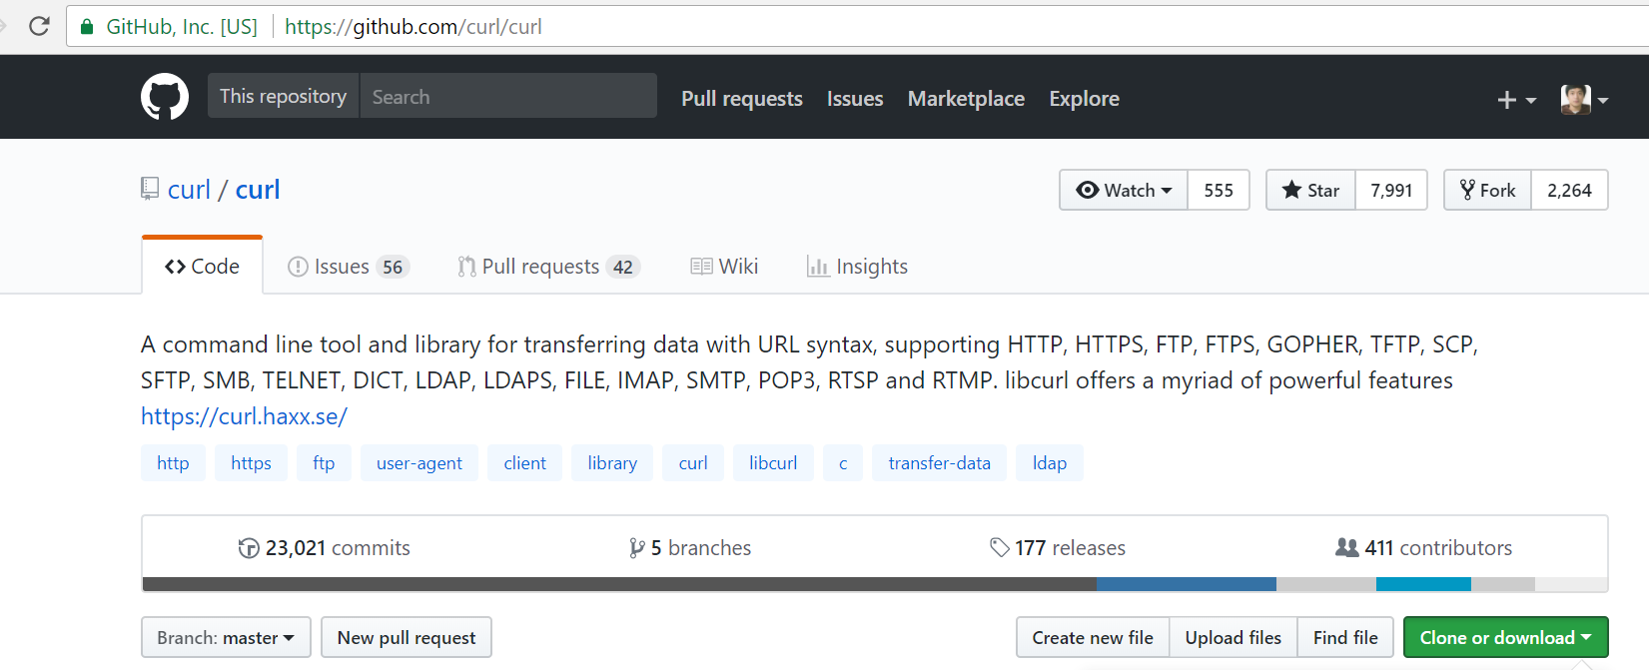

1. From Visual Studio CMD, type nmake /f Makefile.vc mode=dll vc=16

(because my visual studio version is 2017, vc is equal 16.)

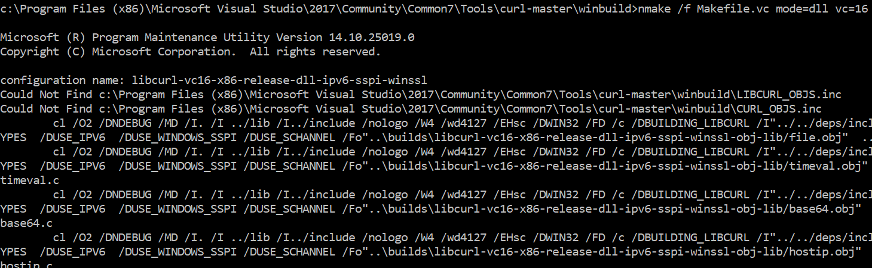

Downloading…

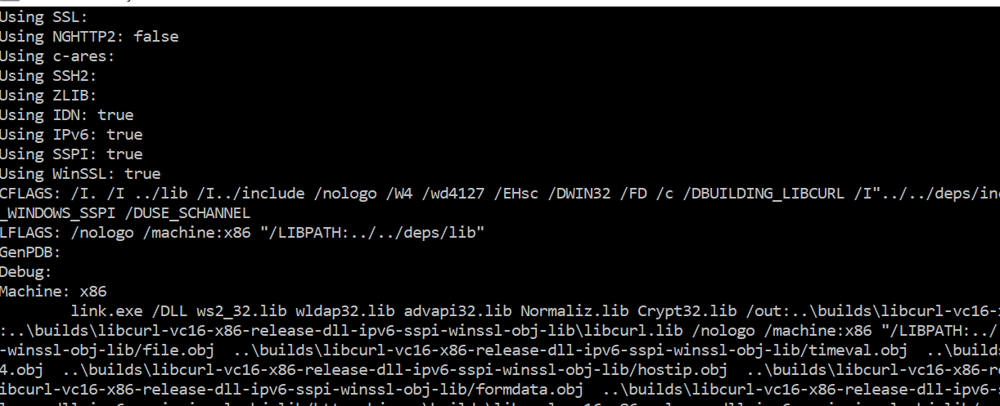

Completed.

1. Setup the Additional Include directories

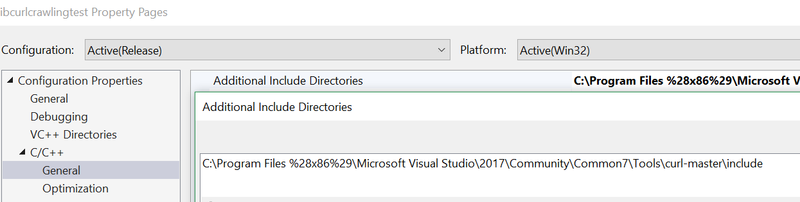

1. Setup the Additional Dependencies as libcurl.lib; in Input in Linker

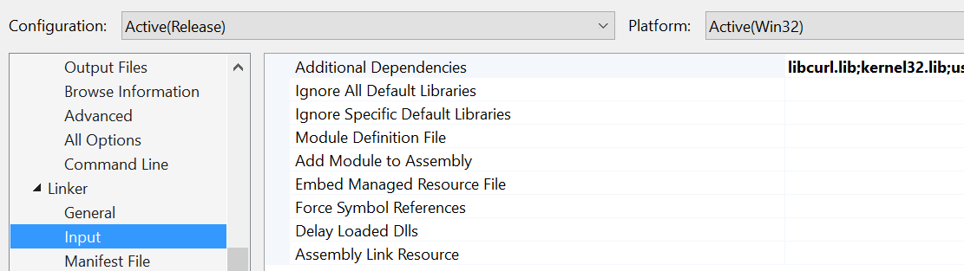

1. Setup the Additional Library Directories

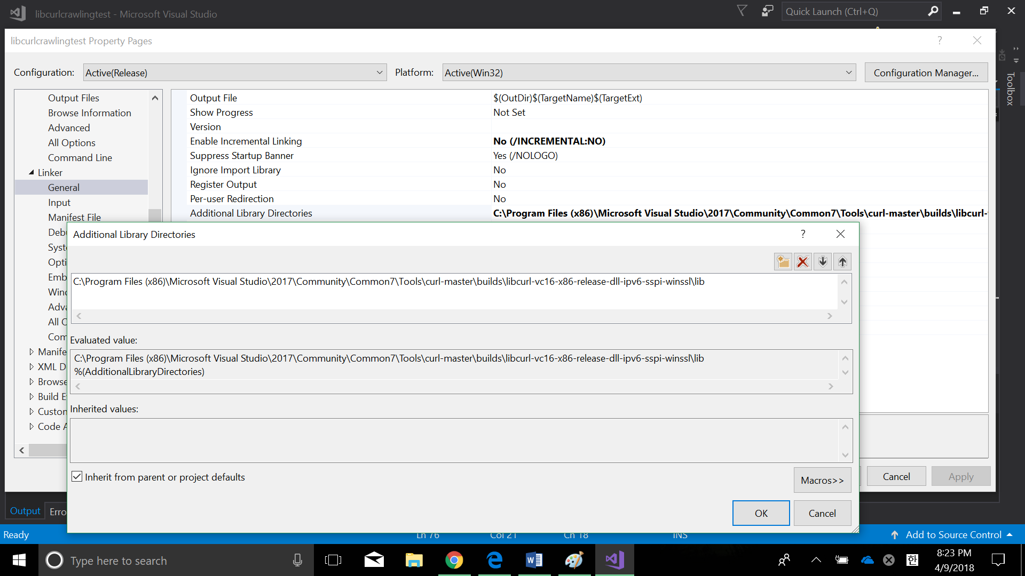

1. The links are connected.

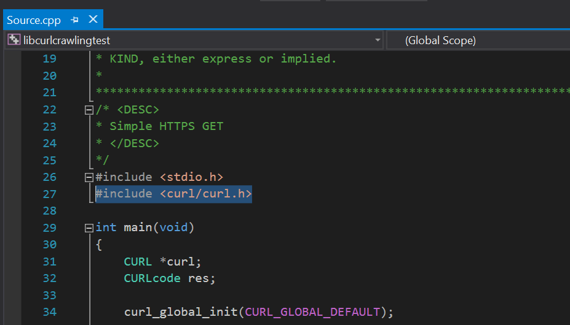

1. Copy & Paste the example code in visual studio

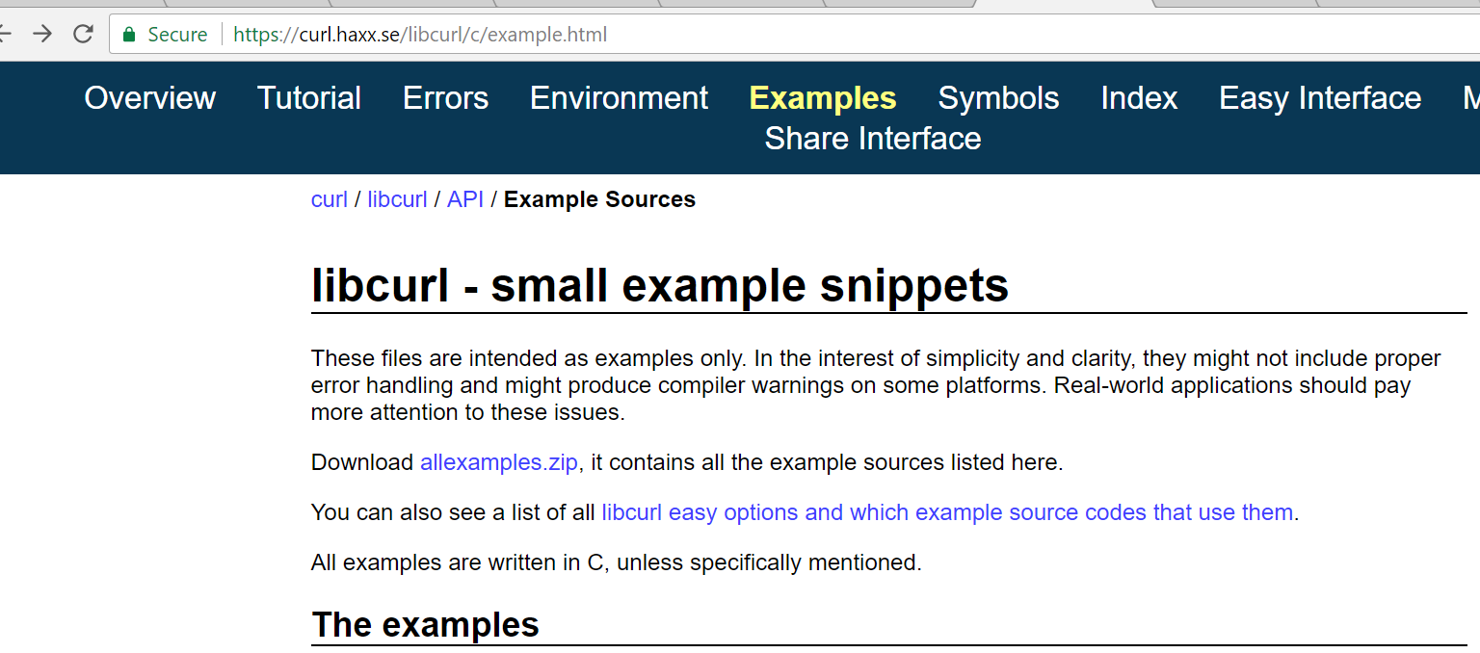



1. From the code, put my personal website inside, “http://joven.design”

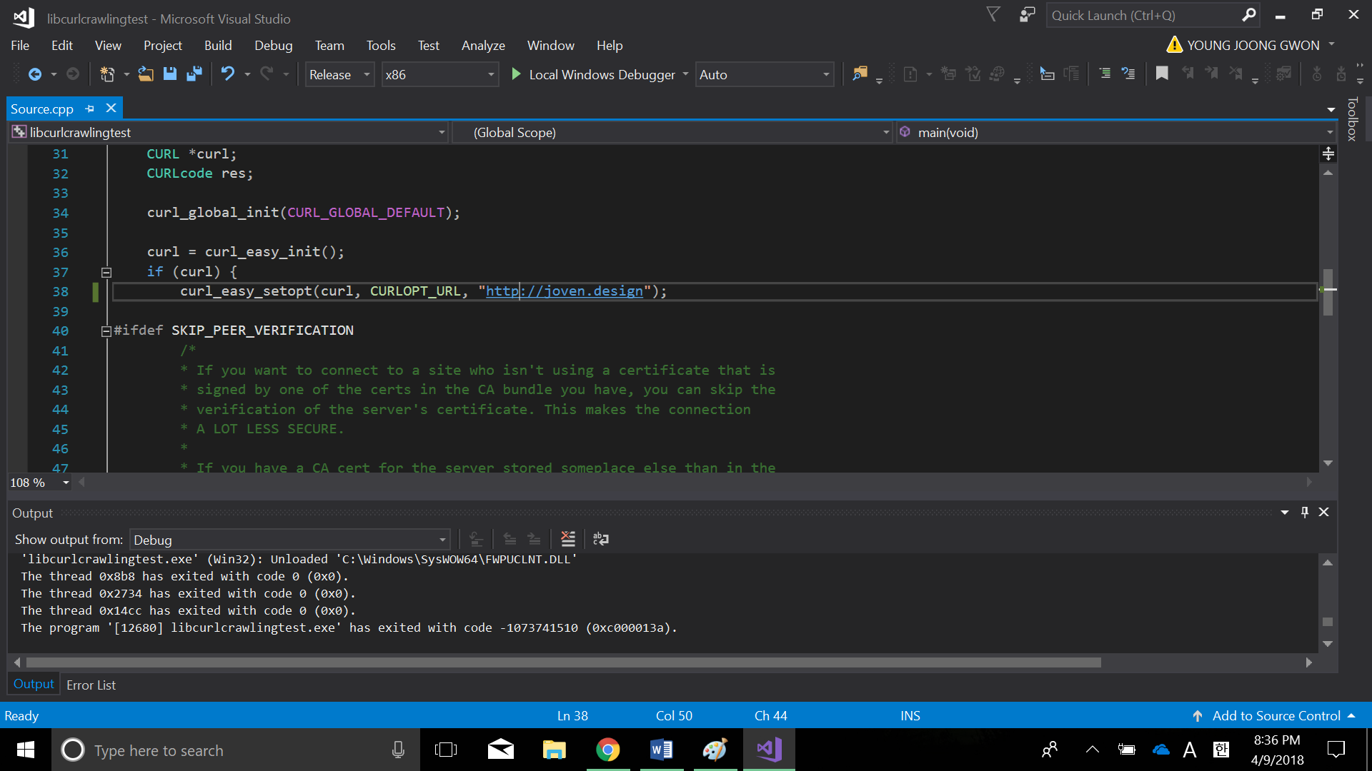

1. I can see every bootstrap codes I created, I mean This code is totally crawling every html codes from my personal website.

