Pycharm

Download requests(http://docs.python-requests.org/en/master/)

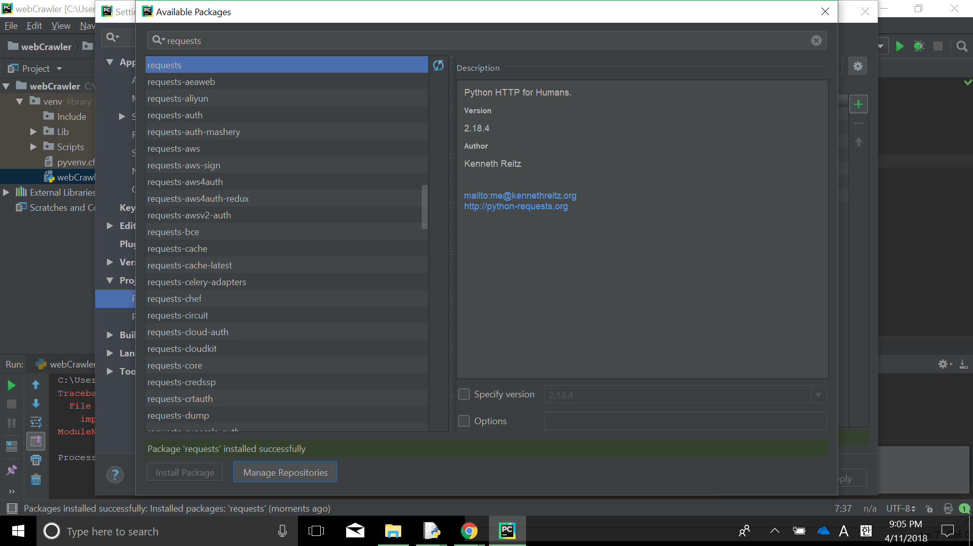

Download bs4

Beautiful Soup sits atop an HTML or XML parser, providing Pythonic idioms for iterating, searching, and modifying the parse tree.

