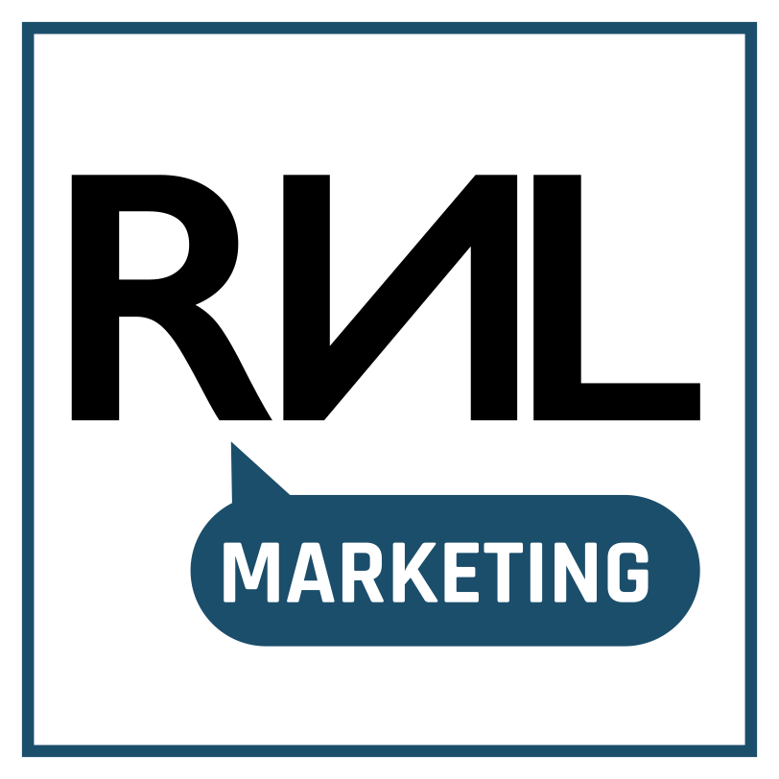
The 10-Question
AI Marketing Diagnostic
Here is how AI is really working (or not working) inside your marketing team. This five-minute audit gives you clarity on where things stand: which tools your team uses, what they produce, and who is responsible for the result.
Transform your team's quick and informal AI adoption into a consistent, structured, and trustworthy system that keeps building your business.
Two dates worth knowing. As of February 2025, European organisations are expected to make sure their people are trained to use AI well. Since August 2026, AI-generated content and AI assistants need to be recognisable as such. Neither is onerous, and both are now part of running marketing properly.

Choose the answer closest to the truth for your team — honest answers make the result useful.

1 | Which AI tools does your marketing actually use, and who approved them?

 | A | A maintained list, with a named owner for every tool
 | B | I could rebuild it from memory and a few invoices
 | C | People choose their own; I know the main ones
 | D | I would have to ask around
A shared list is the cheapest thing on this page and the one that unlocks everything else — visible spend, consistent output, and a straight answer when a client asks what you use. It is also where the EU AI Act's rules start applying.

2 | Does anything carrying your own brand name run on AI you did not build?

 | A | Yes — and we know that makes us its provider, not just its user
 | B | Yes, but we treat it as the vendor's responsibility
 | C | Not yet, but it is on the roadmap
 | D | I am not sure what would count
Putting your logo on an AI assistant changes your position: you stop being a customer of the tool and become the one answering for it. Better to be aware before launch than after — the AI Act treats you as its provider (Article 3(3)), not simply as its user.

3 | When someone talks to your chatbot, assistant, or AI voice agent, are they told it is AI?

 | A | Yes — stated clearly at the first interaction
 | B | It is implied by the design, not stated
 | C | Only if they ask
 | D | We do not have one, or I do not know
Saying so costs nothing and protects trust: customers mind being misled far more than they mind the bot. The AI Act demands it as well, at the first interaction rather than on request (Article 50).

4 | Do you publish AI-generated or AI-altered images, video, or audio of people, places, or events?

 | A | Yes — and every one of them is labelled
 | B | Yes — labelled sometimes, depending on the channel
 | C | Yes — never labelled
 | D | Not that I am aware of
Labelling synthetic images of real people, places, or events is quickly becoming a mark of a brand worth believing. Where the content could be taken for real, the AI Act requires that disclosure (Article 50).

5 | Who signs off AI-drafted copy before it goes out?

 | A | A named person reviews and approves it
 | B | Whoever wrote the prompt gives it a read
 | C | It publishes largely as generated
 | D | It varies by channel and deadline
The most valuable habit on this page. One named person reading everything before it publishes is what protects your voice, your facts, and your reputation — and under the AI Act it is also what removes the disclosure duty for AI-written text (Article 50).

6 | What has your team been taught about the AI tools they use every day?

 | A | Structured training, refreshed as the tools change
 | B | One informal session, or a shared document
 | C | They worked it out between themselves
 | D | Nothing formal
Training is what separates teams whose AI output keeps improving from teams whose output stays unpredictable. As of February 2025, European organisations have also been expected to provide it (Article 4) — with no exemption for small teams.

7 | What customer or employee data goes into those tools?

 | A | Written rules; personal data excluded or covered by contract
 | B | An informal understanding of what is off-limits
 | C | Whatever gets the best output
 | D | I do not know what people paste in
A prompt containing customer data is still a processing decision, and the AI Act leaves the GDPR fully intact alongside it (Article 2(7)). One clear internal rule spares your team from judging it case by case.

8 | Does your targeting ever rely on someone's vulnerability — age, disability, or financial pressure?

 | A | No, and our targeting rules are written down
 | B | No, but nothing is documented
 | C | Possibly, in some campaigns
 | D | I would need to check what the platform optimises for
Ordinary advertising is explicitly fine — the AI Act says so in as many words (Recital 29). The line sits at targeting built to work on someone's vulnerability, and it is worth being able to show which side of it you are on.

9 | Do you use AI for job advertising, candidate screening, or political and election communication?

 | A | Neither
 | B | Recruitment advertising or candidate screening
 | C | Political or election-related communication
 | D | Both, or I am not certain
These are the two places where everyday marketing work carries heavier obligations under the AI Act (Annex III) — competent human oversight, record-keeping, and telling people a system was used on them. A conversation worth having before the next campaign rather than during it.

10 | Which AI decision in your organisation is currently stuck because nobody is certain who owns it?  One line. Be specific — “who approves AI images for social”, not “AI governance”.  This is the most useful answer on the page. It is almost always a question of who decides rather than a question of technology — and it is usually the quickest thing to fix.

YOUR RESULT
What your answers mean
Count your A, B, C, and D answers across questions 1 to 9.
MOSTLY C & D  Experimenting | AI is already in your marketing, but it is running ahead of any shared way of working. This is by far the most common result and rarely a failure of intent — it is simply what happens when useful tools arrive faster than the time to organise them. The good news is that the first improvements here are quick and inexpensive.  Start with: The shared tool list in question 1. Almost everything else gets easier once it exists.

MOSTLY B  Developing | The right habits are there, but they live in people rather than in the way your team works. That holds up well until someone leaves, volumes rise, or a larger client asks how you handle AI. Recording what your team already does is a small job with a disproportionate payoff.  Start with: A one-page AI use policy, and a named owner for published content.

MOSTLY A  Compounding | You can explain how your team uses AI and show who is responsible for it. That is now a commercial advantage rather than an overhead: it reassures larger clients, shortens procurement conversations, and lets you adopt new tools with confidence while others hesitate.  Start with: Your answer to question 10. At this level, the decision nobody owns is what holds you back.

Two answers deserve a closer look. Anything other than A on question 9, or D on question 2, changes which rules apply to you rather than how well you are meeting them. Neither is a problem — both are worth a conversation before your next campaign.

Want the long version?
This is a short form of the diagnostic I run with clients. Schedule a free 30 min call for the deeper audit across tooling, content governance, and data handling. You keep the completed audit at the end of the call.
Bring your answer to question 10.
calendly.com/studio-rnlmkt/30min

Roseline Lemoine · +39 392 664 9331 · studio@rnlmkt.com · www.rnlmkt.com

Marketing that moves your business.
EN · IT · NL · DE · FR
Written from Regulation (EU) 2024/1689. General information for marketing teams, not legal advice.

