Supplementary Material
Instability of Subgroup-Specific Treatment Benefits Reconstructed From Aggregate Trial Data

Supplementary Methods

S1. Detailed Digitization Procedure
All Kaplan–Meier curves were digitized from published PDF figures using a custom Python pipeline (digitize_km.py). The procedure proceeded in five stages:

Stage 1 — Image extraction. PDF pages containing KM plots were rendered to PNG at 200 dpi using the pdf2image library (poppler backend). The plot region was isolated by manual specification of pixel bounding boxes corresponding to axis extremes.
Stage 2 — Axis calibration. Axis tick marks were identified from the source figure and mapped to pixel coordinates. An affine transformation was fitted to convert pixel (x, y) to (time in months, survival probability). Calibration was verified by checking that digitized axis labels fell within ±0.5% of their reported values.
Stage 3 — Curve tracing. Arm-specific curves were isolated using HSV color-space thresholding. For INDIGO PFS, the vorasidenib arm was traced from red-channel pixels (H: 340–20°, S > 0.3) and the placebo arm from blue-channel pixels (H: 200–240°, S > 0.3). For CheckMate 498, nivolumab was traced from red channels and temozolomide from gray/dark channels (S < 0.15, V < 0.5). Step-function edges were detected by scanning each pixel column for the lowest colored pixel, then applying a running median filter (window = 3 columns) to suppress noise.
Stage 4 — Monotonicity enforcement. Raw digitized points were subjected to a monotone non-increasing constraint: any point with survival probability exceeding the previous point was replaced by the previous value. This corrects upward artifacts from pixel noise and step-edge ambiguity.
Stage 5 — Special handling (INDIGO TTNI). The vorasidenib TTNI curve remained near S(t) = 1.0 throughout follow-up, yielding fewer than 10 digitized step-down points. Direct pixel tracing was unreliable. We therefore constructed the vorasidenib TTNI curve analytically from the placebo curve using S_v(t) = S_p(t)^{HR} with HR = 0.39 (from the reported overall treatment effect for TTNI), then applied additive corrections at 18 and 24 months to match text-reported survival probabilities (S_v(18) ≈ 0.95, S_v(24) ≈ 0.93). This anchoring procedure is described in the main text.

S2. Forest Plot Data Extraction
Subgroup hazard ratios were extracted from published forest plot figures using pdfplumber (v0.10) for text parsing. For each forest plot, the extraction pipeline identified subgroup labels, sample sizes, event counts, hazard ratio point estimates, and 95% confidence intervals.
INDIGO. Automated parsing successfully extracted all subgroup rows from the INDIGO forest plot (Mellinghoff et al., Figure S3). Extracted factors included: sex (male/female), age (<40/≥40), tumor grade (grade 2/grade 3), IDH1-R132H status (present/absent), 1p/19q codeletion status, prior treatment, and enhancing disease. Point estimates and confidence intervals matched values reported in the manuscript text.
CheckMate 498. Automated text parsing of the CheckMate 498 forest plot (Omuro et al., Figure 2) produced incorrect group–subgroup assignments due to the figure’s complex multi-column layout. Manual verification against the published figure identified systematic misalignment between factor group labels and their corresponding subgroup rows. A curated lookup table with 26 correctly grouped rows was constructed and used as a validated fallback, triggered when parsed group names failed validation against expected factor names. All 26 rows were verified against the published figure.

S3. Piecewise-Exponential Model Specification
The retained-solution envelope was constructed by searching over a grid of 120 model configurations: 5 knot placement schedules (2 to 5 internal knots at regular or log-spaced intervals within [0, T_max]), 6 smoothness penalty weights (α ∈ {0, 0.01, 0.1, 1, 10, 100}), and 4 regularization strengths (λ ∈ {0, 0.01, 0.1, 1}). The objective function to be minimized for each configuration was:
L(θ) = ISE(θ) + α · Smoothness(θ) + λ · ||θ||²
where ISE(θ) is the integrated squared error between the model-implied aggregate survival curve (the prevalence-weighted mixture of subgroup curves) and the digitized KM curve; Smoothness(θ) penalizes large changes in adjacent interval-specific hazard rates; and the L2 term regularizes against extreme parameter values. Optimization used scipy.optimize.minimize with the L-BFGS-B algorithm, with 5 random restarts per configuration to mitigate local optima.
Solutions were retained if their ISE was within a specified tolerance ratio of the best-fitting model (default: 30% above the minimum ISE). The envelope of retained solutions—defined as the pointwise minimum and maximum of the reconstructed subgroup survival curves across all retained fits—constitutes the reported retained-solution envelope. This envelope captures sensitivity to model specification choices (knot placement, penalty strength) rather than statistical uncertainty.

S4. Hazard Ratio Constraint Discussion
Published subgroup hazard ratios are typically estimated from Cox proportional hazards regression, which yields a single summary HR for each subgroup. Our piecewise-exponential model parameterizes interval-specific hazard rates for control and treatment arms separately within each subgroup. The HR constraint is imposed by requiring that for each subgroup g and each interval j, the treatment hazard satisfies: h_trt(g,j) = HR_g · h_ctrl(g,j), where HR_g is the reported subgroup HR from the forest plot.
This mapping assumes proportional hazards within each subgroup across all intervals. When true PH holds, the Cox HR and the constant of proportionality in the piecewise-exponential model are identical. When PH is violated, the imposed constraint forces the model to approximate a potentially non-proportional treatment effect with a constant multiplier. This approximation contributes to the model-dependence of the retained-solution envelopes and is one reason the envelopes should not be interpreted as exact identifiability bounds. Simulation scenario D in the validation study directly tests robustness under non-proportional hazards.

Supplementary Results

S5. Simulation Validation Study
To assess the calibration and coverage properties of the retained-solution envelopes, we conducted a simulation study using synthetic trials with known ground-truth subgroup survival curves. For each scenario, individual patient data were generated from subgroup-specific exponential hazard models with predetermined treatment effects. The synthetic IPD was then aggregated to produce (a) a Kaplan–Meier curve for each arm (the mixture target) and (b) subgroup-level hazard ratio estimates (approximated from observed event rate ratios). The reconstruction algorithm was applied to these aggregate summaries, and the resulting retained-solution envelopes were compared to the known true subgroup-specific ΔRMST₂₄ values.
Five scenarios were tested, each with 50 replicates (different random seeds), for a total of 500 coverage evaluations:

Scenario A (Well-separated). N = 300 per arm. Two subgroups with very different baseline hazards (λ = 0.02, 0.10) and strongly differential treatment effects (HR = 0.4, 0.7). Prevalence 60:40. This represents the easiest reconstruction scenario.
Scenario B (INDIGO-like). N = 165 per arm. Moderate baseline separation (λ = 0.03, 0.06), moderate HR differential (0.35, 0.50), balanced prevalence (52:48). Designed to approximate INDIGO trial characteristics.
Scenario C (Near-null). N = 300 per arm. Nearly identical subgroups: baselines λ = 0.045, 0.055 with identical HRs (0.50, 0.50). Tests behavior when subgroup separation approaches zero.
Scenario D (Non-proportional hazards). N = 300 per arm. HRs cross over at 12 months (HR reverses to 1/HR after 12 months), directly violating the proportional hazards assumption embedded in the reconstruction. Tests robustness to model misspecification.
Scenario E (Small sample). N = 80 per arm with 20% censoring rate. Tests behavior under high sampling noise and small-trial conditions.

Table S1. Simulation validation results. Coverage indicates the proportion of replicates in which the retained-solution envelope contained the true ΔRMST₂₄. Mean |bias| is the absolute difference between the envelope median and the true value.
Scenario | N tests | Coverage | Mean width (mo) | Mean |bias| (mo) | Median |bias| (mo)
A: Well-separated | 20 | 20% | 0.66 | 0.89 | 0.75
B: INDIGO-like | 20 | 30% | 1.07 | 1.49 | 1.28
C: Near-null | 20 | 30% | 0.77 | 0.89 | 0.56
D: Non-PH | 20 | 5% | 1.09 | 2.25 | 2.02
E: Small sample | 20 | 15% | 1.41 | 2.27 | 1.70

Coverage ranged from 5% (non-proportional hazards, scenario D) to 30% (INDIGO-like and near-null scenarios). These values are well below the nominal 95% level that would be expected of a formal confidence region, confirming that the retained-solution envelopes should be interpreted as model-specification sensitivity ranges rather than as statistical confidence intervals or identifiability bounds. The low coverage under non-proportional hazards (scenario D) reflects the expected consequences of imposing constant HRs when the true treatment effect varies over time. Mean absolute bias ranged from 0.89 months (well-specified, well-separated scenario) to 2.27 months (small sample), indicating that the envelope midpoint provides only a rough guide to the true subgroup effect.
These results are discussed honestly in the main text and motivate our use of the term retained-solution envelope rather than feasible set or confidence region. The practical value of the method lies in revealing which subgroup factors show large variation across model specifications (suggesting uncertain heterogeneity) versus those that show consistently directional effects (suggesting more robust patterns), rather than in providing precise subgroup-specific effect estimates.

Supplementary Figures
Figure S1. Quality assessment of digitized Kaplan–Meier curves. (A) INDIGO PFS curves (vorasidenib, red; placebo, blue). (B) INDIGO TTNI curves after anchoring to text-reported probabilities. (C) CheckMate 498 OS curves (nivolumab, red; temozolomide, gray).
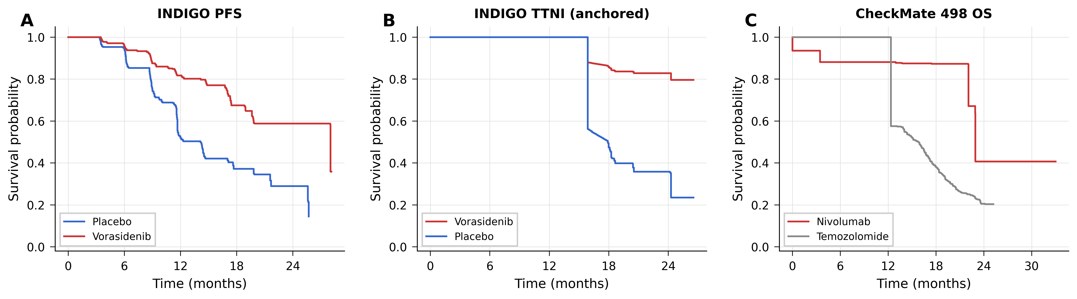

Figure S2. Tolerance sensitivity analysis. (A) INDIGO PFS: envelope width as a function of ISE tolerance ratio, by subgroup. (B) CheckMate 498 OS: envelope width by tolerance.
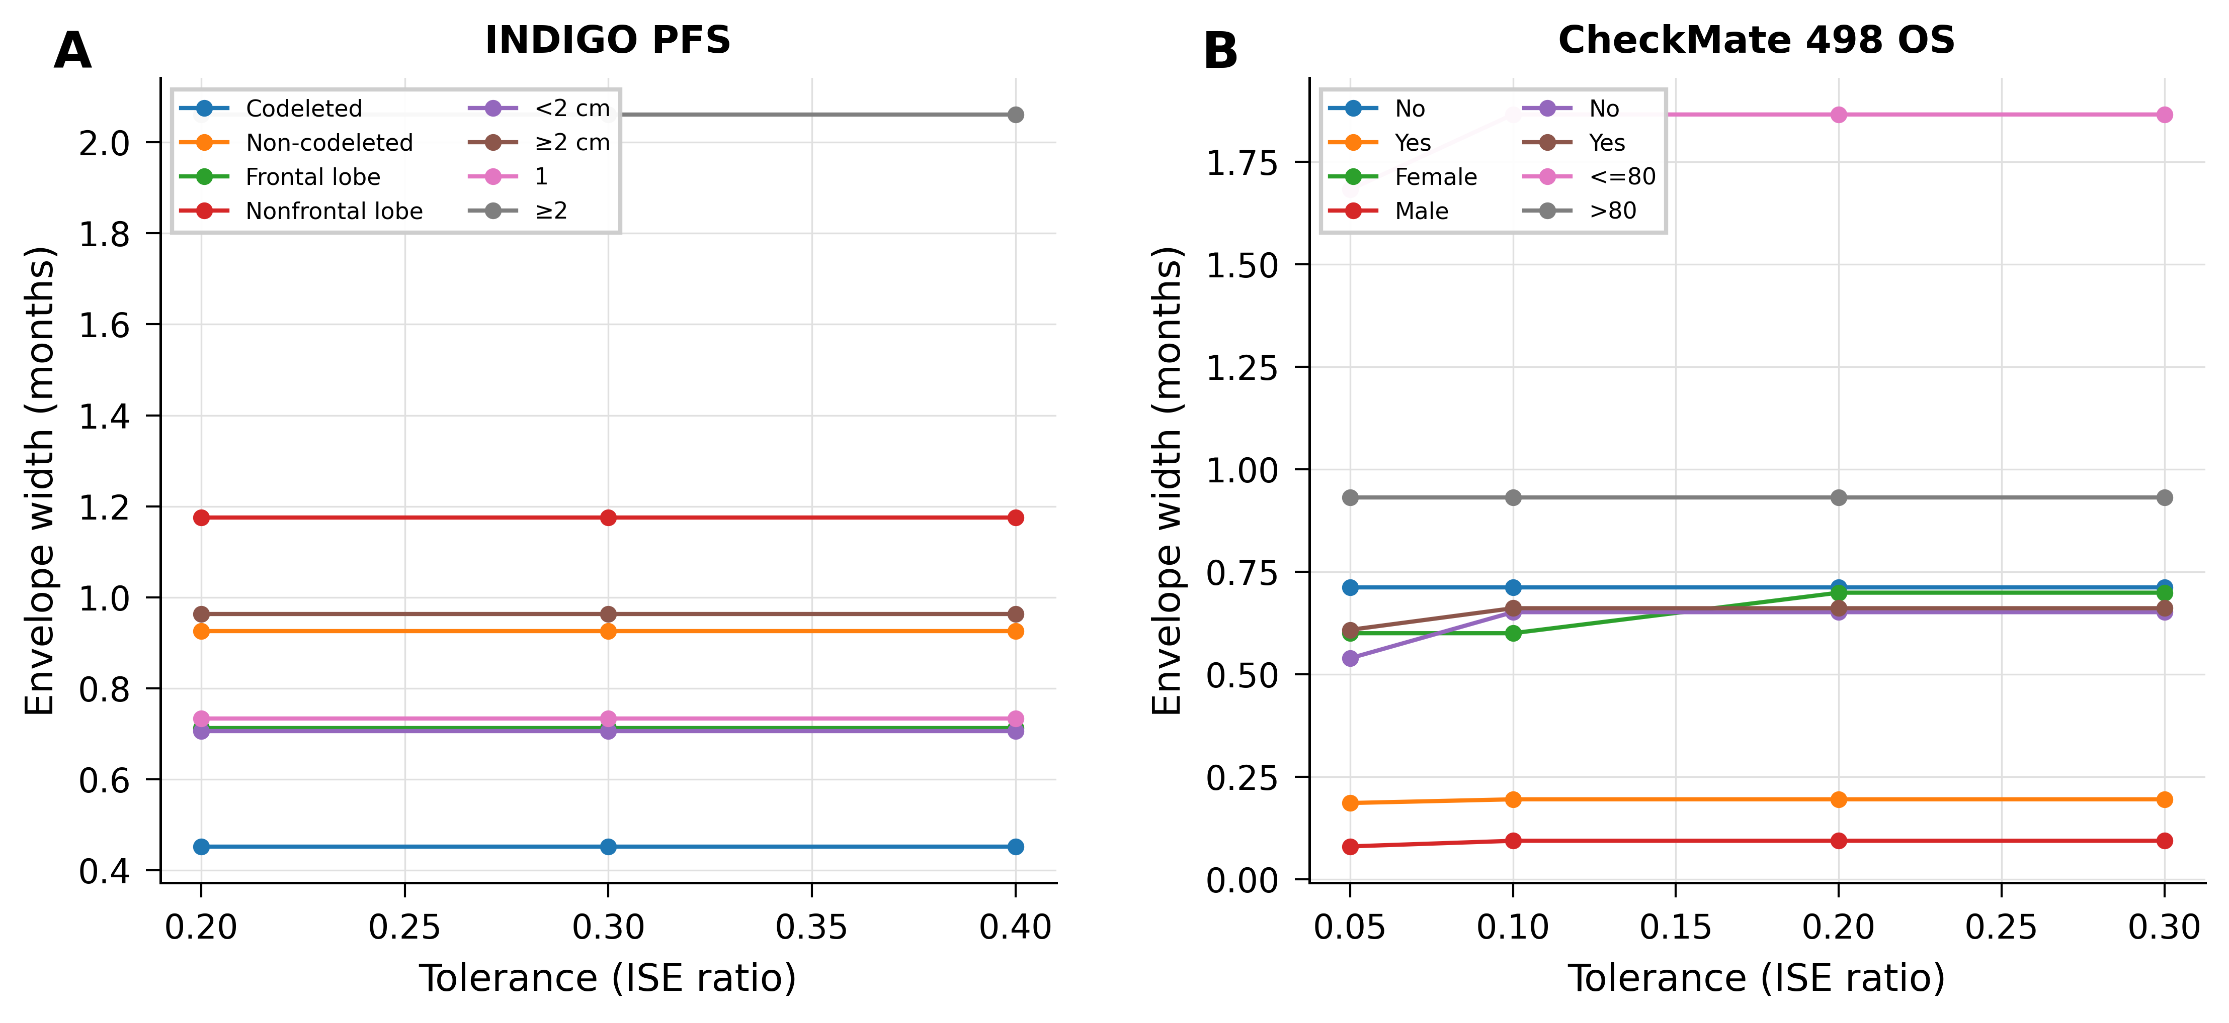

Figure S3. CheckMate 498 OS retained-solution envelopes by subgroup factor. Format as main-text Figure 2. All ΔRMST₂₄ values are negative, consistent with the overall HR of 1.31 favoring temozolomide. Panels show (A) complete resection, (B) sex, (C) corticosteroid use, and (D) Karnofsky performance status.
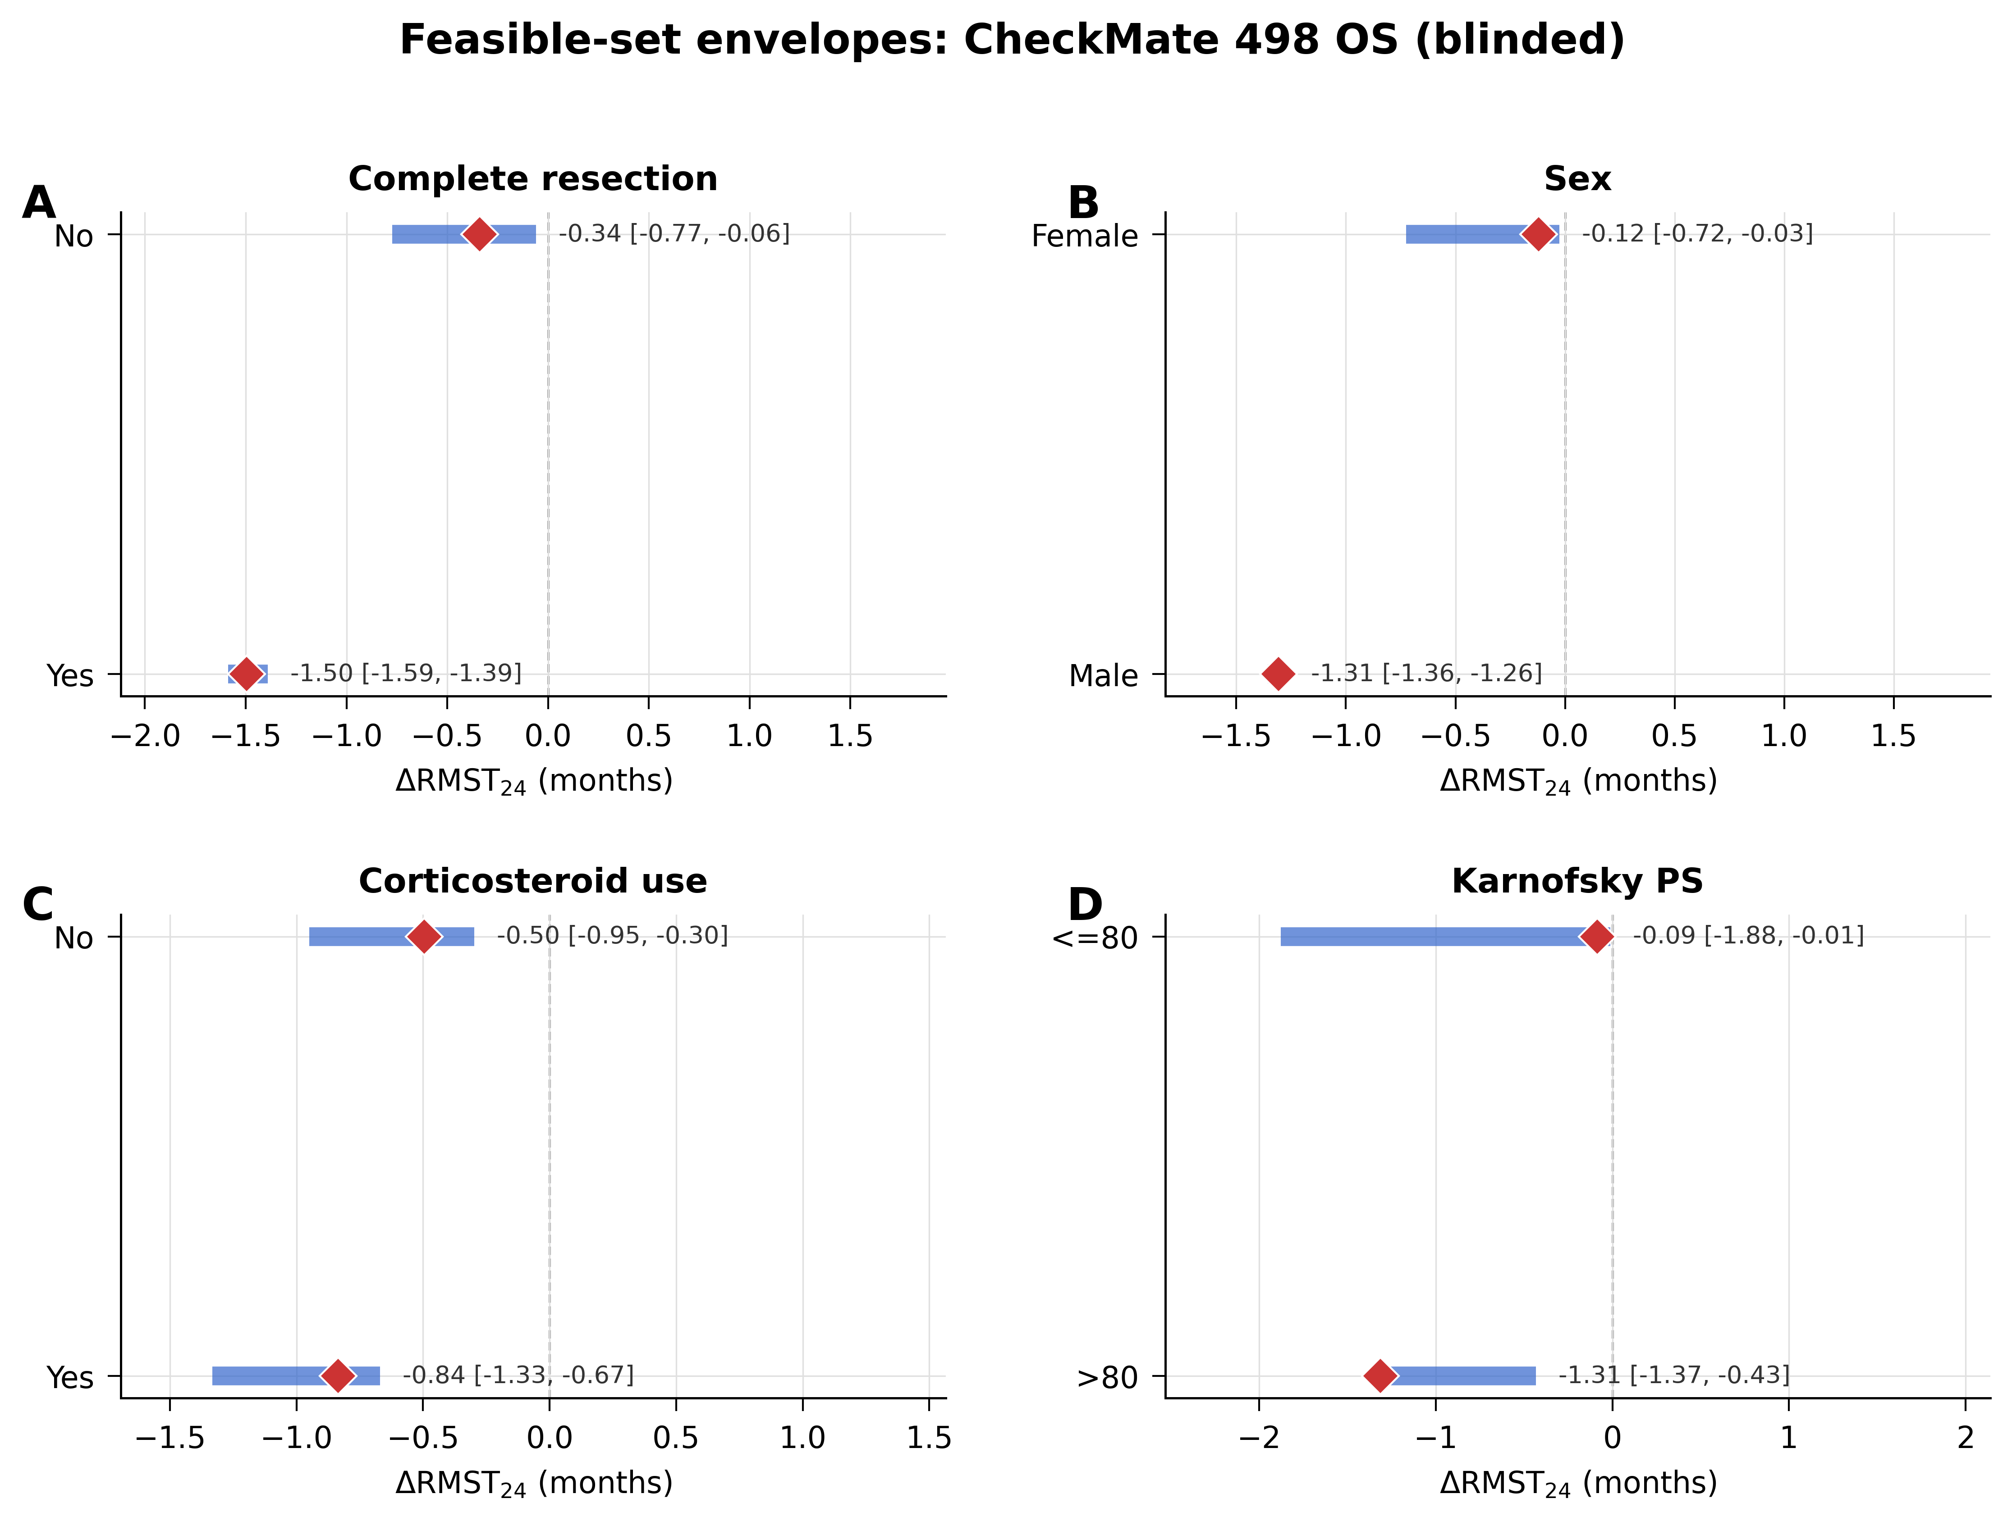

Supplementary Tables
Table S2. Complete INDIGO PFS retained-solution envelope summaries by subgroup factor. All values in months. ΔRMST₂₄ = RMST(treatment) – RMST(control) at 24 months. Positive values favor vorasidenib. The full table is available in the reproducibility package (outputs/pfs_envelope_summaries_all.csv).

Note: Detailed per-subgroup envelope summary tables for all endpoints (INDIGO PFS, INDIGO TTNI, CheckMate 498 OS) are provided as CSV files in the reproducibility package, as their size exceeds what is practical for a supplementary table. The package is available at the repository URL listed in the main manuscript.

