Go to this site:

<http://talktt.azurewebsites.net>

Select Register:

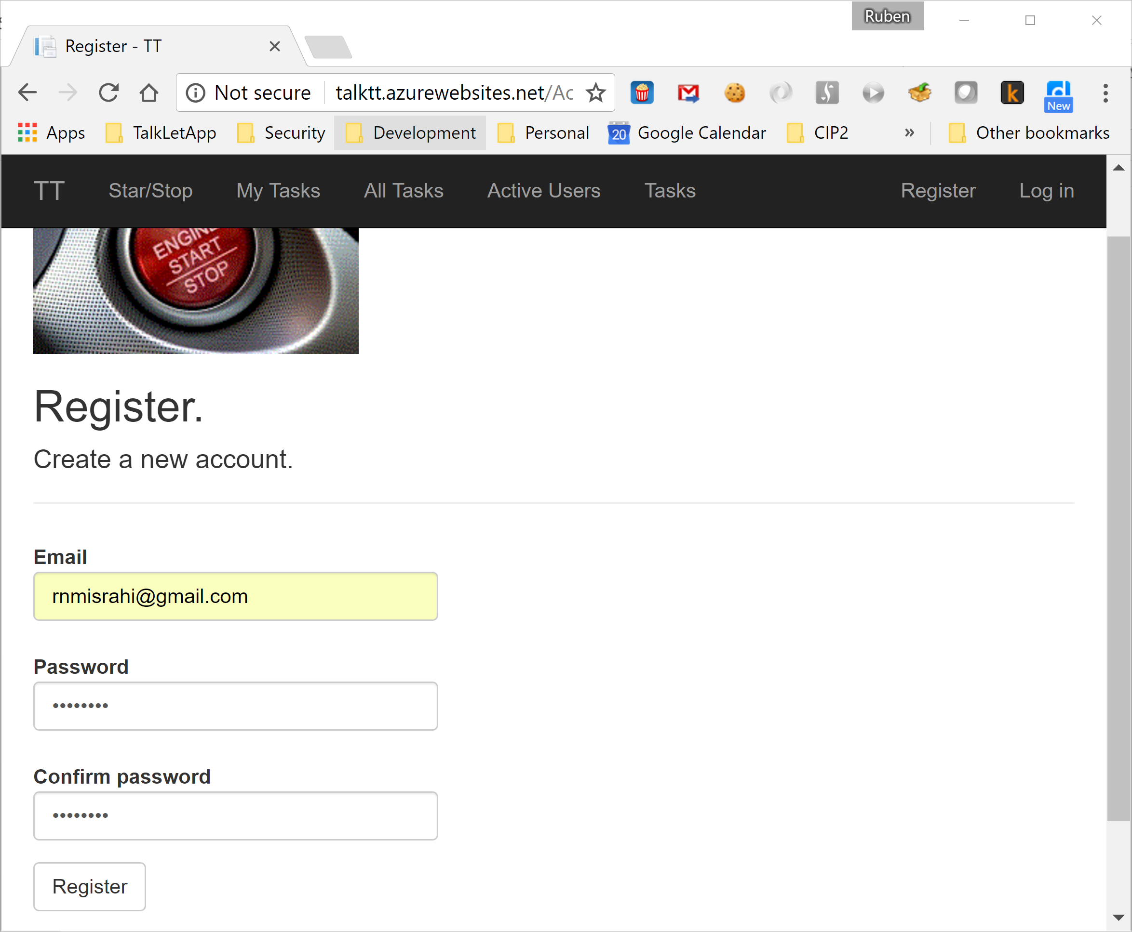

Now it’s a matter of selecting Start/Stop every time you start or stop to work:

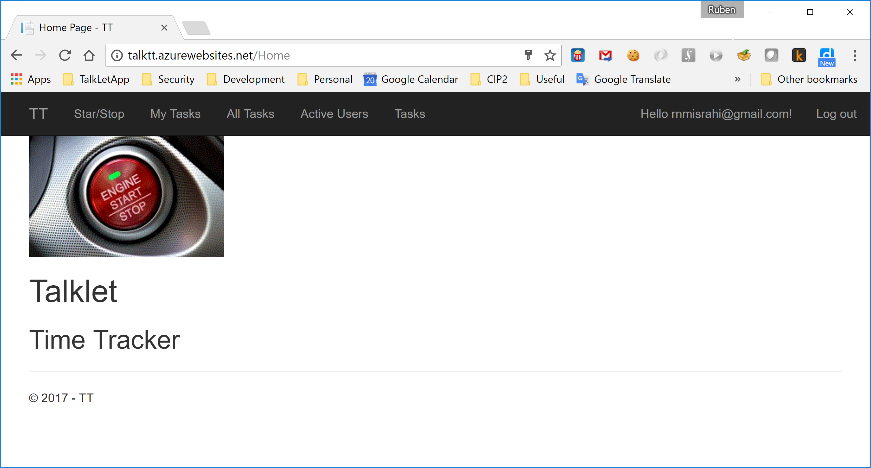

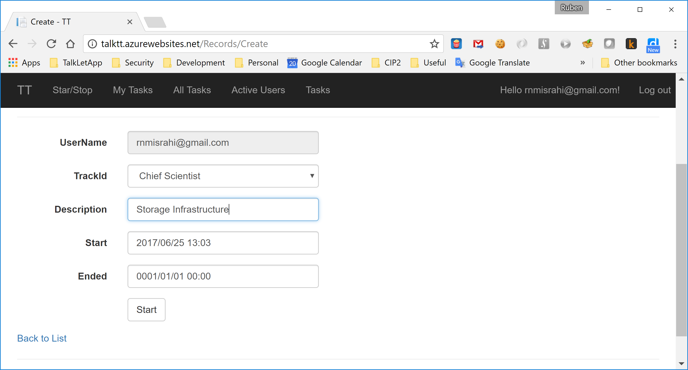

Select the Track and write the description. The start time will show current date/time.

Press Start.

That’s it. Work!

When you finish, select Start/Stop again:

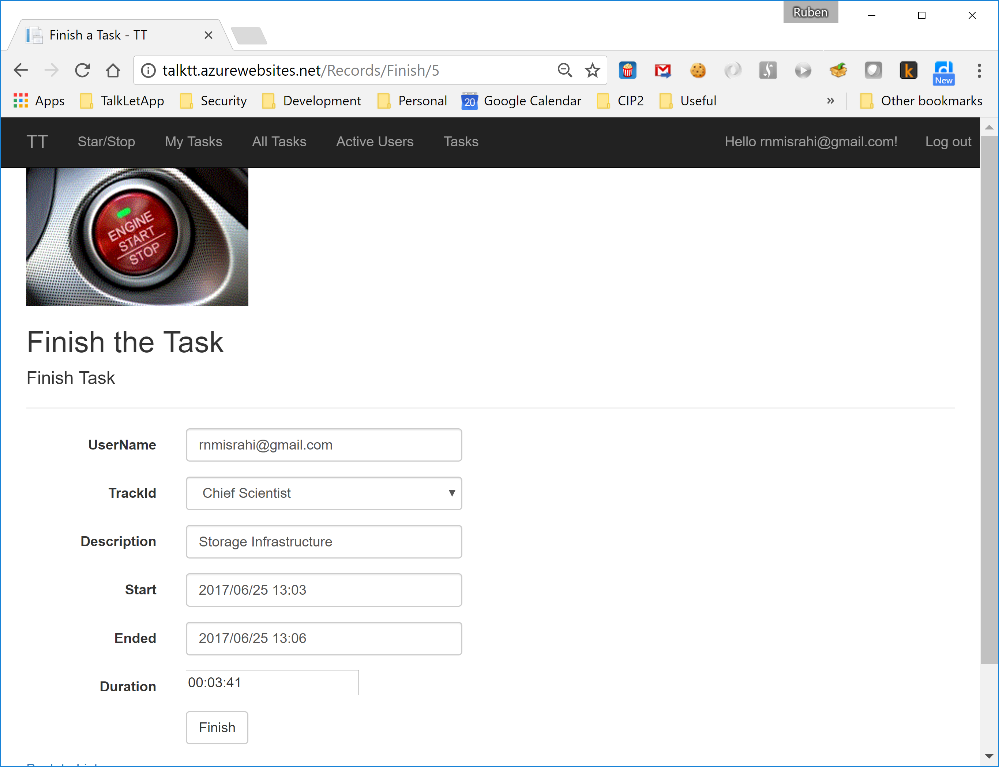

The fields will be filled with the information you gave (you can modify it). Press Finish.

You’re done!

You can review (and edit) your time tracked by selecting My Tasks:

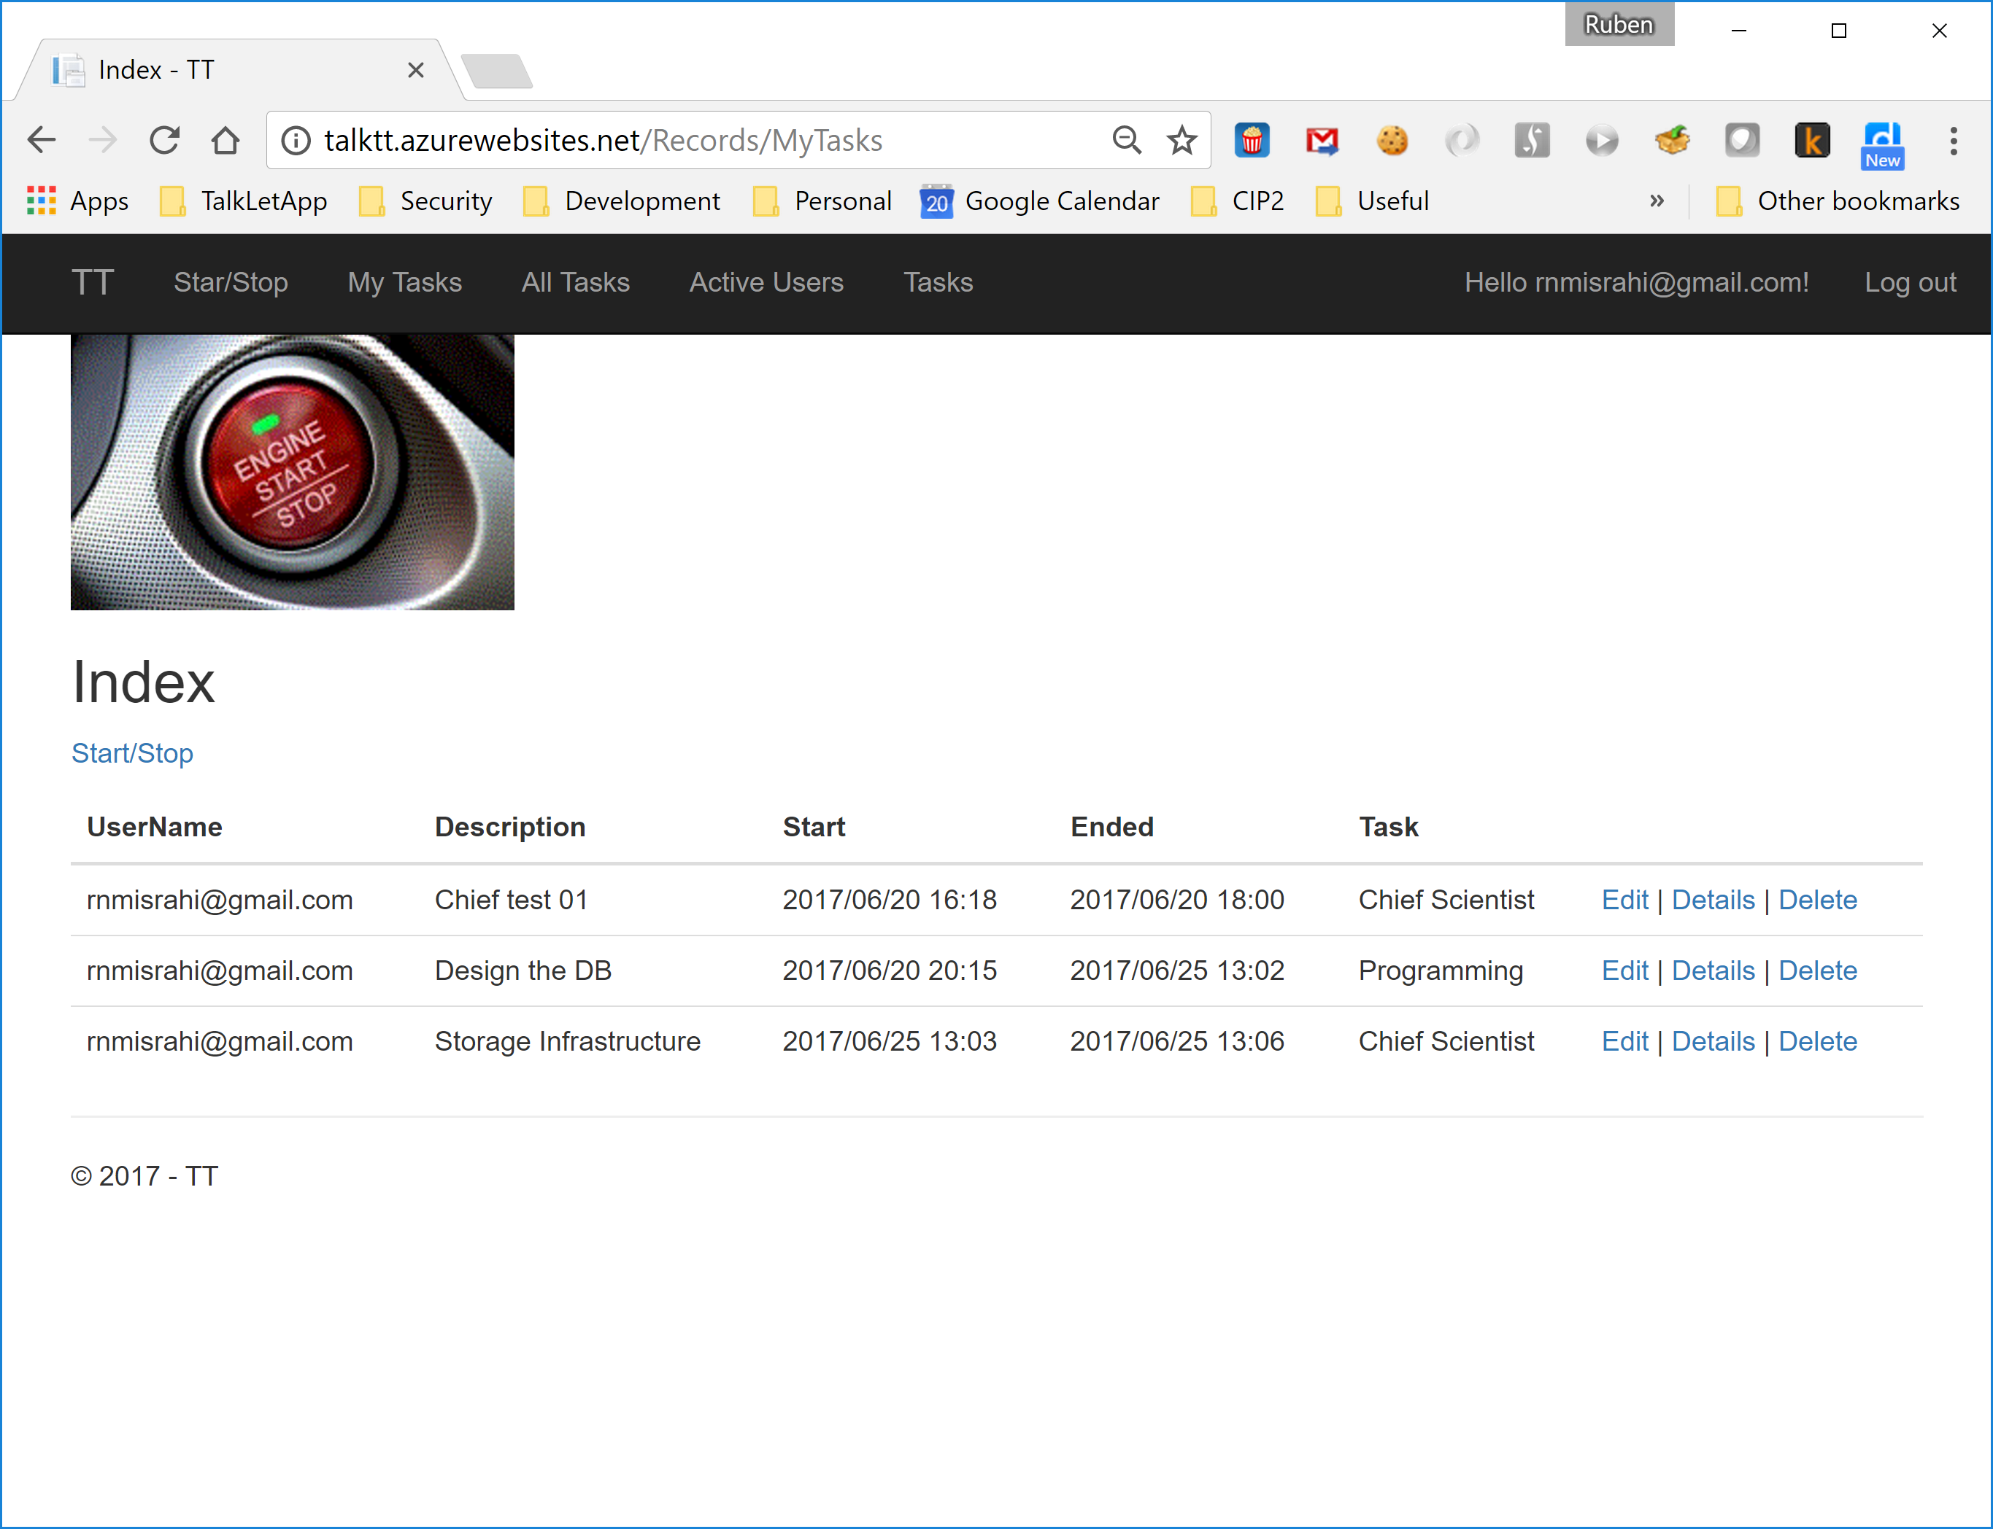

You can also know who’s “Active” by selecting Active Users:

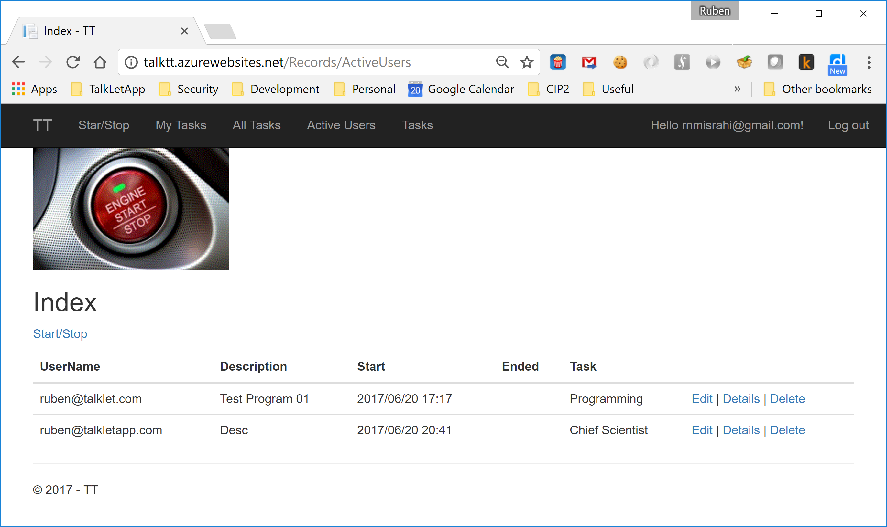

Next time you can just Log In.