mtg-demand-signal: the Current Demand index
Snapshot 2026-05-25. By Cameraderie Cards. Informational only, not financial advice.
The other models in this toolkit react to price. The buy model flags a card that is already rising, the sell model flags one that has peaked, the reprint model flags a supply shock, and the liquidity model tells you whether you can exit. None of them answers the question that sits upstream of all of them: how badly do players actually want this card right now? Demand is the catalyst that causes the moves the other models chase. This model scores every Magic: The Gathering card from 0 to 100 on Current Demand: buy-side desire to acquire the card today. Demand is not the same as liquidity. Liquidity is how easily you can sell; demand is how much the market wants to buy.

What goes into the score
Demand is built from four measurable signals, each percentile-normalized and blended, with per-row renormalization when a signal is missing. EDHREC popularity is the primary driver; revealed price demand is the secondary signal; playability and breadth are supporting terms (the precise blend weights are part of the private pipeline):
Component | Role | What it measures | Source
EDHREC popularity | Primary | how many Commander decks run the card, its inclusion rate, and its salt score: the single best direct measurement of wanting a card | edhrec.parquet
Revealed price demand | Secondary | sustained price appreciation and run-up (1y return, 3y CAGR, z-score, drawdown recovery); demand pressure shows up as rising prices | features.parquet
Playability | Supporting | the substrate that lets demand exist: legal in Commander, legal in an eternal format, flagged a game-changer | printings.parquet
Breadth of want | Supporting | how widely the want spreads: number of printings, because Wizards reprints the cards people keep demanding | printings.parquet
A card scores high when it is run in many Commander decks, is appreciating or holding value, is legal where it is played, and has been reprinted to chase demand. EDHREC leads because it is a direct, per-deck count of players choosing to include a card, the closest thing to a demand meter that exists for this market.

Coverage
Scored 32,731 cards at this snapshot. 28,794 of them carry EDHREC inclusion data (a directly measured Commander demand signal); the rest are scored from the price, playability, and breadth proxies and flagged has_edhrec = false. 4,502 cards have enough tracked price history for the revealed-price-demand signal; where it is absent it is imputed to a neutral level so it can nudge a score but never sink an established card.
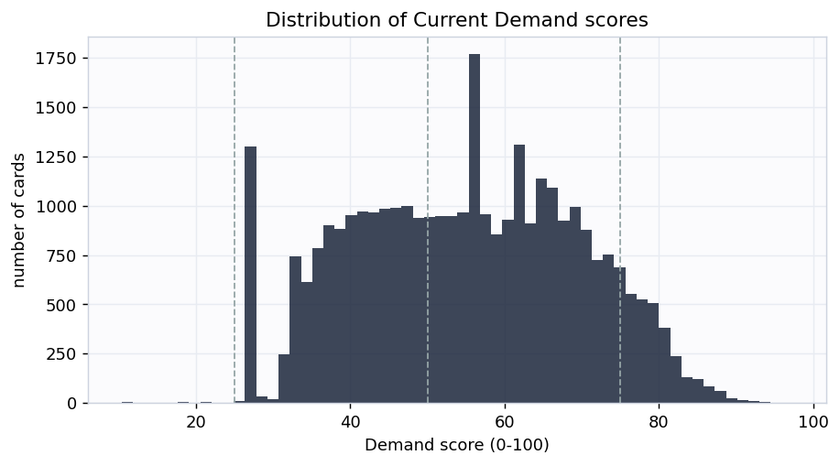
Distribution
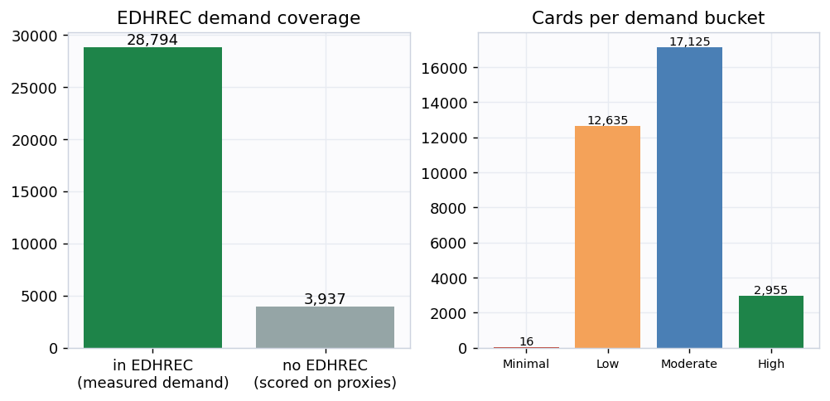
Coverage

Does the score mean anything? Two honest checks
1. More-wanted cards command higher prices. The price LEVEL is deliberately not an input to the score (only price appreciation is). Yet when cards are binned by demand decile, the median market price climbs steadily with demand (Spearman correlation 0.294). The index lines up with what the market actually pays.
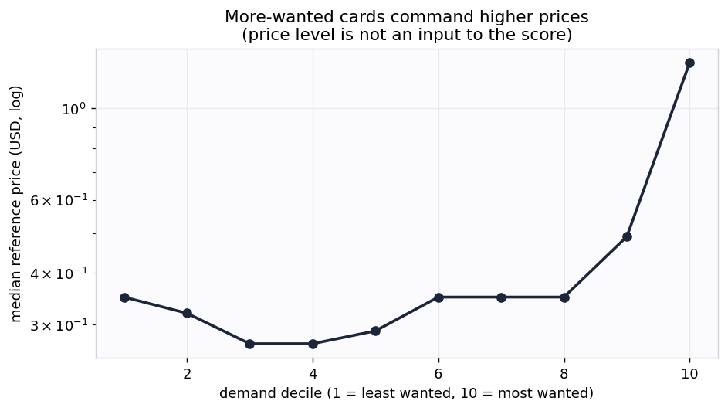
Demand vs price
2. Independent proxies predict EDHREC (the real test). EDHREC is 45% of the headline score, so “demand tracks EDHREC” would be trivially circular. So we build a second ranking from only the non-EDHREC proxies (price demand, playability, breadth) and deliberately exclude EDHREC. The EDHREC inclusion count that ranking never saw still rises monotonically across its deciles (rank correlation 0.502). Signals that never touched EDHREC agree with EDHREC, so the components are measuring the same underlying demand rather than echoing one input.
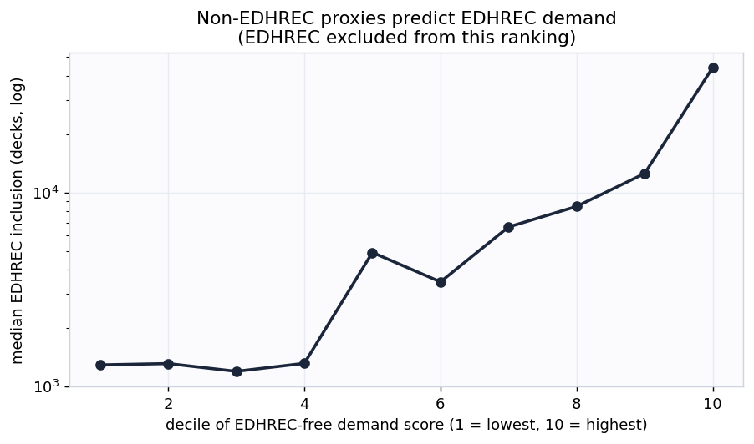
Corroboration

A stronger test: held-out generalization and convergent validity
The two checks above use the full sample. Two further checks go further. Neither turns v1 into a supervised forecast (there is still no ground-truth demand label and no EDHREC time-series), but both are harder to pass than an in-sample correlation.
3. Non-EDHREC signals predict held-out EDHREC demand. We fit a small ridge-regularized linear model that predicts a card’s EDHREC deck count from only its non-EDHREC signals (price demand, playability, breadth, printings, price, legality), using 5-fold cross-validation so every card’s EDHREC count is predicted by a model that never saw that card during fitting. Across 28,794 cards the out-of-fold rank correlation is 0.603 and the out-of-fold R-squared is 0.394. The non-EDHREC signals do not just correlate with EDHREC in-sample, they generalize to predict the EDHREC demand of cards held out of the fit.
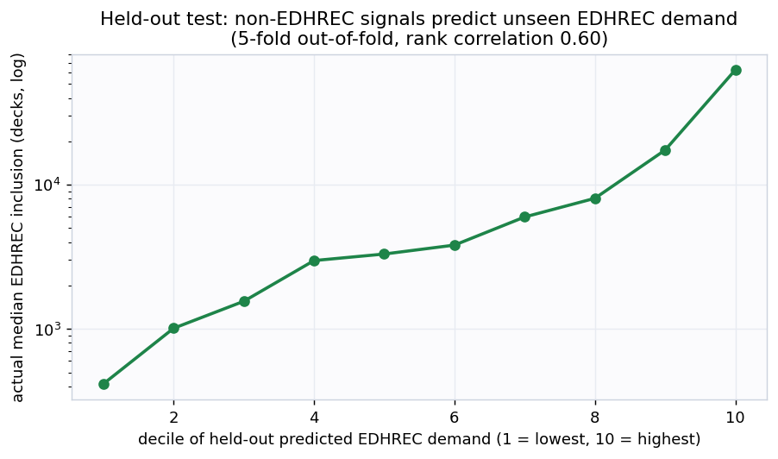
Held-out test
4. The score agrees with three independent models, in the right directions. The sibling models (buy/spike, reprint risk, liquidity) are built by separate pipelines from different data. Current Demand relates to each one exactly as theory predicts, and moderately rather than at 1.0 (which would mean it is redundant with one of them):
Independent model | Cards in common | Rank correlation with demand | Expected
Liquidity (ease of selling) | 32,271 | +0.59 | positive: wanted cards trade more
Reprint risk | 32,691 | +0.35 | positive: Wizards reprints what people demand
Buy / spike signal | 4,329 | +0.08 | mild positive: demand is the spike catalyst
Demand is most correlated with liquidity (wanted cards are easier to sell) but far from identical to it, which is the point: demand and liquidity are related but distinct. Its weak correlation with the spike signal is expected, because spike is about timing a move, not the level of demand.

Example cards
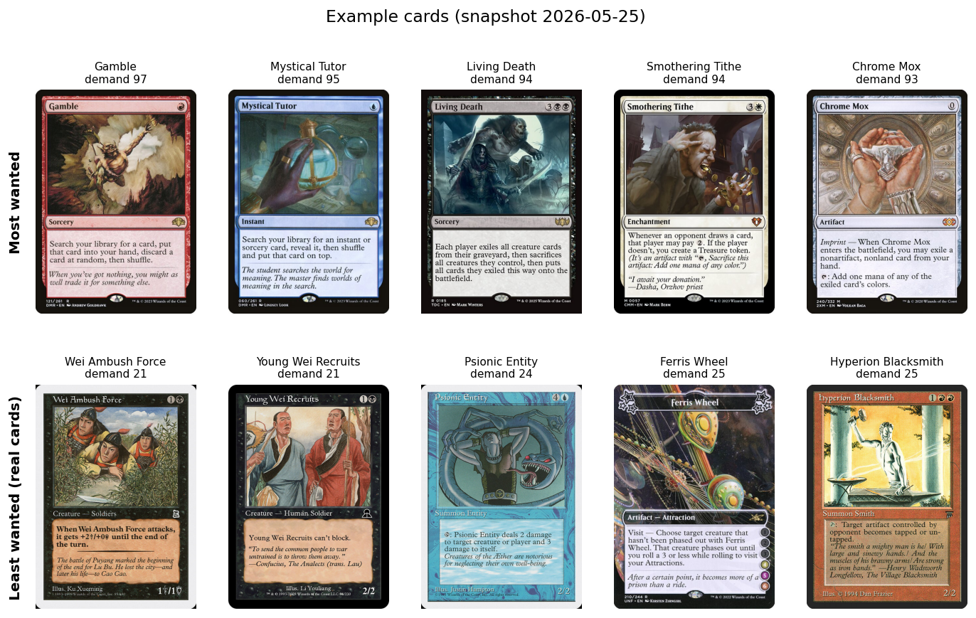
Examples
The most-wanted cards are exactly the ones a Commander player would name: format-defining tutors, fast mana, and staple value engines that go into deck after deck. The least-wanted real cards are narrow, format-marginal pieces that almost no deck chooses to run.

Buckets
Bucket | Score | Cards | Median price | Median EDHREC decks
High demand | 75-100 | 2,955 | $1.44 | 76,758
Moderate demand | 50-75 | 17,125 | $0.35 | 8,230
Low demand | 25-50 | 12,635 | $0.35 | 539
Minimal demand | 0-25 | 16 | $2.71 | 47

How this plugs into the other signals
Demand is the upstream catalyst. A card with rising demand and a pending supply shock (high reprint risk) is the classic setup the buy model is trying to catch; a card with collapsing demand is a sell. Fed as a feature into the spike model, Current Demand is a leading indicator of the price moves the other models react to. Supply down (reprint) and demand up (this model) together explain most large price moves.

Honest limitations
- This is version 1: a transparent composite index, not a supervised forecast. There is no single clean ground-truth label for “demand”, so it carries no held-out accuracy number against future demand. It is validated four ways instead: internal consistency, independent corroboration, a held-out test that predicts unseen EDHREC demand from the non-EDHREC signals, and convergent validity against three independent sibling models. None of these is a forward forecast.
- It measures demand level, not demand growth. It uses a current EDHREC snapshot, not an EDHREC time-series, so it cannot yet tell a card that is climbing in popularity from one that is fading at the same level. A forward-looking “demand momentum” needs historical EDHREC snapshots that are not yet sourced.
- Bans show up as lost demand, once. A Commander ban removes a card from EDHREC inclusion, so a banned card loses its largest component and falls into the lower buckets. Cards banned only in competitive formats (often for being too strong) carry no penalty, because that is not low demand.
- Roadmap: scrape MTGTop8 tournament decklists (metagame adoption), an EDHREC popularity time-series (demand momentum), and Banned and Restricted announcements (ban risk as forward negative demand). The printing table already carries tcgplayer_id for marketplace joins. A natural v2 is supervised: predict forward EDHREC-rank improvement or forward price appreciation.
- Informational only, not financial advice.
Generated by scripts/build_report.py from data/processed/demand_features.parquet.

