mtg-liquidity-signal: the Current Liquidity index
Snapshot 2026-09-29. By Cameraderie Cards. Informational only, not financial advice.
Every existing model in this toolkit tells you direction: will a card rise (buy), has it peaked (sell), is it about to be reprinted (brace). None of them tells you whether you can actually exit. A perfect sell call is worthless on a card that takes months to move and only at a deep discount. This model fills that gap. It assigns every Magic: The Gathering card a Current Liquidity score from 0 to 100: how easily an owner could turn it into cash right now.

What goes into the score
Liquidity is built from four measurable proxies, each normalized to a percentile and blended (weights {‘spread’: 0.4, ‘depth’: 0.25, ‘activity’: 0.2, ‘demand’: 0.15}):
Component | What it measures | Source
Spread | bid-ask cost to round-trip, CardKingdom buylist vs retail on the same printing | multi-venue price feed
Depth | how many venues list the card, whether a dealer will buy it, cross-venue price agreement | multi-venue price feed
Activity | how often the quoted price actually moves over 120 days (a flat price means nothing is trading) | 16-year daily history
Demand | Commander-format popularity (EDHREC) | EDHREC
A card scores high only when it is cheap to exit, sold in many places, actively repricing, and wanted. The weights lean on the spread because that is the cost an owner actually pays to sell.

Coverage
Scored 32,356 cards at this snapshot. 18,162 of them have a real dealer bid (CardKingdom buylist), so their spread is measured, not estimated; the median measured spread is 87.2%. Cards without a dealer bid are flagged is_imputed and scored from depth, activity, and demand only.
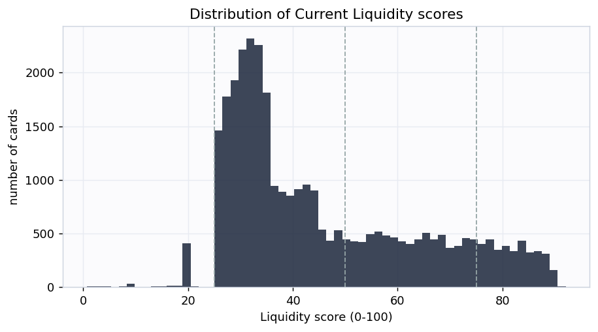
Distribution
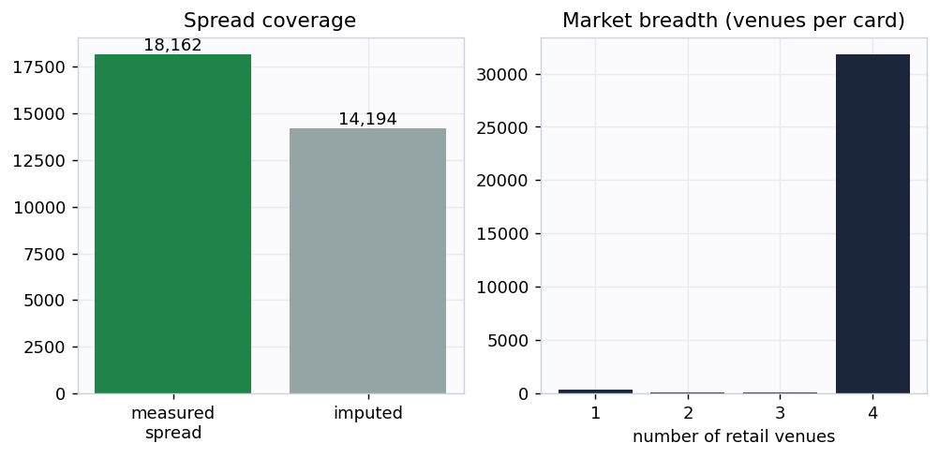
Coverage

Does the score mean anything? Two honest checks
1. Measured spread lines up with the buckets. Cards the index calls illiquid really do cost more to round-trip. Because the spread is one input to the score, this is partly a consistency check rather than a clean test.
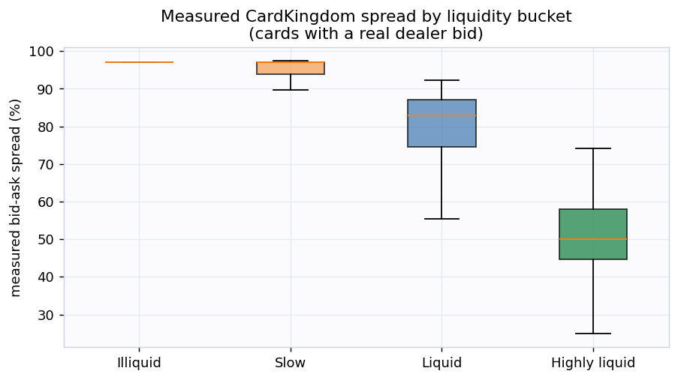
Spread by bucket
2. Independent proxies predict the spread (the real test). If we rank cards using only depth, activity, and demand and deliberately exclude the spread, the measured spread still falls steadily as that spread-free score rises (rank correlation 0.228). The proxies that never saw the spread agree with the spread. That is genuine corroboration, not circular reasoning.
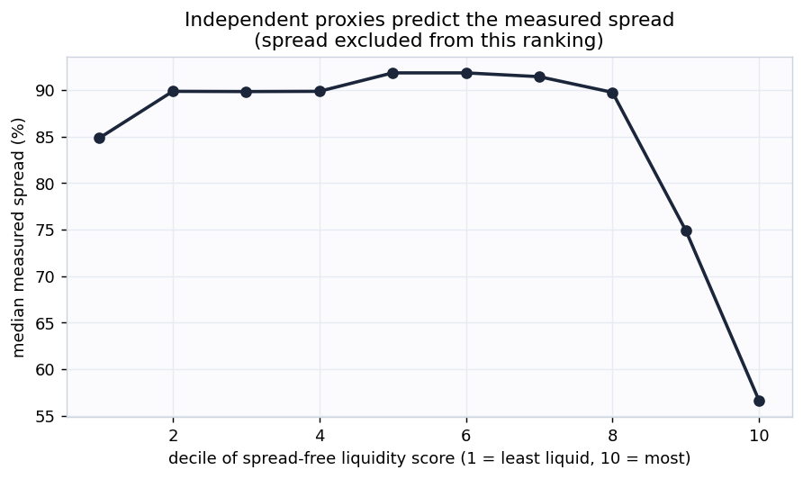
Corroboration

Example cards
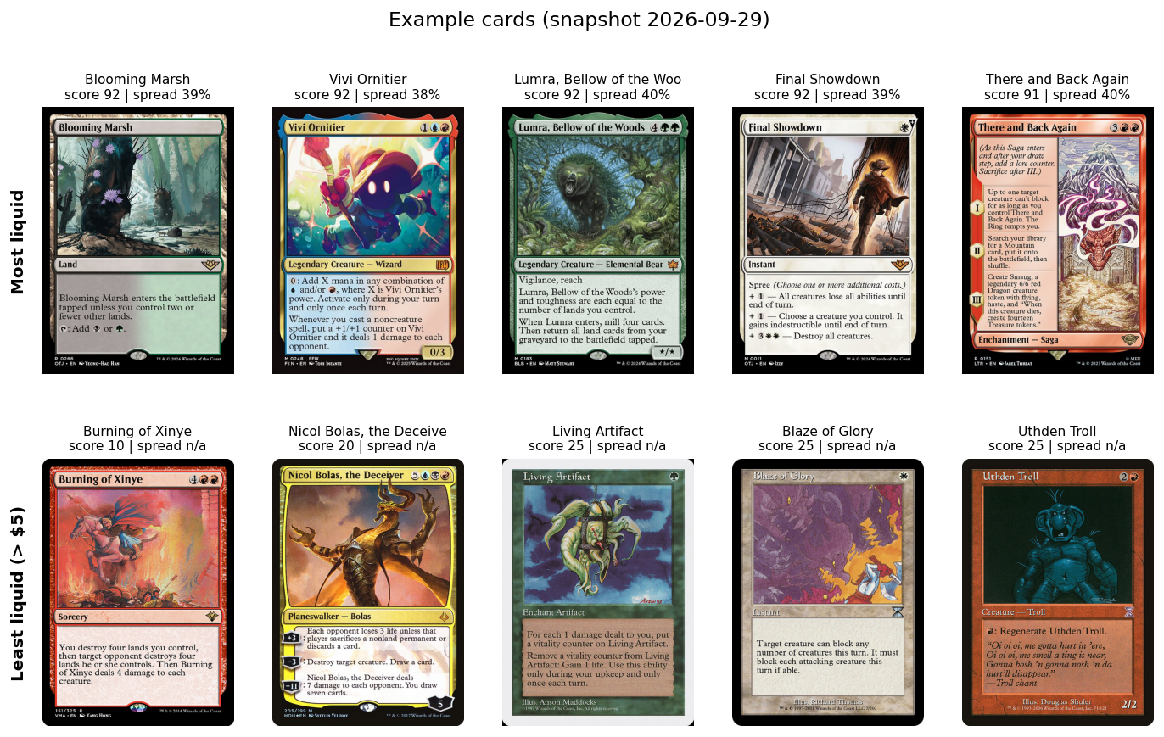
Examples
The most liquid cards are heavily played eternal and Commander staples that sell in minutes at a known price. The least liquid expensive cards are thin-market oddities: no dealer will quote a buy price, and they list in only one or two places.

Buckets
Bucket | Score | Cards | Median measured spread
Highly liquid | 75-100 | 3,597 | 50.0%
Liquid | 50-75 | 7,327 | 82.8%
Slow | 25-50 | 20,911 | 97.1%
Illiquid | 0-25 | 521 | 97.1%

How this plugs into the other signals
Liquidity is a multiplier on every other call. It converts “should I sell” into “can I sell, how fast, at what cost,” and it filters out illiquid buy candidates the spike model would otherwise flag. In the toolkit’s risk-adjusted value equation, the expected value of a position is discounted by its spread and expected time-to-sale to get a net realizable value.

Honest limitations
- This is version 1: a composite proxy index, not a supervised forecast. It does not carry a held-out AUC because there is no public ground-truth label for “days to sale.”
- There is no true traded-volume or listing-count data yet. Spread, price staleness, and venue breadth are stand-ins for depth and velocity. The roadmap adds TCGplayer listing counts and sales velocity (the printing table already carries the join key), which will replace the proxies with measured depth.
- Buylist coverage is CardKingdom-only and United States centric. Cards without a CardKingdom bid have an imputed spread and should be read with that caveat.
- Informational only, not financial advice.
Generated by scripts/build_report.py from data/processed/liquidity_features.parquet.

