mtg-volatility-signal: the Current Volatility index
Snapshot 2026-10-05. By Cameraderie Cards. Informational only, not financial advice.
Every other model in this toolkit tells you direction: will a card rise (buy), has it peaked (sell), is it about to be reprinted (brace), can you exit it (liquidity). None of them tells you how far. A 5% mover and a 300% mover look identical to a probability. This model fills the magnitude gap. It assigns every Magic: The Gathering card a Current Volatility score from 0 to 100: how much its price swings right now, independent of which way.
Unlike the demand and liquidity siblings, which are composite proxy indices, the core of this score is measured directly from each card’s own price history. The number is an annualized realized volatility, not an estimate of one.

What goes into the score
Four measured components, each percentile-normalized and blended (weights {‘realized’: 0.5, ‘drawdown’: 0.25, ‘range’: 0.15, ‘dispersion’: 0.1}):
Component | What it measures | How
Realized vol | annualized volatility of weekly log returns, weighted toward recent weeks (EWMA) | 16-year daily history, resampled weekly
Drawdown | worst peak-to-trough fall and downside-only deviation: the “how far down” | same history
Range | swing amplitude, the inter-quantile price span relative to the price level | same history
Dispersion | jump risk (largest single-week move) and fat tails (kurtosis of returns) | same history
Returns are measured on weekly sampled prices, not daily. Magic cards are thinly traded, so daily marks carry heavy discretization noise (a $1.50 card quoted in $0.25 steps shows fake 20% daily swings) and stale-quote jumps. Resampling to weekly closes diversifies that noise away while preserving genuine week-to-week moves, the standard treatment for an illiquid asset. Volatility is computed from a single representative printing per card (the cheapest well-tracked copy a typical owner holds), never a median across printings, which would manufacture fake volatility when a card’s quoted printings change from day to day.

Coverage
Scored 30,538 cards at this snapshot. 30,471 of them have enough price history for a measured volatility; the small remainder are imputed from a prebuilt volatility feature and flagged is_imputed. The median card has an annualized realized volatility of 25.8%.
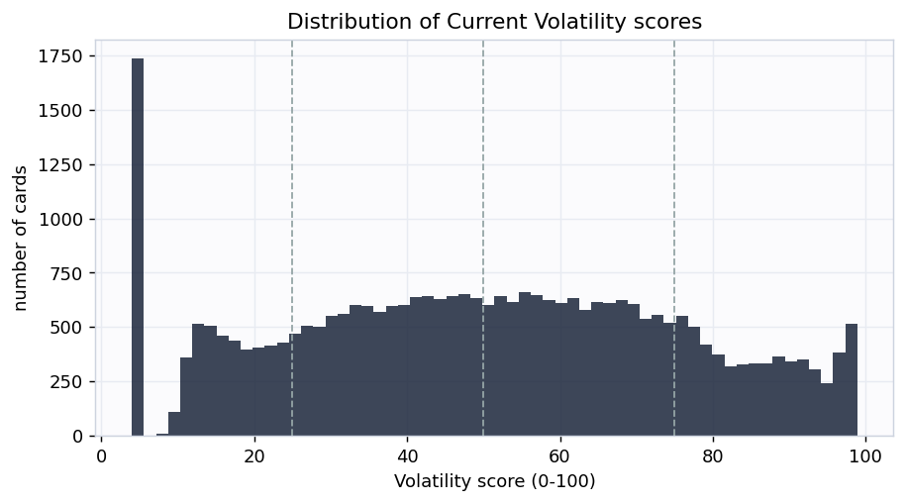
Distribution
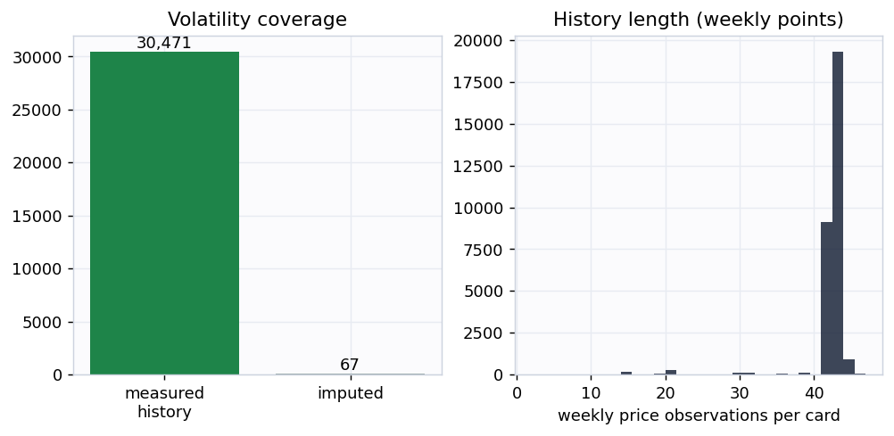
Coverage

Does the score mean anything? Two checks
1. Measured volatility rises with the buckets. A consistency check: the realized volatility the score is built from really does climb monotonically from Stable to Highly volatile.
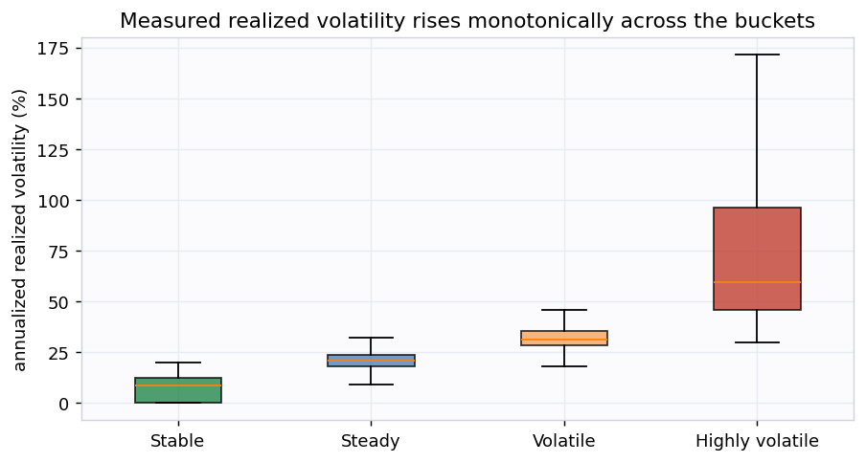
Volatility by bucket
2. Volatility persists (the real test). A backward-looking measurement is only a useful forward signal if volatility is persistent. So we measure each card’s volatility on the first half of its history and, separately, on the second half, and check whether the first predicts the second. It does, at rank correlation nan. The second half is never seen when the first is computed, so this is genuine out-of-time corroboration, not circular. The fitted slope is nan, well below 1: volatility is persistent but mean-reverting, so the forward bands below shrink today’s extreme readings toward the average rather than extrapolating them.
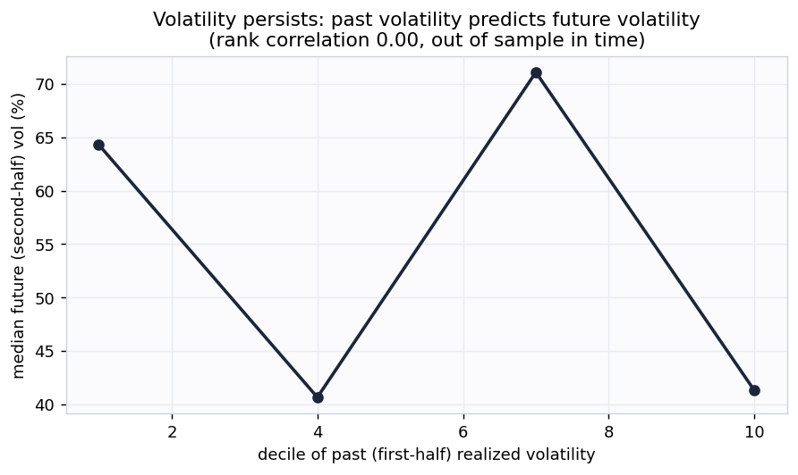
Persistence

The magnitude deliverable: expected range and drawdown
Because the score is a real volatility, it converts directly into the magnitudes the rest of the toolkit needs. For every card the output carries an expected price range at 3, 6, and 12 months (lognormal +/- 1 sigma bands, about a 68% interval) built from the mean-reverting forward volatility, plus a measured max drawdown. Across all cards the median expected 12-month move is about 29.5% (3-month 13.8%, 6-month 20.0%).
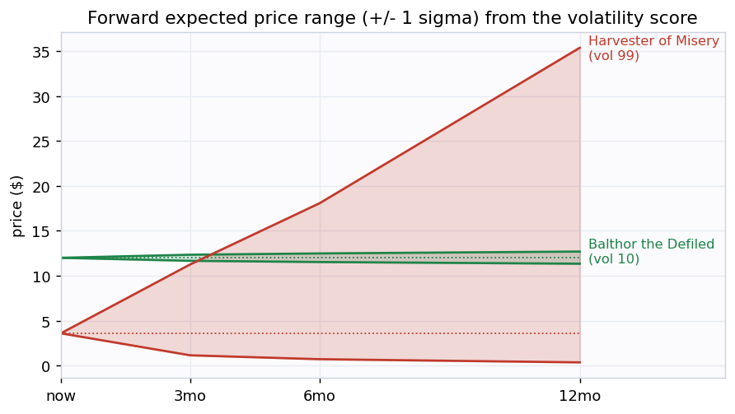
Forward range

Example cards
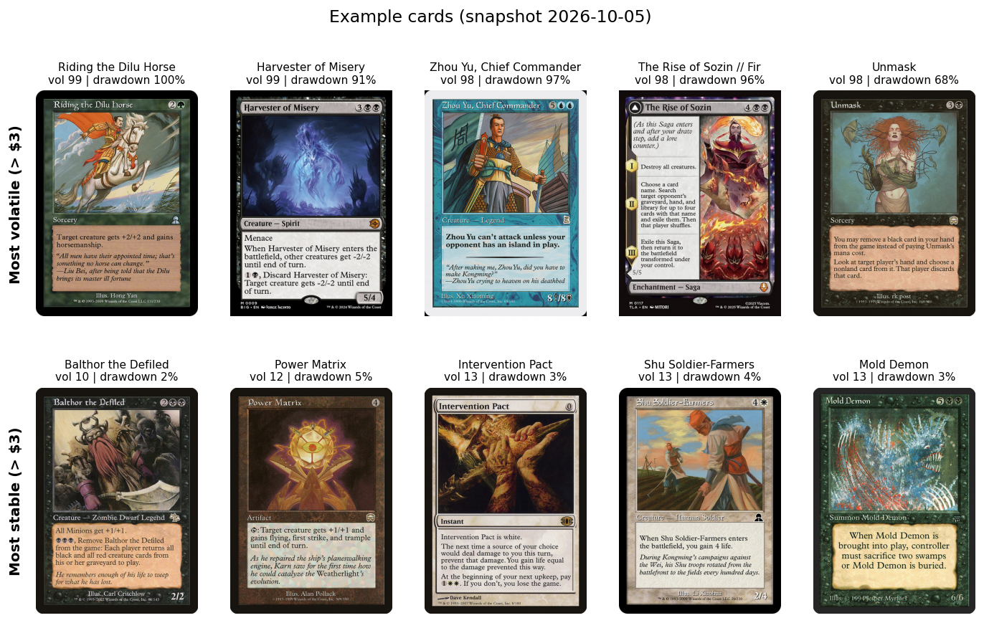
Examples
The most volatile cards are recent hyped releases and thin-market specials that spike and crash, and cards rocked by bans or buyouts. The most stable are heavily-reprinted, deeply-played staples whose price barely moves week to week.

Buckets
Bucket | Score | Cards | Median realized vol
Highly volatile | 75-100 | 5,718 | 59.7%
Volatile | 50-75 | 9,582 | 31.4%
Steady | 25-50 | 9,317 | 20.8%
Stable | 0-25 | 5,921 | 8.6%

How this plugs into the other signals
Volatility is the magnitude term every other signal is missing. The toolkit’s risk-adjusted value is roughly EV = spike_prob x upside - fall_prob x downside - reprint_prob x reprint_crash. The upside and downside terms are exactly what this model supplies: the expected range gives the size of the move, the drawdown gives the worst-case downside. With them the EV becomes genuinely risk-adjusted, and positions can be sized properly: bigger on high-conviction low-variance cards, smaller on the violent ones.

Honest limitations
- This is version 1: a measured realized-volatility index, not an options-implied or forward forecast. The only forward assumption is volatility persistence, which is real but moderate and mean-reverting (slope nan), so the forward bands are estimates, not guarantees.
- Cheap cards carry residual noise. Weekly sampling removes most price-discretization noise, but a sub-$2 card still shows more percentage wiggle than its dollar moves justify. Imagery and examples are restricted to cards over $3 for this reason.
- Volatility is computed from one representative printing. A card’s other printings (foils, old borders, collectible editions) can be much more or less volatile than the tracked copy.
- A stale price looks stable. A card no one trades shows no volatility because nothing reprices, not because it is genuinely calm. Cards moving in under 5% of weeks are flagged stale_price; read them alongside the liquidity signal.
- Informational only, not financial advice.
Generated by scripts/build_report.py from data/processed/volatility_features.parquet.

