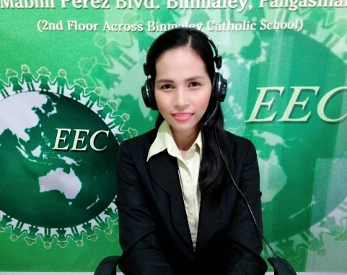Teachers

**Name:** Victoria

**Birthday:** May 9, 1992

**Gender:** Female

**School/University:**The Adelphi College

**Course:** Bachelor of Secondary Education (major in English)

**Career:** Online teacher

**Interest/s:** Reading books, watching movies

**Teacher’s message:**  Education is the most powerful weapon, we can used it to change the world.

To achieve this weapon, let’s learn English to be able to communicate and understand different people in different countries. I am here to help you improve your English skill in an easy way.

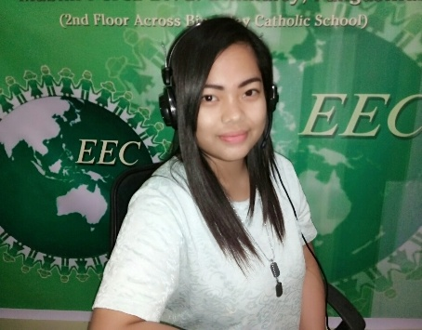**Name:** Katherine

**Birthday:** Sept.8, 1990.

**Gender:** Female

**School/university:** Pangasinan State University.

**Course:** Bachelors of Arts major in English.

**Career:** Online teacher.

**Interest/s:** Reading books, watching movies, hang out with friends, biking and eating.

**Teacher’s message:** Hello everyone! In learning English “Nothing is Impossible”, “Age is just a

Number” just have fun in learning English. Don’t worry because I’m here to help you and I’ll share all my knowledge. In order to reach your dream and become proficient in English.

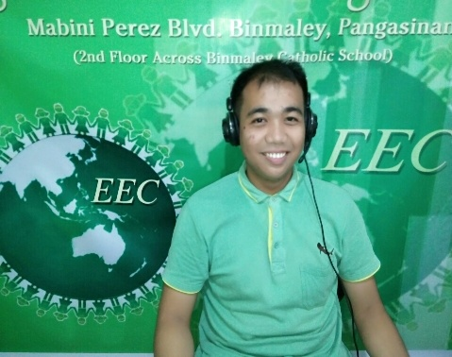**Name:** Arjay

**Birthday:** November 9, 1993

**Gender:** Male

**School/University:** Pangasinan State University

**Course:** Bachelor of Secondary Education (major in Physical Science)

**Career:** Online Teacher

**Interest/s:** Reading books, writing short stories and poems.

**Teacher’s message**: Education’s purpose is to replace an empty mind with an open one. And

learning English is your way to be competent in this world. I’m teacher Arjay and I will help you to be proficient in any aspects of English language. I can assure you that you will learn a lot in a comfortable way.

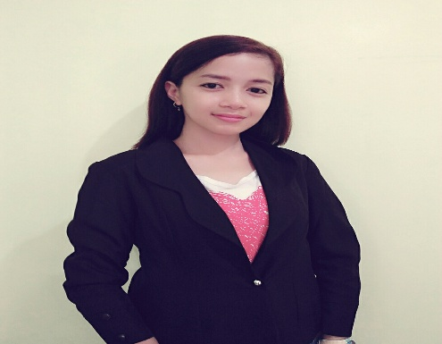

**Name:** Lenie

**Birthday:** November 16

**Gender:** Female

**School/University:** Tesda-Pangasinan College of Fisheries

**Course:** Hotel and Restaurant Technology

**Career:** Online Teacher

**Interest/s:** Reading, watching movies, likes to travel and strolling

**Teacher’s message:**  Learning is a lifetime process. We learn because we want growth and by

learning we can acquire wisdom. Hi, I’m Lenie let us interact in my class with one another. We can exchange opinions and ideas in an easy way. See you in my class.

**Name:** Carolyn

**Birthday:** November 3, 1984

**Gender:** Female

**School/ University:** Pangasinan State Universty

**Course:** Bachelor of Seconday Education major in Social Science

**Career:** Online Teacher

**Interests:** Reading books, watching movies, playing badminton, singing and hanging out with my

friends

**Teacher’s message**: “Learning is a kind of natural food for the mind.” I am teacher Carolyn and I’m

here to help you feed your mind with knowledge and understanding about English. I’ll also do my best to help you build your confidence in speaking in an enjoyable way. So, enroll now in my class. I hope to see you soon.

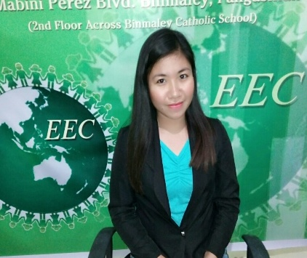**Name:** Caren

**Birthday:** March 25, 1994  
**Gender:** Female

**School/University:** Pangasinan State University

**Course:** Bachelor of Secondary Education (Major in Technology and Livelihood Education)

**Career:** Online Teacher

**Interest/s:** Surfing the net, watching movies, hang out with friends, cooking and eating

**Teacher’s message:** A big journey begins with a little step. So, let’s start learning English step by step. I’m here to help you to have a better understanding about English language. And always remember that education is not received, it is achieved. Teacher Caren will guide you to achieve your goals in learning English language.