**Let’s go books**

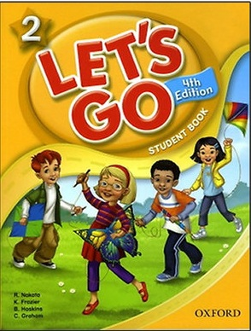

<http://www.amazon.com/Lets-Student-Book-Beginning-Intermediate/dp/0194626199/ref=pd_sim_14_2?ie=UTF8&dpID=519dt8-Nz3L&dpSrc=sims&preST=_AC_UL160_SR124%2C160_&refRID=03DJTYAXZKC3QZBG73M4>

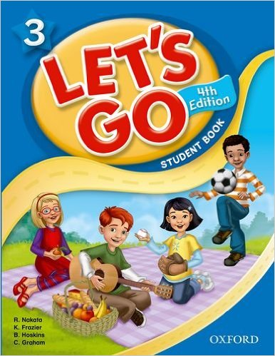

http://www.amazon.com/Lets-Student-Book-Beginning-Intermediate/dp/0194626202/ref=pd_sim_14_3?ie=UTF8&dpID=51diw1v1brL&dpSrc=sims&preST=_AC_UL160_SR120%2C160_&refRID=09GTRJHA09NWND70NR0E

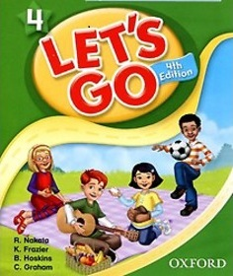

<http://www.amazon.com/Lets-Student-Book-Audio-Intermediate/dp/0194626210/ref=pd_sim_14_3?ie=UTF8&dpID=51bozp94s3L&dpSrc=sims&preST=_AC_UL160_SR116%2C160_&refRID=1W36KEPCV0SJSBHMAZGQ>

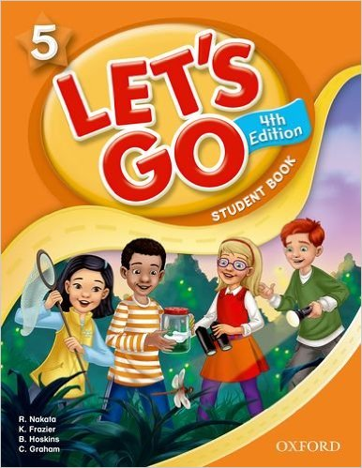

http://www.amazon.com/Lets-Student-Book-Audio-Intermediate/dp/0194626229/ref=pd_sim_14_2?ie=UTF8&dpID=51gZSJY53IL&dpSrc=sims&preST=_AC_UL160_SR116%2C160_&refRID=0WC89DXSRG5XPDJMSQSB

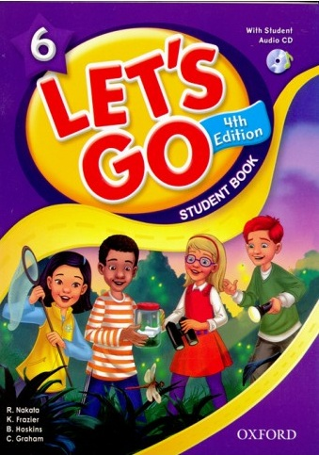

http://www.amazon.com/Lets-Student-Book-Beginning-Intermediate/dp/019464149X/ref=pd_sim_14_6?ie=UTF8&dpID=51l2Zy0x4OL&dpSrc=sims&preST=_AC_UL160_SR124%2C160_&refRID=1MT2G0BBS71D1K9EZ15S

**American Accent training**

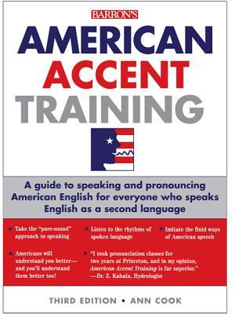

<http://www.amazon.com/American-Accent-Training-Audio-CDs/dp/1438071655/ref=sr_1_1?s=books&ie=UTF8&qid=1450774512&sr=1-1&keywords=american+accent+book>

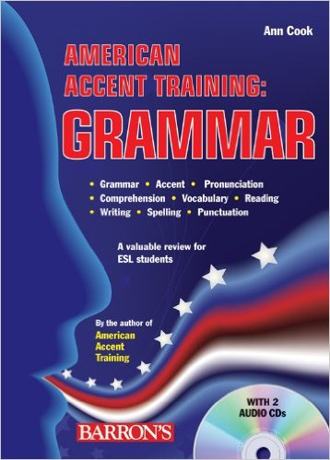

http://www.amazon.com/American-Accent-Training-Grammar-Audio/dp/0764196510/ref=dp_rm_img_4

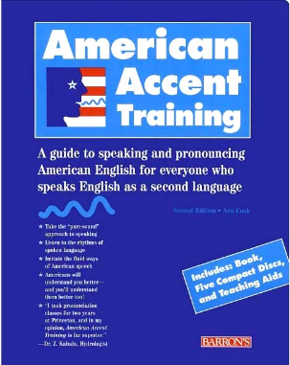

http://www.amazon.com/American-Accent-Training-Edition-Book/dp/0764173693/ref=pd_sim_14_5?ie=UTF8&dpID=51j%2BjbHjQLL&dpSrc=sims&preST=_AC_UL160_SR125%2C160_&refRID=0PQHW926S4B684K0F5PV

**Passages book**

* additional books to be included

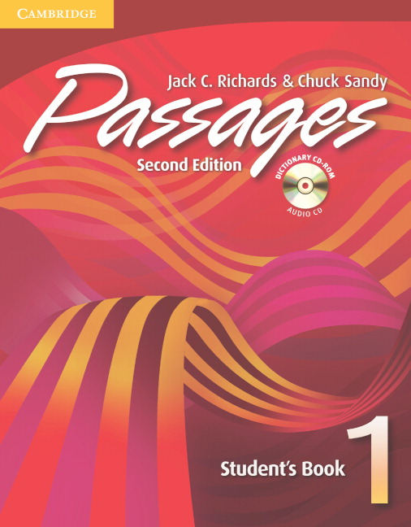

<http://www.amazon.com/Passages-Students-Book-Audio-CD-ROM/dp/B00E284D9A/ref=sr_1_7?s=books&ie=UTF8&qid=1450774689&sr=1-7&keywords=passages+book+2nd+edition>

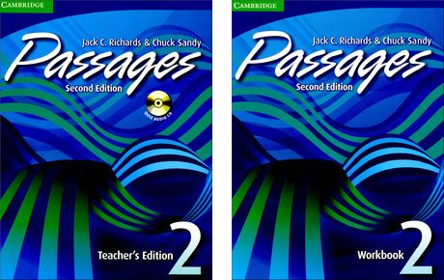

http://www.amazon.com/Passages-Students-Book-Audio-CD-ROM/dp/0521683912/ref=sr_1_4?s=books&ie=UTF8&qid=1450774747&sr=1-4&keywords=passages+2+book+2nd+edition

**Callan method books**

* Just upload the books for this link <http://callan.co.uk/book-shop/6-students>