CSCI 4300: Web Programming
Fall 2016

Project 7: Object-oriented PHP
Due: 11:59 pm, Nov 6th (Sun)
This assignment is about using PHP to fetch data from files and web services in HTML, and XML formats. You must match in appearance and behavior the following web page. You also need to use Classes and getter/setter and other functions in PHP:
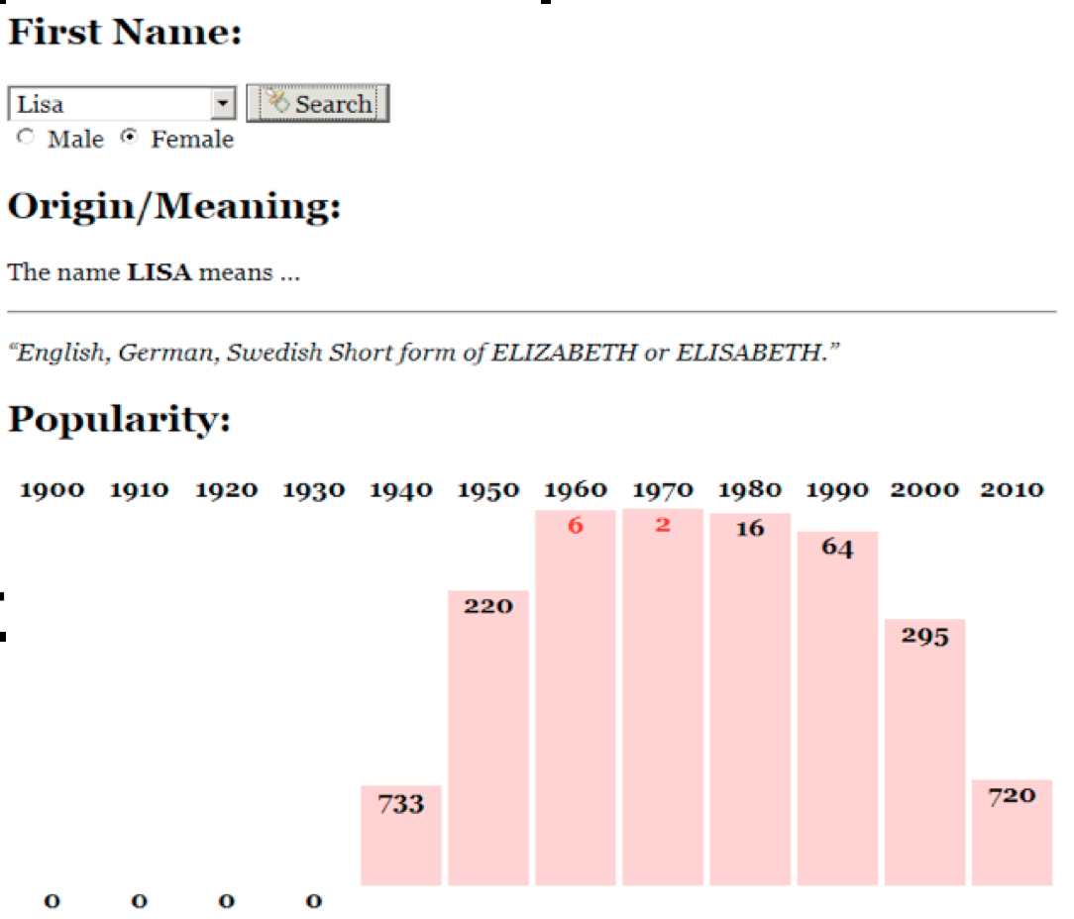
Every 10 years, the Social Security Administration provides data about the 1000 most popular boy and girl names for children born in the US for each gender, at http://www.ssa.gov/OACT/babynames/. Your task for this assignment is to write JavaScript code for a web page to display the baby names, popularity rankings, and meanings. You will also need to write PHP code for the server side.
We will provide you with the HTML (names.html) code to use. Turn in the following files:
- names.js, the JavaScript code for your Baby Names web page's behavior (although it is not required you are permitted to us jQuery).
- names.css, the CSS styles for your web page's appearance
- babynames.php, server side code
Data:
Your program reads data from a web service at babynames.php. All data sent to your program from babynames.php needs to follow the formats below.
This web service accepts two different types of queries, specified using a query string with a parameter named type. Each type of query produces output in HTML, and XML format. (You can test queries by typing in their URLs in your web browser's address bar and seeing the result.)

1. meaning: The first query type is meaning, which outputs information about that baby name's meaning in HTML format as a web page fragment. In addition to the always-required type query parameter, the meaning query requires a second parameter named name. The following query returns the results below:
babynames.php?type=meaning&name=morgan
<div><p>The name <strong>MORGAN</strong> means ...</p> <hr />
<p><q>Welsh, English From the Old Welsh masculine name Morcant, which was
possibly derived from Welsh mor "sea" and cant "circle".</q></p></div>
When this data comes back to your page from the server, inject it into the div with id of meaning:
<div id="meaning"> <!-- insert the HTML fragment here --> </div>
If the name you pass doesn't have any meaning data, the babynames.php service will just output a general message about how that name has no known meaning; you can handle this case the same way as usual, by injecting the HTML that is returned into the page.
2. rank: The second query type is rank, which returns XML data about that baby name's popularity rank in each decade. The rank query requires two additional parameters named name and gender. The gender should be m or f. The server needs to provide separate data for each gender; the same name might be more/less popular for boys than for girls.
The overall XML document tag is called <baby> and has an attribute name for the baby's first name and gender. Inside the <baby> tag are several <rank> tags, one for each decade. Each <rank> tag contains an attribute named year representing the year of data. The text inside the <rank> tag is that name's popularity in that year.
The data has 13 rankings per name, from 1890 to 2010, from 1 (popular) to 999 (unpopular). A rank of 0 means the name was not in the top 1000. The following query would output the results below (abbreviated):
babynames.php?type=rank&name=morgan&gender=m
<baby name="Morgan" gender="m">
<rank year="1890">375</rank>
<rank year="1900">410</rank>
...
<rank year="2010">518</rank>
</baby>
If you submit a query for an unknown name, your request will return an HTTP error code of 410 (Gone).

Appearance and Behavior:
The font for the page body (including form controls such as text boxes and buttons) is 12pt Georgia, with a fallback of the default serif font on the system. Heading fonts are proportional to this.
The HTML page given to you shows a heading of "First Name:" followed by a select element with id of allnames. The page should fetch the list of all names from the web service as described previously, fill itself with an option for each name, and then enable itself.
The rest of the page is inside of a large div with the id of resultsarea. Initially this div is hidden, but when the user clicks Search after selecting a name from the select box, you should make this area appear. (You can make an area of the page appear by calling the .show() method on its HTML DOM object, or .hide() to make it disappear.) Nothing should happen and no data should be fetched if the user selects the initial "(choose a name)" option in the list.

Meanings: The next section of the page has the heading "Origin/Meaning:". It is initially blank. When the user chooses a name from the select box, that name's meaning data should be fetched and injected into the page into the paragraph with id of meaning. The meaning has a q (quote) element that should appear in italic.

Rankings: The next section of the page has the heading "Popularity:". It is initially blank. When the user chooses a name from the select box, that name's ranking information should be fetched and injected into the page into this area. Specifically, there is an HTML table with the id of graph in this area, initially empty:
<table id="graph"></table> <!-- baby name ranking data should be inserted here -->
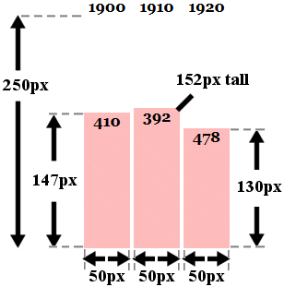
If a name is selected from the selection box, you should use the DOM to fill the table with two rows of data: the first lists each of the decades as table header cells (th), and the second shows a vertical bar representing that name's ranking for that year in the data. For example, the table after searching " might look like this:
<table id="graph">
<tr><th>1890</th><th>1900</th><th>1920</th>...<th>2010</th></tr>
<tr>
…
<td><div>410</div></td> <!-- ranking for 1900 -->
<td><div>392</div></td> <!-- ranking for 1910 -->
<td><div>478</div></td> <!-- ranking for 1920 -->
…
</tr>
</table>
The ranking bars are drawn as divs inside each table cell td of the second row of the table. Each ranking bar uses a pinkish background color of #FFBBBB. The bar's width is exactly 50px. Its height should be one fourth as many pixels as the "inverse ranking" for that decade. The inverse ranking is defined to be 1000 minus the ranking. For example, a ranking of 880 would lead to a bar with a height of 30 because one fourth of (1000 - 880), or 120, is 30. (Note that division is exact in JavaScript; 13 / 4 is 3.25. Round down height values using parseInt.)
The overall height of each td cell in the second row of the graph table is 250px. The bottoms of the bars are aligned vertically; achieve this by setting the td table cells to have a vertical-align of bottom.
If the given name was not in the top 999 rankings for that decade, its rank in the XML will be 0. You should handle this special case by drawing the ranking bar div with a height of 0 pixels tall.
Within each ranking bar appears the ranking number for that decade. The numbers appear in bold text at the top of the bar, horizontally centered within the bar. If the ranking is very popular (1 through 10 inclusive), the ranking number should appear in red. Some less popular rankings (around 900 and up, or 0) have numbers that drop below the bottom of the graph; this is expected and you don't need to treat this as a special case.
Some name/gender combinations (such as Aaliyah/male) in the overall list do not have any ranking data. In such a case, the babynames.php query will return an error code of 410. You should handle this case by displaying a message indicating that there was no ranking data for the chosen name. There is already a div in the page with the id of norankdata that contains such a message, but it is hidden by default, so you must show it in such cases.
<div id="norankdata"> <!-- show me when the name has no rank data -->
There is no ranking data for that name/gender combination.
</div>

Subsequent Searches: The user can use the page to make multiple searches. When making a search, any data from a previous name should be cleared from the screen. You can remove all HTML content inside an area of the page by setting its innerHTML to an empty string. For example, to clear out the div with the id of example:
$("example").innerHTML = ""; // clear out any child elements from this area
Be careful to test your page with several searches in a row. For example, if one search has no ranking data (such as Aaliyah/male), you will have shown the grapherror message. But on the next search, you should hide this message.

How to submit:
Submit your ".zip" file using ELC. Only team leaders need to make a submission. Every student needs to submit a peer-evaluation form within 24 hours of the project submission deadline.
Do not place your solution on a public web site. Submit your own work and follow the course misconduct policy.

