**A Novel Approach to Writing Novel Science Fair Titles**

Ethan Wilk (1), ~~BASIS Scottsdale~~ Harvard University Dept. Of Memes, Ritvik Warrier (1), ~~BASIS Scottsdale~~ Harvard University Dept. Of Memes.

*Disclaimer: Only for those avoiding Harvard reject schools (anything other than Harvard).*

**Abstract:** We propose a novel deep learning based model for improving science fair titles, thereby increasing the chance of acceptance to Intel ISEF. While extensive literature exists in the fields of project topics and poster design, limited research into the linguistic syntax of science fair titles exists. Via the amalgamation of title semantics from past ISEF winners by category and geographical location, we have developed a de novo approach to improving your title and thus your chance at ISEF by 82.7%.

**Method:** To answer this question and bring some much-needed light to this field, we received an internship to work with Dr. Novela from Harvard University. In the 17 minutes we worked with him, we developed an algorithm to pull titles from ISEF winners of past years. We then inserted this data into a machine learning model created by the RaymoVerse’s own Raymond Nucuta to reach our conclusions about the linguistic significance of a science fair title.

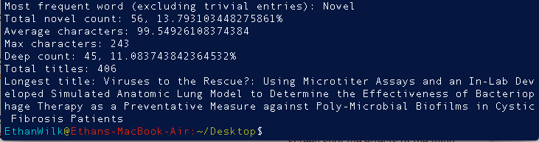

(*Actual Data*)

**Our Findings:** After retrieving the necessary data for this project, we reached two particular conclusions. Firstly, it is imperative that any science fair project include at least three buzzwords in its title if it has any chance at making it to ISEF. The list of buzzwords is as follows: *novel (the most frequently used buzzword), machine learning, artificial intelligence, deep learning, non-invasive, de novo, revolutionary, adaptive, innovative, data mining, big data, augmented reality, virtual reality, blockchain, internet of things, quantum computing, and computer vision*. Without them, your chances at ISEF are about as high as your chance of playing for Duke’s basketball team from BASIS. Secondly, the length of your project title can be a pivotal deciding factor on whether you will advance to ISEF, or maintain the plebian rank of AzSEF. Our model found that the average ISEF winner’s title is 99 characters long, with the maximum being 243. To be safe, your title should maintain a character count within the range 150 and 200. Otherwise, you might be at risk of losing a scholarship to Harvard. As a bonus finding, we are conclusive of two websites that contain the most novelties: “Github” and “Papers With Code”. If you are unfamiliar with either one, they are free websites that both contain a plethora of novelties that any intellectual could effectively make their very own. Our research highly recommends Papers With Code to those who are feeling particularly uncreative, and disdain writing one’s own report. The packages offered via Papers With Code are inclusive of all aspects of being a Novel Scientist.

**Implications:** Prior to conducting a “novel” Science Fair project, many “novel” scientists ponder how much they will truly learn. The answer? Probably nothing. But will one gain automatic admission to Harvard College? Abso-novel-outely. So, as a significant upside to our technique, you don’t have to worry about ending up at a Harvard reject school. Like “*St-St-Stanf-ord”.* *ugh*. Even the name makes me shudder. By adhering to our approach, you have earned the rights to walk among us, and subsequently, assert your authority as a novel scientist. Unfortunately, there is no such thing as ISEF upon reaching Harvard. But your contributions to the scientific world will sustain for many seconds to come. Until the word ''novel'' becomes obsolete. As a side note, it may be in your best interest to jump the ship now and get in on “de novo '' while it’s still hot. We can affirm that de novo is the new novel. After all, the title is approximately 97.44% of what gets you to ISEF.

**Future Research:** If this paper gets published and we get into Harvard, we’re probably just gonna stop doing research.