ERG4920CG Thesis II

Design of Dynamic Source Routing Protocol for Mobile Sensor Networks

BY

FAN TSZ CHUEN

A FINAL YEAR PROJECT REPORT
SUBMITTED IN PARTIAL FULFILLMENT OF THE REQUIREMENTS
FOR THE DEGREE OF BACHELOR OF INFORMATION ENGINEERING
DEPARTMENT OF INFORMATION ENGINEERING
THE CHINESE UNIVERSITY OF HONG KONG

May, 2005

Acknowledgement
I would like to thank my supervisor, Prof. Lee, for the suggestion of the topic, his words of cheer and credible guidance. I would also like to thank Dr. Chan (The Project Manager of REnex Technology Limited) for his suggested papers, itemized teaching and arranging regular meeting.

Abstract
In order to get the immediate information from each sensor that the primary host cannot directly connect to in a hazardous area, I have designed and optimized a routing protocol to facilitate communication within the network.
The design goal of such an ad hoc network routing protocol is efficient for establishing routes among nodes so that the immediate message can be delivered in a timely manner. By comparison of current routing schemes for ad hoc mobile wireless networks, the Dynamic Source Routing (DSR) protocol is selected to be the foundation of my designed routing protocol. The designed protocol follows the tradition of DSR containing two major mechanisms of “Route Discovery” and “Route Maintenance”. The protocol is designed to be simple, efficient and entirely on-demand for all aspects.
By means of computer simulations, I obtain different sets of results under different simulating conditions so as to create an evaluated and optimized routing protocol.
This report aims to illustrate the characteristics and operations of the designed routing protocol and provide methods to verify its practicability and performance.
Content
Acknowledgement…………………………………………………………….Page 2
Abstract………………………………………………………………………..Page 3
Content……………………………………………………………………...….Page 4
I. Introduction…………………………………………………………...…….Page 6
II. Background…………………………………………………………………Page 8
A. Ad-Hoc Networks………………………………………………………. Page 8
B. Routing Protocols……………………………………………………….Page 8
III. Different Routing Protocols…………………………………..………Page 10
A. Destination-Sequenced Distance Vector (DSDV) ……………..………Page 10
B. Ad-Hoc On-Demand Distance Vector (AODV) ………………..………Page 10
C. Dynamic Source Routing (DSR) ……………………………...………. Page 10
D. Summary…………………………………………………………….... Page 11
IV. Designed Routing Protocol……………………………………….……Page 12
A. Route Discovery…………………………………………………...….. Page 12
B. Route Maintenance……………………………………………...……. Page 13
C. Routing Example……………………………………………………… Page 13
D. Summary………………………………………………………….……Page 14
V. Application…………………………………………………………….….. Page 15
A. Problem of Real-time Wireless Hazardous Material Sensing……...… Page 15
B. Retransmission Mechanism……………………………………………Page 17
C. Flooding Strategy and Collision Avoidance………………….…..……Page 18
D. Routing Table…………………………………………………..………Page 18
E. Packet’s Header……………………………………………..…………Page 18
VI. Simulation Program……………………………………………...…….. Page 19
A. Introduction……………………………………………………………Page 19
B. Program Flow……………………………………………..………….. Page 19
C. Program Architecture………………………………...………………. Page 20
i. Global Constants………………………………..…………………Page 20
ii. Essential Variables……………………………..…………………Page 21
iii. Variables for Statistics………………………...…………………Page 22
iv. Functions…………………………………………………………Page 22
D. Topology Simulation……………………………….………………......Page 24
i. Background…………………………………………………..……Page 24
ii. Topology Variability………………………………………………Page 25
VII. Performance evaluation…………………………………………….…Page 28
A. Verification……………………………………………………….……Page 28
B. Performance Testing…………………………………………...………Page 29
VIII. Conclusion…………………………………………………...…………Page 31
Appendix I (Program Source Code) ……………………………………..……Page 32
Appendix II (Program Output) ………………………………………………..Page 42
References……………………………………………………………………Page 48
I. Introduction
This project mainly focuses on the mobility of wireless communication. I have to design a protocol that is suitable for multi-hop mobile ad-hoc networks (MANET) based on the Dynamic Source Routing protocol, simulate the protocol and evaluate its performance on different situations so as to approach the optimized setting of the protocol.
The project is very practical as it is in collaboration with a company, REnex Technology Limited. And, it is a significant project as it can spread or move over a region where network connectivity needs to be provided without the aid of any pre-existing communication infrastructure. Each mobile node of an ad-hoc network operates not only as a host but also as a router, forwarding packets for other mobile nodes in the network that may not be within the transmission range of the source (please refer to the figure 1 below). Each node participates in an ad-hoc routing protocol that allows it to discover multi-hop paths through the network to any other node.
I am going to develop a protocol for the situation of real-time wireless hazardous material sensing (please refer to the figure 2 below) suggested by Dr. Chan (The Project Manager of REnex Technology Limited). In some cases, people need to detect or monitor the hazardous material (e.g. poisonous gas) in dangerous areas. Some gas detectors with wireless connectivity carried by firemen or remote control moving machines will be moved around in the dangerous area to collect data, and then send it back to the primary host periodically. Because of the long distance between the primary host and gas detectors, it may not be possible to connect all gas detectors directly to the primary host. Thus, each gas detector (mobile hop) of this ad-hoc network operates not only as a host but also a router, forwarding data using multi-hop paths (please refer to the figure 1 below).

Fig. 1. Mobile Ad-Hoc Network, using multi-hop paths (thick line) instead of one-hop paths (thin line)

Hop 6
Hop 4
Hop 1
Hop 5
Hop 3
Hop 2
Primary Host
Dangerous Area
Safe Area
Fig. 2. A real Application for the Ad-Hoc Mobile Network

II. Backgound
A. Ad-Hoc Networks [12]
An ad-hoc network is a multi-hop wireless network where the connectivity is cooperatively maintained by all nodes without any centralized infrastructure such as base stations. If these nodes dynamically change their positions, this network is called a mobile ad-hoc network (MANET). So, a MANET may simply be defined as a group of movable nodes connected together without existence of a centralized access point. Each node operates not only as an end-system, but also as a router to forward packets. The nodes are free to move about and organize themselves into a network. Because of the lack of any fixed infrastructure, it is an attractive networking option for connecting mobile devices quickly and spontaneously.
MANETs have some salient characteristics [8]. Firstly, dynamic topologies: the network topology may change randomly and rapidly at unpredictable times because of the arbitrary free motion of nodes. Secondly, bandwidth-constrained, variable capacity links: the capacity of wireless links is obviously lower than that of hard-wired links. As a result, the problem of network congestion becomes more significant. Thirdly, power-constrained operations [11]: nodes in a MANET usually rely on batteries as its main energy source, so power conservation may become the essential issue for them. Lastly, limited physical security: mobile wireless networks often rely on existing link security techniques to resist security threats.
B. Routing Protocols
Routing protocol is used to provide necessary information to discover routes between nodes in order to facilitate communication within the network. The main goal of an ad-hoc network routing protocol is to establish correct and efficient routes between a pair of nodes so as to deliver information in a timely manner. Route construction should be done with a minimum of overhead and bandwidth consumption. This observation motivates attempts to adapt existing routing protocols for use in MANETs.
Routing protocols may generally be classified into two categories [8]:
- Table-Driven
- Source-Initiated (On-Demand)
Table-Driven Routing Protocols: Such protocols attempt to maintain consistent, up-to-date routing information from each node to every other node in the network. These protocols require each node to maintain one or more tables to store routing information. In order to maintain a consistent network view, they respond to changes in network structure by broadcasting updates throughout the network. The differences among them are the number of related routing tables and the methods to exchange updates. Because of the pre-existing and constantly maintained routing tables, communications with arbitrary destinations experience minimal initial delay and a route to every node in the network is always available, regardless of whether it is necessary or not. However, a large amount of additional control traffic is needed to continually support these benefits and there is a serious limitation of the resources of the bandwidth and battery power in mobile devices.
Source-Initiated On-Demand Routing Protocols: This type of routing protocol creates routes only when there is a need by source node. A node will initiate a route discovery process when it requires a route to a destination. Once a route has been established, it is kept by a route maintenance procedure until either the destination becomes inaccessible among all paths from the source or the route is no longer desired. The advantage of on-demand is to use far less bandwidth to maintain routing tables in the network. But, it may lead to the problem of larger latency.
III. Different Routing Protocols
A. Destination-Sequenced Distance Vector (DSDV) [1]
The Destination-Sequenced Distance Vector is a kind of table-driven routing protocols. Every mobile node in the network maintains a routing table in which the entire possible destination addresses and the number of hops to each destination are stored. Each entry is marked with a sequence number assigned by the destination node in order to distinguish the freshness of the routes. A main disadvantage with this algorithm is that it requires bi-directional links to operate.
B. Ad-Hoc On-Demand Distance Vector (AODV) [2], [3]
The Ad-Hoc On-Demand Distance Vector routing protocol described in [2] builds on the DSDV algorithm previously described. AODV is an improvement on DSDV. By creating routes on a demand basis instead of maintaining a complete list of entry in routing tables in DSDV, it can significantly decrease the control traffic. When a source node desires to send a message to a destination and does not know any valid paths to its destination, it initiates a path discovery process so as to broadcast a route request (RREQ) packet. Any nodes including the destination have a current route to the destination responds by unicasting a route reply (RREP) message to the source node. The information obtained through RREQ and RREP messages is stored with other routing information and maintained by each node in its routing table. Sequence numbers are used to eliminate the old routes.
C. Dynamic Source Routing (DSR) [4], [5], [6], [8], [9], [10]
The Dynamic Source Routing protocol (DSR) is based on source routing, such that the originator of each packet decides an ordered list of nodes through which the packet must pass while traveling to the destination. In order to decrease the number of entries in the routing table of each node, the immediate nodes do not need to store the up-to-date routing information to route the packet that they forward because the source node has already determined the routing path.
The DSR protocol consists of two major mechanisms: Route Discovery and Route Maintenance. Route Discovery is the mechanism by which a node S, wishing to send a packet to a destination D, obtains a source route to D. Route Maintenance is the mechanism by which the originator S of a packet detects if the network topology has changed such that it can no longer use this route to the destination D because some of the nodes listed on the route have moved out of range of each other [10].
To carry out the Route Discovery, when a source node sends a packet to a destination, it first checks its route caches that contain the source routes to determines whether there is already a route to the destination. If it has an unexpired route to the destination, it will use this route. If not, it performs the Route Discovery, it locally broadcasts a non-propagating ROUTE REQUEST packet to inexpensively query the route caches of each of its neighbors for a route to the destination, and it optimizes the case in which the destination is directly reachable. If it cannot receive any replies within the nominal one-hop round trip time, the source node will transmit a propagating ROUTE REQUEST packet by flooding to the network in a controlled manner. Either the destination node or another node that knows the route to the destination can reply a ROUTE REPLY packet to the source node. If the destination node knows the route, it places the route record contained in the ROUTE REQUEST packet into the ROUTE REPLY packet. If the responding node is an intermediate node, it appends its cached route to the route record in order to generate the ROUTE REPLY packet. To return the reply, if symmetric links are support, the node may reverse the route in the route record as the route to the source node. If symmetric links are not supported, the node may perform the Route Discovery again to find out a route to the source node.
Route Maintenance is only carried out when a node attempts to forward a packet to other node indicated in the packet’s source route but not succeed. Route Maintenance declares that link in the source route has been broken, and notifies the source node with a ROUTE ERROR packet. As a result, the source node will remove the hop in error from node’s route cache and all routes containing the hop are truncated at that point.
D. Summary
To conclude, DSR is a very popular routing protocol. The main reason is that it operates entirely on demand and requires no periodic activity of any kind at any level within the network. Thus, there are absolutely no routing overhead packets when all nodes are approximately stationary with respect to each other, and all routes required for current situation has been discovered [12]. Therefore, I decide to design a protocol which is fully suitable for the above real situation mainly based on the DSR protocol.
IV. Designed Routing Protocol
In order to suit the case for the problem of real-time wireless hazardous material sensing, I have designed a routing protocol based on the DSR protocol. Same as DSR, the protocol consists of two phases:
A. Route Discovery
Route Discovery is the mechanism by which a node S wishing to send a packet to a destination node D obtains a source route to D. Route Discovery is used only when S attempts to send a packet to D and does not already know a route to D. The node initiating a Route Discovery is known as the “initiator” of the Route Discovery, and the destination node for which the Route Discovery is initiated is known as the “target” of the Route Discovery.
Route Discovery operates entirely on demand, with a node initiating Route Discovery based on its own origination of new packets for some destination address to which it does not currently know a route. Route Discovery does not depend on any periodic or background exchange of routing information or neighbor node detection at any layer in the network protocol stack at any node.
The source node S has a packet to send to the destination D. S firstly consults its own route cache to determine whether it has a route to D. If there is a route to D, it will use the route to send the packet to D. If it cannot find any route to D, it performs the Route Discovery. It broadcasts a propagating ROUTE REQUEST packet to the network in a controlled manner by the means of flooding. Either the destination node or any node that know the route to D can reply a ROUTE REPLY packet to S. For example, if the node K knows a route to D, it will reply a ROUTE REPLY packet, which is generated by appending its cached route to the route record, to S. Assuming that the network supports symmetric links, K uses the original path to reach S by reversing the route record.
In the problem of real-time wireless hazardous material sensing, there is a primary host that does polling to every node in network periodically. Then, each gas detector will send back a reply packet containing its state (e.g. the percentage of a hazardous material at its location) to the primary host after each receiving the polling message.
Thus, the data required to be transmitted in the network is divided into two major categories. They are the polling message and the information of the state of detectors. For the real situation, the size of them is very small. So, they are designed to be included in the packets of ROUTE REQUEST or ROUTE REPLY in the process of Route Discovery in order to save one round trip traveling. For example, if the primary host desires to do polling on a detector and does not know a route to it, it will broadcast a ROUTE REQUEST packet containing the polling message and the detector will reply a ROUTE REPLY packet including its state.
B. Route Maintenance
Route Maintenance is the mechanism by which a source node S is able to detect, while using a source route to some destination node D, if the network topology has changed such that it can no longer use its route to D because a link along the route no longer works. When Route Maintenance indicates that a source route is broken, S can attempt to use any other route it happens to know to D, or can invoke Route Discovery again to find a new route for subsequent packets to D. Route Maintenance for this route is used only when S is actually sending packets to D.
A node S attempts to transmit a packet to the destination D, and finds that there is no reply packet after the time-out period such as 100ms. At that moment, S will try to retransmit the packet to D using the same source route. If the transmission is still unsuccessful after the maximum retransmission times such as three times, S will delete this source route and give up this polling. S keeps on doing polling on another node. For sometime later, S needs to transmit a packet to D. Because of no source route to D in the route cache of S, S will perform Route Discovery to find a route.
C. Routing Example
Fig. 3. Operation of the designed routing protocol based on DSR
SS, KS, K, B
Flooding
ROUTE
REQUEST

Send data to D
Send data to D

Delete S,K,B,D
S, K, B, DS, K, B, DS, K, B, D
S, K, B, DS, K, B, DS, K, B, D
S, K, B, DS, K, B, D
Forwarding unsuccessfully
No reply packet
ROUTE
REPLY

Data received

B
D
K
S
Route Discovery

Route Maintenance
There is a routing example illustrated in the figure 3. First of all, S does not know the route to D, so it performs Route Discovery to find D. By the means of flooding, D receives a ROUTE REQUEST packet containing a route record “S, K, B”. Then, D replies a ROUTE REPLY packet containing the source route “S, K, B, D” by appending its route cache “D” to the route record “S, K, B”. Using the source route, S successfully sends data to D. For the unstable network topology, the link between K and B is broken. S suffers time-out while sending data to D and cannot receive any reply packets after the maximum retransmission times. Consequently, S deletes the source route “S, K, B, D”.
D. Summary
In the problem of real-time wireless hazardous material sensing, there is a primary host that does polling to every node in network periodically.
Primary host S does polling on a node D1
Is there any route to D1
Flooding the polling message
Does flooding succeed to find a new route
No
Yes
Send polling message to D1
Yes
Successfully deliver polling message and receive reply
Do polling on another node such as D2
Retransmission
Yes
No
Retransmission time < maximum retransmission time
Yes
Give up current polling
No
No
Route Discovery
Route Maintenance
Fig. 4. A summary flow chart of the designed routing protocol
V. Application
As mention in the Introduction, the designed protocol is developed for the problem of real-time wireless hazardous material sensing (please refer to the figure 2 in page 7) suggested by Dr. Chan (The Project Manager of REnex Technology Limited). For our experience, it is sometimes required for us to detect or monitor the hazardous material (e.g. poisonous gas) in some dangerous area. For the situation we concerned is that some real-time wireless hazardous material sensors (or monitors) with wireless connectivity carried by firemen or remote control moving machines will be moved around in this dangerous area to collect related data and then instantly send it back to the primary host, which is in the safe area, periodically. Each senor will continuously send its state to the primary host one by one. For the dynamic topology, a simple, efficient and entirely on-demand routing protocol is necessary for this high frequency and small amount of traffic. Because of the long distance between the primary host and each senor, it is impossible to exchange all data directly. Thus, the routing process should be multi-hop in peer-to-peer communication. As a result, each senor of this ad-hoc network operates not only as a host but also a router, forwarding data using multi-hop paths (please refer to the figure 1 in page 7).
A. Problem of Real-time Wireless Hazardous Material Sensing
A real example on the problem of real-time wireless hazardous material sensing using the designed routing protocol:
 | X
Primary host | Sensor X | Connectivity | Routing path
Table 1. Labels’ description
1
2
3
1
2
3
1
2
3
1
2
3
State 1
State 4
State 2
State 3
…
…
Fig. 5. Illustration of the changing of the network topology
In the initial state (State 1), assuming all sensors can directly communicate with the primary host. For the real situation, the primary host will do polling periodically on every sensor. Doing polling is that the primary host will send a REQUEST packet to a senor, after the sensor received the REQUEST packet, it will reply the primary host by sending a REPLY packet containing its state (e.g. the percentage of a hazardous material at its location). For example, the primary host will do polling on sensor 1 first, then senor 2 and so on. After one round trip, it will do polling on sensor 1 again and so on.
After a while, the topology has been changed. For example, the sensor 1 has gone far away from the primary host (State 2). There is not a direct connectivity between the primary host and sensor 1. But, because of the existence of sensor 2 between them, sensor 2 can act as a bridge (i.e. router) to restore the connectivity. Thus, the routing packet can be sent from the primary host to sensor 1 through the sensor 2 and vice versa.
For the view of the designed protocol, in State 2, while the primary host is doing polling on sensor 1, it firstly searches from its routing table to see whether it has a route to sensor 1. For this case, it finds that there is a route to sensor 1. Thus, the primary host sends a REQUEST packet to sensor 1 using the route in its routing table. But, after the TIMEOUT value, the primary host still cannot receive any REPLY packet. At this moment, the Retransmission Mechanism is being turned on. If the retransmission time reaches the maximum retransmission time, it implies that the route found from the routing table is invalid. So, the invalid entry in the routing table will be deleted. Consequently, the current polling will be given up and the primary host will continue to do polling on next sensor, i.e. sensor 2.
After a round trip, the primary host does polling on sensor 1 again. It will find that there is no relative route to sensor 1 from its routing table. At this moment, it will broadcast a FLOODING packet to all sensors in order to find a route to the target sensor. Hence, any sensor who are the target sensor or has the route to the target sensor will reply the primary host. So, sensor 1 will reply the primary host by saying that sensor 2 has a route to sensor 1 and the routing table in all relative host or sensors will be updated. As a result, the primary host can find a route (next hop is sensor 2) to sensor 1 from its routing table and finish the polling successfully.
After some time, the primary host may not be able to communicate with sensor 3 (State 3). Thus, the same mechanism happened in doing polling on sensor 1 in State 2 will be used to find a route to sensor 3 in State 3. Then, the network topology keeps changing and the same mechanism is applied to reestablish new routes.
However, for some cases, the flooding mechanism may not be successful due to the possibility of collision. In State 4, in order to reestablish a new route to sensor 2, sensor 1 and sensor 3 send FLOODING packets to sensor 2 at the same time. Because of the wireless communication, two FLOODING packets will collide with each other. Consequently, the primary host will give up this polling and it will not be succeeded this time. In order to avoid the possibility of collision, backoff algorithm will be used. When sensor 1 and sensor 3 need to send FLOODING packets to sensor 2, they will wait a backoff period before sending out the FLOODING packet. Because of the randomness of the time of the backoff period, sensor 1 and sensor 3 have chances to send out packets at different time. In State 4, the backoff period of sensor 1 is shorter than that of sensor 3, so sensor 1 can successfully send to a FLOODING packet to sensor 2 to finish the reestablishment procedures.
B. Retransmission Mechanism
The Retransmission Mechanism ensures that the routing path is really invalid, eliminating any other possibilities such as packet loss, high levels of congestion that lead to buffer overflow in routers and environmental problems.
C. Flooding Strategy and Collision Avoidance
Flooding strategy can help the primary host to reestablish a new route in a simple and efficient way. But, there is a critical problem that we need to solve. This is the possibility of collision. The backoff algorithm is the direct solution to perform collision avoidance. Every FLOODING packet will be sent after the random backoff period. As a result, the sender have shorter backoff period can successfully sent out the packet. If there are four time slots in the algorithm, the packet may be sent out in time slot 0, 1, 2 or 3. In the following example, the packet is sent in the longest time period, i.e. time slot 3.
Fig. 6. Example of backoff algorithm with four time slots: [0 1 2 3]
0 1 2 3
time
D. Routing Table
Routing table is the essential information stored in each hops. Two sets of information will be stored in each routing table, destination hop (address) and next hop (address). Every destination hop has a corresponding next hop. For instance, if one sensor needs to send a packet to hop X, it will firstly search the first column that stored the information of destination hop from its routing table to see whether there is a desired entry. Secondly, if there is an entry same as its destination, the sensor will send out its packet to the corresponding next hop that is stored in the second column.
E. Packet’s Header
Option Type | Sequence No. | Source Address | Destination Address
Option Type: Used to distinguish three types of packet: REQUEST, REPLY and FLOODING packet.
Sequence No.: That is sequence number used to store the identity and the freshness of the packet. Every packet has a unique sequence number.
Source Address: Used to store the source sender of the packet.
Destination Address: Used to store the destination hop of the packet.
VI. Simulation Program
A. Introduction
In order to evaluate the performance, functionality and practicality of the designed routing protocol, I have to carry out a series of testing procedures. Simulation is the most direct way to achieve our objective. Furthermore, in the view of economics, using computer programming to simulate the real situation is cost-effective and efficient. Making use of the simulation program helps us to recognize and demonstrate the performance and the utility of the protocol as well as to optimize it by providing lots of valuable information.
The simulation program is written in CSIM which is a widely-used simulation toolkit. CSIM is a discrete event simulator for describing parallel processor architectures and software mappings. A CSIM program models a system as a collection of CSIM processes which interact with each other by using the CSIM structures. The purpose of modeling a system is to produce estimates of time and performance. The model maintains simulated time, so that the model can yield insight into the dynamic behavior of the modeled system.
The source code and one of the outputs of the program, which is compiled and run in the SPARC Solaris in the computer lab of the Department of Information Engineering, have been attached to the Appendix I and II respectively.
B. Program Flow
In the first place, a process called “sim” must be created to start simulation. Then, all simulating procedures will be placed in a while loop that is controlled by a fixed value of simulating time. After this predefined simulating time, the simulating process will be terminated.
Once the simulation program starts, it will initial all the routing tables and print them out. The network topology is set to be a fundamental case that all the sensor hops can be directly connected to the primary host. Then, the primary host will do polling on each sensor hops respectively and continuously. For example, if the primary host does polling on sensor 1, it will firstly search from its routing table to see whether there is a route (i.e. next node) to sensor 1. After getting the information of next node, it will send request to next node (i.e. sensor 1 in this case). Sensor 1 will reply it using the same mechanism. It is a complete polling on one sensor. In some cases, the polling will be time-out such as packet loss (due to loss probability), path’s invalidity (due to changing of the topology) and unsuccessful flooding (due to packet’s collision). Besides, the network topology will be changed randomly to approach to the real situation. During simulating, the program will keep printing out all the related information like polling information and routing tables. At the end of the program, it will generate an overall report to display all the important statistics such as average time-out probability, the maximum time to reestablish a new route and the number of collisions.
C. Program Architecture
i. Global Constants
All the value of these constants is designed according to the principle of the designed protocol and the situation of the real world. And, all time units are assumed as 1 millisecond.
Constants’ Description:
LOSTPROB | 0.01 | The loss probability due to packet loss while transmission
MAXREPOLLTIME | 3 | The maximum times for retransmission while doing polling
NUMBEROFNODE | 17 | The number of nodes in the network including the primary host
REQUEST_TIME | 2.0 | The time for transmitting a REQUEST packet
REPLY_TIME | 4.0 | The time for transmitting a REPLY packet
SENSOR_COMPUTATION_TIME | 30.0 | The computation time on packets in the sensors
MASTER_COMPUTATION_TIME | 10.0 | The computation time on packets in the primary host
PROPAGATION_DELAY | 0.01 | The propagation delay for transmitting a packet
TIMEOUT | 150.0 | The time-out value while doing polling on a sensor
FLOODING_TIME | 30.0 | The time for transmitting a FLOODING packet including the computation time
WAITTING_TIME | 2 | The number of the time slots provided for sender to wait while sending FLOODING packet, the selective time slots: [ 0 1 2 ]
ONE_TIMESLOT | 10.0 | The waiting time for one time slot
ii. Essential Variables
int table[NUMBEROFNODE][2][NUMBEROFNODE]
Function | A three dimension array used to store all the routing tables  First parameter: Used to differentiate different routing tables  Second parameter: Two columns, one is used to store the destination while other is used to store the immediate next node  Third parameter: The number of entries of the routing table
Type | Integer
Example | table: S7  0 | 0  1 | -1  2 | -1  3 | -1  4 | -1  5 | -1  6 | 6  7 | -1  8 | 8  9 | -1  10 | -1  11 | -1  12 | -1  13 | -1  14 | -1  15 | -1  16 | -1 | That is the routing table of sensor 7.  e.g. table[7][0][2] = 2; table[7][1][2] = -1:  There is no route to the destination: sensor 2

int topology[NUMBEROFNODE][NUMBEROFNODE]
Function | A two dimension array used to store network topology  First parameter: Used to store all the nodes which have a connectivity to a particular node  Second parameter: Used to provide entries to store all nodes
Type | Integer
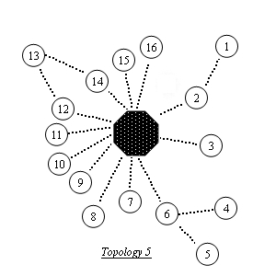  Example |  | -0| -1 -2 -3 -1 -1 -6 -7 -8 -9 10 11 12 -1 14 15 16  -1| -2 -1 -1 -1 -1 -1 -1 -1 -1 -1 -1 -1 -1 -1 -1 -1  -2| -0 -1 -1 -1 -1 -1 -1 -1 -1 -1 -1 -1 -1 -1 -1 -1  -3| -0 -1 -1 -1 -1 -1 -1 -1 -1 -1 -1 -1 -1 -1 -1 -1  -4| -6 -1 -1 -1 -1 -1 -1 -1 -1 -1 -1 -1 -1 -1 -1 -1  -5| -6 -1 -1 -1 -1 -1 -1 -1 -1 -1 -1 -1 -1 -1 -1 -1  -6| -0 -4 -5 -1 -1 -1 -1 -1 -1 -1 -1 -1 -1 -1 -1 -1  -7| -0 -1 -1 -1 -1 -1 -1 -1 -1 -1 -1 -1 -1 -1 -1 -1  -8| -0 -1 -1 -1 -1 -1 -1 -1 -1 -1 -1 -1 -1 -1 -1 -1  -9| -0 -1 -1 -1 -1 -1 -1 -1 -1 -1 -1 -1 -1 -1 -1 -1  10| -0 -1 -1 -1 -1 -1 -1 -1 -1 -1 -1 -1 -1 -1 -1 -1  11| -0 -1 -1 -1 -1 -1 -1 -1 -1 -1 -1 -1 -1 -1 -1 -1  12| -0 13 -1 -1 -1 -1 -1 -1 -1 -1 -1 -1 -1 -1 -1 -1  13| 12 14 -1 -1 -1 -1 -1 -1 -1 -1 -1 -1 -1 -1 -1 -1  14| -0 13 -1 -1 -1 -1 -1 -1 -1 -1 -1 -1 -1 -1 -1 -1  15| -0 -1 -1 -1 -1 -1 -1 -1 -1 -1 -1 -1 -1 -1 -1 -1  16| -0 -1 -1 -1 -1 -1 -1 -1 -1 -1 -1 -1 -1 -1 -1 -1
iii. Variables for Statistics
int polling_time | Store the total number of times of polling
int tout_time | Store the total time-out time
int begin_findnewroute[NUMBEROFNODE] | Store the beginning time of the reestablishment of a new route on a particular node
int end_findnewroute[NUMBEROFNODE] | Store the ending time of the reestablishment of a new route on a particular node
int maxtime_findnewroute | Store the maximum time of the reestablishment of a new route on any node
int totaltime_findnewroute | Store the total time of the reestablishment of a new route on any node so as to calculate the average reestablishing time
int totalfreq_findnewroute | Store the total number of times of reestablishing a new route
int totalfreq_collision | Store the total number of times of collision while sending FLOODING packet
iv. Functions
sim()
Function | Main function of the program including the main while loop, retransmission and topology changing mechanism
Input Parameter | Nil
Output Parameter | Nil

int polling(int source, int dest)
Function | Doing polling on particular sensor and simulate the possibility of packet loss
Input Parameter | The node doing polling and its destination
Output Parameter | 1: success; 0: packet loss; -1: invalid route; -2: collision occur

void packet(int source)
Function | Simulate the transmission process
Input Parameter | The node doing polling
Output Parameter | Void

int getnextnode(int nownode, int dest)
Function | Search in the routing table to see whether there is related routing information ( i.e. next node )
Input Parameter | The node which is the present position of the routing packet and the destination of it
Output Parameter | The information of next node; -1: no route to its destination

int flooding(int nownode, int target)
Function | Used to start flooding mechanism when there is no relative routing information in its routing table and update the related routing tables after the flooding mechanism; Calculate the maximum time for reestablishing a new route
Input Parameter | The node which is the present position of the routing packet and the destination of it
Output Parameter | The information of next node; -1: flooding does not succeed

int connect(int nownode, int nextnode)
Function | To see whether there is a connectivity between two nodes
Input Parameter | The node which is the present position of the routing packet and the immediate next node that the packet will be routed for
Output Parameter | 1: Yes (there is a connectivity between them); 0: No

inittable()
Function | Initialize all the routing tables
Input Parameter | Nil
Output Parameter | Nil

printtable()
Function | Print out all the routing tables
Input Parameter | Nil
Output Parameter | Nil

void printonetable(int temp)
Function | Print out one particular routing table
Input Parameter | The node that its routing table will be printed out
Output Parameter | Void

void topologies(int type)
Function | Change current topology to a particular one
Input Parameter | The type of the topology which will be changed
Output Parameter | Void

void deleteroute(int a, int b)
Function | Delete the routes between hop a and hop b in a's routing table
Input Parameter | The nodes that their connected route will be deleted
Output Parameter | Void

int changetopology(int old)
Function | Determine how to change to topology so as to approach to the situation of real world
Input Parameter | The current topology
Output Parameter | The next topology which the network will change to

genreport()
Function | Print out an overall report to display all the important statistics such as average time-out probability, the average and maximum time to reestablish a new route and the number of collisions
Input Parameter | Nil
Output Parameter | Nil
D. Topology Simulation
i. Background
In order to get the best simulating effect on the situation of real world, it is important to have a smart strategy to simulate the change of topology of the real situation. For our situation, all the sensor hops will move randomly and may go away from the connectivity space of the primary host. Moreover, because of the long distance transmission of the sensors’ modem which is able to transmit packet up to a few kilometers, the movement of each sensor is low relative to the very high frequency of doing polling on each sensor. Thus, the frequency of the topology change is very low. Besides, the most important thing for us to study is how long for the system to reestablish the connections upon these topology changes. For providing deterministic service guarantees, the maximum time for the system to reestablish the connections to all the sensors and receive data from each of them is necessary to evaluate and study. Also, for the particular use, it is not necessary for the primary host to get information successfully on every time of polling.
ii. Topology Variability
For the simulating use, I have constructed ten different representative topologies (Topology 0, Topology 1, … , Topology 9) .In the simulating process, the network topology will randomly be changed to a particular one among them from time to time. At the beginning of the simulation, the network topology will be set as Topology 0.
The flow chart of the changing process and all the topologies are illustrated below:
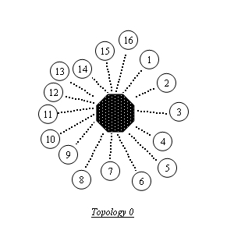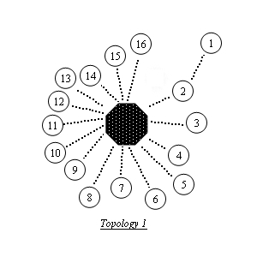
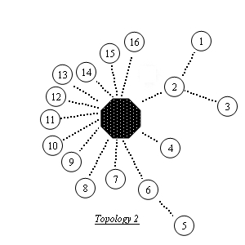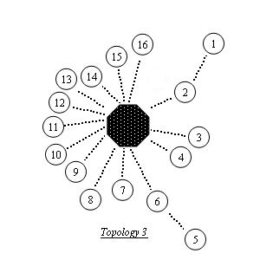
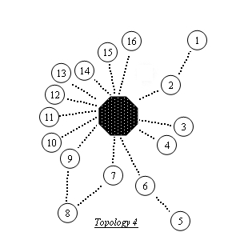
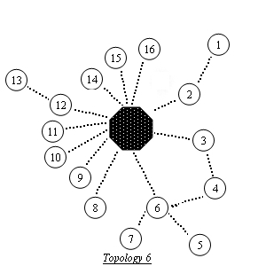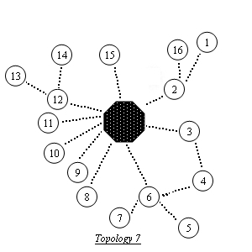
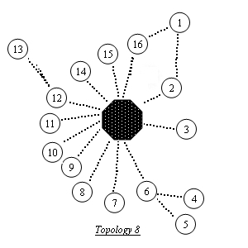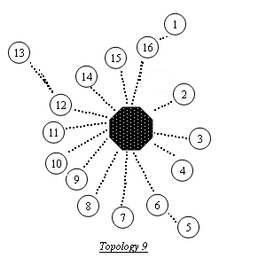

T0
T2
T3
T4
T5
T6
T7
T8
T1
T9
1/2
1/2
1/3
1/3
1/3
Fig. 7. The flow chart of changing process
In the Topology 2, there are probability of 1/2 to go to the Topology 3 and probability of 1/2 to go the Topology 4. Equally, the Topology 9 has probability of 1/3 to jump back to each of three previous topologies (0, 2, 5).
VII. Performance Evaluation
With the help of the simulation program, it is convenient to carry out the whole simulation process in an efficiently way. For the practical use of the protocol, its performance is mainly controlled by how fast it can reestablish a new route after it finds that the current route is invalid. For providing deterministic service guarantees, the maximum time for the system to reestablish the connections to all the sensors and receive data from each of them is necessary to evaluate and study.
A. Verification
Before executing the performance testing on the protocol, I have carried out a set of verification on the simulation program to test the program whether it is running properly. In the real situation, increasing the total simulation time will directly increase the number of time for reestablishing a new route because of the continuously changing network topology. Besides, the maximum time to reestablish a new route will also be increased because of the increased probability of collision.
From the below simulation results, the total number of time and the maximum time for reestablishment will follow the increase of the simulation time to increase.
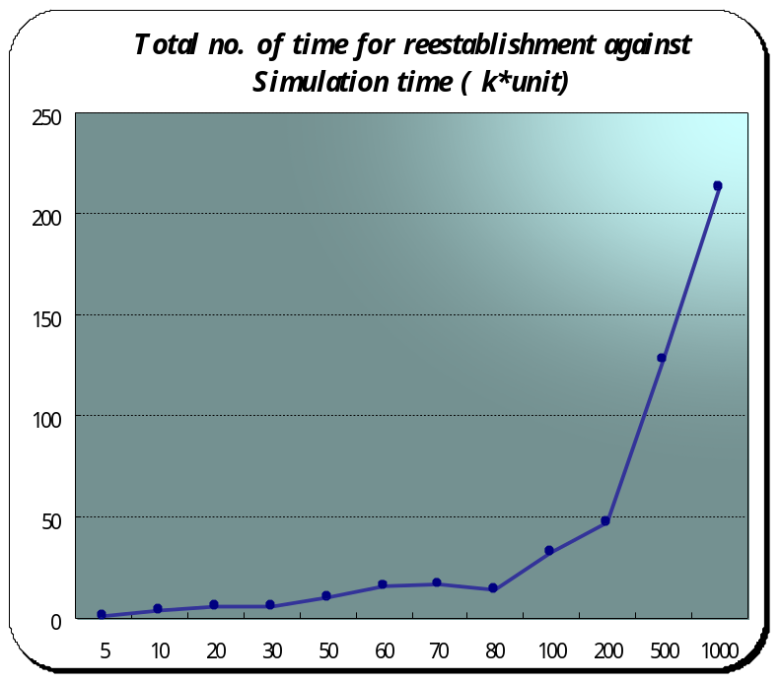
Y-axis | X-axis
1 | 5
4 | 10
6 | 20
6 | 30
10 | 50
16 | 60
17 | 70
14 | 80
32 | 100
47 | 200
128 | 500
213 | 1000

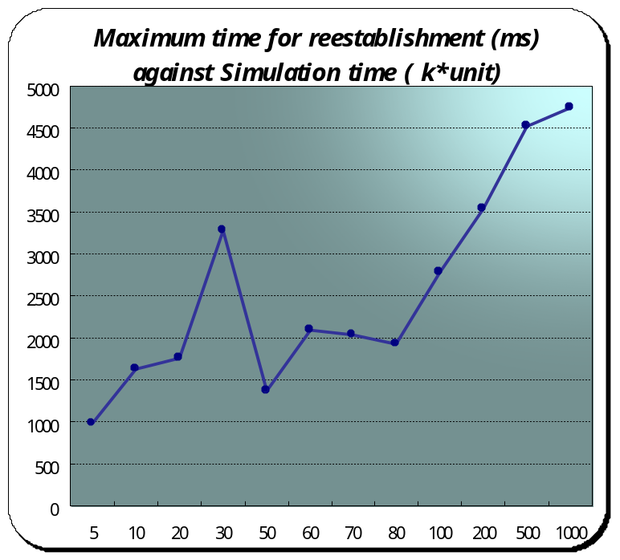  Y-axis | X-axis
978 | 5
1636 | 10
1768 | 20
3272 | 30
1364 | 50
2092 | 60
2040 | 70
1918 | 80
2770 | 100
3542 | 200
4518 | 500
4750 | 1000

B. Performance Testing
The time required for reestablishing a new route will be affected by the setting of the protocol such as the maximum number of retransmission, the timeout value and the backoff period that is the number of waiting time slots before sending out a FLOODING packet. The maximum number of retransmission set as 3 is good enough to ensure the invalidity of the routing path. The timeout value is designed a little bit larger than the time of 3 hops routing that is the longest path that the protocol is necessary to support. Because of the long distance transmission capacity of sensors, up to 3 hops routing is enough to the use of real situation.
The possibility of collision can be decreased by enlarging the backoff period, but the delay of sending packets will also be increased. So, it is unpredictable to know if the reestablishing time will decrease or not when increasing the backoff period. The below graphs show that the relation among the backoff period, collision frequency and reestablishing time.

Y-axis | 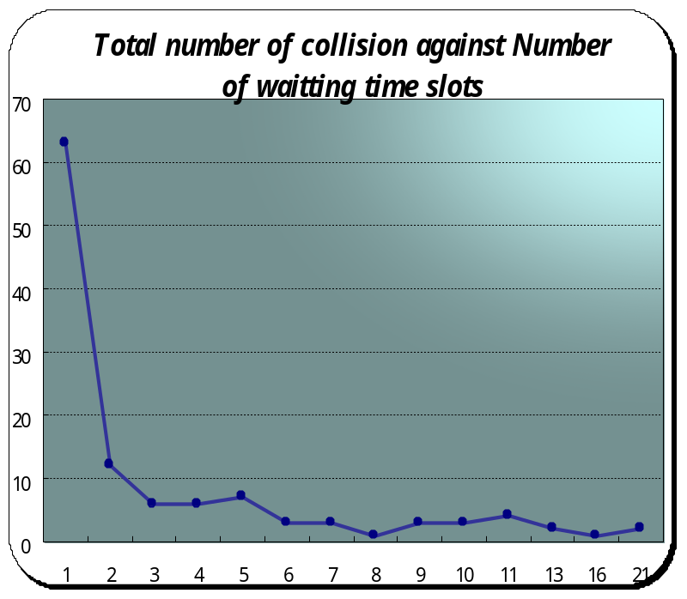  X-axis
63 | 1
12 | 2
6 | 3
6 | 4
7 | 5
3 | 6
3 | 7
1 | 8
3 | 9
3 | 10
4 | 11
2 | 13
1 | 16
2 | 21
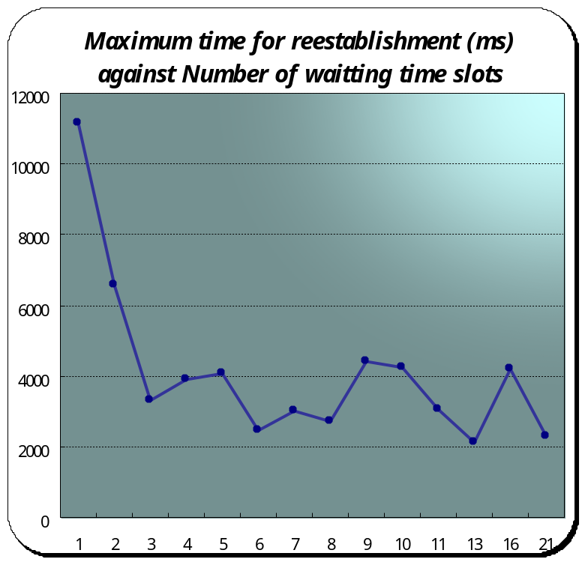
Y-axis | X-axis
11170 | 1
6561 | 2
3318 | 3
3889 | 4
4082 | 5
2472 | 6
3010 | 7
2734 | 8
4402 | 9
4236 | 10
3074 | 11
2138 | 13
4200 | 16
2270 | 21

To summarize, from the above graph, we can find that keeping enlarging the number of waiting time slots cannot improve the reestablishing time much more. The number of time slots set as 3 is good enough to avoid huge number of collision occurred. And, for the worst case study, the maximum reestablishing time is just about a few seconds that is very satisfying for the real situation.
VIII. Conclusion
The Dynamic Source Routing protocol (DSR) is a simple and efficient routing protocol designed specifically for use in multi-hop wireless ad hoc networks of mobile nodes. DSR allows the network to be completely self-organizing and self-configuring, without the need for any existing network infrastructure or administration. The protocol is composed of the two main mechanisms, namely "Route Discovery" and "Route Maintenance", which work together to allow nodes to discover and maintain routes to arbitrary destinations in the ad hoc network [9]. In order to design the most suitable routing protocol for the problem of real-time wireless hazardous material sensing, I decide to design a protocol mainly based on the DSR protocol.
In the process of designing the routing protocol, I try to let the protocol simpler and more suitable for the sensing problem. I am using the minimum procedures to achieve the routing target among nodes. By reducing the traffic in the network, for example, including the polling messages and states’ information to the control packets, it leads to lower total energy consumption among each node. Also, there is no any periodic routing update among nodes, all the operations are entirely on-demand. The protocol is designed to try to not implement any redundant or unnecessary practices.
Simulation is the most direct way to challenge the protocol. Using computer programming to simulate the real situation is cost-effective in the view of economics. A simulation program based on the real situation and the designed routing protocol has been written to recognize the functionality and practicality of the routing protocol. After carrying a set of evaluation procedures, the routing protocol has been further optimized.
Furthermore, in this project, I have finished to study and evaluate the performance of my designed protocol on the system of 16 sensors. However, for the scalability of the algorithm on the system with more sensors, a further investigation is worth to perform to apply the algorithm on large scale systems as well as the real products.
In conclusion, I have finished designing a routing protocol that has been evaluated to satisfy the situation of real world. The routing protocol is simple, efficient and entirely on-demand. It is greatly suitable for the case of real-time wireless hazardous material sensing.
Appendix I (Program Source Code)
/*
* Simulation program for Dynamic Source Routing Protocol
* written in CSIM
*
* @Modified date: 7/5/2005
* @Author: Fan Tsz Chuen Roy
* @SID: 02729143
*
* Final Year Project
* CUHK Information Engineering
*
*/

/* assume all the time unit = 1ms */
#include <csim.h>

#define LOSTPROB 0.01 /* lost prob. */
#define MAXREPOLLTIME 3 /* maximum repolling times */
#define NUMBEROFNODE 17 /* total number of nodes including the master */

#define REQUEST_TIME 2.0 /* request's packet time */
#define REPLY_TIME 4.0 /* reply's packet time */
#define SENSOR_COMPUTATION_TIME 30.0 /* sensor reply computation time */
#define MASTER_COMPUTATION_TIME 10.0 /* master polling computation time */
#define PROPAGATION_DELAY 0.01 /* propagation delay */
#define TIMEOUT 150.0 /* time out value */
#define FLOODING_TIME 30.0 /* flooding's packet time */
#define WAITTING_TIME 8 /* Waitting time when sending flooding packet */
#define ONE_TIMESLOT 10.0 /* Time for one time slot */

int table[NUMBEROFNODE][2][NUMBEROFNODE]; /* routing tables */
int topology[NUMBEROFNODE][NUMBEROFNODE]; /* network topology */

/* for statistics */
int polling_time = 0;
int tout_time = 0;
int begin_findnewroute[NUMBEROFNODE];
int end_findnewroute[NUMBEROFNODE];
int maxtime_findnewroute = 0;
int totaltime_findnewroute = 0;
int totalfreq_findnewroute = 0;
int totalfreq_collision = 0;

/* initialize the function protocol */
void packet(int);
int polling(int, int);
int getnextnode(int, int);
void topologies(int);
int connect(int, int);
void deleteroute(int, int);
int flooding(int, int);
void printonetable(int);
int changetopology(int);

FACILITY n; /* Network */

sim() {
int i, j;
int out;
int repoll_time; /* repolling times */
int start_time;
long change; /* changing topology */
int stime;
int oldtopology = 0;
int newtopology;

reseed(NIL, 34024); /* reseed a new sequence once starting the program */
inittable(); /* initialize the routing tables */
topologies(oldtopology); /* topologies: type 0 */

create("sim"); /* make this a process */
n = facility("network");

while (simtime() < 500000.0) /* simulation time */
{
for (i=1; i<NUMBEROFNODE; i++ ) /* from sensor S1 to sensor S16, total 16 sensors */
{
repoll_time = 0;
out = 0; /* out = false, haven't finish polling on particular sensor */

while ((out == 0 || out == -1) && repoll_time < MAXREPOLLTIME )
{
start_time = simtime(); /* get the current time */

out = polling(0, i);
polling_time++;
printf("polling time: %d\n\n", polling_time);

if (out == 0)
{
printf("~~~~ TIME OUT ~~~~\n");
}

if ((out == 0 || out == -1) && (simtime() - start_time < TIMEOUT))
{
printf("~~~~ HOLD NOW ~~~~\n");
/* hold until reach the timeout value */
hold(TIMEOUT - (simtime() - start_time));
tout_time++;
}
repoll_time++;
}

/* delete outdated routes in the routing tables when repoll times = 3 */
if (repoll_time == 3)
{
begin_findnewroute[i] = simtime();
printf("\nBegin reestablish[%d]: %d\n\n", i, begin_findnewroute);
deleteroute(0, i);
}

change = random_int(1, 50);
/* prob. to chang topology on each polling = 1/50 */
if (change == 1)
{
newtopology = changetopology(oldtopology);
topologies(0);
topologies(newtopology); /* change the currnet topology */
printf("<< New topology: %d >>\n", newtopology);
oldtopology = newtopology;

stime = simtime();
printf("simtime: %d\n\n", stime);
reseed(NIL, stime);
}

}
}
genreport(); /* print suitable statistics in the report */
printf("\n\n");
report();
terminate();
}

int polling(int source, int dest) {
double ramdom_value;
int nextnode;
int nownode;

printf("Polling on [ %d ]\n", dest);
nownode = source;
do
{
nextnode = getnextnode(nownode, dest);

/* if there is no route to dest, use flooding to find route */
if (nextnode == -1)
{
nextnode = flooding(nownode, dest);
if (nextnode == -1) /* flooding is not success */
{
return -2;
}
}

/* there is no connection between nownode and nextnode */
if (connect(nownode, nextnode) == 0)
{
printf("\n~~~~ No real connection~~~~\n\n");
return -1;
}

ramdom_value = uniform(0.0, 1.0);
if (ramdom_value > LOSTPROB)
{
printf("Send request: \n");
packet(source); /* send request from Master to other */
} else {
return 0;
}
nownode = nextnode;

hold(SENSOR_COMPUTATION_TIME); /* wait for the computation time in the sensor */
printf("Sensor computing ...\n");
}
while (nownode != dest);

do
{
nextnode = getnextnode(nownode, source);

/* if there is no route to source, use flooding to find route */
if (nextnode == -1)
{
nextnode = flooding(nownode, source);
if (nextnode == -1) /* flooding is not success */
{
return -2;
}
}

/* there is no connection between nownode and nextnode */
if (connect(nownode, nextnode) == 0)
{
printf("\n~~~~ No real connection~~~~\n\n");
return -1;
}

ramdom_value = uniform(0.0, 1.0);
if (ramdom_value > LOSTPROB)
{
printf("Reply: \n");
packet(dest); /* send reply from other to Master */
} else {
return 0;
}
nownode = nextnode;

if (nownode != source)
{
hold(SENSOR_COMPUTATION_TIME);/* wait for the computation time in the sensor */
printf("Sensor computing ...\n");
} else {
hold(MASTER_COMPUTATION_TIME);/* wait for the computation time in the master */
printf("Master computing ...\n");
}
}
while (nownode != source);

return 1;
}

void packet(int source) {

if (source == 0) /* from Master to other */
{
reserve(n); /* using the network, other need to wait */
hold(REQUEST_TIME + PROPAGATION_DELAY); /* wait for request transmit time */
printf("M --> \n");
release(n); /* release the network */
}
else /* from other to Master */
{
reserve(n); /* using the network, other need to wait */
hold(REPLY_TIME + PROPAGATION_DELAY); /* wait for reply transmit time */
printf("S ==> \n");
release(n); /* release the network */
}

}

int getnextnode(int nownode, int dest) {
int i;
int nextnode = -1;

for (i=0 ; i<NUMBEROFNODE ;i++ )
{
if (table[nownode][0][i] == dest)
{
/* get the nextnode value in suitable row of the suitable table */
nextnode = table[nownode][1][i];
printf("nownode: %d ; next node: %d\n", nownode, nextnode);
break;
}
}
return nextnode;
}

/* use flooding to find whether the immediate nextnode have a route to destination */
int flooding(int nownode, int target) {
int i, j;
int temp;
int temp_time;
int temphop1 = -1;
int temphop2 = -1;
long temphop1_wait = -1;
long temphop2_wait = -1;
int temphopOK = -1;

printf("\nFlooding: %d <-> %d\n\n", nownode, target);
if (connect(nownode, target) == 1) /* if there is a connection between them */
{
printf("Flooding OK, next node: %d\n", target);
table[nownode][1][target] = target; /* update the routing table of nownode */
table[target][1][nownode] = nownode; /* update the routing table of target */

hold((FLOODING_TIME + REQUEST_TIME)*2); /* for transmission and computing time */

printonetable(nownode);
printonetable(target);
return target;
} else {
for (i=0 ; i<NUMBEROFNODE ;i++ )
{
temp = table[nownode][1][i];
if (temp != -1)
{
for (j=1 ; j<NUMBEROFNODE ;j++ )
{
if (topology[j][temp] == target)
{
if (temphop2 == -1)
{
temphop1 = temp;
temphop2 = temp;
break;
}
temphop2 = temp;
break;

}
}
}
}
if (temphop1 != temphop2)
{
/* waiting time before send flooding packet (collision occur) */
temphop1_wait = random_int(0, WAITTING_TIME); /* waitting time */
temphop2_wait = random_int(0, WAITTING_TIME);

printf("Potential colli.: %d(%d)->%d<-%d(%d)\n", temphop1, temphop1_wait, target, temphop2, temphop2_wait);

/* hop who has min. waiting time will go first */
if (temphop1_wait > temphop2_wait)
{
temphopOK = temphop2;
hold(ONE_TIMESLOT * temphop2_wait); /* wait for some timeslots' time */
} else {
temphopOK = temphop1;
hold(ONE_TIMESLOT * temphop1_wait);
}
} else { /* no potential collision */
if (temphop1 == -1) /* flooding dose not succeed */
{
printf("Flooding does not succeed\n");
return -1;
}
temphop1_wait = random_int(0, WAITTING_TIME); /* waitting time */
hold(ONE_TIMESLOT * temphop1_wait);
temphopOK = temphop1;
}

/* collision occur, give up this polling */
if (temphop1_wait == temphop2_wait)
{
totalfreq_collision++;
printf("Collision occur: %d\n", totalfreq_collision);
printf("Flooding does not succeed\n");
return -1;
}

printf("Flooding OK, next node: %d\n", temphopOK);
table[nownode][1][target] = temphopOK; /* update the routing table of nownode */
table[temphopOK][1][nownode] = nownode; /* update the routing table of temp */
table[temphopOK][1][target] = target;
table[target][1][nownode] = temphopOK; /* update the routing table of target */
table[target][1][temphopOK] = temphopOK;

hold((FLOODING_TIME + REQUEST_TIME)*2); /* for transmission and computing time */
hold((FLOODING_TIME + REQUEST_TIME)*2); /* for transmission and computing time */

printonetable(nownode);
printonetable(temphopOK);
printonetable(target);

/* caculate the time to find a new route */
end_findnewroute[target] = simtime();
printf("\nEnd reestablish[%d]: %d\n",target, end_findnewroute);
temp_time = (end_findnewroute[target] - begin_findnewroute[target]);
/* choose the max re-establish time */
if (temp_time > maxtime_findnewroute)
{
maxtime_findnewroute = temp_time;
}
totaltime_findnewroute += temp_time;
totalfreq_findnewroute++;
printf("Max reestablish(freq): %d(%d)\n\n", maxtime_findnewroute, totalfreq_findnewroute);

return temphopOK;
}
}

int connect(int nownode, int nextnode) {
int i;

for (i=1 ;i<NUMBEROFNODE ;i++ )
{
/* check if there is a connection between nownode and nextnode */
if (topology[i][nownode] == nextnode)
{
return 1; /* 1 means there is a connection */
}
}
return 0;
}

/* intialize each routing table */
inittable() {
int i, j;
printf("intialize the routing table\n");

/* intialize the master's routing table */
for (i=1 ;i<NUMBEROFNODE ;i++)
{
table[0][0][i] = i;
table[0][1][i] = i;
}

/* intialize sensors' routing table */
for (i=1 ;i<NUMBEROFNODE ;i++ )
{
for (j=0 ;j<NUMBEROFNODE ;j++ )
{
table[i][0][j] = j;
table[i][1][j] = -1;
}
table[i][1][0] = 0;
}

/* print table */
printtable();

printf("\n");
}

printtable() {
int i, j;

/* print table */
printf("table: Master\n");
for (j=0 ;j<NUMBEROFNODE ;j++ )
{
printf("%d | %d\n", table[0][0][j], table[0][1][j]);
}
printf("\n");
for (i=1 ;i<NUMBEROFNODE ;i++ )
{
printf("table: S%d\n", i);
for (j=0 ;j<NUMBEROFNODE ;j++ )
{
printf("%d | %d\n", table[i][0][j], table[i][1][j]);
}
printf("\n");
}
}

/* print a particular table */
void printonetable(int temp) {
int j;
printf("table: S%d\n", temp);
for (j=0 ;j<NUMBEROFNODE ;j++ )
{
printf("%d | %d\n", table[temp][0][j], table[temp][1][j]);
}
printf("\n");
}

/* different topologies */
void topologies(int type) {
int i, j;
switch (type)
{
case 0:
{
/* all become minus one, indicate there is no connection*/
for (i=0 ;i<NUMBEROFNODE ;i++ )
{
for (j=0 ;j<NUMBEROFNODE ;j++ )
{
topology[i][j] = -1;
}
}

for (i=0 ;i<NUMBEROFNODE ;i++ )
{
topology[0][i] = i;
topology[i][0] = i; /* M is connected to all hops */
}
for (i=1 ;i<NUMBEROFNODE ;i++ )
{
topology[1][i] = 0; /* all hops is connected to M */
}
break;
}

case 1:
{
topology[1][0] = -1; /* delete S1 in row M */
topology[1][1] = 2; /* S2 replaces M in row S1 */
topology[2][2] = 1; /* add S1 in row S2 */
break;
}
case 2:
{
topology[1][0] = -1;
topology[3][0] = -1;
topology[5][0] = -1;
topology[1][1] = 2;
topology[1][3] = 2;
topology[2][2] = 1;
topology[3][2] = 3;
topology[1][5] = 6;
topology[2][6] = 5;
break;
}
case 3:
{
topology[1][0] = -1;
topology[5][0] = -1;
topology[1][1] = 2;
topology[2][2] = 1;
topology[1][5] = 6;
topology[2][6] = 5;
break;
}
case 4:
{
topology[1][0] = -1;
topology[5][0] = -1;
topology[1][1] = 2;
topology[2][2] = 1;
topology[1][5] = 6;
topology[2][6] = 5;
topology[8][0] = -1;
topology[1][8] = 7;
topology[2][8] = 9;
topology[2][7] = 8;
topology[2][9] = 8;
break;
}
case 5:
{
topology[1][0] = -1;
topology[4][0] = -1;
topology[5][0] = -1;
topology[13][0] = -1;
topology[1][1] = 2;
topology[2][2] = 1;
topology[1][4] = 6;
topology[1][5] = 6;
topology[2][6] = 4;
topology[3][6] = 5;
topology[1][13] = 12;
topology[2][13] = 14;
topology[2][12] = 13;
topology[2][14] = 13;
break;
}
case 6:
{
topology[1][0] = -1;
topology[4][0] = -1;
topology[5][0] = -1;
topology[7][0] = -1;
topology[13][0] = -1;
topology[1][1] = 2;
topology[2][2] = 1;
topology[1][4] = 3;
topology[2][4] = 6;
topology[2][3] = 4;
topology[2][6] = 4;
topology[1][5] = 6;
topology[3][6] = 5;
topology[1][7] = 6;
topology[4][6] = 7;
topology[1][13] = 12;
topology[2][12] = 13;
break;
}
case 7:
{
topology[1][0] = -1;
topology[4][0] = -1;
topology[5][0] = -1;
topology[7][0] = -1;
topology[13][0] = -1;
topology[1][1] = 2;
topology[2][2] = 1;
topology[1][4] = 3;
topology[2][4] = 6;
topology[2][3] = 4;
topology[2][6] = 4;
topology[1][5] = 6;
topology[3][6] = 5;
topology[1][7] = 6;
topology[4][6] = 7;
topology[1][13] = 12;
topology[2][12] = 13;
topology[16][0] = -1;
topology[14][0] = -1;
topology[1][16] = 2;
topology[3][2] = 16;
topology[1][14] = 12;
topology[3][12] = 14;
break;
}
case 8:
{
topology[1][0] = -1;
topology[4][0] = -1;
topology[5][0] = -1;
topology[13][0] = -1;
topology[1][1] = 2;
topology[2][1] = 16;
topology[2][2] = 1;
topology[2][16] = 1;
topology[1][4] = 6;
topology[1][5] = 6;
topology[2][6] = 4;
topology[3][6] = 5;
topology[1][13] = 12;
topology[2][12] = 13;
break;
}
case 9:
{
topology[1][0] = -1;
topology[5][0] = -1;
topology[13][0] = -1;
topology[1][1] = 16;
topology[2][16] = 1;
topology[1][5] = 6;
topology[2][6] = 5;
topology[1][13] = 12;
topology[2][12] = 13;
break;
}
case 11: /* use for testing */
{
topology[1][0] = -1;
topology[1][1] = 2;
topology[2][1] = 3;
topology[2][2] = 1;
topology[2][3] = 1;
break;
}
}
}

/* delete the routes between hop a and hop b in a's routing table */
void deleteroute(int a, int b) {
int j;

for (j=0 ;j<NUMBEROFNODE ;j++ )
{
if (table[a][0][j] == b)
{
table[a][1][j] = -1; /* delete the outdated route in routing table of hop a */
}
}
printf("Del entry %d\n in routing table: S%d\n", b, a);
printonetable(a);

}

/* input the previous topology, output the next topology */
int changetopology(int old) {
long prob;
if (old == 2)
{
prob = random_int(0, 1);
if (prob == 0)
{
return 3;
} else {
return 4;
}
}
if (old == 9)
{
prob = random_int(0, 2);
if (prob == 0)
{
return 0;
} else if (prob == 1)
{
return 2;
} else {
return 5;
}
}
return (old + 1);
}

genreport() {
int k;
printf("The average time-out probability is: %.6f\n", (double)tout_time/polling_time);
printf("The max time to reestablish: %.2fmsec\n", (double)maxtime_findnewroute);
printf("The average time to reestablish(freq): %.2fmsec(%d)\n", (double)totaltime_findnewroute/totalfreq_findnewroute,totalfreq_findnewroute);
printf("Total number of collisions: %d\n", totalfreq_collision);
/* print all the waitting time slot */
printf("Waiting time slot: [");
for (k=0; k <= WAITTING_TIME ; k++ )
{
printf(" %d", k);
}
printf(" ]\n");
}
Appendix II (Program Output)

intialize the routing table
table: Master
0 | 0
1 | 1
2 | 2
3 | 3
4 | 4
5 | 5
6 | 6
7 | 7
8 | 8
9 | 9
10 | 10
11 | 11
12 | 12
13 | 13
14 | 14
15 | 15
16 | 16

table: S1
0 | 0
1 | -1
2 | -1
3 | -1
4 | -1
5 | -1
6 | -1
7 | -1
8 | -1
9 | -1
10 | -1
11 | -1
12 | -1
13 | -1
14 | -1
15 | -1
16 | -1

table: S2
0 | 0
1 | -1
2 | -1
3 | -1
4 | -1
5 | -1
6 | -1
7 | -1
8 | -1
9 | -1
10 | -1
11 | -1
12 | -1
13 | -1
14 | -1
15 | -1
16 | -1

table: S3
0 | 0
1 | -1
2 | -1
3 | -1
4 | -1
5 | -1
6 | -1
7 | -1
8 | -1
9 | -1
10 | -1
11 | -1
12 | -1
13 | -1
14 | -1
15 | -1
16 | -1

table: S4
0 | 0
1 | -1
2 | -1
3 | -1
4 | -1
5 | -1
6 | -1
7 | -1
8 | -1
9 | -1
10 | -1
11 | -1
12 | -1
13 | -1
14 | -1
15 | -1
16 | -1

table: S5
0 | 0
1 | -1
2 | -1
3 | -1
4 | -1
5 | -1
6 | -1
7 | -1
8 | -1
9 | -1
10 | -1
11 | -1
12 | -1
13 | -1
14 | -1
15 | -1
16 | -1

table: S6
0 | 0
1 | -1
2 | -1
3 | -1
4 | -1
5 | -1
6 | -1
7 | -1
8 | -1
9 | -1
10 | -1
11 | -1
12 | -1
13 | -1
14 | -1
15 | -1
16 | -1

table: S7
0 | 0
1 | -1
2 | -1
3 | -1
4 | -1
5 | -1
6 | -1
7 | -1
8 | -1
9 | -1
10 | -1
11 | -1
12 | -1
13 | -1
14 | -1
15 | -1
16 | -1

table: S8
0 | 0
1 | -1
2 | -1
3 | -1
4 | -1
5 | -1
6 | -1
7 | -1
8 | -1
9 | -1
10 | -1
11 | -1
12 | -1
13 | -1
14 | -1
15 | -1
16 | -1

table: S9
0 | 0
1 | -1
2 | -1
3 | -1
4 | -1
5 | -1
6 | -1
7 | -1
8 | -1
9 | -1
10 | -1
11 | -1
12 | -1
13 | -1
14 | -1
15 | -1
16 | -1

table: S10
0 | 0
1 | -1
2 | -1
3 | -1
4 | -1
5 | -1
6 | -1
7 | -1
8 | -1
9 | -1
10 | -1
11 | -1
12 | -1
13 | -1
14 | -1
15 | -1
16 | -1

table: S11
0 | 0
1 | -1
2 | -1
3 | -1
4 | -1
5 | -1
6 | -1
7 | -1
8 | -1
9 | -1
10 | -1
11 | -1
12 | -1
13 | -1
14 | -1
15 | -1
16 | -1

table: S12
0 | 0
1 | -1
2 | -1
3 | -1
4 | -1
5 | -1
6 | -1
7 | -1
8 | -1
9 | -1
10 | -1
11 | -1
12 | -1
13 | -1
14 | -1
15 | -1
16 | -1

table: S13
0 | 0
1 | -1
2 | -1
3 | -1
4 | -1
5 | -1
6 | -1
7 | -1
8 | -1
9 | -1
10 | -1
11 | -1
12 | -1
13 | -1
14 | -1
15 | -1
16 | -1

table: S14
0 | 0
1 | -1
2 | -1
3 | -1
4 | -1
5 | -1
6 | -1
7 | -1
8 | -1
9 | -1
10 | -1
11 | -1
12 | -1
13 | -1
14 | -1
15 | -1
16 | -1

table: S15
0 | 0
1 | -1
2 | -1
3 | -1
4 | -1
5 | -1
6 | -1
7 | -1
8 | -1
9 | -1
10 | -1
11 | -1
12 | -1
13 | -1
14 | -1
15 | -1
16 | -1

table: S16
0 | 0
1 | -1
2 | -1
3 | -1
4 | -1
5 | -1
6 | -1
7 | -1
8 | -1
9 | -1
10 | -1
11 | -1
12 | -1
13 | -1
14 | -1
15 | -1
16 | -1

Polling on [ 1 ]
nownode: 0 ; next node: 1
Send request:
M -->
Sensor computing ...
nownode: 1 ; next node: 0
Reply:
S ==>
Master computing ...
polling time: 1

Polling on [ 2 ]
nownode: 0 ; next node: 2
Send request:
M -->
Sensor computing ...
nownode: 2 ; next node: 0
Reply:
S ==>
Master computing ...
polling time: 2

SKIP

<< New topology: 1 >>
simtime: 1668

Polling on [ 2 ]
nownode: 0 ; next node: 2
Send request:
M -->
Sensor computing ...
nownode: 2 ; next node: 0
Reply:
S ==>
Master computing ...
polling time: 35

Polling on [ 3 ]
nownode: 0 ; next node: 3
Send request:
M -->
Sensor computing ...
nownode: 3 ; next node: 0
Reply:
S ==>
Master computing ...
polling time: 36

Polling on [ 4 ]
nownode: 0 ; next node: 4
Send request:
M -->
Sensor computing ...
nownode: 4 ; next node: 0
Reply:
S ==>
Master computing ...
polling time: 37

Polling on [ 5 ]
nownode: 0 ; next node: 5
Send request:
M -->
Sensor computing ...
nownode: 5 ; next node: 0
Reply:
S ==>
Master computing ...
polling time: 38

Polling on [ 6 ]
nownode: 0 ; next node: 6
Send request:
M -->
Sensor computing ...
nownode: 6 ; next node: 0
Reply:
S ==>
Master computing ...
polling time: 39

Polling on [ 7 ]
nownode: 0 ; next node: 7
Send request:
M -->
Sensor computing ...
nownode: 7 ; next node: 0
Reply:
S ==>
Master computing ...
polling time: 40

Polling on [ 8 ]
nownode: 0 ; next node: 8
Send request:
M -->
Sensor computing ...
nownode: 8 ; next node: 0
Reply:
S ==>
Master computing ...
polling time: 41

Polling on [ 9 ]
nownode: 0 ; next node: 9
Send request:
M -->
Sensor computing ...
nownode: 9 ; next node: 0
Reply:
S ==>
Master computing ...
polling time: 42

Polling on [ 10 ]
nownode: 0 ; next node: 10
Send request:
M -->
Sensor computing ...
nownode: 10 ; next node: 0
Reply:
S ==>
Master computing ...
polling time: 43

Polling on [ 11 ]
nownode: 0 ; next node: 11
Send request:
M -->
Sensor computing ...
nownode: 11 ; next node: 0
Reply:
S ==>
Master computing ...
polling time: 44

Polling on [ 12 ]
nownode: 0 ; next node: 12
Send request:
M -->
Sensor computing ...
nownode: 12 ; next node: 0
Reply:
S ==>
Master computing ...
polling time: 45

Polling on [ 13 ]
nownode: 0 ; next node: 13
Send request:
M -->
Sensor computing ...
nownode: 13 ; next node: 0
Reply:
S ==>
Master computing ...
polling time: 46

Polling on [ 14 ]
nownode: 0 ; next node: 14
Send request:
M -->
Sensor computing ...
nownode: 14 ; next node: 0
Reply:
S ==>
Master computing ...
polling time: 47

Polling on [ 15 ]
nownode: 0 ; next node: 15
Send request:
M -->
Sensor computing ...
nownode: 15 ; next node: 0
Reply:
S ==>
Master computing ...
polling time: 48

Polling on [ 16 ]
nownode: 0 ; next node: 16
Send request:
M -->
Sensor computing ...
nownode: 16 ; next node: 0
Reply:
S ==>
Master computing ...
polling time: 49

Polling on [ 1 ]
nownode: 0 ; next node: 1

~~~~ No real connection~~~~

polling time: 50

~~~~ HOLD NOW ~~~~
Polling on [ 1 ]
nownode: 0 ; next node: 1

~~~~ No real connection~~~~

polling time: 51

~~~~ HOLD NOW ~~~~
Polling on [ 1 ]
nownode: 0 ; next node: 1

~~~~ No real connection~~~~

polling time: 52

~~~~ HOLD NOW ~~~~

Begin reestablish[1]: 308424

Del entry 1
in routing table: S0
table: S0
0 | 0
1 | -1
2 | 2
3 | 3
4 | 4
5 | 5
6 | 6
7 | 7
8 | 8
9 | 9
10 | 10
11 | 11
12 | 12
13 | 13
14 | 14
15 | 15
16 | 16

Polling on [ 2 ]
nownode: 0 ; next node: 2
Send request:
M -->
Sensor computing ...
nownode: 2 ; next node: 0
Reply:
S ==>
Master computing ...
polling time: 53

Polling on [ 3 ]
nownode: 0 ; next node: 3
Send request:
M -->
Sensor computing ...
nownode: 3 ; next node: 0
Reply:
S ==>
Master computing ...
polling time: 54

Polling on [ 4 ]
nownode: 0 ; next node: 4
Send request:
M -->
Sensor computing ...
nownode: 4 ; next node: 0
Reply:
S ==>
Master computing ...
polling time: 55

Polling on [ 5 ]
nownode: 0 ; next node: 5
Send request:
M -->
Sensor computing ...
nownode: 5 ; next node: 0
Reply:
S ==>
Master computing ...
polling time: 56

Polling on [ 6 ]
nownode: 0 ; next node: 6
Send request:
M -->
Sensor computing ...
nownode: 6 ; next node: 0
Reply:
S ==>
Master computing ...
polling time: 57

Polling on [ 7 ]
nownode: 0 ; next node: 7
Send request:
M -->
Sensor computing ...
nownode: 7 ; next node: 0
Reply:
S ==>
Master computing ...
polling time: 58

Polling on [ 8 ]
nownode: 0 ; next node: 8
Send request:
M -->
Sensor computing ...
nownode: 8 ; next node: 0
Reply:
S ==>
Master computing ...
polling time: 59

Polling on [ 9 ]
nownode: 0 ; next node: 9
Send request:
M -->
Sensor computing ...
nownode: 9 ; next node: 0
Reply:
S ==>
Master computing ...
polling time: 60

Polling on [ 10 ]
nownode: 0 ; next node: 10
Send request:
M -->
Sensor computing ...
nownode: 10 ; next node: 0
Reply:
S ==>
Master computing ...
polling time: 61

<< New topology: 2 >>
simtime: 3222

Polling on [ 11 ]
nownode: 0 ; next node: 11
Send request:
M -->
Sensor computing ...
nownode: 11 ; next node: 0
Reply:
S ==>
Master computing ...
polling time: 62

Polling on [ 12 ]
nownode: 0 ; next node: 12
Send request:
M -->
Sensor computing ...
nownode: 12 ; next node: 0
Reply:
S ==>
Master computing ...
polling time: 63

Polling on [ 13 ]
nownode: 0 ; next node: 13
Send request:
M -->
Sensor computing ...
nownode: 13 ; next node: 0
Reply:
S ==>
Master computing ...
polling time: 64

Polling on [ 14 ]
nownode: 0 ; next node: 14
Send request:
M -->
Sensor computing ...
nownode: 14 ; next node: 0
Reply:
S ==>
Master computing ...
polling time: 65

Polling on [ 15 ]
nownode: 0 ; next node: 15
Send request:
M -->
Sensor computing ...
nownode: 15 ; next node: 0
Reply:
S ==>
Master computing ...
polling time: 66

Polling on [ 16 ]
nownode: 0 ; next node: 16
Send request:
M -->
Sensor computing ...
nownode: 16 ; next node: 0
Reply:
S ==>
Master computing ...
polling time: 67

Polling on [ 1 ]
nownode: 0 ; next node: -1

Flooding: 0 <-> 1

Flooding OK, next node: 2
table: S0
0 | 0
1 | 2
2 | 2
3 | 3
4 | 4
5 | 5
6 | 6
7 | 7
8 | 8
9 | 9
10 | 10
11 | 11
12 | 12
13 | 13
14 | 14
15 | 15
16 | 16

table: S2
0 | 0
1 | 1
2 | -1
3 | -1
4 | -1
5 | -1
6 | -1
7 | -1
8 | -1
9 | -1
10 | -1
11 | -1
12 | -1
13 | -1
14 | -1
15 | -1
16 | -1

table: S1
0 | 2
1 | -1
2 | 2
3 | -1
4 | -1
5 | -1
6 | -1
7 | -1
8 | -1
9 | -1
10 | -1
11 | -1
12 | -1
13 | -1
14 | -1
15 | -1
16 | -1

End reestablish[1]: 311576
Max reestablish(freq): 828(1)

Send request:
M -->
Sensor computing ...
nownode: 2 ; next node: 1
Send request:
M -->
Sensor computing ...
nownode: 1 ; next node: 2
Reply:
S ==>
Sensor computing ...
nownode: 2 ; next node: 0
Reply:
S ==>
Master computing ...
polling time: 68

Polling on [ 2 ]
nownode: 0 ; next node: 2
Send request:
M -->
Sensor computing ...
nownode: 2 ; next node: 0
Reply:
S ==>
Master computing ...
polling time: 69

Polling on [ 3 ]
nownode: 0 ; next node: 3

~~~~ No real connection~~~~

polling time: 70

~~~~ HOLD NOW ~~~~
Polling on [ 3 ]
nownode: 0 ; next node: 3

~~~~ No real connection~~~~

polling time: 71

~~~~ HOLD NOW ~~~~
Polling on [ 3 ]
nownode: 0 ; next node: 3

~~~~ No real connection~~~~

polling time: 72

~~~~ HOLD NOW ~~~~

Begin reestablish[3]: 308424

Del entry 3
in routing table: S0
table: S0
0 | 0
1 | 2
2 | 2
3 | -1
4 | 4
5 | 5
6 | 6
7 | 7
8 | 8
9 | 9
10 | 10
11 | 11
12 | 12
13 | 13
14 | 14
15 | 15
16 | 16

Polling on [ 4 ]
nownode: 0 ; next node: 4
Send request:
M -->
Sensor computing ...
nownode: 4 ; next node: 0
Reply:
S ==>
Master computing ...
polling time: 73

Polling on [ 5 ]
nownode: 0 ; next node: 5

~~~~ No real connection~~~~

polling time: 74

~~~~ HOLD NOW ~~~~
Polling on [ 5 ]
nownode: 0 ; next node: 5

~~~~ No real connection~~~~

polling time: 75

~~~~ HOLD NOW ~~~~
Polling on [ 5 ]
nownode: 0 ; next node: 5

~~~~ No real connection~~~~

polling time: 76

~~~~ HOLD NOW ~~~~

Begin reestablish[5]: 308424

Del entry 5
in routing table: S0
table: S0
0 | 0
1 | 2
2 | 2
3 | -1
4 | 4
5 | -1
6 | 6
7 | 7
8 | 8
9 | 9
10 | 10
11 | 11
12 | 12
13 | 13
14 | 14
15 | 15
16 | 16

Polling on [ 6 ]
nownode: 0 ; next node: 6
Send request:
M -->
Sensor computing ...
nownode: 6 ; next node: 0
Reply:
S ==>
Master computing ...
polling time: 77

SKIP

Polling on [ 4 ]
nownode: 0 ; next node: -1

Flooding: 0 <-> 4

Potential colli.: 3(1)->4<-6(1)
Collision occur: 1
Flooding does not succeed
polling time: 167

Polling on [ 5 ]
nownode: 0 ; next node: 6
Send request:
M -->
Sensor computing ...
nownode: 6 ; next node: 5
Send request:
M -->
Sensor computing ...
nownode: 5 ; next node: 6
Reply:
S ==>
Sensor computing ...
nownode: 6 ; next node: 0
Reply:
S ==>
Master computing ...
polling time: 168

Polling on [ 6 ]
nownode: 0 ; next node: 6
Send request:
M -->
Sensor computing ...
nownode: 6 ; next node: 0
Reply:
S ==>
Master computing ...
polling time: 169

Polling on [ 7 ]
nownode: 0 ; next node: -1

Flooding: 0 <-> 7

Flooding OK, next node: 6
table: S0
0 | 0
1 | 2
2 | 2
3 | 3
4 | -1
5 | 6
6 | 6
7 | 6
8 | 8
9 | 9
10 | 10
11 | 11
12 | 12
13 | 12
14 | 14
15 | 15
16 | 16

table: S6
0 | 0
1 | -1
2 | -1
3 | -1
4 | -1
5 | 5
6 | -1
7 | 7
8 | -1
9 | -1
10 | -1
11 | -1
12 | -1
13 | -1
14 | -1
15 | -1
16 | -1

table: S7
0 | 6
1 | -1
2 | -1
3 | -1
4 | -1
5 | -1
6 | 6
7 | -1
8 | -1
9 | -1
10 | -1
11 | -1
12 | -1
13 | -1
14 | -1
15 | -1
16 | -1

End reestablish[7]: 311576
Max reestablish(freq): 1822(5)

Send request:
M -->
Sensor computing ...
nownode: 6 ; next node: 7
Send request:
M -->
Sensor computing ...
nownode: 7 ; next node: 6
Reply:
S ==>
Sensor computing ...
nownode: 6 ; next node: 0
Reply:
S ==>
Master computing ...
polling time: 170

Polling on [ 8 ]
nownode: 0 ; next node: 8
Send request:
M -->
Sensor computing ...
nownode: 8 ; next node: 0
Reply:
S ==>
Master computing ...
polling time: 171

Polling on [ 9 ]
nownode: 0 ; next node: 9
Send request:
M -->
Sensor computing ...
nownode: 9 ; next node: 0
Reply:
S ==>
Master computing ...
polling time: 172

Polling on [ 10 ]
nownode: 0 ; next node: 10
Send request:
M -->
Sensor computing ...
nownode: 10 ; next node: 0
Reply:
S ==>
Master computing ...
polling time: 173

Polling on [ 11 ]
nownode: 0 ; next node: 11
Send request:
M -->
Sensor computing ...
nownode: 11 ; next node: 0
Reply:
S ==>
Master computing ...
polling time: 174

Polling on [ 12 ]
nownode: 0 ; next node: 12
Send request:
M -->
Sensor computing ...
nownode: 12 ; next node: 0
Reply:
S ==>
Master computing ...
polling time: 175

Polling on [ 13 ]
nownode: 0 ; next node: 12
Send request:
M -->
Sensor computing ...
nownode: 12 ; next node: 13
Send request:
M -->
Sensor computing ...
nownode: 13 ; next node: 12
Reply:
S ==>
Sensor computing ...
nownode: 12 ; next node: 0
Reply:
S ==>
Master computing ...
polling time: 176

Polling on [ 14 ]
nownode: 0 ; next node: 14
Send request:
M -->
Sensor computing ...
nownode: 14 ; next node: 0
Reply:
S ==>
Master computing ...
polling time: 177

Polling on [ 15 ]
nownode: 0 ; next node: 15
Send request:
M -->
Sensor computing ...
nownode: 15 ; next node: 0
Reply:
S ==>
Master computing ...
polling time: 178

Polling on [ 16 ]
nownode: 0 ; next node: 16
Send request:
M -->
Sensor computing ...
nownode: 16 ; next node: 0
Reply:
S ==>
Master computing ...
polling time: 179

Polling on [ 1 ]
nownode: 0 ; next node: 2
Send request:
M -->
Sensor computing ...
nownode: 2 ; next node: 1
Send request:
M -->
Sensor computing ...
nownode: 1 ; next node: 2
Reply:
S ==>
Sensor computing ...
nownode: 2 ; next node: 0
Reply:
S ==>
Master computing ...
polling time: 180

Polling on [ 2 ]
nownode: 0 ; next node: 2
Send request:
M -->
Sensor computing ...
nownode: 2 ; next node: 0
Reply:
S ==>
Master computing ...
polling time: 181

Polling on [ 3 ]
nownode: 0 ; next node: 3
Send request:
M -->
Sensor computing ...
nownode: 3 ; next node: 0
Reply:
S ==>
Master computing ...
polling time: 182

<< New topology: 7 >>
simtime: 13074

Polling on [ 4 ]
nownode: 0 ; next node: -1

Flooding: 0 <-> 4

Potential colli.: 3(0)->4<-6(2)
Flooding OK, next node: 3
table: S0
0 | 0
1 | 2
2 | 2
3 | 3
4 | 3
5 | 6
6 | 6
7 | 6
8 | 8
9 | 9
10 | 10
11 | 11
12 | 12
13 | 12
14 | 14
15 | 15
16 | 16

table: S3
0 | 0
1 | -1
2 | 2
3 | -1
4 | 4
5 | -1
6 | -1
7 | -1
8 | -1
9 | -1
10 | -1
11 | -1
12 | -1
13 | -1
14 | -1
15 | -1
16 | -1

table: S4
0 | 3
1 | -1
2 | -1
3 | 3
4 | -1
5 | -1
6 | -1
7 | -1
8 | -1
9 | -1
10 | -1
11 | -1
12 | -1
13 | -1
14 | -1
15 | -1
16 | -1

End reestablish[4]: 311576
Max reestablish(freq): 2660(6)

Send request:
M -->
Sensor computing ...
nownode: 3 ; next node: 4
Send request:
M -->
Sensor computing ...
nownode: 4 ; next node: 3
Reply:
S ==>
Sensor computing ...
nownode: 3 ; next node: 0
Reply:
S ==>
Master computing ...
polling time: 183

Polling on [ 5 ]
nownode: 0 ; next node: 6
Send request:
M -->
Sensor computing ...
nownode: 6 ; next node: 5
Send request:
M -->
Sensor computing ...
nownode: 5 ; next node: 6
Reply:
S ==>
Sensor computing ...
nownode: 6 ; next node: 0
Reply:
S ==>
Master computing ...
polling time: 184

SKIP

Polling on [ 9 ]
nownode: 0 ; next node: 9
Send request:
M -->
Sensor computing ...
nownode: 9 ; next node: 0
Reply:
S ==>
Master computing ...
polling time: 664

<< New topology: 5 >>
simtime: 49813

Polling on [ 10 ]
nownode: 0 ; next node: 10
Send request:
M -->
Sensor computing ...
nownode: 10 ; next node: 0
Reply:
S ==>
Master computing ...
polling time: 665

Polling on [ 11 ]
nownode: 0 ; next node: 11
Send request:
M -->
Sensor computing ...
nownode: 11 ; next node: 0
Reply:
S ==>
Master computing ...
polling time: 666

Polling on [ 12 ]
nownode: 0 ; next node: 12
Send request:
M -->
Sensor computing ...
nownode: 12 ; next node: 0
Reply:
S ==>
Master computing ...
polling time: 667

Polling on [ 13 ]
nownode: 0 ; next node: -1

Flooding: 0 <-> 13

Potential colli.: 12(1)->13<-14(1)
Collision occur: 4
Flooding does not succeed
polling time: 668

Polling on [ 14 ]
nownode: 0 ; next node: 14
Send request:
M -->
Sensor computing ...
nownode: 14 ; next node: 0
Reply:
S ==>
Master computing ...
polling time: 669

Polling on [ 15 ]
nownode: 0 ; next node: 15
Send request:
M -->
Sensor computing ...
nownode: 15 ; next node: 0
Reply:
S ==>
Master computing ...
polling time: 670

Polling on [ 16 ]
nownode: 0 ; next node: 16
Send request:
M -->
Sensor computing ...
nownode: 16 ; next node: 0
Reply:
S ==>
Master computing ...
polling time: 671

The average time-out probability is: 0.132638
The max time to reestablish: 2660.00msec
The average time to reestablish(freq): 1476.40msec(15)
Total number of collisions: 4
Waiting time slot: [ 0 1 2 ]

References
[1] Charles Perkins and Pravin Bhagwat, “DSDV Routing over a Multihop Wireless Network of Mobile Computers”, from “Mobile Computing”, Norwood (MA): Kluwer, 1996

[2] Charles E. Perkins and Elizabeth M. Royer. “Ad-Hoc On-Demand Distance Vector Routing.” Proceedings of the 2nd IEEE Workshop on Mobile Computing Systems and Applications, New Orleans, LA, February 1999, pp. 90-100.

[3] Elizabeth M. Royer and Charles E. Perkins. “An Implementation Study of the AODV Routing Protocol.” Proceedings of the IEEE Wireless Communications and Networking Conference, Chicago, IL, September 2000.

[4] David B. Johnson and David A. Maltz. Dynamic Source Routing in Ad Hoc Wireless Networks. In Mobile Computing, edited by Tomasz Imielinski and Hank Korth, chapter 5, pages 153-181. Kluwer Academic Publishers, 1996

[5] Josh Broch, David B. Johnson, and David A. Maltz. The Dynamic Source Routing Protocol for Mobile Ad Hoc Networks. Internet-Draft, draft-ietf-manet-dsr-03.txt, October 1999. Work in progress.

[6] David B. Johnson. Routing in Ad Hoc Networks of Mobile Hosts. In Proceedings of the IEEE Workshop on Mobile Computing Systems and Applications, pages 158-163, December 1994.

[7] Joseph P. Macker and M. Scott Corson, “Mobile Ad Hoc Networking and the IETF”, ACM Mobile Computing and Communications Review, Volume 3, Number 2, April 1999.

[8] Elizabeth M. Royer and Chai-Keong Toh, “A Review of Current Routing Protocols for Ad Hoc Mobile Wireless Networks”, IEEE Personal Communication, April 1999
[9] Yih-Chun Hu, David B. Johnson, and David A. “Maltz. The Dynamic Source Routing Protocol for Mobile Ad Hoc Networks”, Internet-Draft, draft-ietf-manet-dsr-09.txt, April 2003.
[10] Josh Broch, David B. Johnson, and David A. Maltz, “Quantitative Lessons From a Full-Scale Multi-Hop Wireless Ad Hoc Network Testbed”.
[11] Yu-Chee Tseng, Chih-Shun Hsu and Ten-Yueng Hsieh, “Power-Saving Protocols for IEEE 802.11-Based Multi-Hop Ad Hoc Networks”, 2002.
[12] Ritabrata Roy, “Introduction to Ad-Hoc Network Routing Algorithms”.

