**Heroes of Pymoli – Observations**

1.

[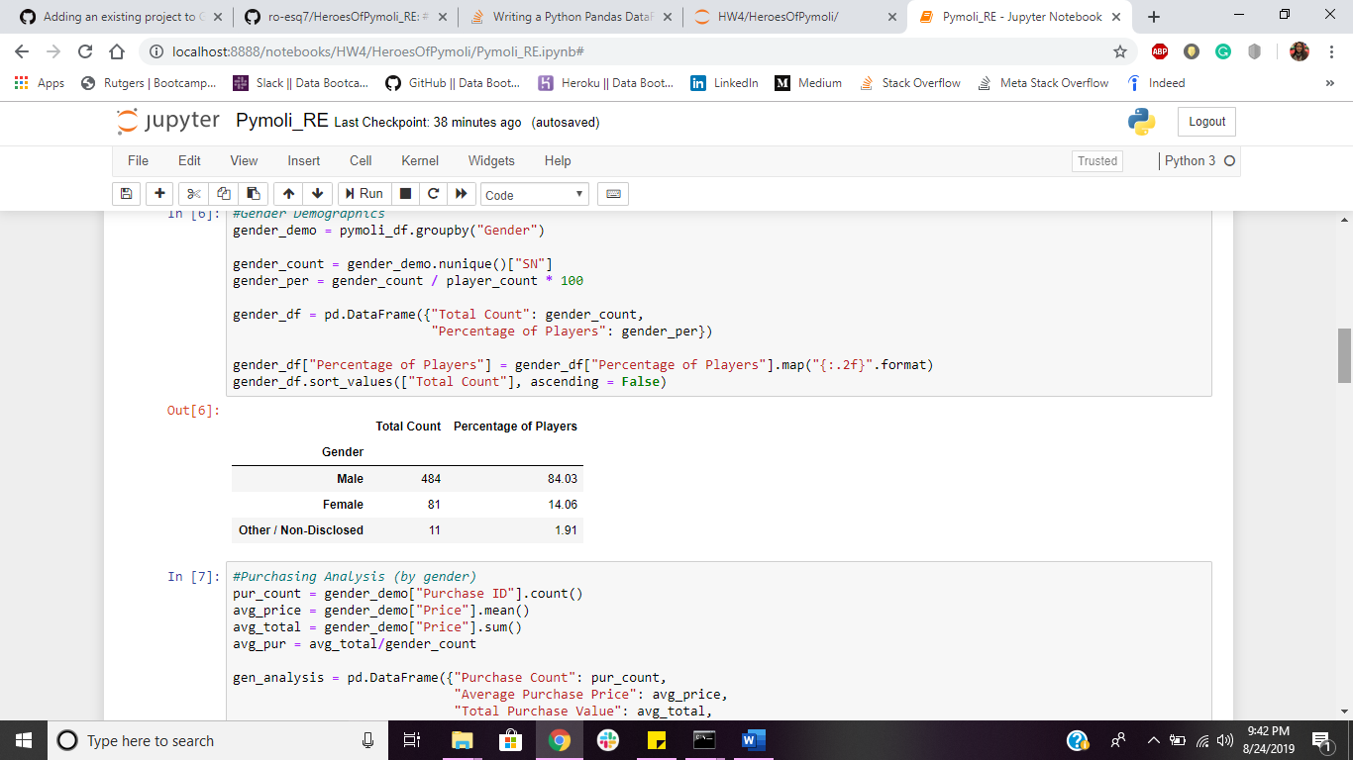](https://github.com/ro-esq7/HeroesOfPymoli_RE.git)

[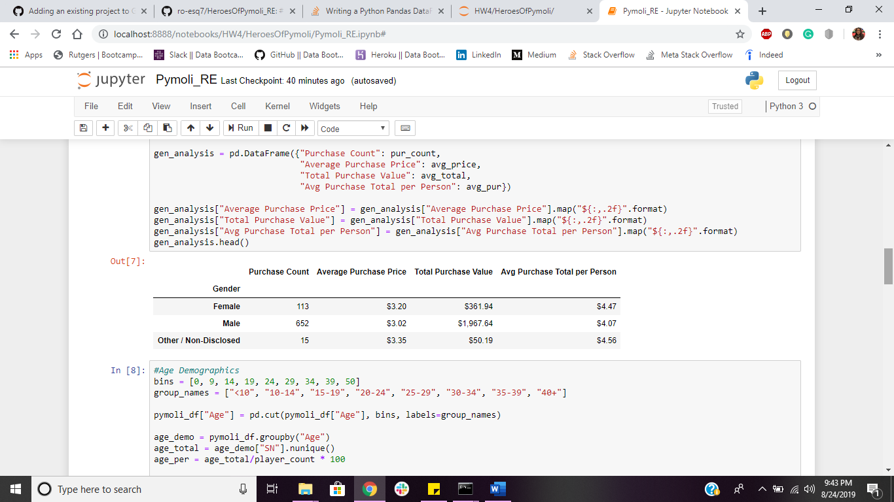](https://github.com/ro-esq7/HeroesOfPymoli_RE.git)

The male demographic (**84.03%**) dominates the Heroes of Pymoli gaming world with the highest total purchase value of **$1,967.64** (*as seen above*). The female demographic (**14.06%**) ranks second with a **$361.94** total purchasing value.

2.

[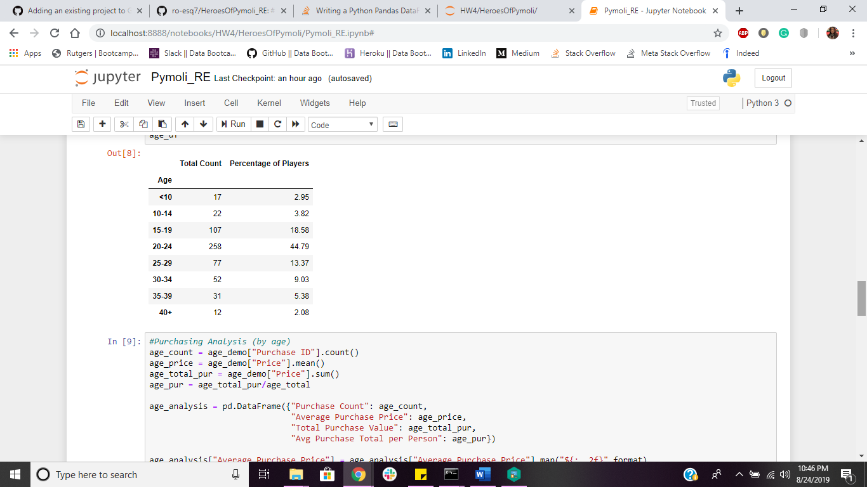](https://github.com/ro-esq7/HeroesOfPymoli_RE.git)

[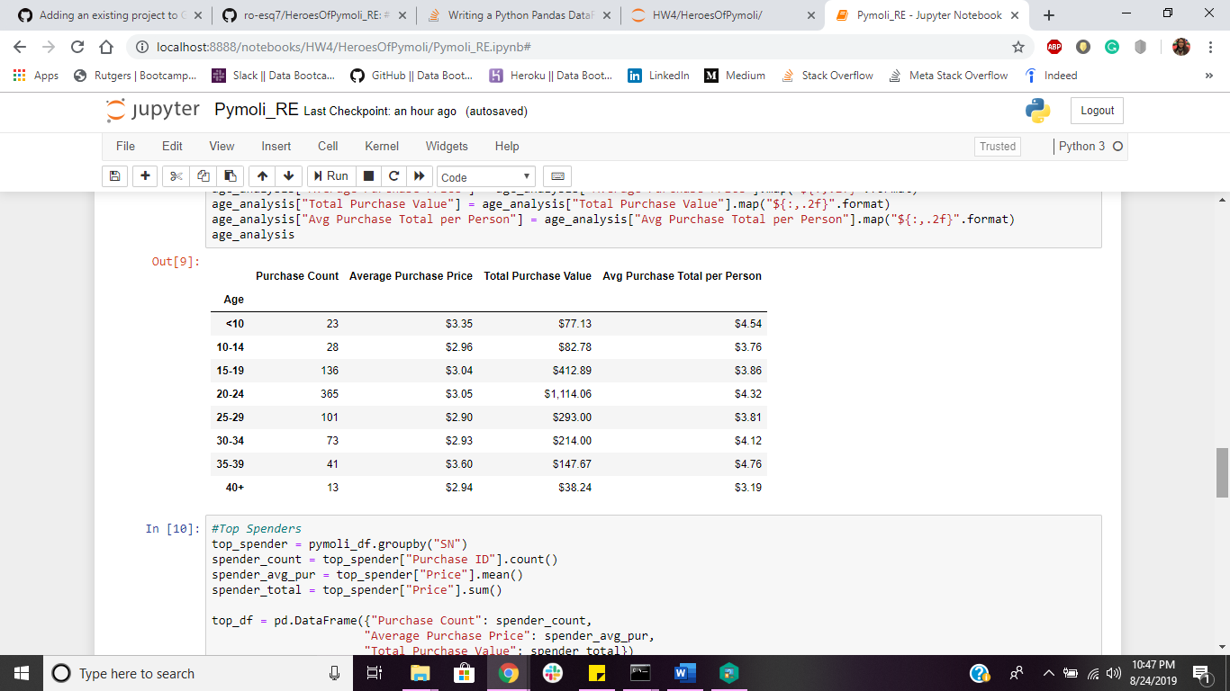](https://github.com/ro-esq7/HeroesOfPymoli_RE.git)

The young adult age range (20 – 24) takes up **44.79%** of the Heroes of Pymoli gaming world. It also has the highest total purchasing value of **$1,114.06** (*as seen above*). The teen age range (15 - 19) comes second with a **18.58%** presence and a total purchasing value of **$412.89**.

3.

[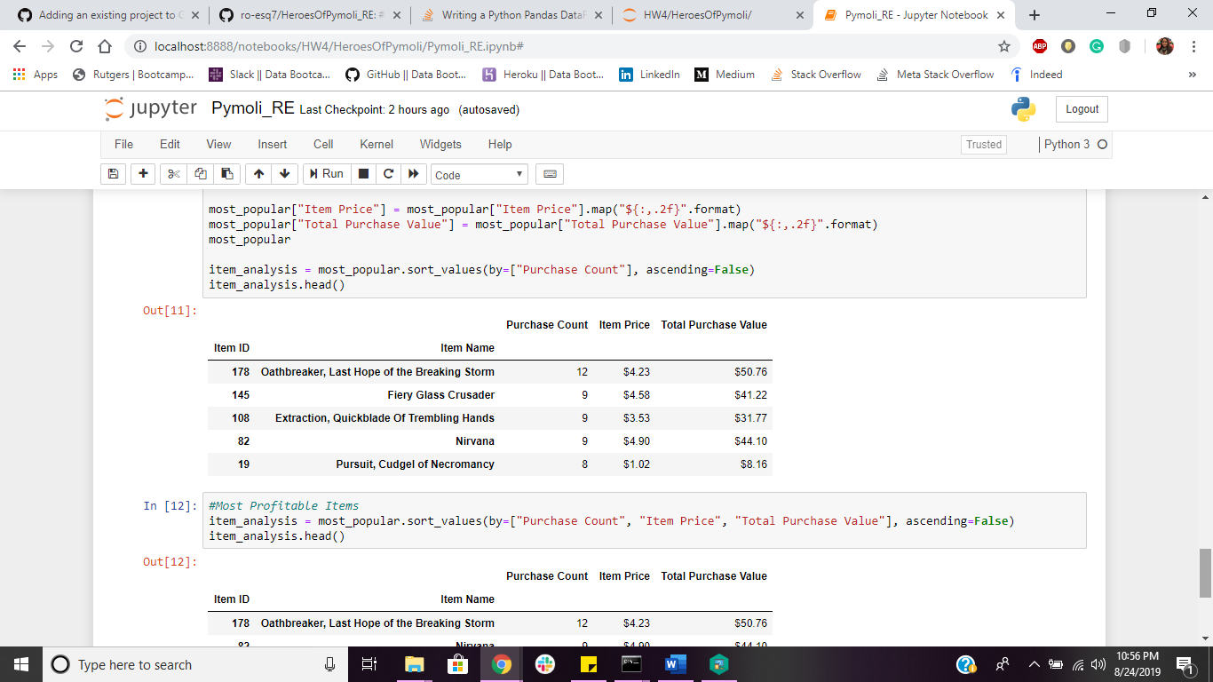](https://github.com/ro-esq7/HeroesOfPymoli_RE.git)

[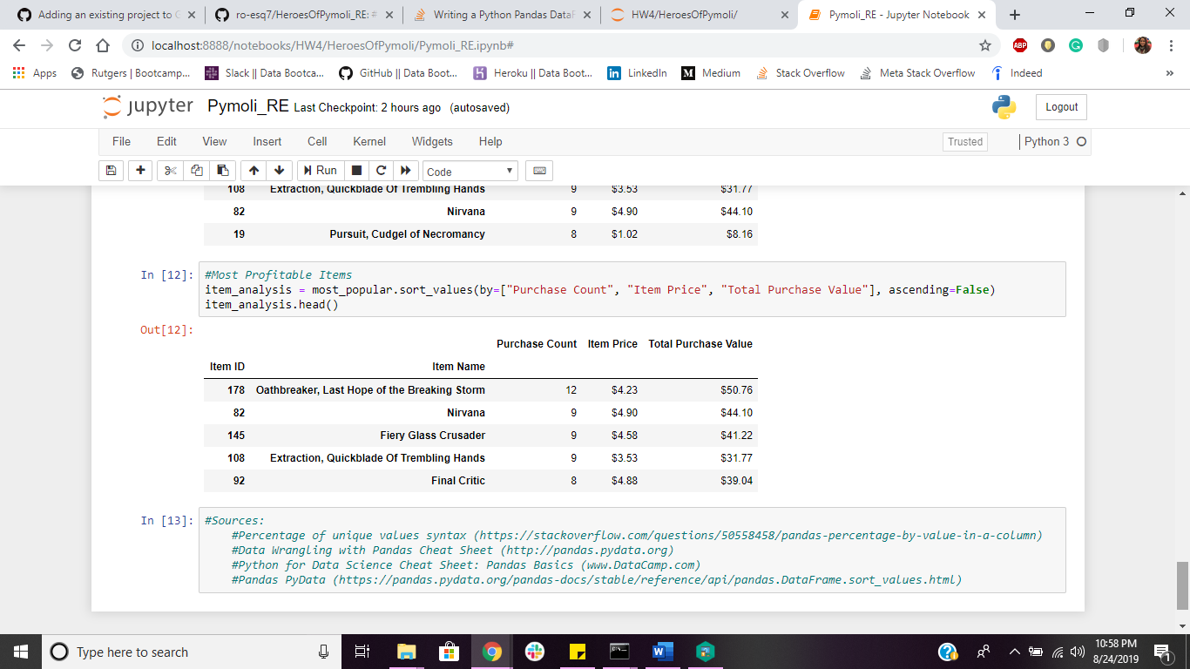](https://github.com/ro-esq7/HeroesOfPymoli_RE.git)

**Oathbreaker, Last Hope of the Breaking Storm** is the #1 gamer’s choice (**Purchase Count: 12**) with the highest profits out of all games (**Total Purchase Value: $50.76**). **Nirvana** ranks second (**Purchase Count: 9**) with a **$44.10** total purchase value.