Fifa World Cup 2026
The Fifa World Cup is an international football tournament that started in 1930. From relatively small beginnings, it has grown to be a multi-billion dollar industry. The Fifa clearing house managing international player transfers saw nearly USD$1 billion since late 2022 (FIFA, 2026a). From 6.9 million fans at live matches to 29 billion video views on official social media (FIFA, 2026b), revenue from Fifa World Cup 2026 events including ticketing, marketing, broadcasting and sponsorship rights exceeded USD$9 billion (The Data Expert, 2026). These are just the Fifa numbers but it’s the gambling industry where the big numbers lie. Gaming Compliance International reports USD$593 billion dollars as a conservative estimate of the wagering value of the 2026 competition (Sobrado, 2026). Statisticians record and analyse every conceivable statistic about each player, club and match. Predictive modelling is used to forecast outcomes and set odds for competitive gambling on the competition results.
This project attempts to predict goal difference in all 104 matches. It uses a multiple linear regression model with 8 explanatory variables. The variables chosen are based on pre-match data and based on coach salaries, official Fifa ranking, round number, statistical experience and age of each 26 player, and speculated expected goals per match.
Model 2.1 Multiple linear regression model to predict Goal difference
Variables
11 initial variables chosen to be reduced to 8 most effective. Each variable is the difference between teams except for round number.
- Coach salary (this as indicative of an investment or a ‘drive’ within the team)
- Ranking (as official recognised team skill level)
- XG (expected goals by ‘statsdontlie’ statisticians)
- Median age (may indicate experience level)
Caps – experience at international level. Grouped and averaged by playing position because teams differ in their makeup but there are only so many positions on the pitch at the same time
- Goalkeeper cap (level of experience at professional level. Not averaged because all teams have 3)
- Forward players mean cap
- Defence players mean cap
- Midfield players mean cap
Goals – by players at international level
- Forward players mean goals
- Squad goal rate (total goals divided by caps)
- Round number (categorised from 1-8)

Data sources
https://worldcupstats.football/teams/#sort=delta_points%2Cdesc Team ranking at 1/04/2026
https://www.salaryleaks.com/blogs/world-cup-2026-coach-salary-rankings Coach estimated annual salary at 12/06/2026
https://fdp.fifa.org/assetspublic/ce281/pdf/SquadLists-English.pdf
https://en.wikipedia.org/wiki/2026_FIFA_World_Cup_squads# Final squad stats 2/06/2026 caps, goals, players, DOB. PDF imported and cleaned in excel
https://www.thestatsdontlie.com/football/world-cup-2026/ Expected goals per match extracted from frame info embedded google sheet
https://theanalyst.com/articles/france-vs-england-stats-world-cup-2026-bronze- Expected goal for the third place final (not listed on statsdontlie)

Methods
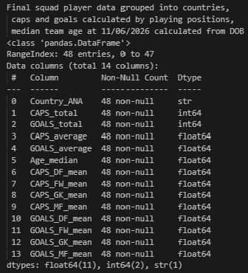
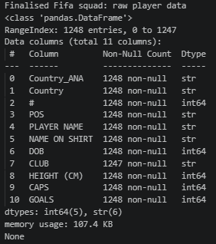
Once the variables were decided on and the data located, the data was loaded into excel for cleaning and collating. Raw player data was grouped and categorised in python(figures1,2) before exporting back to excel to finalise the linear regression datasheet (figure 3). Initial testing used 11 variables. After evaluating model power and correlation (figure 4), this number was reduced to 8 by removing the variables with least relationship to actual goal difference. Surprisingly squad goal rate, midfield and defence player caps had less impact on goal difference than coach salary so these were eliminated in the final dataset.
Figure 1 Raw player dataset
Figure 2 Squad dataset from player data
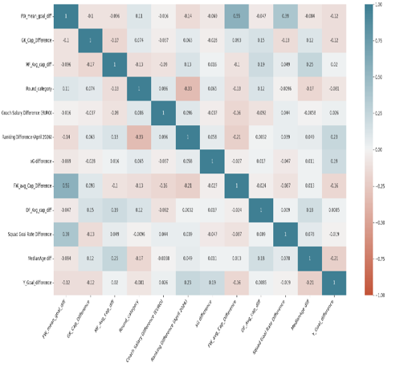
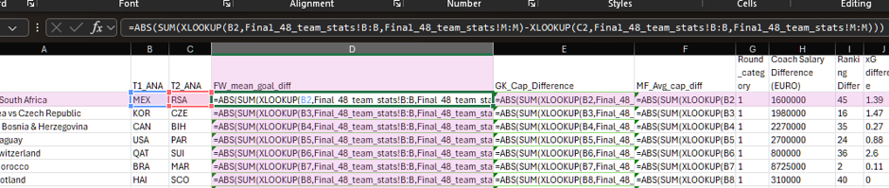
^ Figure 3 Data wrangling in excel
< Figure 4 Correlation heatmap-11 variables
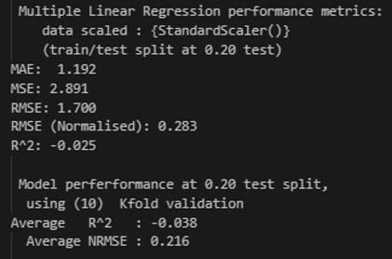
Results
Figure 5 Skicit-learn model performance metrics
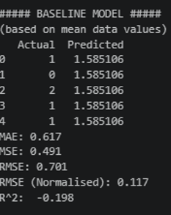
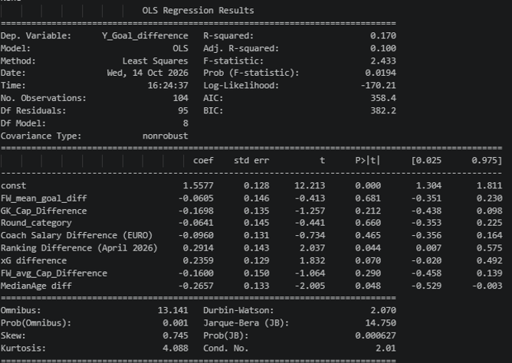
Multiple scalers were tried in Python to find best fit for modelling but there appeared to be no strong linear correlations in the dataset. Scikit-Learn linear regression with StandardScaler and K-fold validation performed very poorly with negative results (figure 5) but at least better than Baseline modelling (figure 6). The best combination was Statsmodel package with PowerTransform scaler. With an adjusted R² = .1, this model can explain 10% of results.
^Figure 6 Baseline performance metrics
< Figure 7 Multiple linear regression summary after power transformation
Conclusion
These variables are ultimately not very effective at predicting goal difference. I believe this could be improved upon using different variables, perhaps player possession or shot success rates. Top player salary might also show interesting results considering the effect of coach salary. This process has illustrated the important of accessing expert knowledge and doing rigorous research earlier in the project to choose appropriate explanatory variables.
References
The Data Expert. (2026, April 21). FIFA world cup 2026 revenue statistics | key facts. The Global Statistics. https://www.theglobalstatistics.com/fifa-world-cup-revenue-statistics/
Fédération Internationale de Football Association. (2026). FIFA world cup 2026TM shines spotlight on FIFA Clearing House and training rewards as USD 1 billion milestone approaches. Fifa.Com. https://inside.fifa.com/subuniverse-clearing-house/media-releases/world-cup-2026-shines-spotlight-clearing-house-training-rewards-1-billion-usd-milestone
FIFA. (2026). Inside FIFA. Fifa.Com. https://inside.fifa.com/tournament-organisation/fifa-world-cup-2026-by-the-numbers
Sobrado, B. (2026, June 18). World cup betting hits $593 billion, 69% unregulated: GCI. Forbes. https://www.forbes.com/sites/boazsobrado/2026/06/18/world-cup-of-crime-593-billion-bet-as-illegal-books-take-69/

Error
I put an earlier version of the report through Turnitin and now it will not accept another
