Bladerunner Examination

Introduction

This project aimed to find the crux of Silicon Valley’s success. With the world idolizing this region in Northern California for its technological marvels and vast success in the technological industry, it begs the question: what makes this place so successful? With this experiment, it aimed to take in the two most prominent qualities of this region, and model them with human interaction to develop a cohesive system, modeling this region.

In the research paper that this study was based on, *Blade Runner Economics: Will Innovation Lead the Economic Recovery?*, written by Daniele Archibugi, the author discusses the effects of innovation on economic development. This paper provided the model of Schumpeterian theories, leading to this research to be based fundamentally upon providing evidence of such a phenomenon.

The system used to model such an occurrence was created with the program NetLogo, and the attributes of each agent were split between wealth and inventiveness. With this experiment, the main focus was to find the contributing factors of these regions forming, and display clusters and regions through the use of simulation. As a whole, the aim was to see if wealth and inventiveness were abound in a certain proximity, that there would be cluster formation, creating regions similar to that of Silicon Valley.

Methodology

With the use of NetLogo, the process of creating the model and visually displaying it was expedited, and created the opportunity to manipulate the factors being accounted for. However, it was the use of NetLogo’s custom language that was a learning curve. It resembles basic object-oriented-programming, and references the different functions that NetLogo provides.

The model followed two primary subsets of the population: the incredibly creative/inventive and the wealthy. This value of inventiveness was based on an IQ threshold of approximately 145, and was selective upon the randomized population. Along with this, the wealthy was based on a percentage of the population. This was set at 1%, based on the average estimate from The New York Times Article, “The Millionaire Next Door: The Surprising Secrets of American's Wealthy”, written by Thomas J. Stanley, Ph.D And William D. Danko, Ph.D.

With the knowledge of this extreme income, it was simple to create a percentage system in NetLogo for the wealthy population.

set percent-wealthy PercentWealthy

set wealthyTurtles (percent-wealthy * 0.01 * TurtleCount)

set rest (TurtleCount - wealthyTurtles)

This code from the program displays the set up of global variables, particularly the wealthy turtles. With a slider that referenced the percent-wealthy value, it multiplied that value by a hundredth, and also multiplied that by the count of turtles. In order to subtract this population from the rest, the value of wealthyTurtles was simply subtracted from the population.

Aside from the wealth, the core component of inventiveness also had to be accounted for. This was done by taking the ‘rest’ value, and using that as a reference number.

create-turtles rest

[

setxy random-xcor random-ycor

set inventive? false

set wealthy? false

]

let iCount percent-inventive

ask n-of (iCount * 0.01 * TurtleCount) turtles [

set inventive? true

]

As it can be seen, the rest value was used to give the turtles a random position, and then the iCount variable was created to seek the inventive count based on the slider’s percentage value.

Before the building of the code and the system itself, there was a necessity of research on the topic of inventiveness and wealth throughout the region of Silicon Valley, tech companies, and venture capitalists. In the Forbes article, “The Scary Smart Are The Scary Rich: Examining Tech's Richest On The Forbes 400,” written by author Ryan Mac, it addresses the key point that makes Silicon Valley, and tech companies as a whole, so unique: their CEO’s and leaders are geniuses. This concept was integrated into the program, as it accounted for not only the dichotomy of intelligent or wealthy, but the two converged to create the ultra-wealthy and intelligent investor/inventor.

ifelse inventive? and wealthy?

[ set color blue ]

Since there was overlap of the thresholds, it was simple to classify those turtles that were both inventive and wealthy by assigning them a separate color: blue.

In order to create a path that the turtles could follow to find the shortest distance between each other, in order to congregate, an algorithm was required. As the code depicts, it displays the declaration of the x and y coordinates of the turtles. This would then be used for the distance formula, an algebraic expression that yields the shortest distance between two points.

;; m

to-report getM [f g p q]

report ((g - q) / (f - p))

end

;; c

to-report getC [f g p q]

report (g - ((getM f g p q) * f))

end

;; x

to-report getX [m c f g]

let b (f - m * (c - g))

let a ((m ^ 2) + 1)

let bsq_4ac sqrt((b ^ 2) - (a * ((f ^ 2) + ((c - g) ^ 2) - (dist ^ 2))))

report ((b + bsq_4ac) / a)

end

;; y

to-report getY [m x c]

report ((m * x) + c)

end

This algorithm was utilized because of the lack of NetLogo’s functionality in terms of finding the closest distance between the two points. However, despite its increased computation, it develops a more accurate cluster.

Results

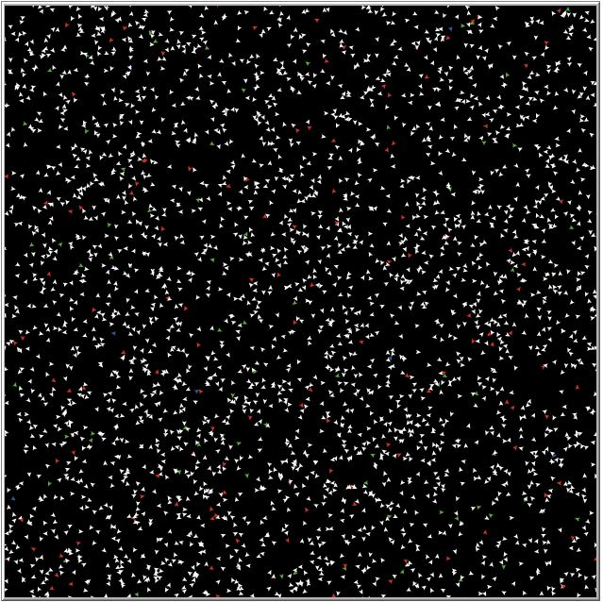

(Figure 1-Set Up)

As it can be seen faintly, this population of 3,000 turtles has several different red turtles, which indicates a high IQ (slider set to 4.5% of population). There are also several wealthy turtles around the plane, scattered throughout.

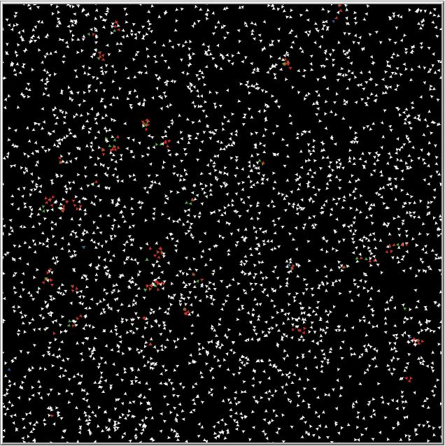

(Figure 2-Cluster Formation)

A few seconds into the simulation, there are clusters that can be seen forming around the plane. The slider for wealth was set to a small cluster (2.6%). Since there are both wealthy and intelligent people, the overlap is translated into the minute amount of blue turtles.

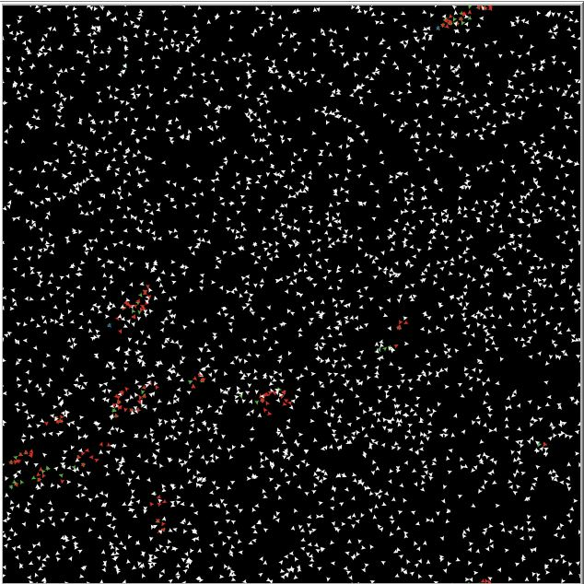

(Figure 3-Region Formation)

With more time spent for the simulation, these regions begin forming. These clusters of intelligent turtles and wealthy turtles begin to form.

Discussion

So what do these results display? With the selected factors for this simulation, it can be seen that there is a direct relation between the two examined factors (wealth and inventiveness), and the formations of large regions. Somewhat like the concept of mob-mentality, these turtles congregated wherever other turtles with desirable traits congregated, thus leading to growth of clusters.

As the initial aim was to prove that the inventiveness, mixed with proper funding, was a primary region for cluster formation in Silicon Valley-like regions, it was well proved by the simulation. These factors, combined with a relatively close proximity, contributed to these different clusters.

In today’s world, it is integral in identifying the primary factors that lead to development, in order to understand how further innovation can be promoted or inhibited.

References

Archibugi, Daniele. “Blade Runner Economics: Will Innovation Lead the Economic Recovery?” Research Policy, vol. 46, no. 3, 2017, pp. 535–543., doi:10.1016/j.respol.2016.01.021.

Kahl, D. “The Millionaire next Door Thomas J. Stanley and William D. Danko Marietta, GA: Longstreet Press, Inc.; 1996.” Financial Services Review, vol. 6, no. 3, 1997, p. 221., doi:10.1016/s1057-0810(97)90015-9.

Mac, Ryan. “The Scary Smart Are The Scary Rich: Examining Tech's Richest On The Forbes 400.” Forbes, Forbes Magazine, 26 Nov. 2012, www.forbes.com/sites/ryanmac/2012/09/24/the-scary-smart-have-become-the-scary-rich-examining-techs-richest-on-the-forbes-400/#1e5ff70538cc.

Wilensky, Uri, and William Rand. An Introduction to Agent-Based Modeling: Modeling Natural, Social, and Engineered Complex Systems with NetLogo. The MIT Press, 2015.