Research Article

Stone Tool Use Structures Handedness in Wild Macaques

Author list

Rohit Negi¹, Suchinda Malaivijitnond^{2,3}, Tracy L. Kivell⁴, Lydia V. Luncz¹

Orchid IDs

Rohit Negi - https://orcid.org/0000-0002-8550-9863

Suchinda Malaivijitnond –

Tracy L. Kivell – https://orcid.org/0000-0001-5087-0897

Lydia V. Luncz –

Affiliations

¹Technological Primates Research Group, Max Planck Institute of Evolutionary Anthropology, Leipzig, Germany

²National Primate Research Center of Thailand, Chulalongkorn University,
Saraburi, Thailand

³Department of Biology, Faculty of Science, Chulalongkorn University, Bangkok, Thailand

⁴Department of Human Origins, Max Planck Institute for Evolutionary Anthropology, Leipzig 04103, Germany

Author for correspondence:

Rohit Negi
Email - rohit_negi@eva.mpg.de

Keywords

Handedness, social foraging, task complexity, behavioral lateralization, stone tool-use, wild long-tailed macaques

Abstract

Population-level right-handedness is a unique feature of human behavior. Most current frameworks of human handedness propose a multicausal origin but with tool-related behaviors considered a central driver. Here, we studied how technological and socio-ecological factors interact to shape handedness patterns in a stone tool-using wild population of long-tailed macaques (Macaca fascicularis). We studied five different foraging behaviors, ranked with increasing complexity in order of mechanical and motor demands: food-rubbing, food-pounding, food-washing, and two stone-tool behaviors: nut cracking and oyster foraging. We quantified hand use across these behaviors to examine how task complexity relates to handedness expression. Individual handedness strength increased significantly with task complexity. Adult macaques exhibited exclusive hand preferences during complex tool-use behaviors such as oyster processing, while right- and left-handed individuals occurred in nearly equal proportions across our sample. Hand preference also shaped social foraging dynamics in that opposite-handed individuals were more likely to forage near one another during stone-tool-assisted oyster foraging. Because oysters are fixed to the substrate and vary in orientation, we posit that different strike angles may allow recently exploited rocks to remain profitable to an opposite-handed neighbour. Our findings indicate that complex tool-use highlight distinct individual handedness, while socio-ecological conditions may support the coexistence of varying hand preferences in macaques. Together, these results demonstrate how technological and socio-ecological factors interact to shape handedness within groups of non-human primates.

Introduction

Across all human societies, there is a strong propensity for behavioral lateralization. It is most clearly expressed as a population-level right-hand bias for skilled, coordinated, and sequential manual actions (Papadatou-Pastou et al., 2020). This pronounced and consistent pattern distinguishes humans from other primates and represents one of the clearest examples of population-level behavioral asymmetry (Cashmore et al., 2008). Despite its ubiquity, the evolutionary processes that produced this pattern remain unresolved, generating substantial empirical and theoretical debate regarding the selective pressures that shaped human handedness.

Human handedness has deep evolutionary roots in the hominin lineage (Estalrrich & Rosas, 2013; Frayer et al., 2012; Lozano et al., 2017; Volpato et al., 2012). Patterns of asymmetry in stone tools, cut marks on bones, and dental wear suggest increasing right-hand dominance with the emergence of more complex, bimanual technologies and the social transmission of tool-use skills (Frayer et al., 2012, 2016). Rather than arising from a single selective pressure, most current frameworks propose a multicausal origin for human handedness (Püschel et al., 2026). Tool use, bipedalism, bimanual coordination, gestural communication, brain expansion and lateralization have likely interacted over time to produce the populational-level right hand bias in modern humans (Bailoo et al., 2019; Braccini et al., 2010; Díaz et al., 2021; Prieur et al., 2020).

Population-level handedness emerges from the hand preferences of individuals. Before an entire population can become biased toward one hand, individuals must first develop strong and consistent hand preferences. Identifying the processes that facilitate the expression of handedness at an individual-level is therefore an important step toward understanding the evolution of population-level handedness patterns (Ströckens et al., 2013). Comparative and evolutionary frameworks suggest that behaviors that require high levels of motor precision and cognitive control promote stronger hand preferences (MacNeilage et al., 1987; Napier, 1962). A central framework in this discussion is the concept of task complexity, which states that behaviors requiring greater motor precision, sequential actions, or differentiated roles between the hands should promote stronger hand preferences than simpler manual behaviors (Fagot & Vauclair, 1991; Frost, 1980). Many non-human primate species (hereafter primates) routinely perform complex manual tasks, such as extractive foraging, that place high demands on motor precision and coordination (Das et al., 2020; Heldstab et al., 2016; Motes Rodrigo et al., 2018; Schmidlin et al., 2011). Under the task complexity framework, such primate species would be expected to show strong individual-level handedness.

Large comparative studies have tested this prediction predominantly on captive primates using a standardized tube task: a complex bimanual coordination task in which individuals hold a tube with one hand while extracting food with the other. Across these studies, primates frequently exhibited individual hand preferences but did not consistently develop aligned population-level handedness patterns (Caspar et al., 2022; Soto et al., 2022). The strength of individual handedness varied across species, with average absolute handedness values ranging from 0.26–0.77 [but see the values for highly arboreal species during feeding in trees (Caspar et al., 2022; Nelson and Boeving, 201]. In contrast, humans exhibit exceptionally strong individual handedness (0.95), which means humans almost always use a preferred hand for complex manual tasks (Cochet and Vauclair, 2012). These findings suggest that complex manual behaviours promote individual-level handedness in primates, but do not fully explain the exceptionally strong lateralization observed in humans.

Task complexity describes the motor and cognitive demands of a behaviour but strength of manual preference may also be influenced by the frequency with which such complex behaviors are performed. Complex manual behaviours that are important for survival may reinforce consistent hand use through repeated practice. Tool-assisted foraging in primates may represent one such behaviour. Tool use often requires both hands to perform different but coordinated roles, such as stabilizing and manipulating, holding and striking, or supporting and extracting. These forms of bimanual differentiation may reinforce lateralisation over time. When access to key resources depend on tool use, repeated engagement in these behaviours may amplify and stabilize hand preferences at the individual level, resulting in exceptionally handed individuals.

Once strong individual hand preferences have emerged, variation in individual hand preference becomes exposed to additional selective pressures because hand preference can influence how individuals exploit their environment and interact with conspecifics. Consequently, understanding the evolution of handedness requires examining both the behaviours that facilitate strong individual hand preferences and the socio-ecological conditions under which those preferences are expressed. Here, we investigate how tool use and socio-ecological context together shape handedness patterns in a wild primate population.

Long-tailed macaques (Macaca fascicularis) in southern Thailand and Myanmar habitually use stone tools to process nuts and marine invertebrates (Gumert et al., 2009; Luncz et al., 2017; Malaivijitnond et al., 2007). We studied a coastal-dwelling group, Little Island Group (LIG), of wild stone-tool-using long-tailed macaques on Boi Island in southern Thailand (Luncz et al., 2019). In addition to stone tool use, the LIG macaques routinely perform a range of simpler manual behaviors as part of their daily foraging, including food rubbing, food washing, and food pounding. The manual behaviors vary from simple unimanual actions to motorically complex stone-tool-assisted tasks. The diversity of manipulative foraging behaviors makes the LIG macaques an ideal model for examining how task complexity shapes hand preferences in a wild primate population.

Beyond this diversity in foraging behaviour, the LIG group inhabits an ecological setting in which stone-tool use may be especially important for resource acquisition. LIG macaques are restricted to a small island where they primarily use stone tools to exploit shellfish, particularly oysters (Saccostrea sp.). Oysters are replenished by ocean currents (Haase et al., 2012) and provide a predictable, abundant, and highly caloric food resource. Such resources may be particularly valuable in island environments, where alternative food sources are generally more limited than on the mainland (ref). Consistent with this expectation, our observations show that oysters constitute a major component of the LIG macaques' diet (Fig. 2a). As a result, the stone-tool-assisted behaviours required to access oysters are performed repeatedly throughout the year. Such repeated practice may reinforce motor skill and consistent hand use, potentially strengthening individual-level handedness.

Our first aim was to examine how task complexity was potentially correlated with individual hand preferences across the gradient of manual behaviours performed by LIG macaques. We quantified individual hand preferences across five manual behaviors, in increasing order of mechanical and motor demands: food rubbing, food pounding, food washing, and two stone-tool-assisted behaviors (nut cracking and oyster foraging). As task complexity increases, hand preference was expected to become more pronounced. Accordingly, we predicted clearer individual-level hand preferences during stone-tool-assisted behaviors than during lower-demand manual actions such as rubbing or washing. Consistent with broader comparative patterns in wild non-human primates, we did not expect these asymmetries to produce aligned population-level handedness.

If strong individual hand preferences exist, they can create the opportunity for handedness to influence how individuals exploit shared resources and interact with conspecifics. Our second aim therefore examined whether the socio-ecological context of our most complex task, stone-tool-assisted oyster foraging, may relate to how existing variation in individual hand preference influences social organization within the population. Oyster foraging occurs on exposed intertidal rocky shores that provide little structural refuge from avian predators and human disturbance. These conditions may promote foraging in proximity to conspecifics. At the same time, broader foraging theory predicts that the benefits of proximity should be balanced against the costs of resource competition (Pyke, 1984). Because oysters are fixed to rocky substrates and vary in orientation, some strike angles are easier to exploit with one hand than the other. Rocks exploited by one individual may remain profitable for individuals with the opposite hand preference, making opposite-handed associations profitable. We therefore examined whether pairs of monkeys with opposite hand preferences were more likely to forage close to one another than pairs of monkeys sharing the same hand preference during stone-tool-assisted oyster processing. This allowed us to evaluate whether individual differences in hand preference were associated with fine-scale social foraging patterns during stone-tool assisted oyster foraging.

Together, these two aims allow us to examine some of the potential factors that shape individual hand preferences and the conditions under which individual-level asymmetries may scale to influence group-level social organization in stone-tool using wild primates. By investigating how task complexity and local ecology interact within a single population of tool-using primates, this study offers a rare opportunity to trace the pathway from individual lateralization to population-level structure.

Methods -

Study site and study group

This study was conducted on Boi Island in the Ao Phang Nga National Park, southern Thailand (Luncz et al., 2019). All data were collected by RN over 230 field days between November 2023 and March 2025 and between December 2025 and March 2026. The study focused on a wild group of stone tool using long-tailed macaques (Macaca fascicularis) called LIG. A field-site map of Boi Island and the study area is provided in Figure 1.

The study group was a multi-male multi-female social group consisting of approximately 70 individuals during the study period (Supplementary Table 1). All individuals were fully habituated to human observers and were identified using physical characteristics including body size, facial features, pelage patterns, scars, and tail morphology. We include in this study only adult monkeys, totalling 34 individuals (13 males and 21 females). Infants and younger juveniles were excluded because hand preferences during early ontogeny may not yet reflect stable adult patterns of manual lateralization (Hook & Rogers, 2000; Hopkins & Bard, 1993; Nelson, 2022).

Behavioral observations and data collection

Behavioral data were collected using focal animal sampling and scan sampling techniques. To examine the relationship between hand preference and task complexity we studied a set of naturally occurring food-processing behaviors routinely performed by the LIG macaques. These behaviors share the common function of processing food items prior to consumption but differ markedly in their motor and mechanical demands. The behaviors were food rubbing, food washing, food pounding, and two stone-tool-assisted behaviors (nut-cracking and oyster processing). Food rubbing involves repeatedly rubbing food items, most commonly rattan fruits, against a wooden substrate before consumption. Food washing consists of rinsing food items, primarily Sonneratia alba fruits, in tide pools prior to eating. Food pounding involves pounding a food item such as clams against a hard surface to break the outer tissues and access the edible portions. Nut-cracking and oyster processing involve the use of handheld stone tools to crack sea almonds and open oysters, respectively. Representative examples of these behaviors are shown in Video 1, and stone-tool-assisted oyster processing is illustrated in Figure 1b.

For each behavioral event, we recorded the identity of the acting individual, the behavioral context, and the hand performing the principal manipulative action. Food rubbing, food pounding, and oyster processing were performed with one hand at a time; therefore, we recorded the hand manipulating the food item or stone tool. Food washing and nut cracking could involve differentiated roles for the two hands. During food washing, one hand supported the fruit while the other rubbed it between the hands and the water; the upper, actively-rubbing hand was recorded. During bimanual nut cracking, one hand was positioning and stabilizing the nut, while the other was holding the stone and appling the downward force; the hand holding the stone tool was recorded. Hand use was therefore classified according to the hand performing the principal action in each behavior. Opportunistic handheld video recordings were used to verify behavioral classifications and hand-use coding. Behavioural observations were supplemented opportunistically with handheld video recordings to verify behavioural classifications and hand-use patterns.

To examine fine-scale spatial associations during foraging, we conducted scan-based proximity observations. During each scan, we recorded the identity of the focal individual, the identities of all nearby adult individuals within 5 m, their distance from the focal individual (<1 m, <3 m, or <5 m), and the behavioural context of the focal individual at the time of the scan. Dyads were subsequently constructed from focal-neighbour pairings. For each dyad, we quantified the frequency with which the two individuals were observed within each proximity category across three behavioural contexts: stone-tool-assisted oyster foraging, foraging without tools, and all other activities, such as grooming, resting, and travelling. Nut-cracking events were excluded from these analyses because they occurred too infrequently at the individual level to permit meaningful comparisons. Based on our hypothesis that handedness influences fine-scale spacing meaning distance between individuals during stone-tool-assisted oyster foraging, we predicted that any effect would be strongest at the shortest distances and weaker or absent at larger distances and in other behavioural contexts. Because long-tailed macaques form female-philopatric societies, related females may associate closely irrespective of handedness. We therefore repeated the analyses twice: first using all adult dyads and then using only male–female dyads to reduce potential kinship-related biases in spatial associations.

Statistical Methods

Guttman scaling of behavioral complexity

To quantify variation in task complexity, we arranged five foraging behaviors (food rubbing, food pounding, washing, nut-cracking, and oyster processing) along a simple-to-complex continuum using Guttman scaling. We scored each behavior using five binary task-feature indicators that capture key motor and cognitive demands associated with food processing: transportation requirement, target-specific manipulation, tool use, multi-planar tool manipulation, and bimanual coordination. The operational definitions of these task features are provided in supplementary Table 2. Each feature was scored as present (1) or absent (0), producing a task-feature matrix for all five behaviors (Supplementary Table 3). Under a cumulative Guttman scale, more complex behaviors are expected to contain most or all of the task features present in simpler behaviors. We therefore assessed the extent to which the observed behavioral sequence conformed to this cumulative structure using the coefficient of reproducibility (CR), a measure of how closely the observed data match the expected cumulative pattern. Complexity scores were calculated as the proportion of task features present, producing values ranging from 0 (least complex) to 1 (most complex). The resulting complexity scale was subsequently used to examine the relationship between task complexity and handedness strength.

Task complexity and handedness strength

To test whether handedness strength increased with behavioral complexity, we examined the relationship between complexity scores derived from the Guttman scale to individual handedness strength (AbsHI) across the five foraging behaviors. To quantify individual hand preferences, we calculated a handedness index (HI) for each individual and behavior as: HI = (R − L) / (R + L) (ref). Here, R and L represent the number of right- and left-hand events recorded for a given behavior. Values approaching +1 indicate strong right-handedness, values approaching −1 indicate strong left-handedness, and values near 0 indicate no clear directional preference. Because our objective was to examine the strength rather than the direction of hand preference across the behavioral complexity gradient, we calculated the absolute handedness index (AbsHI = |HI|). Values approaching 1 indicate strong lateralization, whereas values approaching 0 indicate ambidextrous behavior. For behaviors in which individuals simultaneously used both hands, one event was added to both the left- and right-hand counts prior to calculating HI. This approach preserved ambidextrous hand use within the handedness metric rather than excluding such observations. Because multiple observations were available for the same individuals across behaviors, we used a repeated-measures correlation to examine the relationship between task complexity and handedness strength while accounting for non-independence among observations from the same subject. Only individuals represented in at least two task-complexity levels were included in the analysis.

Individual- and population-level patterns of handedness

To examine individual- and population-level handedness, we focused on stone-tool-assisted oyster processing. We selected oyster processing because it represented the most complex behavior in our task-complexity scale and involved skilled, coordinated, and sequential manual actions. Such behaviors are expected to elicit the strongest expression of hand preferences and are therefore considered particularly informative for investigating population-level patterns of handedness (Ocklenburg & Güntürkün, 2018). Individuals were classified as left-handed, right-handed, or ambidextrous based on their oyster-processing handedness scores. To determine whether individual hand preferences differed significantly from chance expectations, we conducted two-tailed binomial tests comparing the frequency of the dominant hand against a null expectation of equal left- and right-hand use (50:50). Population-level handedness was assessed by comparing the number of left- and right-handed individuals within the study population.

Effects of handedness on foraging partner composition

To investigate whether hand preference influenced fine-scale spatial associations between individuals, we analysed scan-sampling observations of focal–neighbour associations. Each focal–neighbour pair was classified as either opposite-handed (1) or same-handed (0) based on the hand preference of both individuals during oyster processing (Supplementary Table 3). We modelled the probability that an association consisted of opposite-handed individuals using a generalized linear model (GLM) with binomial error structure and a logit link function. Behavioural context, proximity category, and their interaction were included as fixed effects. To account for the possibility that female kinship could influence spatial associations in this female-philopatric species, we repeated the analysis using only male–female associations. Model fit was evaluated by comparing the full model with a null model using likelihood-ratio tests. Overdispersion was assessed using the package AER, and model assumptions were evaluated by inspecting simulated residuals generated with DHARMa. Diagnostic plots assessing residual uniformity, overdispersion, and outlier structure are provided in Supplementary Figure S1. All analyses were conducted in R version 4.5.1 (R Core Team, 2025).

Ethical Statement

Research permissions and ethical approval were obtained from the National Research Council of Thailand (NRCT), the Department of National Parks, Wildlife and Plant Conservation of Thailand (DNP), and the ethical committees of Faculty of Science, Chulalongkorn University (protocol review number). All research was observational and non-invasive. We acknowledge that field-based studies inevitably influence the behavior of wild animals and we therefore strictly adhere to the 2014 Code of Best Practices for Field Primatology established by the American Society of Primatologists and the International Primatological Society.

Results -

Guttman scaling of behavioral complexity

Five different foraging behaviors (food rubbing, food pounding, washing, nut-cracking, and oyster processing) were arranged along a simple-to-complex continuum using Guttman scaling (Supplementary Table 3). More complex behaviors generally incorporated the task features present in simpler behaviors (coefficient of reproducibility: CR = 0.84; four Guttman errors). Food rubbing was identified as the simplest behavior (Guttman score = 0.00) because it lacked all five task-feature indicators. In contrast, stone-tool-assisted oyster processing was identified as the most complex behavior (Guttman score = 0.80), incorporating transportation of tools and food items, target-specific manipulation, tool use, and three-dimensional implementation of tool movements. The remaining behaviors occupied intermediate positions along the complexity gradient, with food pounding scoring 0.20, food washing 0.40, and stone-tool assisted nut-cracking 0.60 (Table 3).

Task complexity and handedness strength

Handedness strength increased overall with task complexity (Figure 3). Macaques showed relatively weak hand preferences during food rubbing, the simplest behaviour on the complexity scale (mean AbsHI ± SD = 0.29 ± 0.28, n = 23 individuals). Mean handedness strength was substantially higher during food pounding (0.96 ± 0.13, n = 29), food washing (0.87 ± 0.18, n = 26), nut cracking (0.99 ± 0.06, n = 25), and oyster processing (0.97 ± 0.16, n = 31). Despite some variation between successive behaviours, the repeated-measures analysis showed that individuals increasingly relied on a preferred hand as task complexity increased (r = 0.60, df = 102, p < 0.05, 95% CI = 0.47–0.71). Nut cracking and oyster processing, the two most complex behaviours on the Guttman scale, were characterized by exclusive use of a preferred hand (Supplementary Table 4).

Individual- and population-level patterns of handedness

Oyster processing revealed exceptionally strong individual hand preferences: most adults (96.8%) always used the same hand when opening oysters with stone tools (binomial test: p < 0.001; Supplementary Table 4). Only one adult male (BAB) was ambidextrous for stone-tool assisted oyster processing. Laterality stayed consistent within individuals for stone-tool assisted tasks. Monkeys that used the right hand for stone-tool assisted nut-cracking also used the right hand for oyster processing, and the same held for left-handed individuals (Supplementary Table 4). Despite these strong individual biases, there was no population-level preference: right- and left-handed adults were nearly equally represented (~ 55% vs 45%, respectively). Males were predominantly right-handed (87.5% right-handed) whereas females showed a bias toward left-handedness (38% right-handed vs. 62% left-handed; Supplementary Table 4).

Effects of handedness on foraging partner composition

The likelihood that two neighbouring monkeys differed in handedness depended both on their behavioural context (oyster foraging, non-tool foraging, and all other activities) and on how closely they were positioned to one another (likelihood ratio test: χ² = 53.07, df = 8, p < 0.001). During oyster foraging, monkeys were most likely to forage near opposite-handed individuals when they were in close proximity to each other i.e., less than 3m (Table 1). This means left-handed individuals frequently forage alongside right-handed individuals, and vice versa. This tendency to associate with opposite-handed individuals weakened at greater distances, with monkeys separated by 5m significantly less likely to differ in handedness than monkeys within one metre of one another (GLM: estimate: β = -0.64, p = 0.011). This pattern was specific to oyster foraging. During less complex activities, individuals were far less likely to associate with different-handed monkeys (Table 1). Compared with oyster foraging at close proximity (<1 m), opposite-handed pairings were less common during foraging without tools (β = −1.36, p = 0.002) and during all other activities (β = −0.69, p = 0.005). Representative examples of opposite-handed individuals foraging in close proximity are shown in Video 2.

Because long-tailed macaques live in female philopatric societies, closely related females may associate with one another independent of handedness. We found that female–female associations comprised 59.8% of observations in the full dataset (Supplementary Table 6). To account for potential confounding effects arising from stable female kin associations, we repeated the analysis using only male–female associations. In the subset of male-female dyads, dyad-handedness showed a similar pattern (χ² = 18.41, df = 4, p < 0.001; Supplementary Table S4). Male–female pairs were most likely to differ in hand preference during oyster foraging, whereas opposite-handed associations were substantially less common during foraging without tools (β = –0.17, p = 0.005) and during all other activities (β = –0.07, p < 0.001). Unlike the full dataset, proximity did not influence whether male–female pairs differed in handedness (all p > 0.14) (Supplementary Table 4).
Discussion

Understanding how increasingly complex technological behaviors may shape the evolution of manual lateralization remains a critical challenge in tracing the origins of population-level handedness in humans. This study explores how tool use may affect individual and population level handedness structure in a wild population of stone-tool using long-tailed macaques. By combining measures of task complexity, individual hand preferences, and fine-scale social associations during foraging, our study provides insights into how local ecological conditions may shape the strength and direction of manual lateralization in wild primates.

Task complexity and handedness strength

Our results showed that individual-level handedness increased consistently as task complexity increased. Individuals that showed weak or inconsistent hand preferences during simpler behaviors, such as food rubbing, and almost exclusively relied on a single preferred hand during more demanding tool-assisted nut cracking and oyster processing behaviors. Complex behaviors such as stone tool use require high levels of motor precision and coordination, and hand specialization has been linked to improved task performance (Mangalam et al., 2015; McGrew and Marchant, 1999). High individual-level handedness during complex tasks may therefore reflect the performance advantages associated with hand specialization. Similar associations between task complexity and handedness strength have been reported in cercopithecids (Leca et al., 2010; Regaiolli et al., 2016; Schweitzer et al., 2007), platyrrhines (Motes Rodrigo et al., 2018; Nelson and Boeving, 2015) and non-human apes (Boesch, 1991; Brand et al., 2017). Together, these findings suggest that as task demands increase, primates respond by consistently relying on a preferred hand, although the strength of lateralization varies considerably among species and behaviors.

In our study, stone-tool-assisted nut and oyster processing were characterized by exceptionally strong individual hand preferences. With the exception of a single adult male, all individuals exclusively relied on one preferred hand to process oysters with stone-tools (AbsHI ~ 0.97). This value lies near the upper end of the distribution reported across anthropoid primates, for which the overall comparative estimate is approximately 0.67 (Püschel et al., 2026). The strength of individual handedness observed in LIG macaques during stone tool-assisted behaviours is comparable in magnitude to that reported in humans (0.94; Cochet and Vauclair, 2012). It should be noted that this similarity concerns the strength of individual preferences rather than their population-level direction: humans show pronounced population-level right-handedness, whereas left- and right-handed individuals were nearly equally represented among the LIG macaques.

Stone-tool use provides one possible explanation for the strong hand preferences observed in LIG macaques. Among the three non-human primate lineages known to habitually use stones as tools, chimpanzees (Pan troglodytes) show strong individual-level handedness during stone-tool use, with values ranging between 0.79 to 1.00 in the wild (Boesch, 1991; Humle and Matsuzawa, 2009; Sugiyama et al., 1993; Biro et al., 2006). In contrast, wild bearded capuchins (Sapajus libidinosus) generally exhibit weaker hand preferences while using stone tools in the wild (0.67-0.77, De A. Moura, 2015; Falótico 2011). Together, these comparisons suggest that although stone-tool use promotes individual hand preferences in primates, it does not invariably produce the near-exclusive hand use observed in LIG macaques. Additional factors are therefore likely to further amplify individual hand preferences in this population.

The importance of stone-tool-assisted foraging may help explain why individual handedness is particularly strong in LIG macaques. Chimpanzees and capuchins primarily use stone tools to access hard-shelled food resources, particularly nuts, which tend to be seasonally available (Boesch et al., 2017; Carvalho et al., 2008; Falótico and Ottoni, 2016; Fragaszy et al., 2004; Spagnoletti et al., 2012). In contrast, LIG macaques use stone tools to mainly access shellfish, particularly oysters (Fig 1b), that are available throughout the year. Within a spatially constrained island ecosystem, such a predictable and reliable food resource may become especially important. As a result, the stone-tool-assisted behaviors required to access oysters may also become important, leading to repetitive engagements in such behavior. Repeated performance of these behaviors over time may reinforce reliance on the preferred hand, as individuals repeatedly practice and refine the same motor patterns.

Oyster processing is also mechanically demanding. Nuts can be positioned on a horizontal anvil, allowing force to be applied repeatedly along a perpendicular, downward direction. In contrast, oysters are attached to the substrate and cannot be repositioned before processing. Macaques must therefore strike from a variety of angles, sometimes overhead, while repeatedly directing force to the same, specific location on the oyster. Oyster processing therefore requires both force and precision under highly variable conditions, making it a particularly complex form of tool use. The combination of this task complexity and repetitive nature of the behavior due to the context specific importance of oyster foraging may contribute to the exceptionally strong individual hand preferences observed in the present study.

Comparably strong individual hand preferences have also been reported in highly arboreal primates, such as spider monkeys (Ateles) and langurs (Trachypithecus), with handedness values for reaching during feeding of 0.94 and 0.98 respectively (Caspar et al., 2022; Nelson and Boeving, 2015). These asymmetries have been linked to the demands of feeding in an arboreal environment, where individuals repeatedly maintain postural stability with one hand while simultaneously reaching for and manipulating food items with the other (MacNeilage et al., 1987). Long-tailed macaques are not highly arboreal primates and yet exhibit similarly strong hand preferences. Feeding while hanging in arboreal primates and stone-tool-assisted oyster foraging in macaques may therefore represent different examples of ecologically important complex behaviors that are repeatedly performed over time and which facilitate the expression of exceptionally strong individual hand preferences. Together, these comparisons suggest that the strength of individual handedness may depend less on tool use or substrate use alone and more on how important and repeatedly practiced a complex manual behavior is within a particular ecological context.

Effects of handedness on foraging partner composition

Local ecological conditions may also influence how different hand preferences are distributed within social groups. Although the LIG macaques showed no overall population-level bias toward either left- or right-handedness, opposite-handed individuals were significantly more likely to forage together during stone-tool-assisted oyster processing than during non-tool foraging or other behavioural contexts. This association was evident only at close range. Opposite-handed neighbours were common within 1 m and 3 m, but this pattern disappeared when individuals were 5 m apart. In contrast, monkeys engaging in non-tool foraging, resting, travelling, or grooming showed no comparable tendency to associate with opposite-handed individuals.

Oyster foraging takes place on exposed rocky shores where predation risk may favor foraging near conspecifics (Josephs et al., 2016). Strongly lateralized individuals are forced to repeatedly exploit the same physical foraging space in close proximity to one another. Broader foraging frameworks predict that the benefits of proximity to conspecifics should be balanced against the costs of efficient resource exploitation (Pyke, 1984). Oysters are fixed to the rock substrate and vary in orientation. Some strike angles are easier to exploit for individuals with particular hand preference than the other. As a result, rocks exploited by one individual may remain profitable for individuals with the opposite hand preference, likely making opposite-handed associations more beneficial.

The extent to which monkeys are aware of the hand-use patterns they display during foraging remains unknown. Individuals may recognize and remember the hand preference of others and actively choose foraging partners with opposite hand preferences. Or they may simply rely on increased foraging outcomes associated with opposite handed partners. The simpler explanation is an outcome-based process in which repeated positive foraging outcomes reinforce associations with particular partners through associative learning (O’Hearn et al., 2025; Rescorla, 1988). Repeatedly obtaining favorable foraging outcomes when near an opposite-handed partner may gradually increase an individual's tendency to associate with such partners. Because oyster foraging is an important and repeatedly performed behavior in this system (Fig 1a), mixed-handed associations may emerge and persist through repeated reinforcement without requiring explicit recognition of hand preference.

Together, our findings suggest that the ecological context of oyster foraging in LIG macaques may shape handedness simultaneously at two levels. At the individual level: the importance, complexity, and repeated nature of stone-tool use drives strong hand preferences. At the population level: the geometric properties of oysters, the exposed foraging environment, and repetitive engagement in the stone-tool-assisted oyster foraging due to the context specific importance of this behavior may favor mixed-handed group composition as a foraging strategy. Local ecology may therefore explain how strongly lateralized individuals may become and also how handedness becomes organized within populations.

Our findings map closely onto the two-stage evolutionary model for human handedness, where strong individual-level handedness evolved early across the hominin lineage, whereas pronounced population-level rightward directionality could have emerged later alongside encephalization and the emergence of the genus Homo (Püschel et al., 2026). The macaques on Boi Island may act as a model to illustrate conditions in which manual lateralization becomes beneficial in a living primate population. Increasingly important complex behaviors may drive individual lateralization to exceptionally high levels without producing population-level directionality in handedness. This also suggests that complex manual behaviors may increase the benefits of stable functional specialization between the hands, but these benefits may apply equally to both left- and right-handed individuals.

Our work demonstrates how techno-socio-ecological factors may shape handedness at both the individual and population levels simultaneously. The unique ecological conditions of oyster foraging appear to promote strong individual hand preferences while also favoring mixed-handed population structure through foraging advantages associated with mixed-handed group composition. Together, these findings suggest that understanding the evolution of handedness requires considering the complexity of a behavior, as well as the ecological context in which that behavior is repeatedly performed.

Acknowledgments

We thank the Department of National Parks, Wildlife and Plant Conservation (DNP), Thailand, and the National Research Council of Thailand (NRCT) for permission to conduct this research. We are grateful to the staff of the National Primate Research Center of Thailand for logistical support throughout the project. We also thank the field assistants and local collaborators whose assistance made long-term data collection possible. Finally, we thank members of the Technological Primates Research Group for helpful discussions and comments on earlier versions of this manuscript.

Conflict of Interest

The authors declare no competing interests.

Author Contributions (CRediT)

Rohit Negi: Conceptualization, Methodology, Investigation, Data curation, Formal analysis, Visualization, Writing – original draft.

Suchinda Malaivijitnond: Resources, Writing – review & editing.

Tracy L. Kivell: Writing – review & editing.

Lydia V. Luncz: Conceptualization, Methodology, Supervision, Funding acquisition, Visualization, Project administration, Writing – review & editing.

Data Availability Statement

The data and R code supporting the findings of this study are publicly available in the GitHub repository handedness_LTM at: https://github.com/ro-negi/handedness_LTM. A permanent archived version of the repository, with a DOI, will be deposited in Zenodo before publication.

Tables -

Table 1 - Generalized linear model results for adult dyad handedness. The constant (intercept) represents the probability that a dyad was different-handed when foraging on oysters with stone tools at <1 m proximity. Estimates (β) are log-odds of a dyad being different-handed for each category.

Predictors | Categories | Estimate (β) | SE β | z | P
Model 1: dyad_handedness ~ behavioral.context*dyad.proximity
Constant | - | 0.81093 | 0.22713 | 3.570 | 0.000356 ***
Behavioral context | Foraging without tools | -1.35747 | 0.44173 | -3.073 | 0.002119 **
 | Other | -0.69018 | 0.24834 | -2.779 | 0.005450 **
Dyad proximity | 3m | 0.02267 | 0.27268 | 0.083 | 0.933747
 | 5m | -0.64439 | 0.25294 | -2.548 | 0.010848 *
Interactions | Foraging_without_tools:<3m> | 0.13301 | 0.53925 | 0.247 | 0.805174
 | other:<3m> | -0.27695 | 0.31654 | -0.875 | 0.381619
 | Foraging_without_tools:<5m> | 1.04522 | 0.49404 | 2.116 | 0.034374 *
 | other:<5m> | 0.39879 | 0.28997 | 1.375 | 0.169039

Figures:
Figure 1: Research site in Boi Yai island, Ao Phang Nga National Park, Thailand.
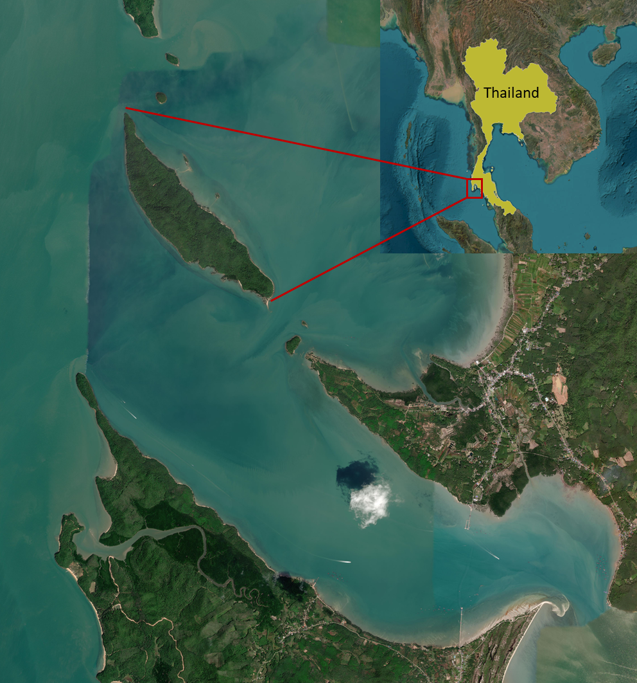

Figure 2: a) Average proportion of time spent by macaques on stone tool assisted oyster foraging compared to other food resources. b) An adult female macaque (Cac) using axe hammering technique to process a rock oyster.
(a) | (b)
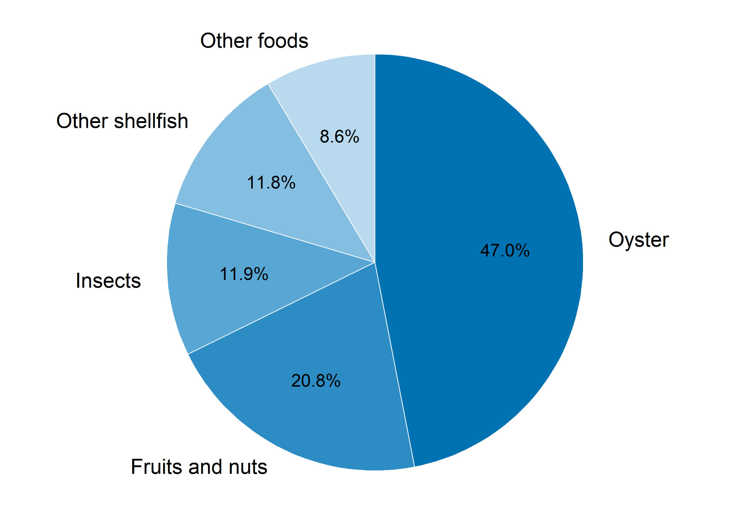 | 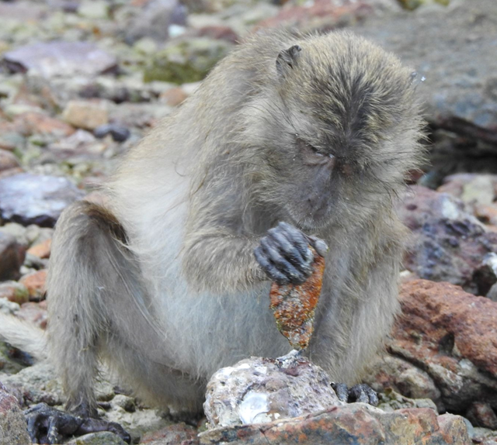

Figure 3 - Absolute handedness index (|HI| = |(Right − Left) / (Right + Left)|) increased across five behavioral contexts of increasing complexity (rubbing, pounding, washing, nut-cracking, and oyster processing). Each point represents an individual, with point intensity indicating the number of individuals sharing the same HI value within a given task. The black line shows a simple linear regression added for visualization, and the shaded area depicts its 95% confidence interval. This plot shows that macaques who barely favored either hand in the simple tasks shifted to a clear, consistent hand preference once the task complexity increased.
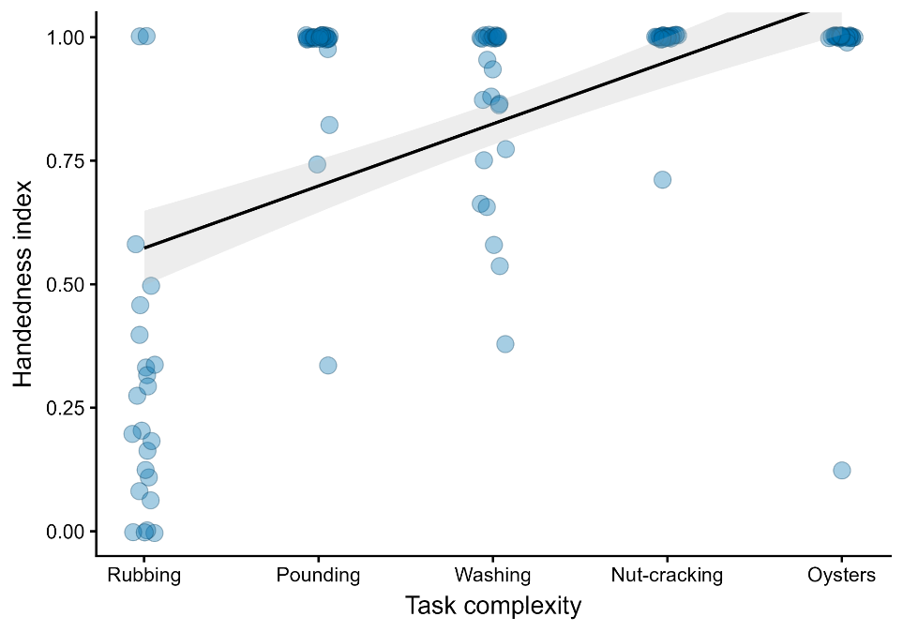
Supplementary Tables -

Table 1 - Group composition of the LIG group as of Apr 2026.

Adult males | Adult females | Juveniles and infants
13 | 21 | 36

Table 2 - Individual level handedness strength (Abs HI) values for tool-using wild primates. † represent studies where AbsHI values are calculated based on the data given in the respective studies. N represents the number of individuals that contributed to the data.

Reference | Species | setting | N | Behavior | AbsHI
Boesch, 1991 | P. troglodytes | wild | 35 | stone-tool use (percussive) | 0.79 ± 0.25†
Sugiyama et al., 1993 | P. troglodytes | wild | 7 | stone-tool use (percussive) | 1
Humle & Matsuzawa, 2009 | P. troglodytes | wild | 22 | stone-tool use (percussive) | 0.98 ± 0.05
Biro et al., 2006 | P. troglodytes | wild | 22 | stone-tool use (percussive) | 1
De A. Moura, 2015 | Sapajus libidinosus | wild | 6 | stone-tool use (percussive) | 0.67 ± 0.39
Falotico, 2011 | Sapajus libidinosus | wild | 43 | stone-tool use (percussive) | 0.77 ± 0.31
Salmi et al., 2023 | Sapajus libidinosus | wild | 10 | wooden-tool use (percussive) | 0.44 ± 0.37
Lonsdorf & Hopkins, 2005 | P. troglodytes | wild | 17 | probe tool use (termite-fishing) | 0.58 ± 0.34
Nishida & Hiraiwa, 1982 | P. troglodytes | wild | 20 | probe tool use (ant-fishing) | 0.286 ± 0.33†
Grew & Marchant, 1992 | P. troglodytes | wild | 11 | probe tool use (termite-fishing) | 0.537 ± 0.36†
Lilak & Phillips, 2008 | Sapajus apella | wild | 7 | stick tool use  (dipping) | 0.68 ± 0.24
Sousa et al., 2009 | P. troglodytes | wild | 14 | Leaf-tool use | 0.500 ± 0.34

Table 3 - Task-feature indicators used in the Guttman cumulative scaling analysis, along with their definitions. Each feature is scored as present (1) or absent (0) and represents a specific motor or cognitive requirement of the pre-processing behaviors.

Behavior | Description
Transportation required | Food item or tool(s) must be moved to a separate processing location before manipulation (1/0)
Target-specific manipulation | Action is directed toward a specific structural point of the food item (1/0)
Tool use | Tool is actively used to act on or modify the food item (1/0)
Three-dimensional implementation of tool | Manipulation requires coordinating tool movements across multiple spatial directions and approach angles, rather than within a single plane (1/0)
Bimanual coordination | Both hands are used in a coordinated manner during the manipulation (1/0)

Table 4: Task-feature matrix for the five macaque pre-processing behaviors. This table presents the binary scoring of each behavior across the five task-feature indicators used to construct the cumulative complexity scale: transportation requirement, target-specific manipulation, tool use, three-dimensional implementation, and bimanual coordination.

Behavior | Transport | Target | Tool | 3D | Bimanual | Pattern | Sum of features | Guttman score
Rubbing | 0 | 0 | 0 | 0 | 0 | 00000 | 0 | 0.00
Food pounding | 0 | 1 | 0 | 0 | 0 | 01000 | 1 | 0.20
Washing | 1 | 0 | 0 | 0 | 1 | 10001 | 2 | 0.40
Nut-cracking | 1 | 0 | 1 | 0 | 1 | 10101 | 3 | 0.60
Oyster processing | 1 | 1 | 1 | 1 | 0 | 11110 | 4 | 0.80

Table 5: Individual hand-use patterns during oyster processing. The Handedness Index (HI) was calculated as (Right − Left) / (Right + Left), where values near +1 indicate strong right-handedness, values near −1 indicate strong left-handedness, and values near 0 indicate no clear bias. N denotes the number of independent focal observations, while n represents the average number of oysters processed within a focal observation. Individual lateralization was assessed with a binomial test comparing the dominant hand’s strike count against a 50:50 expectation. †represent the only ambidextrous monkey in the troop.

subjects | sex | right | left | N | n | HI | p_value
ALI | m | 114 | 0 | 7 | 16.29 | 1 | < 0.0001
Aur | f | 1399 | 0 | 41 | 34.12 | 1 | 0
†BAB | m | 283 | 175 | 20 | 22.9 | 0.236 | < 0.0001
BAT | m | 285 | 0 | 9 | 31.67 | 1 | < 0.0001
BEL | m | 11 | 0 | 3 | 3.67 | 1 | 0.0009
Bet | f | 0 | 224 | 15 | 14.93 | -1 | < 0.0001
Cac | f | 947 | 0 | 27 | 35.07 | 1 | < 0.0001
Dan | f | 0 | 568 | 38 | 14.95 | -1 | < 0.0001
Fla | f | 0 | 1241 | 30 | 41.37 | -1 | 0
Gra | f | 0 | 1228 | 46 | 26.7 | -1 | 0
Har | f | 0 | 1106 | 29 | 38.14 | -1 | 0
Iyl | f | 829 | 0 | 32 | 25.91 | 1 | < 0.0001
Jim | f | 0 | 1177 | 36 | 32.69 | -1 | 0
KAL | m | 206 | 0 | 5 | 41.2 | 1 | < 0.0001
Kay | f | 0 | 2195 | 49 | 44.8 | -1 | 0
Lip | f | 0 | 2350 | 38 | 61.84 | -1 | 0
Nai | f | 0 | 1064 | 39 | 27.28 | -1 | < 0.0001
Ore | f | 0 | 399 | 14 | 28.5 | -1 | < 0.0001
PAT | m | 129 | 0 | 11 | 11.73 | 1 | < 0.0001
Pin | f | 661 | 0 | 19 | 34.79 | 1 | < 0.0001
Qui | f | 1836 | 1 | 44 | 41.75 | 0.999 | 0
RAM | m | 0 | 3 | 1 | 3 | -1 | 0.25
Rob | f | 0 | 1413 | 37 | 38.19 | -1 | 0
San | f | 0 | 577 | 21 | 27.48 | -1 | < 0.0001
Tai | f | 867 | 0 | 20 | 43.35 | 1 | < 0.0001
TED | m | 247 | 0 | 14 | 17.64 | 1 | < 0.0001
TIN | m | 41 | 0 | 3 | 13.67 | 1 | < 0.0001
TUT | m | 359 | 0 | 9 | 39.89 | 1 | < 0.0001
Vul | f | 0 | 2107 | 38 | 55.45 | -1 | 0
Whi | f | 1577 | 0 | 40 | 39.42 | 1 | 0
Yai | f | 1276 | 0 | 40 | 31.9 | 1 | 0

Table 6 - Generalized linear model results for the male-female dyad handedness. The constant (intercept) represents the probability that a dyad was different-handed when foraging on oysters with stone tools at <1 m proximity. Estimates (β) are log-odds of a dyad being different-handed for each category.

Predictors | Categories | β | SE β | z | p
Model 1: dyad_handedness ~ beh.context + proximity
Constant | - | 0.8301 | 0.2761 | 3.006 | 0.002646 **
Beh.context | Foraging without tools | -0.9962 | 0.3570 | -2.790 | 0.005268 **
 | Other | -0.9000 | 0.2429 | -3.706 | 0.000211 ***
Proximity | <3m | -0.1661 | 0.2767 | -0.600 | 0.548312
 | <5m | 0.1932 | 0.2376 | 0.813 | 0.416040

Table 7 -
Sex combination | Same-handed | Opposite-handed | Total | % of all observations
Female – Female | 525 | 597 | 1122 | 59.8
Male - Female | 270 | 387 | 657 | 35.1
Male - Male | 93 | 3 | 96 | 5.1

Supplementary Figures:
Figure 1: DHARMa diagnostic plots.

(a) | (b)
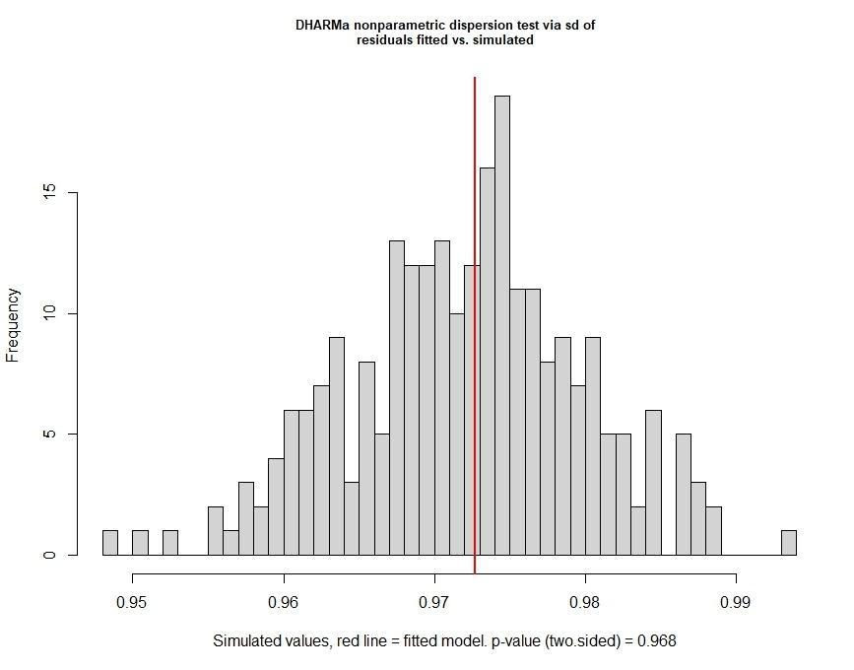 | 